DIP_Lab_Task # 12

Submitted By: Aman Tariq
Roll No: 2023-SE-29
Course Name: DIP
Course Code: SE-3112
Session: 2023-2027
Submitted To: Engr. Ahmed Khawaja

Lab Task 12_Report
Title: Thresholding and Segmentation Techniques
1. Introduction
Image segmentation is the process of partitioning an image into meaningful regions for analysis or processing. Thresholding and clustering-based methods are widely used for segmenting grayscale and color images.
This lab demonstrates:
- Global, Otsu, and Adaptive Thresholding
- K-Means Clustering for color segmentation
- Mean Shift Segmentation
2. Objectives
- Apply different thresholding techniques to extract foreground from background
- Segment color images using K-Means clustering
- Perform Mean Shift filtering for image segmentation
- Compare the effectiveness of each method visually
3. Tools and Libraries Used
- Python
- OpenCV (cv2)
- NumPy
- Matplotlib
- Google Colab
4. Methodology / Procedure
Step 1: Image Upload
- User uploads a color image.
- The image is converted to grayscale for thresholding operations.
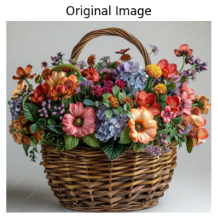
Step 2: Thresholding
- Global Thresholding:
  - Applies a fixed threshold (127) to classify pixels as foreground or background.
  - Effective for images with uniform lighting.
- Otsu Thresholding:
  - Automatically determines the optimal threshold by minimizing intra-class variance.
  - Works well for bimodal histograms.
- Adaptive Thresholding:
  - Threshold is calculated for local regions, accounting for varying illumination.
  - Useful for images with non-uniform lighting.
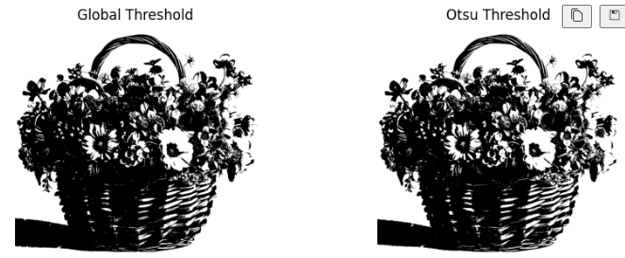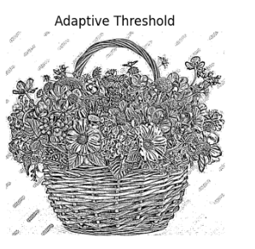
Step 3: K-Means Segmentation
- Converts the image to a feature space and clusters pixel values into k groups.
- Applied for k = 2, 3, 4.
- Useful for color image segmentation and quantization.
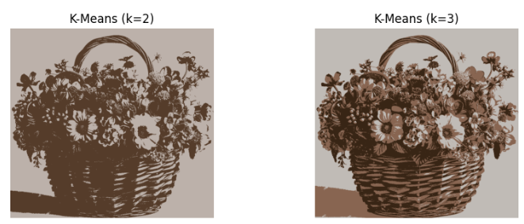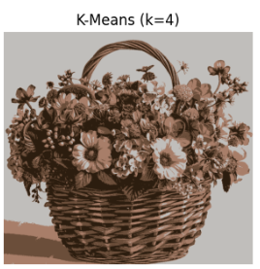
Step 4: Mean Shift Segmentation
- A non-parametric clustering method that smooths the image while preserving edges.
- Groups pixels based on spatial proximity and color similarity.
- Produces visually coherent regions and preserves object boundaries.
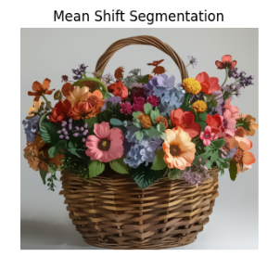
5. Results
Method | Observations
Global Threshold | Clear separation for well-lit images; fails with uneven illumination
Otsu Threshold | Automatic threshold selection; works well for bimodal intensity images
Adaptive Threshold | Effective under non-uniform lighting; highlights local details
K-Means (k=2) | Segments the image into two dominant color clusters
K-Means (k=3) | More detailed segmentation with three clusters; reduces color complexity
K-Means (k=4) | Further segmentation; may introduce over-segmentation
Mean Shift | Smooths regions while preserving edges; ideal for object-based segmentation
6. Conclusion
- Thresholding is simple and fast, best for grayscale images with uniform lighting.
- Otsu and Adaptive methods improve results for varying illumination.
- K-Means segmentation reduces color complexity and clusters pixels into meaningful regions.
- Mean Shift segmentation preserves edges and produces visually smooth regions.
- Choosing a segmentation method depends on the image characteristics and the task at hand.

THE END

