

MINOR PROJECT
SYNOPSIS REPORT
Pattern Recognition and Lyrical Semantic Analysis

Submitted By
Specialization/Batch | SAP ID | Name
AIML - 12 | 500123859 | Dheeraj Basera
AIML - 11 | 500119459 | Yash Tyagi
AIML - 11 | 500125832 | Aman Tewari

School Of Computer Science
UNIVERSITY OF PETROLEUM & ENERGY STUDIES,
DEHRADUN- 248007. Uttarakhand

Mentor : Amit Kumar

Table of Contents
- Introduction
  - Technical Concepts (Algorithms)
  - Motivation
  - Problem Statement
  - Area of application
  - Dataset and input format
- Literature Review
- Objectives
- Methodology
  - Reference Software model
  - Steps
  - Timeline
- References

Introduction

The rapid expansion of digital music platforms has increased the demand for accurate and personalized recommendation systems. Most existing systems rely primarily on user behavior, genre classification, audio features, or popularity trends. Lyrical content, despite carrying emotional tone, thematic structure, and expressive meaning, remains insufficiently analyzed in mainstream recommendation models.
This project develops an AI-based lyrical pattern recognition system focused on identifying structural and semantic similarities in song lyrics. The approach emphasizes lightweight, interpretable methods using structured feature extraction, vector space representation, and unsupervised machine learning techniques.
Lyrics are transformed into measurable numerical features and grouped using clustering algorithms to discover natural similarity patterns. Recommendations are generated based on vector similarity rather than genre or listening history, enabling cross-genre and cross-style discovery driven purely by lyrical characteristics.
The objective is to design an academically grounded, explainable, and practically implementable framework for lyric-based song recommendation using pattern recognition and unsupervised AI techniques.

Technical Concepts (Algorithms)
The system integrates core AI and machine learning techniques to analyze lyrical content and group similar songs. The selected methods emphasize interpretability, structured modeling, and computational efficiency.
Pattern Recognition
Pattern recognition serves as the foundation of the system. It identifies recurring structural, lexical, and thematic elements within song lyrics. These patterns establish measurable similarity relationships among songs.
Feature Extraction
Lyrics are processed to extract structured textual features such as word frequency distribution, lexical diversity, repetition density, and emotion-oriented term frequencies. Additionally, statistical representations such as TF-IDF are applied to capture term significance across the corpus. These features create a quantitative representation of lyrical content.
Vector Space Representation
All extracted features are transformed into numerical vectors. Each song is represented as a point in a multidimensional vector space, enabling mathematical comparison and similarity computation.
Unsupervised Machine Learning
Since lyrical categories are not predefined, unsupervised learning techniques are applied. K-Means clustering is used to identify natural groupings of songs based on similarities in their vector representations.
Similarity Matching
Songs within the same cluster or those located at minimal vector distance are considered similar. Distance metrics such as cosine similarity or Euclidean distance are used to quantify closeness between lyrical representations.

Motivation
Modern music listeners often seek songs that convey similar emotions or themes, independent of artist, era, or genre. Conventional recommendation systems predominantly rely on collaborative filtering, listening history, and popularity metrics, while the expressive and thematic depth of lyrics remains underutilized. Since lyrics encapsulate storytelling, emotional tone, and conceptual structure, analyzing them can significantly enhance personalization.
This project is motivated by the need to address:
• Limited integration of lyric-based similarity analysis in existing recommendation systems
• Demand for emotion-oriented and meaning-driven song discovery
• Constraints of genre-based classification in capturing listener intent
• Requirement for an interpretable and academically defensible AI framework
• Capability of unsupervised learning to uncover hidden lyrical relationships across songs
The project adopts structured feature-based modeling and statistical text representation instead of complex linguistic models to ensure interpretability, reduced computational overhead, and clear academic traceability of results. The objective is to improve music discovery by systematically identifying lyrical patterns using transparent and scalable AI techniques.

Problem Statement
Despite significant advancements in music recommendation systems, lyrical content remains insufficiently integrated into similarity modeling, even though it strongly influences emotional engagement and listener preference. Most existing systems prioritize user interaction history, genre classification, and audio-based attributes, while the semantic and structural aspects of lyrics receive limited analytical attention.
Current limitations include:
• Inadequate modeling of lyrical similarity
• Overreliance on historical behavior and genre-based categorization
• Limited application of explainable AI techniques for text-driven recommendations
• Lack of systematic unsupervised clustering based on lyrical characteristics
There is a clear need for an AI-based framework that extracts structured lyrical features, identifies similarity patterns through clustering, and generates recommendations in a transparent and interpretable manner.

Area of Application
The proposed system has multiple practical and academic applications across industries and platforms:
• Music streaming platforms aiming to enhance recommendation accuracy through lyrical similarity modeling
• AI-driven personalization systems integrating structured lyrical analysis
• Entertainment analytics firms evaluating thematic and emotional patterns in song content
• Research initiatives in pattern recognition, text mining, and unsupervised clustering
• Academic projects demonstrating interpretable and explainable machine learning models
• Artists and producers analyzing lyrical structures and thematic trends for creative insight

Dataset and Input Format
Primary Dataset
The primary dataset consists of English song lyrics collected from publicly available and open-source platforms, including structured datasets and lyric repositories. The dataset is curated to ensure diversity across genres, themes, and emotional tones.
Each data entry contains:
• Song Title
• Artist Name
• Complete Lyrics Text
The dataset is stored in a structured format (CSV/JSON), where each row corresponds to a single song. The lyrics field serves as the primary input for preprocessing, feature extraction, vectorization, and clustering.
This structured dataset enables systematic extraction of lexical, statistical, and semantic features required for pattern recognition and similarity modeling.

SECONDARY DATA SOURCES:

Secondary data includes lyrics obtained from established online lyric repositories and open datasets. These sources provide diverse songs across different genres and languages.
Sources include:
- Lyrics.com – https://www.lyrics.com/
- AZLyrics – https://www.azlyrics.com/
- Lyrics.ovh API – https://api.lyrics.ovh/v1/
- Kaggle Lyrics Datasets – https://www.kaggle.com/search?q=lyrics+dataset These sources help extract:
- Complete lyrics
- Genre and emotional diversity
- Words and pattern variations across songs

Literature Review
Artificial intelligence has been extensively used in recommendation systems, text mining, and pattern analysis. This section explores relevant literature across three major areas: text-based clustering, music recommendation systems, and unsupervised learning models.

1. Text-Based Pattern Recognition and Clustering
Past studies have shown that text data can be clustered effectively using simple feature extraction techniques and vector-based representations. Traditional algorithms such as K-Means have been used widely for document grouping, revealing underlying patterns without the need for labeled datasets. These studies validate the feasibility of applying unsupervised clustering to song lyrics, which are also text documents.

2. Music Recommendation Systems
Most research in music recommendation focuses on collaborative filtering, genre classification, and audio signal processing. While these methods perform well, they largely ignore metadata such as lyrics. Researchers highlight that lyrics play a key role in emotional perception and thematic classification, yet lyric-based machine learning models are still limited in scope. This project addresses this under-explored dimension.

3. Unsupervised Machine Learning for Content Similarity
Unsupervised learning models have been widely used in domains where labels are difficult to define, such as document organization, sentiment grouping, and anomaly detection. Literature consistently supports the effectiveness of clustering algorithms in discovering natural groups within textual data. These findings support the use of K-Means for identifying lyrical similarity.

Identified Research Gap
Existing studies show limited integration of:
- Lyrical analysis into music recommendation
- Lightweight feature-based text representation
- Explainable AI models for clustering lyrics
- Genre-independent similarity grouping
This project fills these gaps by presenting a pattern-based, interpretable, unsupervised ML framework for lyric similarity.

Objectives
The primary objective of this project is to develop an AI-based system that analyzes lyrical patterns and recommends songs based on unsupervised learning. The goals include:
- Extracting meaningful textual features from song lyrics
- Converting lyrics into structured numerical representations
- Applying clustering techniques to group songs by similarity
- Identifying nearest songs within clusters to support recommendations
- Designing an explainable and academically defensible AI model
- Providing genre-independent recommendation capabilities
- Demonstrating how unsupervised learning can be applied to creative content

Methodology
The system follows a structured methodology combining data preprocessing, pattern extraction, vectorization, clustering, and recommendation generation.

Data Processing and Feature Engineering
The process begins with text cleaning, which includes removing punctuation, converting text to lowercase, eliminating duplicates, and standardizing spacing. Feature engineering extracts characteristics such as lexical counts, emotion-related word frequencies, and repetition metrics.

Vector Creation and Pattern Modeling
Features are transformed into numerical vectors. These vectors mathematically represent lyrics, allowing the model to identify similarities.

Clustering Model Implementation
K-Means clustering is applied to group songs based on similarity in their vector structure.
Songs within the same cluster exhibit related lyrical patterns.

Similarity Matching
Once clustering is complete, distance metrics help identify nearest songs for recommendation.

System Implementation Layers
The system integrates:
- Text cleaning module
- Feature extraction module
- Vector creation engine
- K-Means clustering model
- Recommendation logic

Reference Software Model

The project follows a simplified experimental workflow model designed for iterative development. This allows continuous improvement in feature extraction, clustering performance, and recommendation accuracy.

Reference Software Model: Agile Incremental Development Model This model is chosen because:
- The project grows in small, manageable increments.
- Each component (dataset, features, vectors, clustering, recommendation) is built and tested iteratively.
- It allows continuous improvement and refinement based on testing results.
- Machine learning workflow is naturally iterative, making Agile the best fit.

Steps

Timeline

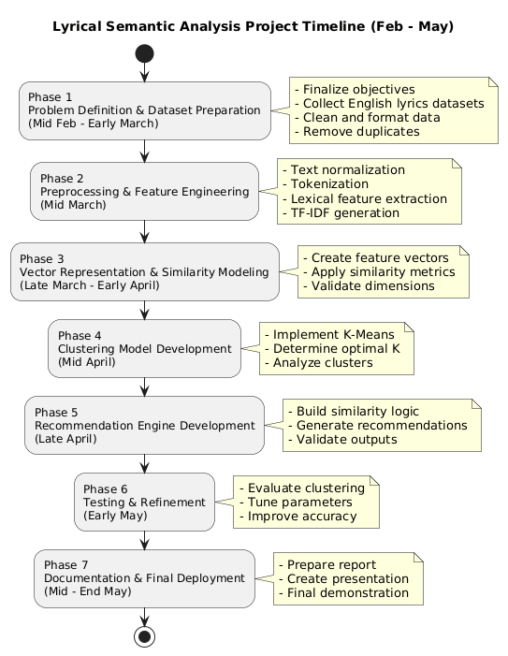

References
ENHANCED MUSIC RECOMMENDATION SYSTEMS USING CONTENT
FILTERING AND K-MEANS CLUSTERING
https://iieta.org/journals/ria/paper/10.18280/ria.380138
MUSIC RECOMMENDATION SYSTEM – IJERT
https://www.ijert.org/music-recommendation-system
ANALYSIS OF MACHINE LEARNING-BASED MUSIC RECOMMENDATION
SYSTEM USING SPOTIFY DATASETS
https://www.researchgate.net/publication/382297001_Analysis_of_machine_learning
-based_music_recommendation_system_using_Spotify_datasets
IMPROVING MUSIC RECOMMENDATION SYSTEM BY APPLYING LATENT
TOPICS OF LYRICS
https://ijiis.org/index.php/IJIIS/article/view/91
RECOMMENDING MUSIC THROUGH LYRICS: A TEXT MINING EXPERIMENT
(MEDIUM ARTICLE)
https://andrewngai9255.medium.com/recommending-music-through-lyrics-a-textmining-experiment-a4319748f8bb
MAPPING EMOTION SCAPES IN POP SONG LYRICS (UNSUPERVISED
CLUSTERING DISCUSSION)
https://link.springer.com/article/10.1007/s42803-025-00103-x

