Music Genre Classification — Project Report
- Students: Aman Tewari
- Emails: Aman.125832@stu.upes.ac.in
- Course: Btech CSE AML B11
- Instructor:Rakesh Ranjan
- Semester/Term: 5th
- Date: 18-11-25

Abstract
This project implements a music genre classification system using deep learning on log-mel spectrograms. The pipeline covers robust audio preprocessing, a CNN-based classifier trained with cross-entropy loss, and a Material Design-inspired desktop GUI for end users. A FastAPI service exposes prediction and metadata endpoints, and a Windows batch script orchestrates clean startup/shutdown of the API and GUI. The system supports NVIDIA GPU acceleration (preferring discrete RTX devices) and handles corrupted or missing audio gracefully. Model checkpoints include validation metrics and are surfaced directly in the GUI.

System Overview
- Data: FMA-Medium (Free Music Archive)
- Preprocessing: Resample to target rate, mono conversion, log-mel spectrograms, optional SpecAugment.
- Model: CNN-based classifier over log-mel inputs.
- Training: Adam optimizer, ReduceLROnPlateau scheduler, best-checkpoint saving with metrics.
- Inference: Torch model wrapped by a predictor with consistent preprocessing.
- UX: CustomTkinter GUI (Material 3 vibe), displays model metrics and predictions.
- API: FastAPI + Uvicorn service exposing health, metrics, genres, and prediction endpoints.
- Orchestration: run_app.bat launches API then GUI, and stops both on exit. Uses global Python environment.

Dataset
- Source: FMA (Free Music Archive) — Medium subset recommended for balance between size and diversity.
- Classes: Multiple music genres; class names in src/config.py (GENRE_LABELS).
- Splits: Stratified train/validation split (seeded for reproducibility).
- Storage: Audio files organized under a dataset directory; spectrograms computed on the fly during training/inference.
- Notes: Ensure licensing compliance when distributing data; FMA is research-friendly.

Data Preprocessing
- Loading: librosa.load with target sample rate; exceptions caught and handled.
- Corrupted/Unsupported Audio: Replaced with a short silent waveform to keep batches valid.
- Features: Log-mel spectrograms (configurable n_fft, hop_length, n_mels).
- Normalization: Per-sample normalization of spectrograms.
- Augmentation: Optional SpecAugment (time/frequency masking) on training only.
- Dependencies: librosa, soundfile, and system ffmpeg installed for MP3/varied codecs.

Model Architecture
- Backbone: Convolutional neural network tailored to spectrogram inputs (2D conv, pooling, dropout).
- Head: Fully connected layers projecting to num_classes = len(GENRE_LABELS) with softmax in evaluation.
- Loss: CrossEntropyLoss.
- Optimizer: Adam with standard betas; weight decay optional.
- Scheduler: ReduceLROnPlateau on validation loss.

Training Configuration
- Device: Auto-detect CUDA; prefer discrete RTX device if present; fallback to CPU.
- Epochs: 10
- Batch Size: 32
- Learning Rate: 0.01
- Early Stopping-Like Behavior: Track best validation loss; save models/best_model.pt with metrics.
- Checkpoint Contents: { epoch, model_state_dict, optimizer_state_dict, val_acc, val_loss }.
- Curves: Training/validation loss and accuracy plotted and saved during/after training.

Results
{

"accuracy": 0.0,

"precision_macro": 0.24079394869836046,

"recall_macro": 0.27722985093623764,

"f1_macro": 0.2442129468015751,

"samples": 300

}

- Best Validation Accuracy: 72.71 %
- Best Validation Loss: 0.9128
- Best Epoch: 8
- Confusion Matrix:
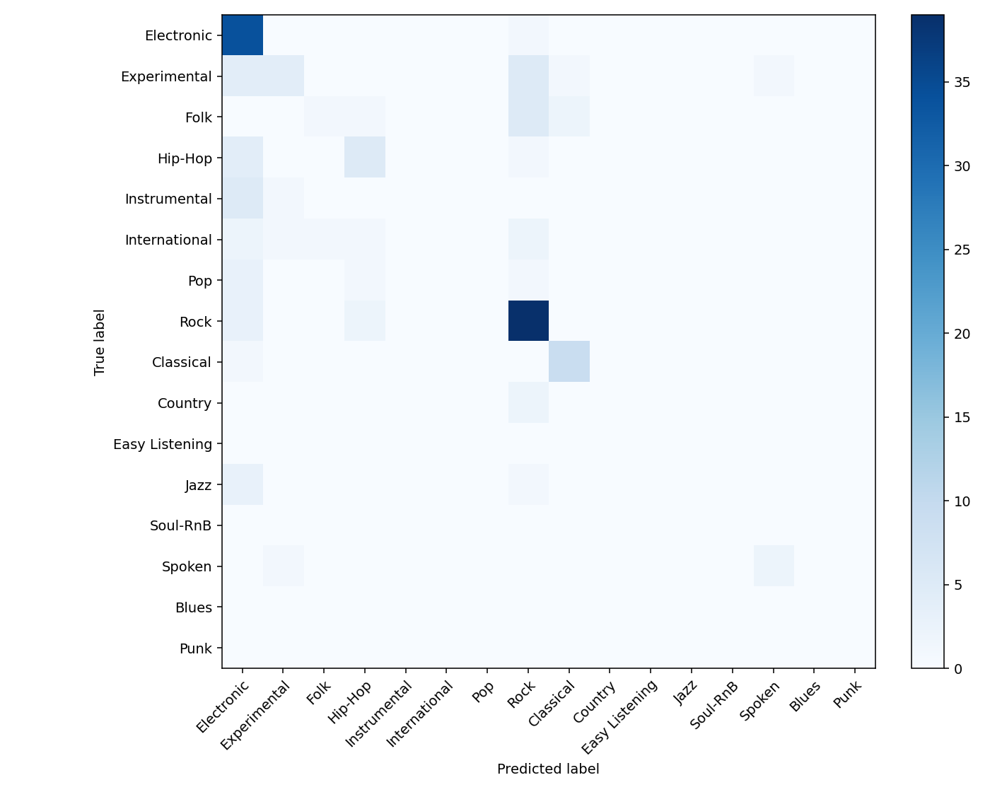

Application (GUI)
- Framework: CustomTkinter (Material Design 3 styling approach).
- Features:
  - Select local audio files and run predictions.
  - Display predicted genre with confidence.
  - Read and display model metrics (val acc/loss/epoch) from models/best_model.pt.
  - Non-blocking UI during loading/inference where feasible.
- Entry Point: run_gui.py (imports app.gui:main).
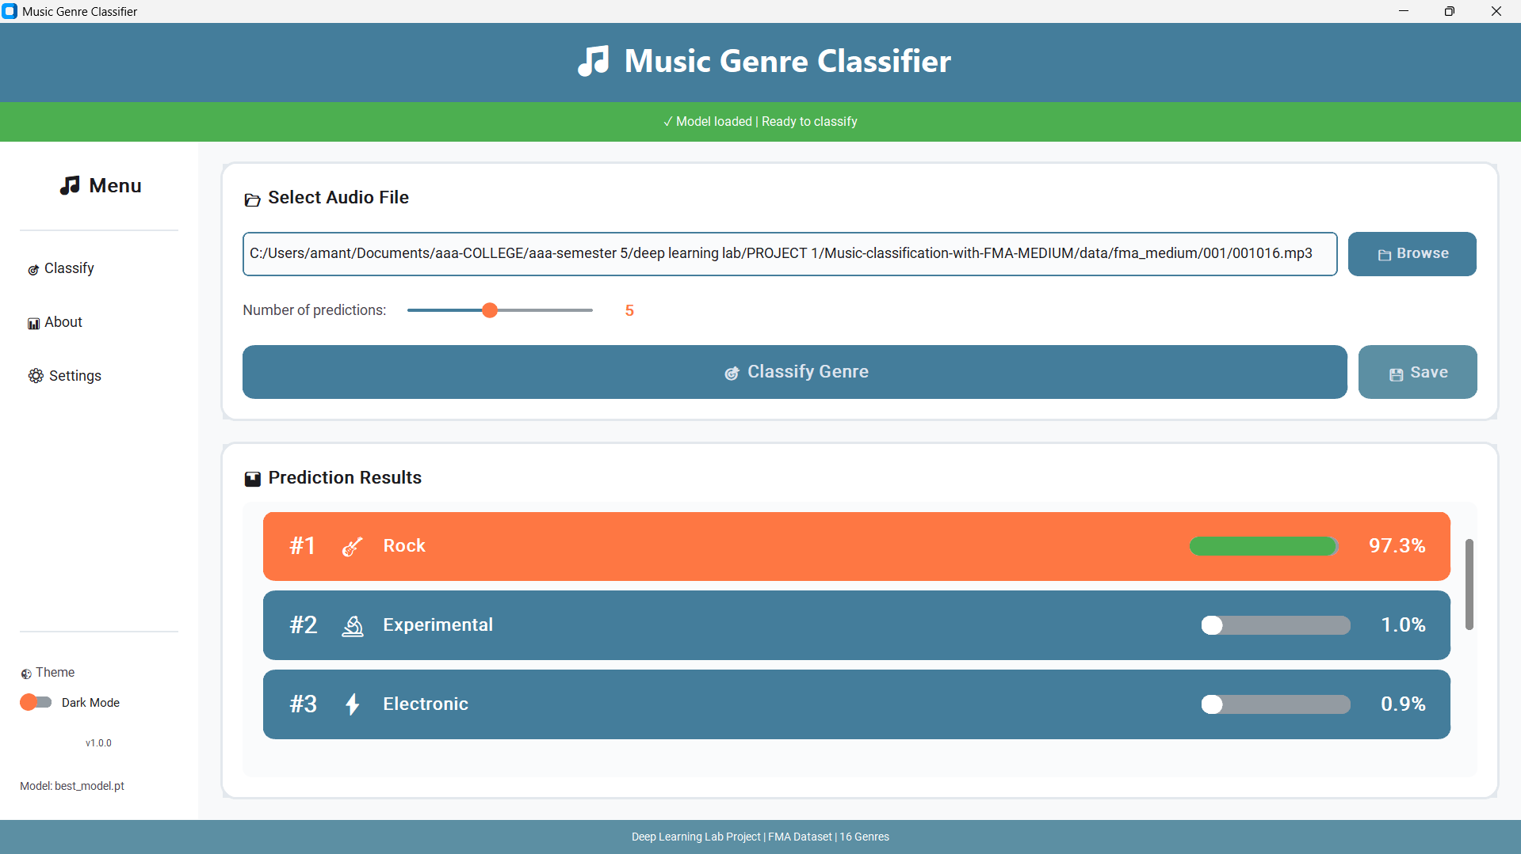

API Service
- Framework: FastAPI + Uvicorn.
- Startup: Loads predictor once and reuses for incoming requests.
- Endpoints:
  - GET /api/health → Basic readiness status.
  - GET /api/metrics → { model_exists, model_path, val_acc, val_loss, epoch } plus ready flag.
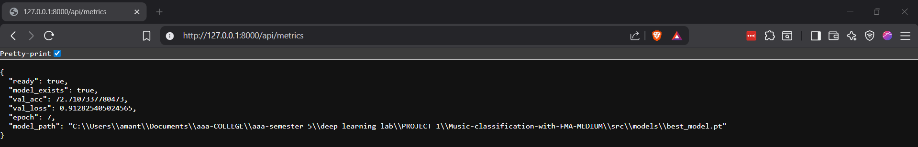
  - GET /api/genres → Returns list of genre labels.
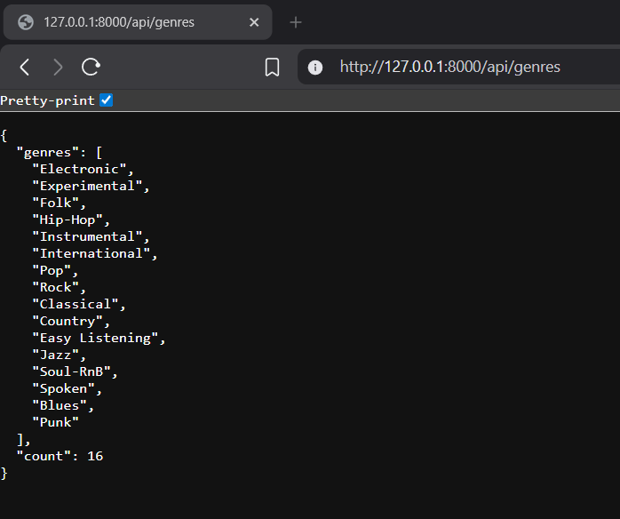
  - POST /api/predict → Accept audio (file/path/spec) and return predicted label + probabilities.
  - GET / → Project metadata + endpoint index.
- Module Path: app.api:app.

Orchestration & Deployment (Windows)
- Batch Script: run_app.bat (global environment; no venv).
  - Starts API: uvicorn app.api:app --host 127.0.0.1 --port 8000 in background.
  - Launches GUI: python .\run_gui.py.
  - On GUI close, shuts down API and cleans related processes.
- Environment: Python 3.11 with PyTorch (CUDA build for GPU), librosa, fastapi, uvicorn, customtkinter, requests, soundfile; ffmpeg in PATH.

Reproducibility & How To Run
- Prerequisites
  - Windows, Python 3.11 on PATH.
  - PyTorch with CUDA (if using GPU), ffmpeg installed system-wide.
  - Install Python deps (if needed):cd <your filepath> pip install torch torchaudio torchvision --index-url https://download.pytorch.org/whl/cu121 pip install librosa soundfile fastapi uvicorn customtkinter requests tqdm matplotlib scikit-learn
- One-click (recommended)
  - Double-click run_app.bat.
  - GUI opens; API runs at http://127.0.0.1:8000.
- Manual run (optional)cd <your filepath> python -m uvicorn app.api:app --host127.0.0.1--port8000# In another terminal python .\run_gui.py

Challenges & Mitigations
- Invalid CUDA device ordinal → Implemented safe auto-selection of best CUDA device; fallback to CPU.
- Audio decode errors (NoBackendError/unsupported codecs) → Installed soundfile, ffmpeg, and added robust exception handling with silent fallback.
- Import paths after restructuring → Made app/ a package; added src/ to sys.path where needed.
- Clean shutdown of API/GUI → Batch script coordinates startup and ensures teardown on exit.

Ethical Considerations
- Dataset biases may affect genre predictions; misclassification is possible.
- Respect licensing terms of training data; avoid sharing copyrighted tracks.

Evaluation Protocol
- Stratified train/validation split with fixed seed.
- Report accuracy, loss; optionally macro/micro F1 and per-class metrics.
- Use held-out validation set only for model selection; avoid test set leakage.

References
- Defferrard et al., FMA: A Dataset for Music Analysis.
- McFee et al., librosa: Audio and Music Signal Analysis in Python.
- Paszke et al., PyTorch: An Imperative Style, High-Performance Deep Learning Library.
- FastAPI documentation.
- Uvicorn ASGI server.
- Park et al., SpecAugment: A Simple Data Augmentation Method for Automatic Speech Recognition.

Appendix A — Project Structure
application root/ ├─ app/ │ ├─ api.py │ └─ gui.py ├─ src/ │ ├─ config.py │ ├─ inference.py │ ├─ model.py │ ├─ preprocessing.py │ └─ metrics.py ├─ models/ │ └─ best_model.pt # created after training ├─ notebooks/ │ └─ train_model.ipynb # training workflow (if present) ├─ run_app.bat ├─ run_gui.py # GUI launcher └─ REPORT.md # this report

Appendix B — API Quick Test
# HealthInvoke-RestMethod-Uri http://127.0.0.1:8000/api/health
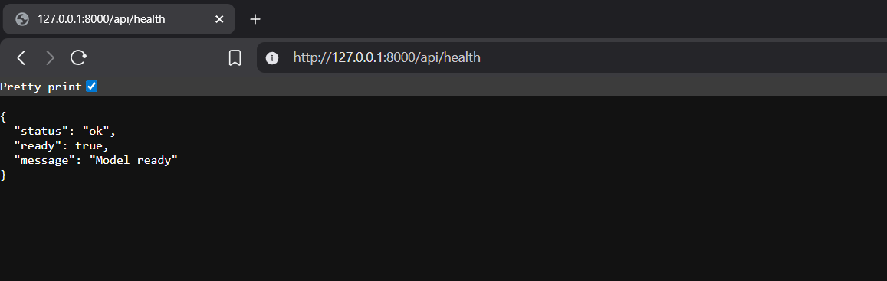
# MetricsInvoke-RestMethod-Uri http://127.0.0.1:8000/api/metrics
