MARKETING MIX MODEL
Snapshot Report
Aurora Skincare Co.
Analysis period: 2022-01-03 to 2024-12-23 (156 weeks)
$96,242,846  Total Revenue Analyzed | 36%  Paid Media Share | 64%  Organic / Baseline Share

Executive Summary
This report identifies which marketing channels are actually driving Aurora Skincare Co.'s revenue, where each channel sits on its response curve, and where the next marketing dollar is best spent.
- Over the 156-week period analyzed, paid media (Meta + Google + TikTok combined) is estimated to drive 36% of total revenue; the remaining 64% comes from organic/baseline demand (brand equity, returning customers, seasonality).
- TikTok is the least saturated channel at 64% of its estimated saturation point — this is the highest-confidence place to test incremental budget.
- Meta is the most saturated channel at 100% of its estimated saturation point — further increases here are likely to yield sharply diminishing returns.
- Competitor activity is estimated to have suppressed revenue by an average of $20,755/week during the 74 weeks of above-average competitor pressure (worst single week: ~$99,134 lost).

How Well Does the Model Fit?
Before trusting any recommendation, we first confirm the model's predicted revenue tracks actual revenue closely, week over week. The shaded band reflects the model's own uncertainty — a Bayesian model reports a credible range rather than a single guess.
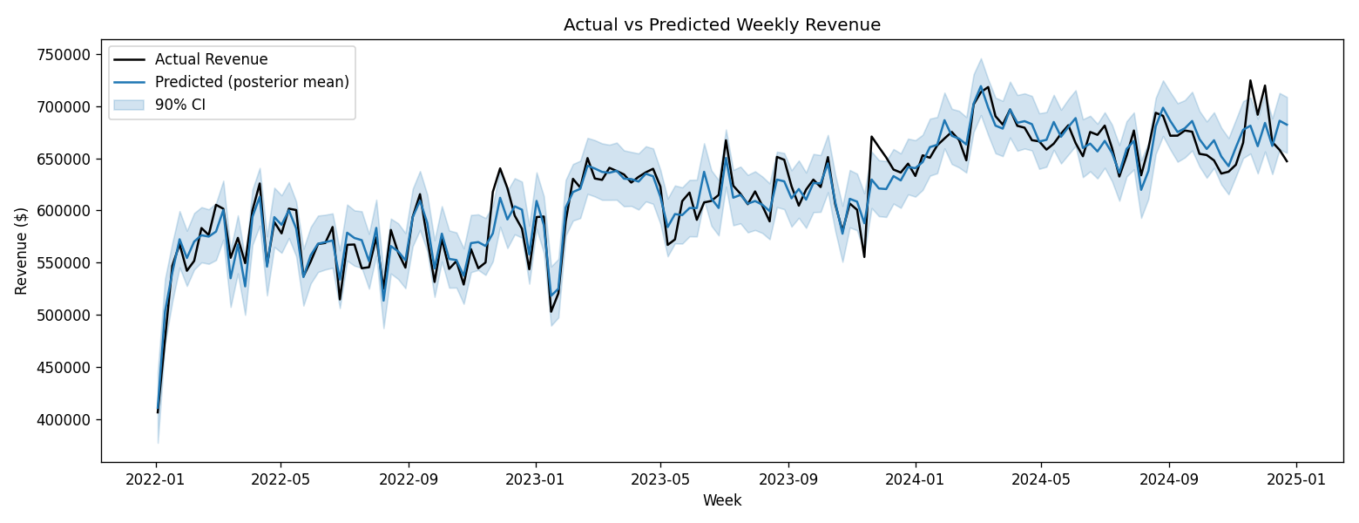

Where Does Revenue Actually Come From?
The chart below decomposes weekly revenue into what each paid channel is estimated to contribute versus the organic baseline (dashed line) — demand that would exist even with zero ad spend.
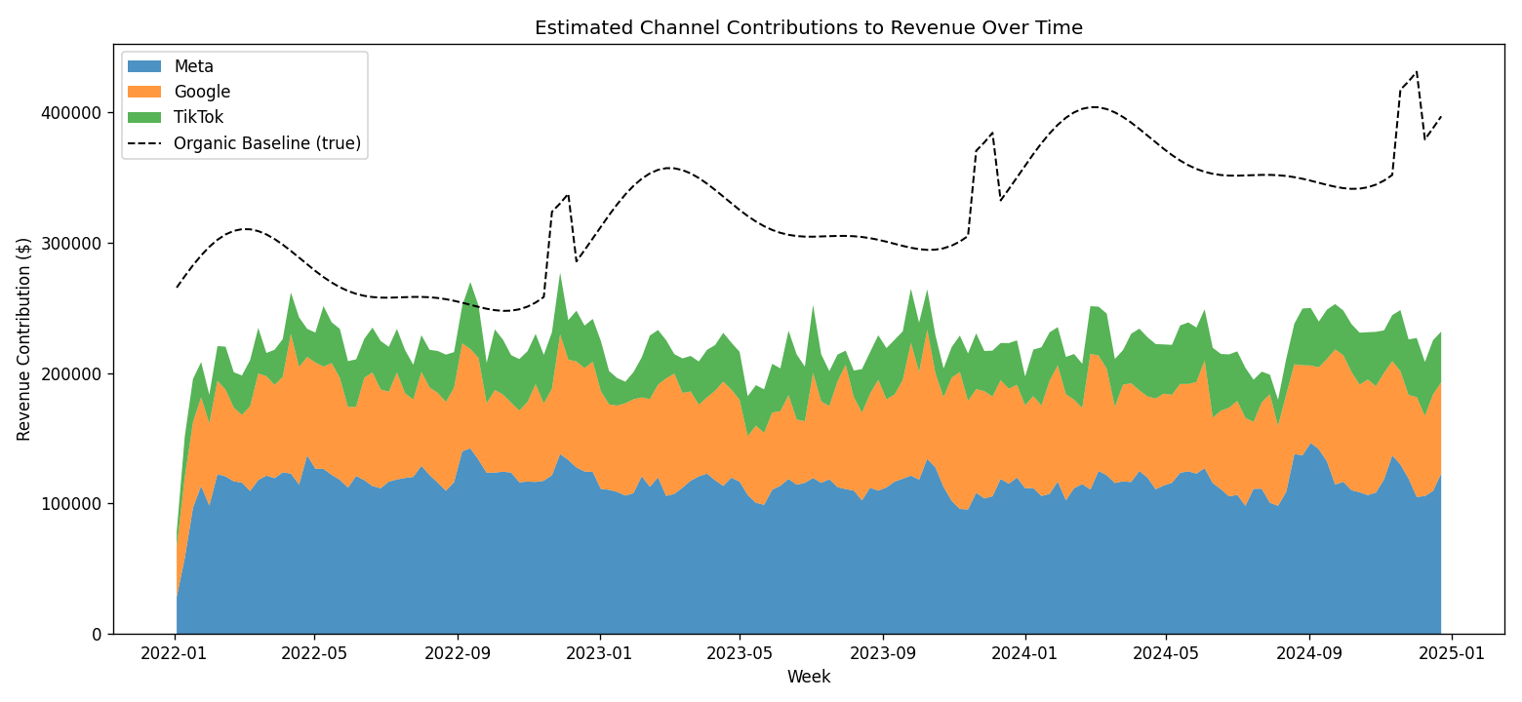

Channel-by-Channel Breakdown
"Saturation" shows how close each channel is to the point where additional spend stops paying off (defined here as 80% of the channel's estimated maximum response).
Channel | Avg Weekly Spend | Est. Weekly Revenue | % of Revenue | Saturation | Recommendation
Meta | $36,512 | $115,314 | 19% | 100% | Hold / Trim
Google | $25,939 | $72,098 | 12% | 65% | Maintain
TikTok | $19,376 | $34,616 | 6% | 64% | Maintain

Saturation Curves — Where Is the Ceiling?
Each curve shows estimated incremental revenue as spend increases. The red marker is the estimated saturation point for that channel. Spend to the right of the marker still helps, but each additional dollar returns much less than the dollars before it.
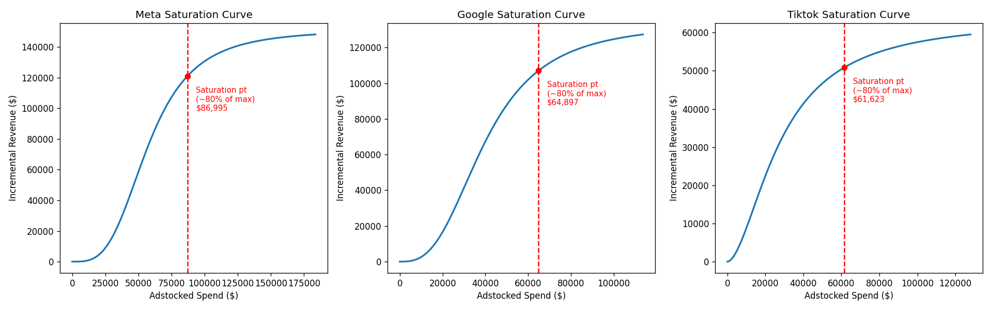

Recommended Actions
Meta — Hold / Trim
At/near saturation — additional spend here will show sharply diminishing returns. Consider holding or trimming budget.
Google — Maintain
Healthy efficiency zone — spend is being used well; moderate room left to grow before diminishing returns kick in.
TikTok — Maintain
Healthy efficiency zone — spend is being used well; moderate room left to grow before diminishing returns kick in.

Methodology & Limitations
This report uses a Bayesian Marketing Mix Model (MMM). Each channel's spend is transformed through (1) an adstock function, capturing how an ad's effect carries over into future weeks, and (2) a saturation (diminishing-returns) curve, capturing how effectiveness declines as spend increases. A baseline term captures organic growth, seasonality, and a competitor pressure index.
Figures reflect posterior means from the fitted model and should be read as estimates with uncertainty, not precise facts. Recommendations are directional guidance for budget conversations, not a substitute for controlled experiments (e.g., geo holdouts or incrementality tests). We recommend refreshing this model quarterly, or after any major shift in channel mix or market conditions.

