MARKETING MIX MODELING
Multi-Channel Spend Optimization Case Study
A data-driven analysis of marketing channel effectiveness, promotional impact, and budget efficiency
Prepared by: [Aman Usman]
Portfolio Case Study — Marketing Analytics Report
July 2026

Executive Summary
This report analyzes 209 weeks of marketing spend and sales data across eight channels — Instagram, Google Ads, TV, YouTube, Newspaper, Influencer, OTT, and competitor spend as a benchmark — alongside promotional campaigns and holiday timing, to determine which marketing investments are actually driving sales.
Bottom line for leadership
Every media channel tested shows a positive relationship with sales. Two findings stand out as immediately actionable: Newspaper spend is dramatically more efficient per dollar than any other channel, and the promotion that looked best in raw sales data (Coupons) is not the one that performs best once other factors are controlled for (BOGO is).

Key findings at a glance:
- All eight channels show a positive contribution to sales — no channel appears to be wasted spend.
- Google Ads and Instagram are the two largest overall drivers of sales in dollar terms.
- Newspaper spend delivers the highest return per incremental dollar (an estimated 13.5x), despite being the smallest budget line.
- BOGO outperforms every other promotion type once media spend and timing are accounted for — reversing what the raw sales averages suggested.
- The model explains typical week-to-week sales movement well, but under-predicts both an extreme sales spike and several sharp dips — a real limitation to know about before relying on it for precise forecasts.
- Standard model-accuracy metrics (R², average error) were not available at the time of this report and are flagged as an open item, not glossed over.

This report is written to be understood without a data science background. Technical detail is included for transparency and reproducibility, but every finding is explained first in plain business terms.

Business Problem
Companies that advertise across many channels face a recurring, expensive question: which channels are actually earning their budget, and which are simply riding along on other demand drivers — promotions, seasonality, or competitor behavior?
Without a structured model, marketing budgets tend to be allocated based on habit or intuition rather than evidence. This carries cost in two directions: money keeps flowing to channels that aren't earning it, while channels that are quietly effective stay under-invested because their impact isn't obvious from sales totals alone.
This project was scoped to answer that question directly for a specific business: 209 weeks of spend across eight channels, plus promotion and holiday data, mapped to weekly sales — with the goal of producing a defensible, data-driven view of channel effectiveness that can inform real budget decisions.

Dataset
The dataset covers 209 weekly observations across 12 columns, spanning early 2022 through early 2026.
Column | Type | Description
date | Date | Week start date
holiday | Flag (0/1) | Whether the week included a holiday
sales_promotion | Category | Promotion running: Normal, BOGO, Coupons, Flash Sale
competitor_spend | Numeric | Estimated competitor marketing spend
8 channel spend columns | Numeric | Weekly spend: Instagram, Google Ads, TV, YouTube, Newspaper, Influencer, OTT
sales | Numeric | Weekly sales — the outcome being explained

Average weekly sales were approximately $2.32M, ranging from $1.08M to $4.34M, with a standard deviation of about $438K. Promotion weeks broke down as: Normal (37.8%), Coupons (31.6%), BOGO (23.0%), and Flash Sale (7.7%, only 16 weeks — a small sample worth keeping in mind). Holiday weeks were rare: only 12 of 209 weeks (5.7%).

Data Cleaning

Inconsistent Date Formats
The date column mixed multiple formats within the same file (e.g., 3/1/2022 as month/day/year alongside 17-01-2022 as day/month/year). Parsing this naively risks silently swapping days and months for some rows — which would quietly corrupt any time-based analysis without an obvious error. A custom parser was built to detect and handle each format explicitly.

Missing Values — the Key Judgment Call
Every media channel had a substantial share of missing values, ranging from 23.9% (Instagram, OTT) to 38.3% (Google Ads).
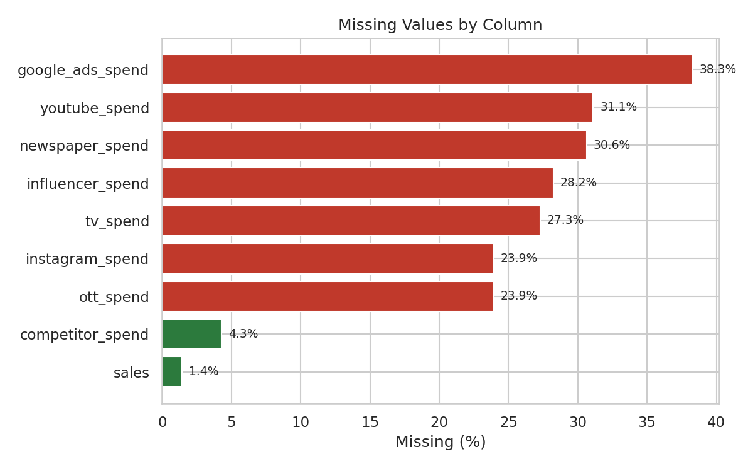
Figure 1. Missing values by column.
Rather than treating this as a data-quality failure to patch with an average, the pattern was interpreted for what it most likely represents: media flighting — channels simply weren't running every week. A week with no Google Ads campaign isn't a mystery to estimate; it's zero spend.
- Media channel spend: missing values recoded to 0 (channel inactive that week).
- Competitor spend: missing only 4.3% of the time with no flighting-style pattern — imputed with the median, treated as a background control variable rather than a channel the business controls.
- Sales (the target): missing in 3 of 209 rows (1.4%) — these rows were dropped rather than imputed, since inventing the number the model exists to explain would corrupt everything downstream.
Final cleaned dataset: 206 weekly rows.

Exploratory Data Analysis
Before any modeling assumptions were introduced, the cleaned data was explored to understand what it actually shows.

Channel Relationships and Raw Correlation with Sales
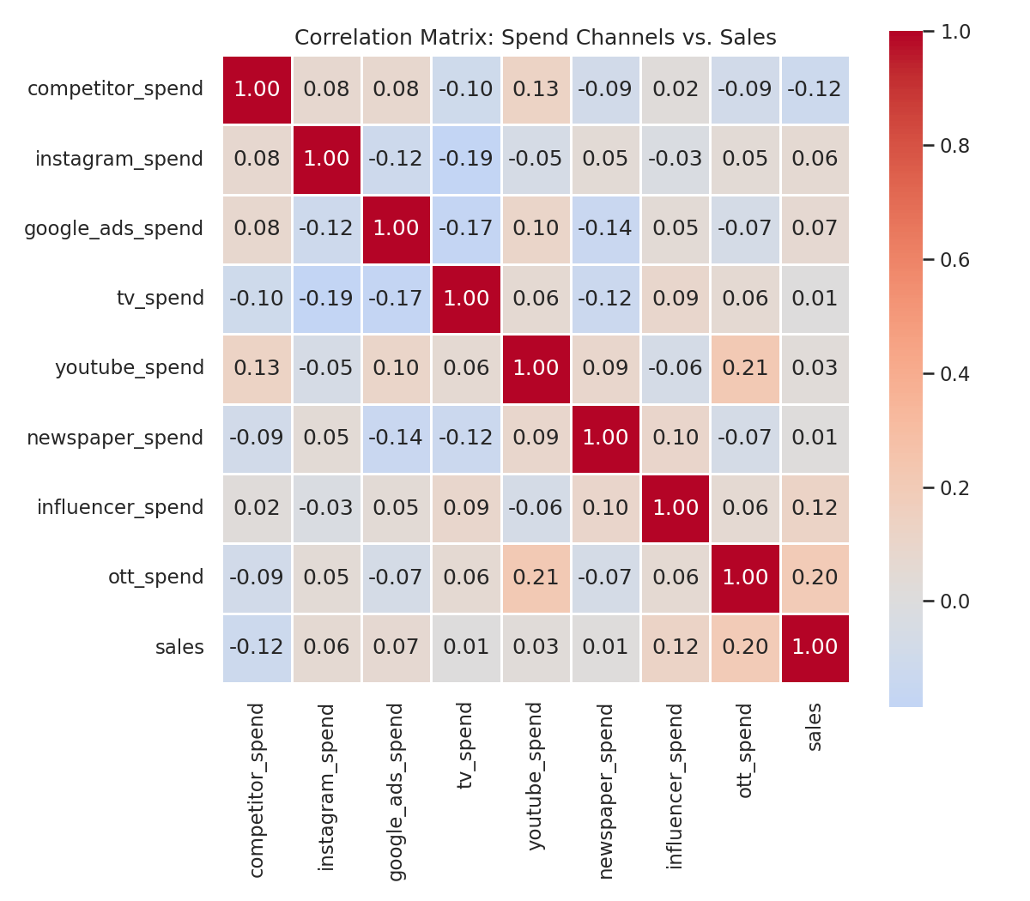
Figure 2. Correlation matrix across all channels and sales.
Two things stand out. First, channels show consistently weak correlation with each other (generally under 0.2) — meaning they weren't run in lockstep, which is favorable for isolating each channel's individual effect later. Second, every channel's raw correlation with sales is weak — the strongest is OTT at 0.196.
Why weak correlation doesn't mean weak impact
Marketing effects are rarely instant or linear: this week's TV spend can influence sales for weeks afterward, and each channel's effectiveness tends to flatten out at higher spend. A simple correlation can't see either dynamic — which is exactly why this analysis moves on to adstock and saturation modeling rather than stopping here (Section 7).

Sales by Promotion Type and Holiday
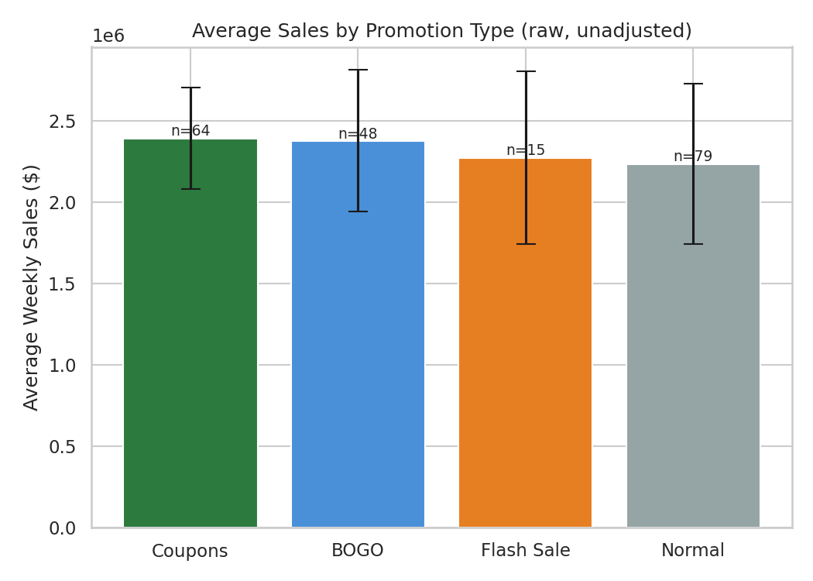
Figure 3. Average weekly sales by promotion type (raw, unadjusted).
In the raw data, Coupons weeks show the highest average sales (~$2.39M), narrowly ahead of BOGO (~$2.38M), with Flash Sale and Normal weeks lower. This raw ranking changes once the model controls for other factors — see Section 9.
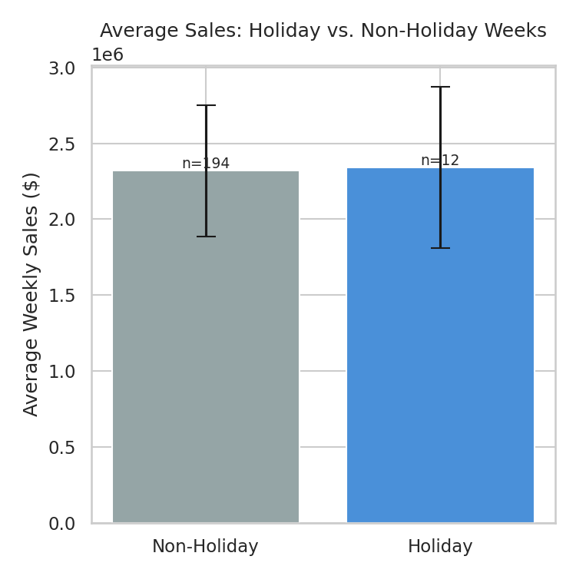
Figure 4. Average weekly sales, holiday vs. non-holiday weeks.
Holiday weeks show almost no difference in average sales — but with only 12 holiday weeks in the entire dataset, this isn't strong evidence either way.

Channel Spend Levels
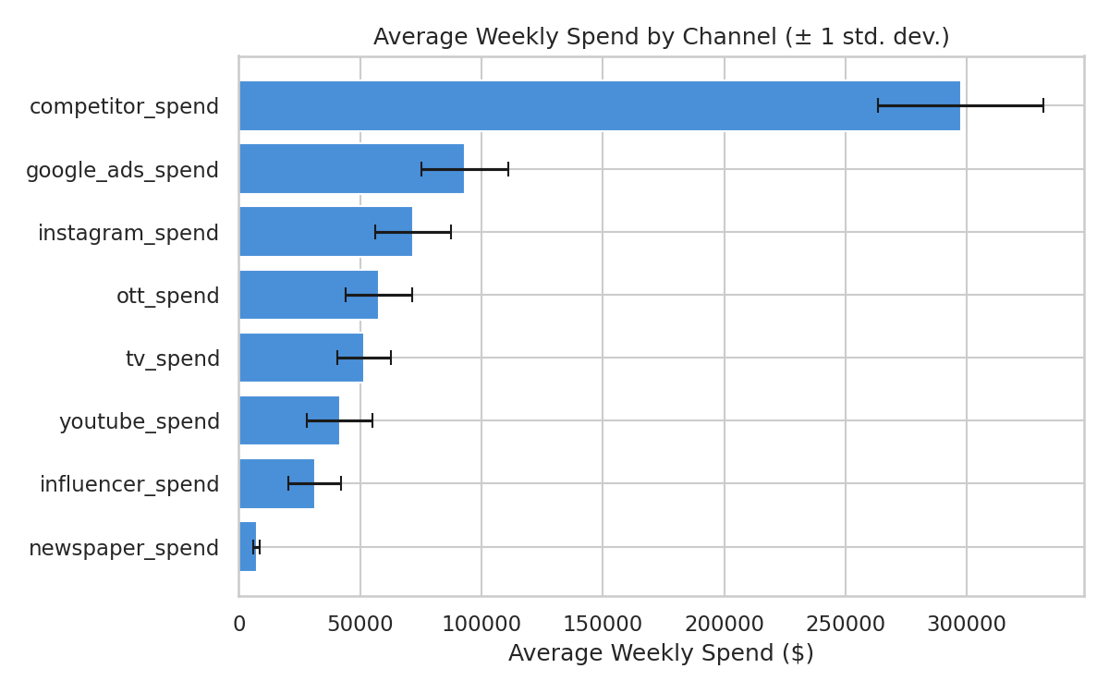
Figure 5. Average weekly spend by channel (± 1 standard deviation).

Feature Engineering
Because raw correlations were weak for the reasons explained above, two standard marketing-mix-modeling transformations were applied to each media channel before modeling:
- Adstock (carryover): each channel's "effective" spend in a given week is modeled as that week's raw spend plus a decayed portion of prior weeks' effective spend — reflecting that impact lingers rather than stopping immediately.
- Saturation (diminishing returns): a log-based transform, scaled per channel, reflects that each additional dollar tends to produce a smaller marginal effect than the dollar before it.
Starting decay rates were assigned by typical channel behavior rather than fit from scratch — broader-reach/brand channels (TV, OTT) were given longer assumed carryover, while direct-response channels (Google Ads) were given shorter carryover. This is a reasonable starting assumption, not a value estimated from this data — an important distinction revisited in the Limitations section.
Channel | Assumed Adstock Decay Rate
TV | 0.60
OTT | 0.60
Newspaper | 0.50
YouTube | 0.40
Instagram | 0.30
Influencer | 0.30
Google Ads | 0.20

Additional model inputs included promotion type (one-hot encoded), the holiday flag, competitor spend, a linear time trend, and week-of-year seasonality terms — so the model has a fair chance to credit general growth or seasonal patterns correctly, rather than mistakenly crediting a media channel for them.

Modeling
Ridge regression (linear regression with L2 regularization) was selected as the baseline model, ahead of a more advanced Bayesian marketing mix model.
- With roughly 15+ engineered features and 206 observations, an unregularized regression risks overfitting — Ridge's penalty shrinks coefficients to reduce that risk.
- Ridge is fast and interpretable, useful for sanity-checking direction and rough magnitude of channel effects before investing in a heavier model.
- Time-series cross-validation (a rolling-window split, not a random shuffle) was used to select the regularization strength, since shuffling weeks randomly would let the model "see the future" during validation.

Representative Code
The two core transformations — adstock and the Ridge fit with time-aware validation — are shown below.
def adstock_transform(x, decay_rate=0.5):
adstocked = np.zeros_like(x, dtype=float)
adstocked[0] = x[0]
for t in range(1, len(x)):
adstocked[t] = x[t] + decay_rate * adstocked[t - 1]
return adstocked

def saturation_transform(x, alpha=1.0):
return np.log1p(alpha * x)

tscv = TimeSeriesSplit(n_splits=5)
grid = GridSearchCV(Ridge(), {'alpha': np.logspace(-2, 3, 30)},
cv=tscv, scoring='r2', n_jobs=-1)
grid.fit(X_scaled, y)
best_model = grid.best_estimator_
The intended end-state for this project is a Bayesian MMM (e.g., PyMC-Marketing), which would estimate the adstock and saturation parameters directly from the data rather than assuming them, and produce uncertainty ranges around each channel's estimated impact. The Ridge model here is a stepping stone toward that, not the final word.

Results

Model Fit: Actual vs. Predicted Sales
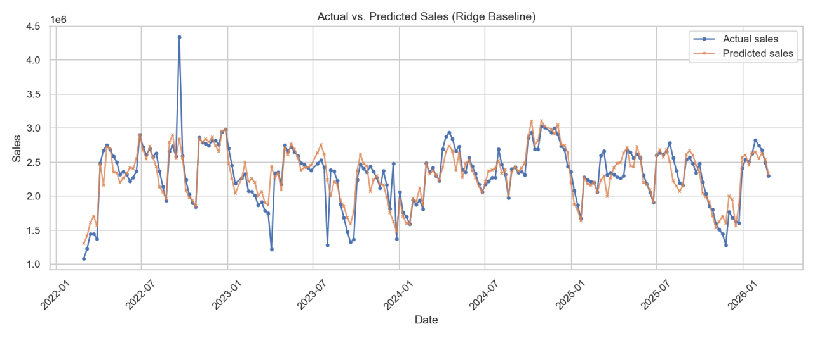
Figure 6. Actual vs. predicted weekly sales, full history.
The model tracks the general oscillating pattern of sales closely across most of the period. Two limitations stand out: a single extreme spike (~$4.34M in mid-2022) is substantially under-predicted, and several sharp troughs (dropping to ~$1.2–1.4M) are also under-captured, with predictions staying noticeably higher in those same weeks.
What's not yet available
Standard accuracy metrics — R² (variation explained), MAE (average dollar error), and MAPE (average percentage error) — were not included in the output reviewed for this report. Without them, this report does not state a precise "how accurate is this model" number. These should be obtained before the model informs high-stakes budget decisions.

Channel Impact on Sales
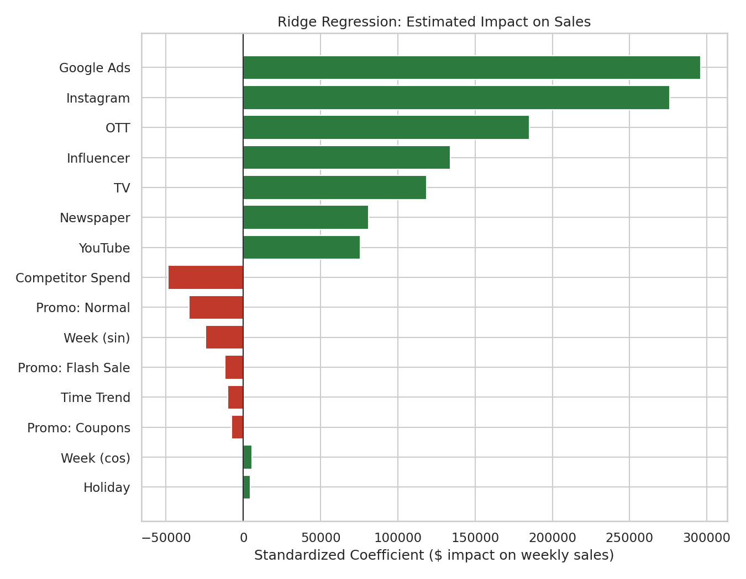
Figure 7. Estimated standardized impact of each driver on weekly sales.
Every media channel came out positive — no channel's coefficient suggests it is actively hurting sales. Google Ads ($295,955) and Instagram ($276,133) are the two largest overall drivers, followed by OTT, Influencer, TV, Newspaper, and YouTube.
A genuine surprise: BOGO beats Coupons once the model controls for other factors
In the raw data (Figure 3), Coupons had the highest average sales. Once the model accounts for media spend, competitor activity, seasonality, and trend, BOGO comes out ahead of every other promotion type, including Coupons. This suggests Coupons' apparent strength was likely riding on other favorable conditions — like higher concurrent media spend — rather than the promotion itself.

Scenario Analysis: Doubling Spend per Channel
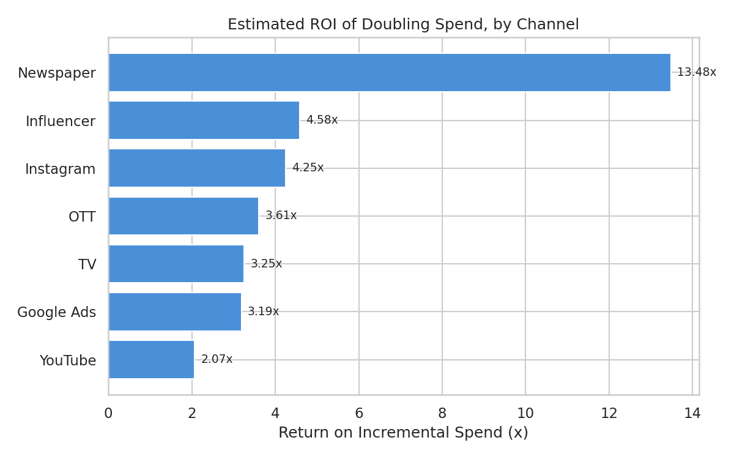
Figure 8. Estimated return (lift ÷ extra spend) if spend were doubled, by channel.
Two different rankings emerge depending on the question asked. Ranked by total dollar impact, Instagram, Google Ads, and OTT stand out. Ranked by efficiency, Newspaper is dramatically ahead of every other channel (13.48x) — its total lift is smaller in absolute dollars simply because its current budget is tiny, but pound-for-pound the model suggests it is the most under-invested channel by a wide margin.

Saturation Headroom
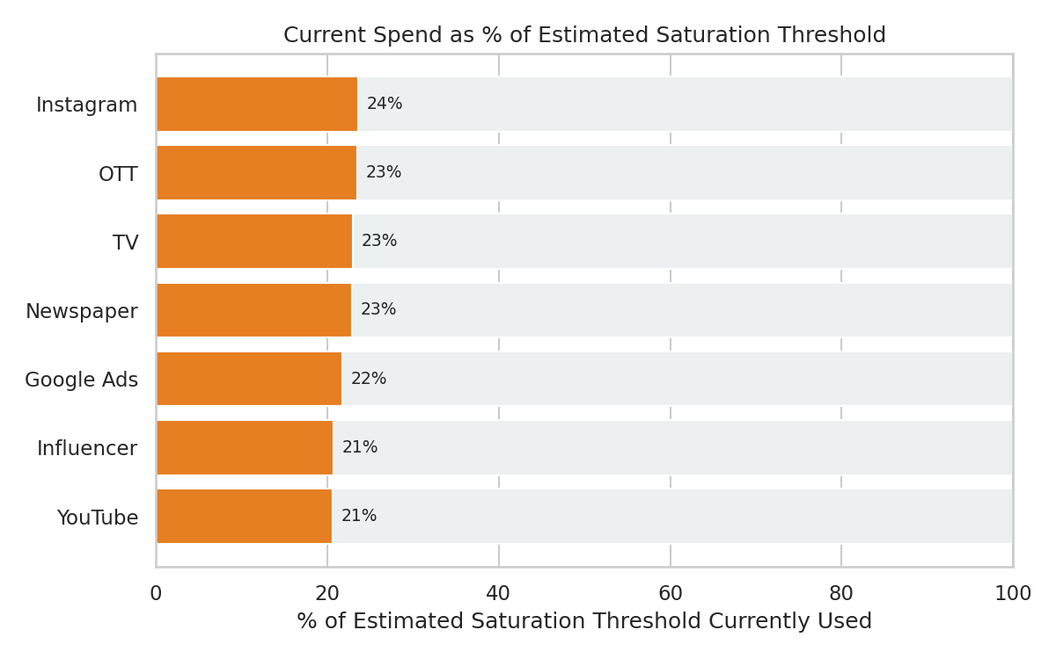
Figure 9. Current spend as a percentage of each channel's estimated saturation threshold.
Every channel is currently spending well below its estimated saturation point (roughly 20–24% of threshold across the board), suggesting room to grow before hitting diminishing returns.
An important caveat
The near-identical 20–24% headroom across all seven channels may partly reflect the mathematical structure of the saturation transform (each channel scaled relative to its own spend variability) rather than an independently discovered, channel-specific pattern. This finding is a hypothesis worth testing with real incremental spend, not a settled fact.

Business Recommendations
- Test a modest, incremental increase in Newspaper spend first. Its estimated ROI (13.48x) is far ahead of every other channel, and its small current budget makes even a meaningful percentage increase a low-risk test.
- Continue investing in Instagram and Google Ads as the primary volume drivers, but validate the saturation-based "room to grow" estimate with a real incremental spend test rather than trusting it at face value.
- Re-examine the Coupons promotion strategy. The controlled model suggests its raw performance may be substantially explained by other concurrent factors, while BOGO shows the strongest standalone effect — worth validating directly, e.g., running BOGO and Coupons in otherwise-matched weeks.
- Treat "every channel has headroom" as a hypothesis, not a green light for a broad spend increase across all channels at once. Test one or two channels incrementally — Newspaper is the clear first candidate.
- Obtain the model's accuracy metrics (R², MAE, MAPE) before using it for a formal budget-allocation decision. The fit is reasonably strong for typical weeks but visibly weaker at the extremes.
- Be cautious drawing any holiday-specific conclusion given the small sample of only 12 holiday weeks.

Limitations
- Modest sample size (206 usable weeks) relative to the number of channels and engineered features, which limits statistical power and motivated the choice of a regularized model.
- The zero-fill assumption for missing media spend is a reasoned judgment call, not independently confirmed against the business's actual campaign calendars.
- Adstock decay rates and saturation scaling were assigned using typical channel behavior, not estimated from this data — the single biggest gap between this baseline and a production-ready model.
- Standard accuracy metrics (R², MAE, MAPE) were not part of the reviewed output and are not stated in this report.
- The near-identical saturation headroom across all seven channels may partly be a mathematical artifact of the transform's fixed structure rather than an independently discovered pattern.
- Correlation, even after transformation, does not establish causality — the Coupons/BOGO reversal is a model-based inference, not a controlled experiment.

Appendix

A. Full Ridge Coefficient Table
Driver | Coefficient ($)
Google Ads | 295,955
Instagram | 276,133
OTT | 185,304
Influencer | 134,003
TV | 118,773
Newspaper | 81,093
YouTube | 75,723
Competitor Spend | -48,724
Promo: Normal | -35,268
Week (sin) | -24,544
Promo: Flash Sale | -12,015
Time Trend | -10,089
Promo: Coupons | -7,666
Week (cos) | 5,555
Holiday | 4,484

B. Full Doubling-Spend Scenario Table
Channel | Extra Spend | Total Lift | Lift % | ROI
Instagram | $11.26M | $47.86M | 10.01% | 4.25x
Google Ads | $11.85M | $37.80M | 7.91% | 3.19x
TV | $7.73M | $25.12M | 5.26% | 3.25x
YouTube | $5.90M | $12.23M | 2.56% | 2.07x
Newspaper | $1.05M | $14.20M | 2.97% | 13.48x
Influencer | $4.65M | $21.27M | 4.45% | 4.58x
OTT | $9.05M | $32.64M | 6.83% | 3.61x

C. Full Saturation Threshold Table
Channel | Est. Saturation Threshold (weekly) | Current Avg. Weekly Spend | Headroom
Instagram | $304,466 | $71,951 | ~24%
Google Ads | $428,853 | $93,216 | ~22%
TV | $225,785 | $51,779 | ~23%
YouTube | $201,385 | $41,591 | ~21%
Newspaper | $32,201 | $7,377 | ~23%
Influencer | $151,465 | $31,375 | ~21%
OTT | $246,252 | $57,737 | ~23%

D. Terminal Output
Placeholder — insert your own screenshot
Add a screenshot of the pipeline running successfully in your terminal (e.g., the console output showing data loading, cleaning steps, and the final "DONE" message). Insert the image directly below this box in Word.

E. Repository / Project Structure
Placeholder — insert your own screenshot
Add a screenshot of your project's file structure or GitHub repository (e.g., showing mmm_ridge_baseline.py, the cleaned dataset, and the output/ folder of charts). Insert the image directly below this box in Word.

