**Industrial Interaction Report on**



WEBSITE AND APPLICATION DEVELOPMENT FOR VEGETABLE LOGS



**Graphic Era deemed to be University.**



**Submitted in partial fulfilment of the requirement for the award of the degree of**

**BACHELOR OF TECHNOLOGY**

**IN**

**COMPUTER SCIENCE & ENGINEERING**

**Submitted by:**

**Aman Verma** **2016622**



**Department of Computer Science and Engineering**

**Graphic Era (Deemed to be University)**

**Dehradun, Uttarakhand**



**CANDIDATE’S DECLARATION**

I hereby certify that the work which is being presented in the Industrial Interaction report entitled **“Website and Application Development for Vegetable Logs”** in partial fulfillment of the requirements for the award of the Degree of Bachelor of Technology in Computer Science and Engineeringin the Department of Computer Science and Engineering of the Graphic Era (Deemed to be University), Dehradun shall be carried out by the undersigned under the supervision of **Mr. Yuvraj Joshi,** Assistant Professor, Department of Computer Science and Engineering, Graphic Era deemed to be University, Dehradun.

Aman Verma

2016622

CSE

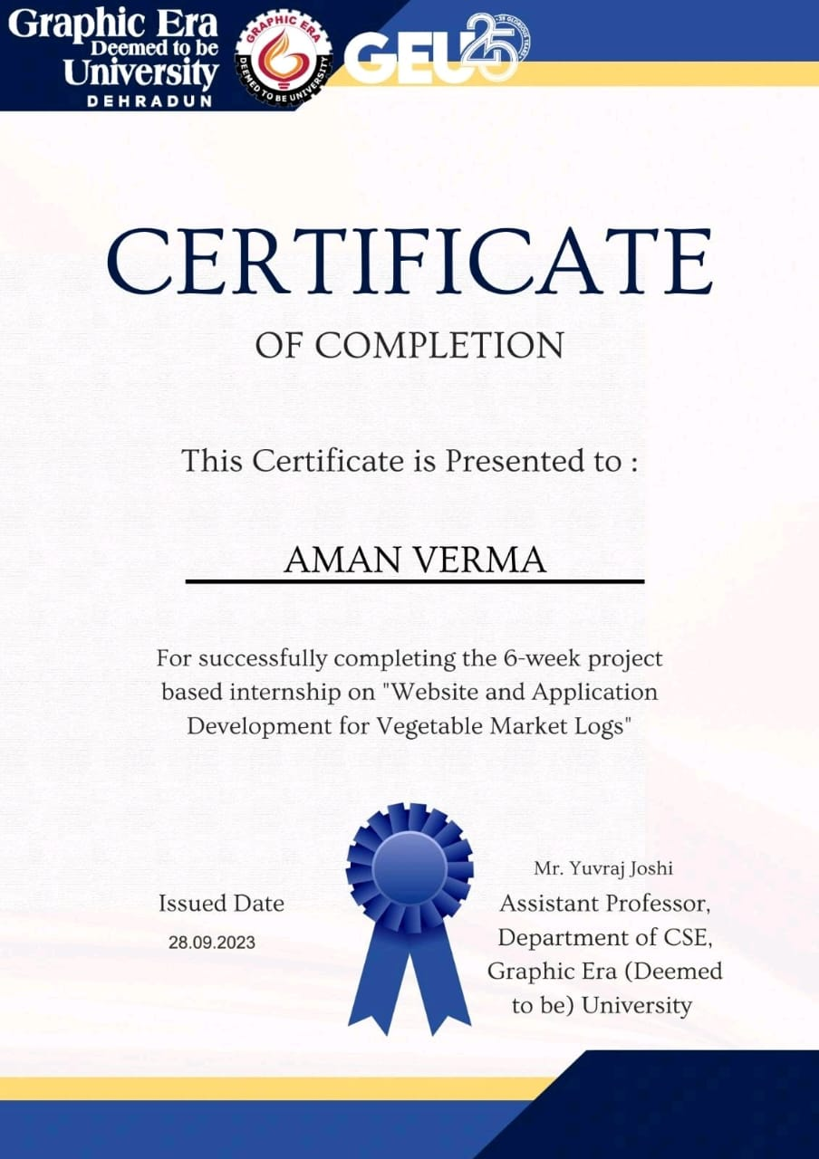

**Contact Details of the Mentor**

Mr. Yuvraj Joshi

Assistant Professor

Graphic Era deemed to be University,

Dehradun

Ph. No.: 96398 78487

## Table of Contents

|  |  |  |
| --- | --- | --- |
| **Chapter No.** | **Description** | **Page No.** |
| Chapter 1 | About the Company | **1** |
| Chapter 2 | Work Responsibilities | **2** |
| Chapter 3 | Work Done | **3-5** |
| Chapter 4 | Skills Learned | **6** |
| Chapter 5 | Conclusion | **7** |

**ACKNOWLEDGMENT**

With immense gratitude, I extend my heartfelt thanks to the Almighty, the Most Gracious, and the Most Merciful, for guiding me through the successful completion of the Academic Research Project. This journey has been a testament to divine blessings and guidance. I am deeply indebted to my parents, whose unwavering encouragement and support have been my pillars of strength. Their belief in my potential and sacrifices have paved the way for my educational milestones. I am profoundly grateful for the opportunities they have provided me to reach this stage in my academic journey. Special appreciation goes to **Mr. Yuvraj Joshi**, my project supervisor, whose patience, motivation, and support have been instrumental in navigating the complexities of this research endeavor. His guidance has been invaluable, and I am truly thankful for his mentorship.

A heartfelt thank you to **Mr. Surender Singh Samant** my academic advisor, for her indispensable assistance in helping me grasp the intricacies of the subject matter. Her dedication to fostering understanding has been a cornerstone of my academic progress.

Lastly, but certainly not least, I extend my gratitude to all those who have supported me directly or indirectly during this project. Your contributions, whether big or small, have played a significant role in my success. I am truly blessed to be surrounded by such a supportive network. In conclusion, I express my deepest appreciation to everyone who has been part of this academic journey, contributing to its success and making it a memorable experience.

**Chapter 1**

**About The Company**

Graphic Era (Deemed to be University) was in existence as Graphic Era Institute of Technology since 1997, with the goal of providing world class-education with a clear focus on cutting-edge technologies, professional development of students, critical thinking, and quality research. The University has achieved numerous milestones in its glorious past based on its academic rigor, consistently Top Performing Students and Alumni and an immensely strong and qualified teaching fraternity.

**Department of Computer Science and Engineering**

**Vision**

To impart quality education for producing highly talented globally recognizable technocrats and entrepreneurs with sound ethics, latest knowledge, and innovative ideas in Computer Science and Engineering to meet industrial needs and societal expectations.

**Mission**

* To impart high standard value-based technical education in all aspects of Computer Science and Engineering through the state-of-the-art infrastructure and innovative approach.
* To produce ethical, motivated, and skilled engineers through theoretical knowledge and practical applications.
* To impart the ability for tackling simple to complex problems individually as well as in a team...
* To develop globally competent engineers with strong foundations, capable of “out of the box” thinking to adapt to the rapidly changing scenarios requiring socially conscious green computing solutions.

**Chapter 2**

**Work Responsibilities**

1. **Front End Developer:** A front-end developer creates the user-facing and interactive front end of websites and web apps.

2. **Back-end developer:** Back-end developers create and manage the systems that allow websites to process data and carry out operations. Back-end developers manage data storage and other server-side operations that are not visible to the user, in contrast to front-end developers, who oversee everything you see on a website.

3. **Data Analyst Intern**: Using statistical and computational methods, a data analyst interprets and analyses data to draw conclusions, guide decision-making, and resolve business issues.

**Chapter 3**

**Work Done**

* 1. **Brief details about the project**

Our vegetable delivery service links consumers with fresh produce seamlessly thanks to the combined powers of Express.js, Node.js, React.js, and MongoDB. Order, browse, and follow deliveries with ease. Technology and nutrition can be combined for a healthy living with ease thanks to responsive user interface, reliable database administration, and effective server-side processing.

Additionally, the website offers an advanced predictive analytics function that makes use of long short-term memory (LSTM) networks. The LSTM model anticipates future costs by examining past vegetable prices, giving users and stakeholders important information for well-informed decision-making in the dynamically shifting market.

* 1. **Work Done on the project.**

The team successfully developed two websites, each with distinct technologies and objectives.

The first website, constructed within a span of three weeks, utilized fundamental web technologies, including HTML, CSS, and JavaScript. HTML, serving as the basic markup language, employed tags within angle brackets to organize and present web content. Complementing this, CSS was employed to enhance the visual appeal of HTML text, utilizing CSS grid and flexbox for efficient design. The responsive design was achieved through the integration of the Bootstrap framework. JavaScript played a pivotal role in improving user experience by introducing interactions, form validation, and dynamic content generation on web pages. Notably, the utilization of Node.js extended JavaScript's functionality to the server side. The resulting multi-page website, developed with Bootstrap and Node.js, featured pages such as login, contact form, cart, and shop. JavaScript's indispensability was evident in ensuring precise form input and fulfilment of necessary fields, contributing to a seamless and interactive user browsing experience.

The second website, developed over subsequent weeks, employed React, Node.js, Express.js, and tailwind CSS, with MongoDB Atlas serving as the database. This phase focused on the comprehensive integration of backend and frontend components in contemporary web development. MongoDB Atlas was highlighted for its effectiveness in data management, security, and scalability. The implementation process involved creating a MongoDB Atlas account, configuring clusters, and establishing backend APIs for seamless database communication. The outcomes included improved performance, scalability, secure user data storage, and a robust backend-frontend connection. The research delved into utilizing an Amazon AWS server with EC2 instances and employing linear regression to forecast vegetable prices.

Furthermore, the exploration of Node.js emphasized its role as an open-source, cross-platform JavaScript runtime environment for server-side development. Key features such as non-blocking I/O, single-threaded event loop, npm, modular organization, and event-driven architecture were elucidated. Node.js was positioned as a versatile tool suitable for building web servers, APIs, real-time applications, streaming services, and other networked applications, offering efficiency in handling concurrency and ensuring responsiveness.

* 1. **My contribution**
     1. I have developed the overview of the project and accordingly developed a Data Flow Diagram (DFD) of the design of the project.
     2. I was responsible to carry out through research about the trending vegetable websites in the open source and carry out a detailed study about them by figuring out their strong points and weak points.
     3. I was also responsible to prepare a list of functionalities that is to be included in the website.
     4. I was responsible to add a feature which will enable the websites to predict prices of the vegetables in the days to come.

3.3.5 Adding the payment gateway. The website integrates Stripe payment gateway. It makes it easier for developers to integrate payment gateway into their website. It facilitates easier online payment using Debit Card, Credit Card, UPI.

3.3.6. After carrying out research I selected LSTM algorithm to predict prices and implemented it.

3.3.7 Integrating ML algorithm to predict the future price of the vegetables by analysing the past prices from various places in India.

**Chapter 4**

**Skills Learned**

**Technical Skills**

4.1 Firsthand knowledge gained by working as a team on a web development project under supervision.

4.2 Programming languages: JavaScript, PHP, MongoDB.

4.3 Software documentation, including component flowcharts, client-server models, and architecture.

4.4 Problem solving

4.5 Debugging in a large project.

4.6 Composing a project that is ready for production. for them to be installed on the cloud server.

**Non- Technical Skills**

4.7 Working on a single project with a five-person team.

4.8 Assignment of responsibilities to teammates.

4.9 Time management to fulfil the mentor's deadline.

4.10 Managing an unexpected surge in work because a team member is not present.

4.11 Present yourself to the supervisor and accept responsibility for your errors and shortfalls.

**Chapter 5**

**Conclusion**

Employing Express.js, Node.js, MongoDB, and React.js, our project culminated in the creation of a vegetable delivery website that offers customers a seamless experience in browsing, ordering, and tracking deliveries. To empower users in navigating the dynamic market, the website incorporates predictive analytics through LSTM networks to forecast future vegetable prices.

The project involved the development of two distinct websites. The first, completed in a three-week timeframe, utilized JavaScript, HTML, and CSS to craft a responsive multi-page design. JavaScript played a crucial role in enhancing user experience, ensuring form validation, and facilitating smooth interactions. The second website, built with React, Node, Express, and MongoDB Atlas, prioritized advanced features. Notable additions included the integration of a Stripe payment gateway and a machine learning system leveraging historical data to predict future vegetable prices.

Contributions to the project were diverse. Individual efforts focused on creating a tab bar, designing the Checkout page, and ensuring website responsiveness. Collaborative contributions spanned the creation of front-end components, integration of the Stripe payment gateway, display of database details, and the implementation of a machine learning algorithm for price prediction.

The skills acquired throughout the project spanned both technical and non-technical domains. Technical proficiency was gained in web development, programming languages (JavaScript, PHP, MongoDB), documentation, problem-solving, debugging, and the preparation of production-ready projects deployable on cloud servers. On the non-technical front, skills encompassed teamwork, task distribution, time management, handling increased workloads, and presenting supervisors with a sense of accountability for any mistakes.