i am planning on creating statistical AI agent project using langgraph. it will be multi agent system. for now i have thought that the input will be a csv from user along with this he can say anything like either he can directly specify any operation he want to perform like regression, anova, or he can mention based on columns that he want to analyse the relationship between two columns, etc. or maybe if he is laymen he can ask i want analysis to be done in this and provide me insights on what can you do in this. so whatever the input. Now i am thinking of having agents like one is descriptive_stats, which outputs info like mean, std dev, confidence interval for each continous column and also finds out anomalies if present anywhere. another agent is preprocessor which cleans and preprocess data like transforming data as analysis must be done independent of units. another agent methodologist, decides then what user had asked and based on problem statement, which test is to be picked. (if user had already written test himself, then this agent can be bypassed.) next agent assumption_checker, picks up the test and based on that test, pre test assumptions are selected that are to be met first. (assumptions are listed in a dict already).this agent then checks if all assumptions are true or not. if yes, then another agent statistician is called, if not, then again the feedback is sent to the previous agent with assumptions_met criteria false along with the probable reason. this message is shown to user that the test selected was this and following assumptions met but those not met are listed below with their respective reason and ask user if shall we rectify it or proceed further. then user has two options either he can tell its ok and compromise assumptions or he say rectify and look for solution) if rectified, then another agent methodology_rectifier checks a local dict which has info like, type of assumption violated as keys and proposed solutions or tests to rectify that assumption are stated. these proposed solutions are asked with user to tell if he wants to proceed with that solution next. if yes, then proposed solution is passed to the statistician agent which applies those changes and finally runs the test. These test results are shared with critic agent which then checks post test assumptions (example residual assumptions), if the assumptions are not met again message is flashed to the user that following assumption was not met, along with the result. if he says its ok. then finish running, but if he says rectify it, then again methodology rectifier is called which again proposes a solution. So this is the rough idea of my project. I am planning to provide application of tests like SLR, MLR, Anova, PCA, t test, ridge regression, mann whitney test, etc. also some tests for assumptions like shapiro, beusch pagan test, durbin watson, etc.
Here is the final proposed flow:

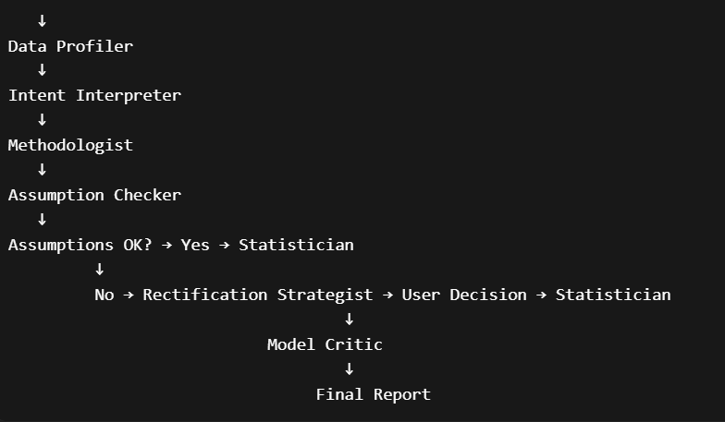

Agent-by-Agent Design Notes
Data Profiler This is your descriptive_stats agent. Beyond mean/std/CI, consider flagging: cardinality of categorical columns, missingness percentage, skewness and kurtosis (relevant later for normality assumptions), and class imbalance if target is categorical. Anomaly detection here using IQR or z-score makes sense. Output should be a structured schema that every downstream agent can reference.
Intent Interpreter This is the trickiest agent to get right. You have three types of input — explicit test request, column-relationship question, and open-ended "just analyse this". You'll need prompt engineering that maps these reliably to a canonical intent object like {intent_type, target_columns, dependent_var, independent_vars, suggested_test_if_any}. Use structured output (Pydantic model) here to keep things stable. This agent should also handle ambiguity by asking clarifying questions before passing downstream — for example if someone says "analyse the relationship between X and Y" you still need to know if Y is continuous or categorical to even begin.
Methodologist The bypass logic you mentioned is right — if user specified a test, skip straight to Assumption Checker. Otherwise this agent picks from your test library based on number of variables, variable types (continuous/categorical/ordinal), number of groups, sample size, and goal (prediction vs inference vs dimensionality reduction). A decision-tree lookup dict will be more reliable here than pure LLM reasoning. Have the LLM fill in the structured fields but let deterministic logic make the final call. This avoids hallucinated test names.

….Preprocessor should come here….
Assumption Checker The dict-of-assumptions-per-test approach is exactly right. Map each test to its required pre-test assumptions, then run the relevant statistical checks programmatically (Shapiro-Wilk, Levene, VIF, etc.). The LLM's role here is only to interpret results and compose the user-facing message. Do not let the LLM decide whether p=0.04 means normality is violated — that's deterministic code. Output: {test, assumptions_checked: [{name, passed, reason}]}.
Rectification Strategist Your local dict mapping violation type to proposed solutions is the right approach. For example, normality violation → suggest log transform, or switch to Mann-Whitney. Non-constant variance → suggest WLS or log-transform on Y, or switch to robust regression. This agent should present options ranked by how minimally invasive they are. The key design question is: does rectification mutate the data (transform columns) or switch the test? Both paths need to be handled and fed back cleanly to the right agent — data transforms go back through a mini-preprocessing step, test switch goes back to Assumption Checker.
Statistician This is pure Python execution — scipy, statsmodels, sklearn. The LLM here is a wrapper that interprets which function to call based on the structured test spec from upstream. Consider using a tool-calling pattern where the agent has access to functions like run_slr(X, y), run_anova(groups), etc., rather than letting it write arbitrary code. Outputs raw results dict — coefficients, p-values, F-stats, R², etc.
Model Critic Runs post-test assumptions programmatically — residual normality (Shapiro on residuals), homoscedasticity (Breusch-Pagan), autocorrelation (Durbin-Watson), influential points (Cook's distance). Same pattern as Assumption Checker. If post-test assumptions fail, the feedback loop to Rectification Strategist makes sense, but be careful about infinite loops here — set a max iteration count.
Final Report Synthesizes everything: what was done, what assumptions held, what was compromised and why, and what the results mean in plain language. This is where the LLM earns its keep — translating a results dict into insight. Tailor the language to whether the user identified as a layperson or expert (which Intent Interpreter should have captured).

LangGraph-Specific Recommendations
Use a StateGraph with a shared state object that accumulates across nodes. Your state should carry: raw data, profiler output, intent object, selected test, assumption results, rectification history, statistician output, critic output, and a user_decision field that gets populated at human-in-the-loop nodes.
Use interrupt_before or interrupt_after at three nodes — after Assumption Checker (show violations, ask proceed/rectify), after Rectification Strategist (confirm proposed solution), and after Model Critic if post-test assumptions fail. LangGraph's native interrupt() mechanism handles this well in 0.2+.
The conditional edges you need are: Assumption Checker → (all pass → Statistician) | (any fail → human node → Rectification Strategist or Statistician with compromise flag), and Model Critic → (all pass → Final Report) | (any fail → human node → loop or finish).

Potential Pitfalls
The biggest risk is state explosion — after a rectification loop, the state needs to clearly track what version of the data and what test is currently active. Keep a rectification_log list in state so the Final Report can explain the full journey.
The second risk is assumption check reliability. Some assumptions like multicollinearity (VIF) or independence of observations can't be fully checked programmatically without domain knowledge. Be transparent in the UI that some checks are heuristic.
Third, for PCA specifically the flow is different — it's exploratory, not hypothesis-driven, so the Assumption Checker and Methodologist logic needs a separate branch for dimensionality reduction intent.

Suggested Tech Stack
LangGraph for orchestration, LangChain for LLM calls with structured output via Pydantic, statsmodels and scipy for all statistical computation, pandas-profiling or ydata-profiling optionally for the Data Profiler, and Streamlit or a simple FastAPI + React setup for the human-in-the-loop UI.
This is a genuinely useful project and the architecture is sound. The key discipline is keeping the LLM out of numerical decisions and in the role of interpreter and communicator, with deterministic Python doing the actual stats. Want me to sketch out the LangGraph state schema or the assumption dict structure?

