USER MANUAL

Computerized Stationary Management System

Pakistan State Oil (PSO)

Generated on: August 08, 2025

TABLE OF CONTENTS

1. Introduction

2. Getting Started

3. Authentication System

4. Dashboard Overview

5. Inventory Management

6. Email Management

7. User Profile Management

8. Troubleshooting

9. Appendix

1. Introduction - Landing Page

The Computerized Stationary Management System is a comprehensive web-based application designed for Pakistan State Oil (PSO) to manage inventory operations efficiently.

Key Features:

• Real-time Analytics & Reporting

• Role-based Access Control

• Secure Data Management

• Email Notifications

• Stock History Tracking

The landing page provides access to both login and signup functionality through a tabbed interface.

Screenshot:

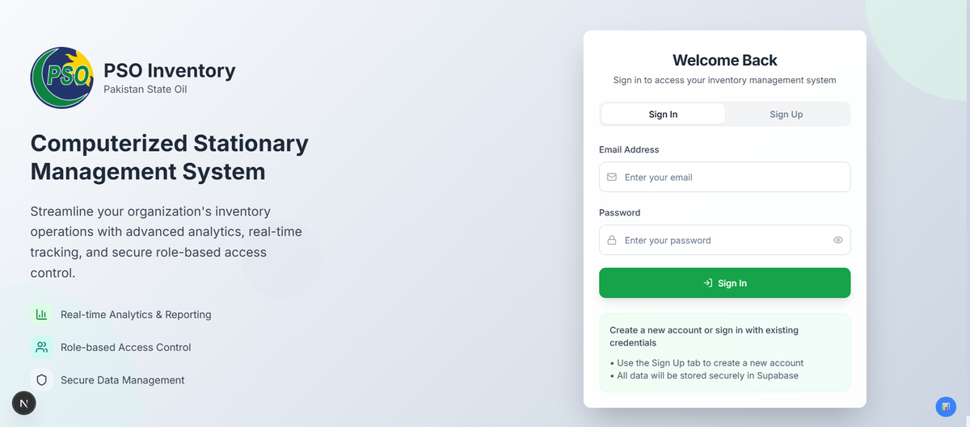

2. Authentication System

The authentication system provides secure access to the inventory management system.

Login Process:

1. Enter your registered email address

2. Enter your password

3. Click 'Sign In' to access the dashboard

Sign Up Process:

1. Enter your full name

2. Provide a valid email address

3. Create a secure password

4. Click 'Sign Up' to create your account

The system includes form validation and error handling for security.

Screenshot:

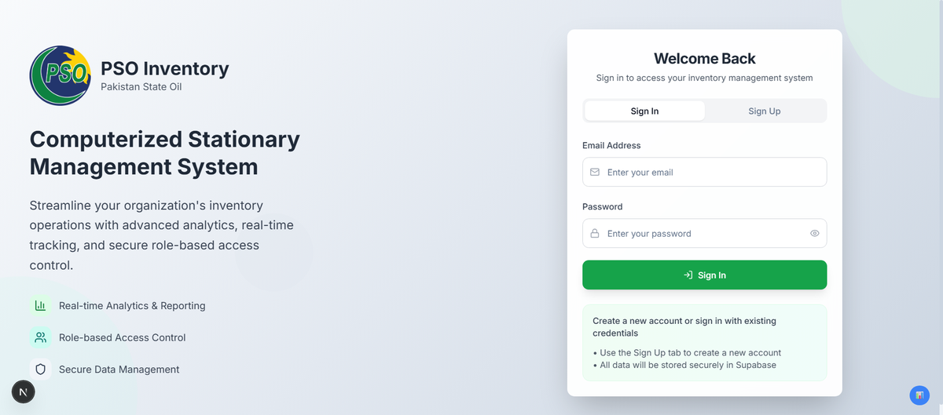

2.1 User Registration

New users can register using the Sign Up tab.

Screenshot:

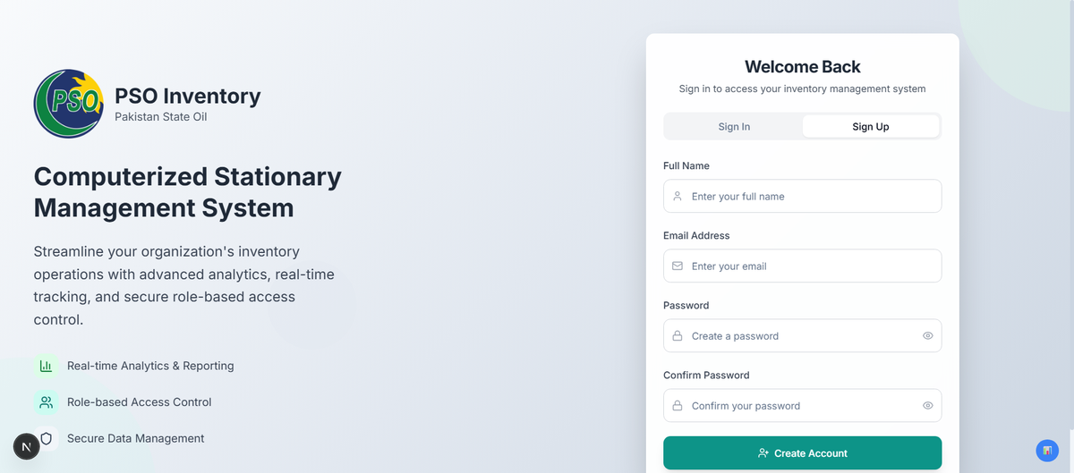

4. Inventory Management

The Inventory Management section is the core of the system, providing comprehensive tools for managing stock items.

The inventory section contains three main tabs:

1. Inventory Overview - Combined view of all inventory data

2. Current Stock - Real-time stock levels and item details

3. Stock History - Historical transactions and movements

Features available in inventory management:

• Add new inventory items

• Update stock quantities

• Track stock movements

• Generate reports

• Search and filter items

Screenshot:

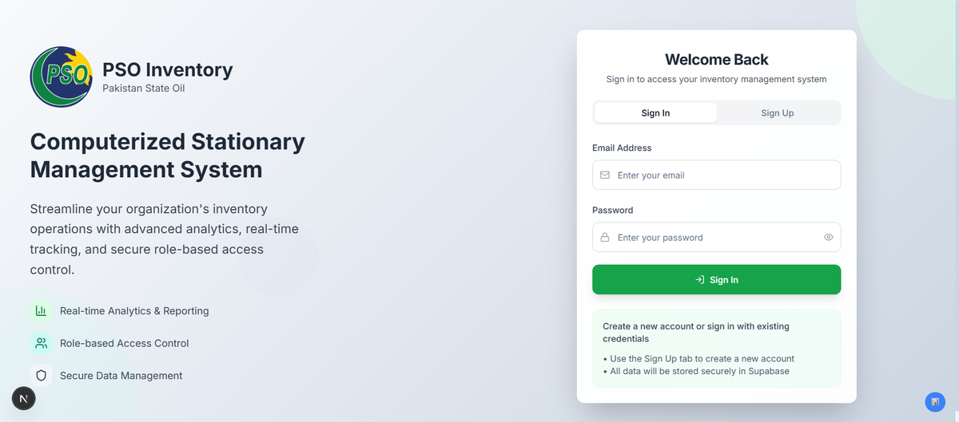

4.3 Adding New Items

The Add Item page allows users to add new inventory items to the system.

Required Information:

• Item Name - Descriptive name of the item

• Description - Detailed description

• Quantity - Initial stock quantity

• Location - Storage location

• Category - Item classification

Process:

1. Fill in all required fields

2. Verify information accuracy

3. Click 'Add Item' to save

4. System will confirm successful addition

Screenshot:

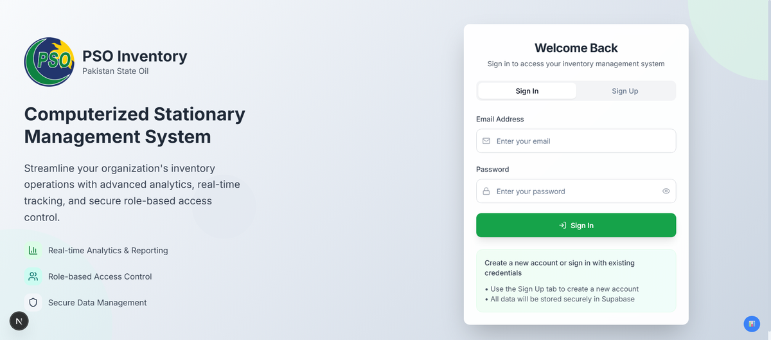

5. Email Management

The Email Management system provides automated communication capabilities.

Features:

• Send automated inventory reports

• Configure email templates

• Manage recipient lists

• Schedule regular reports

• Test email configuration

Email Types:

• Low stock alerts

• Daily/Weekly inventory reports

• Stock movement notifications

• System maintenance alerts

Configuration Options:

• SMTP server settings

• Email templates customization

• Recipient management

• Scheduling preferences

Screenshot:

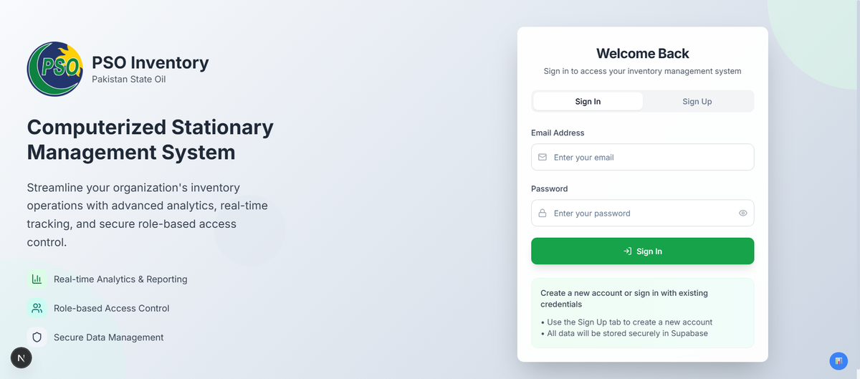

6. Troubleshooting

Common Issues and Solutions:

Login Problems:

• Verify email and password are correct

• Check internet connection

• Clear browser cache and cookies

• Contact system administrator if issues persist

Performance Issues:

• Refresh the page

• Check internet connection speed

• Close unnecessary browser tabs

• Use supported browsers (Chrome, Firefox, Safari)

Data Not Loading:

• Wait for page to fully load

• Refresh the page

• Check if you have proper permissions

• Contact support if data appears missing

Email Issues:

• Verify email configuration

• Check spam/junk folders

• Ensure recipient email addresses are correct

• Test email configuration in Email Management

Browser Compatibility:

• Use modern browsers (Chrome 90+, Firefox 88+, Safari 14+)

• Enable JavaScript

• Allow cookies for the application domain

7. Appendix

System Requirements:

Minimum Browser Requirements:

• Google Chrome 90 or later

• Mozilla Firefox 88 or later

• Safari 14 or later

• Microsoft Edge 90 or later

Network Requirements:

• Stable internet connection

• Minimum 1 Mbps download speed

• JavaScript enabled

• Cookies enabled

Security Features:

• Secure HTTPS connection

• Session-based authentication

• Role-based access control

• Data encryption in transit

Support Information:

• For technical support, contact your system administrator

• Keep your login credentials secure

• Report any security concerns immediately

• Regular system backups are performed automatically