Innovation and Entrepreneurship Project Showcase
Venture Idea | GharSewa – Household Workers Management System
Team Members: Khushi Hooda, Aman Jain, Jhalak Kapila, Rohit Fogla |  | Course Faculty: Dr. Nirupama M P

Venture idea in Brief (100 words):
GharSewa is a digital platform that connects families with verified domestic workers such as maids, cooks, electricians, plumbers, and helpers. The sector is highly unorganized, leading to safety concerns, absenteeism, and unreliable service. GharSewa solves this by offering police-verified worker profiles, transparent pricing, secure UPI escrow payments, and attendance tracking. For households, it ensures trust, convenience, and dependable service. For workers, it provides steady income, recognition, and fair employment practices. The platform aims to formalize India’s informal domestic worker sector and bring dignity, structure, and digital inclusion to millions of workers across Tier-2 and Tier-3 cities.

Our venture aims to create an organized digital ecosystem where households can easily access reliable, skilled, and verified home-service workers through a single platform.

We focus on transforming the fragmented domestic worker sector by standardizing service quality, ensuring transparent pricing, and offering a safe, technology-driven hiring experience.

The platform bridges the gap between customer demand and worker availability, especially in fast-growing Tier-2 and Tier-3 cities where organized home services are still limited.

By leveraging digital tools, we provide workers with stable job opportunities, while enabling families to enjoy trustworthy, on-time, and professional household services.

Exemplar startup chosen and one applied lesson in your venture idea: (100 words):
We selected Urban Company as our exemplar startup. Urban Company demonstrated how standardization, trust-building, and technology can transform a completely unorganized service sector. One key lesson applied to GharSewa is verified workforce and quality assurance. Just as Urban Company uses KYC and training to maintain trust, GharSewa integrates Aadhaar and police verification, ratings, and punctuality tracking to ensure reliable domestic help. Their journey shows that a service marketplace scales successfully when both customers and workers benefit—through transparency, fair pay, and tech-enabled processes.

This learning directly shapes GharSewa’s model for safe, consistent, and trustworthy home services.

Urban Company showed how digital platforms can streamline home-services by using structured workflows and customer-centric processes.

Their success highlights the need for clear service categories, predictable pricing, and strong worker management systems to build trust at scale.

A key takeaway for GharSewa is focusing on operational discipline—ensuring reliability through scheduling, service tracking, and performance monitoring.

Urban Company’s growth demonstrates that a well-managed marketplace can uplift workers economically while delivering consistent value to customers.

Team Picture (Max 4 pictures):
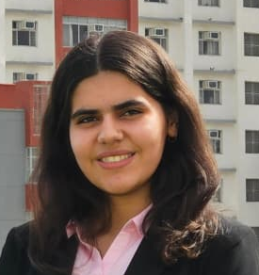
Khushi Hooda Aman Jain Jhalak Kapila Rohit Fogla

Venture Business Model Canvas (Use the BMC template):
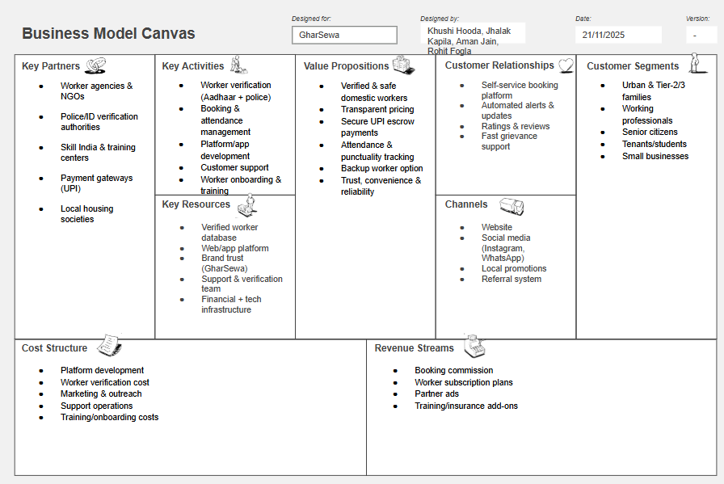

Links/QR: For the poster, video

Poster Video

