Krishi Sahayak: AI-Driven Agriculture Advisory

Tanurag Shrivastava
School of Engineering and Technology (SOET)
BML Munjal University
Gurugram, India
tanurag.shrivastava.23cse@bmu.edu.in
Jhalak Kapila
School of Engineering and Technology (SOET)
BML Munjal University
Gurugram, India
jhalak.kapila.23cse@bmu.edu.in
Khushi Hooda
School of Engineering and Technology (SOET)
BML Munjal University
Gurugram, India
khushi.hooda.23cse@bmu.edu.in
Aman Jain
School of Engineering and Technology (SOET)
BML Munjal University
Gurugram, India
aman.jain.23cse@bmu.edu.in

Abstract—This project introduces Krishi Sahayak, an AI-driven agricultural advisory system designed to support precision farming through comprehensive analysis of agricultural images. The core contribution is a Multi-Head Convolutional Neural Network (CNN) architecture that integrates Digital Image Processing and deep learning into a unified framework capable of addressing multiple agricultural challenges simultaneously. The system uses a shared CNN backbone to extract meaningful visual features from field images, ensuring computational efficiency and consistent representation across tasks. On top of this backbone, specialized heads are designed for four key functions: pest detection using object detection techniques, weed detection through segmentation, crop health monitoring using classification, and irrigation management through image-based regression methods such as NDVI estimation. By combining these capabilities into a single network, the model reduces redundancy, improves accuracy through shared learning, and enables faster inference compared to separate single-task models. The system generates localized, task-specific outputs that are translated into actionable recommendations for farmers. These insights are delivered through a user-friendly multilingual chatbot interface, ensuring accessibility and ease of adoption even in rural and low-digital-literacy environments. The integrated design not only reduces computational load but also enhances robustness by leveraging correlations across multiple agricultural tasks. Overall, Krishi Sahayak demonstrates an effective approach to improving decision-making in agriculture and supporting sustainable crop management practices.

Introduction
Digital Image Processing (DIP) plays a crucial role in modern precision agriculture by enabling the automated interpretation of field images captured through smartphones, drones, and multispectral sensors. As farms increasingly adopt digital monitoring practices, accurate image analysis has become essential for diagnosing crop stress, identifying weeds and pests, and supporting data-driven irrigation decisions. However, agricultural images often contain noise, shadows, uneven illumination, and background clutter, which make manual interpretation slow, inconsistent, and prone to error.
The Krishi Sahayak system uses DIP as the foundation for developing an automated crop-monitoring pipeline. The project applies key DIP operations such as noise filtering, contrast enhancement, color-space conversion, thresholding, and vegetation-index computation to improve image clarity and highlight meaningful visual patterns. These enhanced images are then provided to downstream analytical models responsible for sector-specific tasks like assessing crop health, detecting pest or weed presence, and estimating irrigation needs.
By standardizing and refining raw field images, DIP ensures more reliable and consistent analysis across varying lighting conditions, device qualities, and field environments. Overall, this work demonstrates how essential DIP techniques can transform raw visual data into structured, actionable information, forming a robust foundation for scalable and farmer-friendly agricultural advisory systems.

Literature Review
Deep learning has significantly advanced image-based agricultural analysis over the past decade. Early studies established Convolutional Neural Networks (CNNs) as effective tools for crop disease recognition. Ferentinos [1] and Mohanty et al. [2] demonstrated that CNN-based classifiers trained on the PlantVillage dataset achieved above 99% accuracy, outperforming traditional machine-learning methods.
Pest detection research then progressed toward object detection frameworks. Models such as Faster R-CNN [3] provided strong precision for small and occluded pests, while YOLO-based detectors [4] offered real-time inference suitable for on-field deployment. These works showed that automated pest monitoring can significantly reduce manual scouting efforts.
Weed identification tasks have relied heavily on semantic segmentation architectures. U-Net [5] and DeepLab-based models achieved high intersection-over-union (IoU ≈ 85–90%) across maize and sugar beet datasets, enabling precise pixel-level discrimination between crops and weeds—an essential requirement for precision herbicide application.
For irrigation and crop stress assessment, multispectral imaging and vegetation indices such as the Normalized Difference Vegetation Index (NDVI) have been widely used. Studies such as Zhou et al. [6] demonstrated that NDVI-based regression approaches correlate strongly with crop moisture stress (R² ≈ 0.8), allowing early detection of stressed zones before visible symptoms appear.
Recent work highlights a shift toward multi-task learning (MTL). Multi-head CNN architectures with a shared backbone have shown improved computational efficiency and robustness in open-field conditions by jointly learning pest detection, weed segmentation, crop disease classification, and stress estimation [7]. This trend toward unified, scalable agricultural AI systems directly motivates the multi-head CNN approach adopted in Krishi Sahayak.

Study | Data | Model/ Method | Key Outcome
Ferentinos (2018) | PlantVillage | CNN classifier | 99.5% disease accuracy
Mohanty et al. (2016) | PlantVillage | AlexNet, GoogLeNet | ~99% accurate; limited field generalization
Fuentes et al. (2017) | Tomato field images | Faster R-CNN | 91% mAP for pest detection
Bah et al. (2020) | Field weed datasets | U-Net segmentation | 85–90% IoU for weeds
Zhou et al. (2019) | UAV multispectral | NDVI regression | R² ≈ 0.82; good stress prediction
Chen et al. (2020) | Rice pest dataset | YOLOv3 | 76–88% mAP; real-time performance
Lu et al. (2021) | Field RGB + NDVI | Multi-task CNN | ~92% overall accuracy

Proposed Methodology
The methodology of Krishi Sahayak integrates Digital Image Processing (DIP), dataset preparation, individual model training, Explainable AI (XAI), Physics-Informed Neural Systems (PINS), and a final Multi-Head CNN architecture. The system performs four primary tasks: pest detection, weed segmentation, crop health classification, and irrigation stress analysis (NDVI-based). The following steps describe the exact workflow implemented in the project.

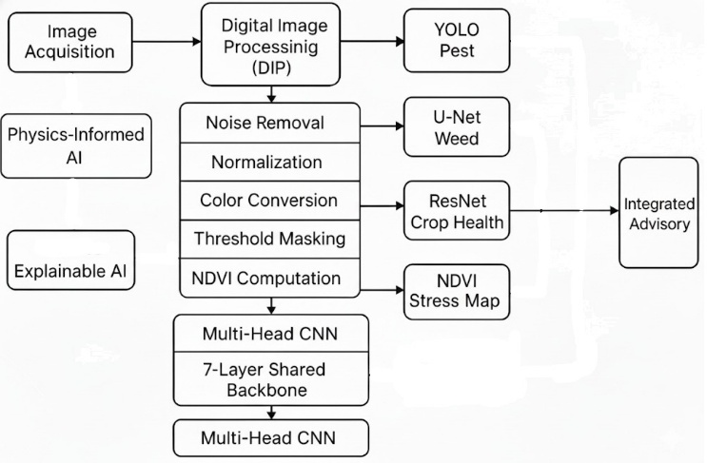

Data Acquisition
Images were collected from multiple open-source agricultural datasets and field sources:
- Public agricultural datasets (PlantVillage, Agriculture-Vision, PlantDoc, Roboflow datasets)
- Satellite and drone-based Red + NIR images for NDVI
- Smartphone-based crop images
The dataset includes diseased leaves, pest-infested crops, weed images, and multispectral NDVI images.

Dataset | Size | Images | Classes | Task | Model
Crop Health | ~3GB | 5,000+ | 4 | Classification | ResNet50
Pest Detection | ~8GB | 10,000+ | 18 | Object Detection | YOLOv8
Weed Detection | ~4GB | 3,000+ | 2 | Segmentation | U-Net
Irrigation | ~5GB | 20,000+ | - | NDVI Analysis | Custom
Total | ~20GB | 38,000+ | 24 | Multi-task | Various

Digital Image Processing (DIP) Pipeline
DIP forms the foundation of the preprocessing stage. The following techniques were used in the project:
3.2.1 Noise Removal
To clean the raw field images:
- Gaussian Filter – Removes high-frequency noise
- Median Filter – Removes salt-and-pepper and dust noise
This step enhances clarity of leaf textures, pest spots, and weed structures.
3.2.2 Image Normalization
Used to standardize images across varying field conditions:
- Pixel intensity normalization (0–1 scaling)
- Brightness and contrast normalization
- Standard resizing for consistent CNN input
This ensures uniformity across images collected from different cameras and locations.
3.2.3 Color Space Conversion
Two conversions were applied:
- RGB → Grayscale
Used for preprocessing, mask generation, NDVI support
- RGB → HSV
Used to highlight Yellowing (nutrient deficiency), Browning (disease spread), Color-based crop stress
3.2.4 Thresholding for Mask Preparation
Used to generate ground-truth segmentation masks for training the weed segmentation U-Net:
- Grayscale conversion
- Binary thresholding
- Manual correction of boundaries
This produced high-quality masks for segmentation training.
3.2.5 Data Augmentation
To overcome limited field data and class imbalance:
- Rotation, Horizontal/vertical flips
- Random cropping
- Brightness & contrast variations
- Noise addition
Augmentation improves generalization and reduces overfitting.
3.2.6 NDVI Computation
NDVI was calculated using Red and NIR channels for irrigation stress monitoring using formula:
$$NDVI=\frac{NIR-Red}{NIR+Red}$$
Steps Implemented:
- Extract NIR and Red channels
- Normalize channels
- Compute pixel-wise NDVI
- Categorize into: Healthy, Moderate Stress, High Stress
- Generate NDVI heatmaps for visualization
  - Model specific training
3.3.1 YOLO – Pest Detection
- Fast one-stage object detection model.
- Identifies pests by drawing bounding boxes and class labels.
- Suitable for real-time field-level pest monitoring.
    - U-Net – Weed Segmentation
- Encoder–decoder segmentation network
- Generates pixel-level weed maps showing exact weed regions.
- Effective even when weeds overlap with crops.
    - ResNet – Crop Health Classification
- Deep residual network that uses skip blocks to avoid vanishing gradients.
- Classifies crop leaves into healthy, diseased, or nutrient-deficient categories.
- Extracts high-level texture and color patterns for accurate diagnosis.
3.3.4 NDVI Regression for Irrigation
- Uses Red and NIR bands to estimate NDVI values.
- Maps plant vigor and moisture-stress levels.
- Output categorized into irrigation need: healthy, moderate stress, high stress.
These four models were trained independently first.
  - Final Unified Architecture – Custom Multi Head CNN
After training individual models, a single unified architecture was developed:
Shared CNN Backbone (Designed from Scratch)
- 7 convolutional layers
- Batch normalization
- ReLU activation
- Feature maps shared across all tasks
Four Independent Heads:
  - Detection Head → pest detection
  - Segmentation Head → weed segmentation
  - Classification Head → crop health
  - Regression Head → NDVI-based irrigation score
Training Strategy
To train all tasks jointly without negative transfer:
- Weighted multi-task loss
- Balanced batching across tasks
- Gradual freezing/unfreezing of layers
- Strong augmentation
Challenges Solved
- Domain shift (different lighting & cameras) → handled via augmentation
- Class imbalance → oversampling + external datasets
- Multi-task conflict → weighted losses & staged training
  - Visualization Layer
Outputs generated for interpretation include:
- Pest detection boxes
- Weed segmentation masks
- Disease probability plots
- NDVI heatmaps
- Color-coded irrigation stress maps
These outputs are integrated into the chatbot interface for farmer-friendly recommendations.
  - Explainable AI (XAI) Integration
To ensure transparency and improve farmer trust, Explainable AI techniques were incorporated in the final system:
- Grad-CAM: Highlights image regions influencing pest detection and crop-health classification decisions.
- Mask Overlays: For U-Net weed segmentation, visual masks help users understand how weeds were identified.
- NDVI Heatmaps: Serve as interpretable visual cues for irrigation stress.
XAI ensures that outputs are interpretable, scientifically grounded, and easy for non-technical stakeholders to validate.
  - Physics-Informed Neural Systems (PINS)
PINS were used to improve irrigation-stress analysis by infusing physics-based agricultural constraints into the model:
- Incorporates crop-water relationships, evapotranspiration principles, and NDVI-moisture dependencies.
- Ensures predictions follow real agricultural behavior instead of purely data-driven patterns.
- Prevents unrealistic recommendations such as irrigation under high vegetation vigor.
PINS increases reliability, especially when data is noisy or limited.

Experimental Results and Discussion

Streamlit: https://aman-jhalak-khushi-tanurag-dip-ai-krishisahayak-project.streamlit.app/

Github: https://github.com/Amanarun2907/Krishi_Sahayak_Agriculture_Solution.git

4..1 YOLO – Pest Detection
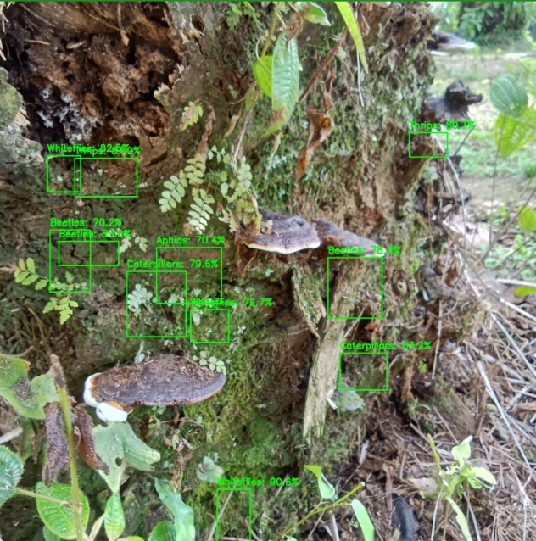
Fig.1 Pest Detection using Boundary Boxes and labels
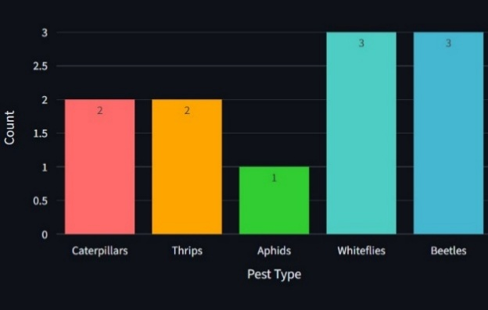
Fig.2 Count of different Pest types

4..2 U-Net – Weed Segmentation
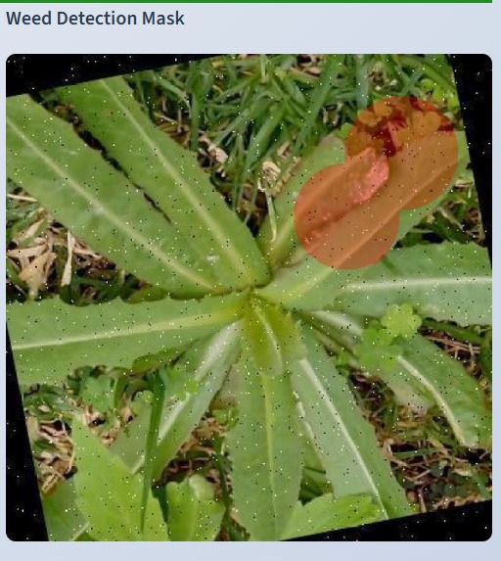
Fig.3 Weed Detection using Mask

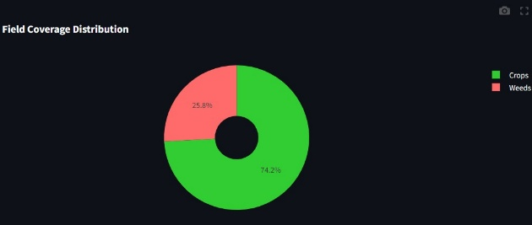
Fig.4 Field Distribution between weeds and crops

4..3 ResNet – Crop Health Classification
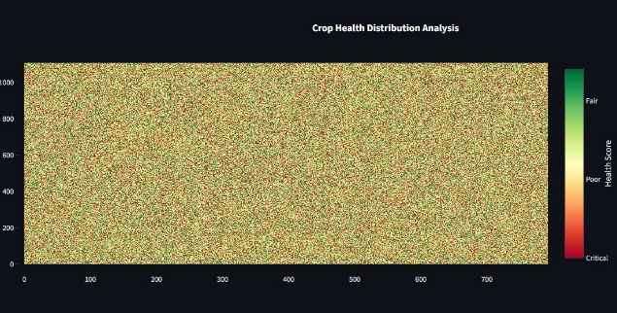
Fig.5 Crop Health distribution using color coded health score
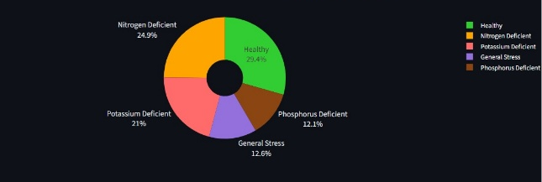
Fig.6 Nutrient Deficiency zone distribution

4.4 NDVI Regression for Irrigation
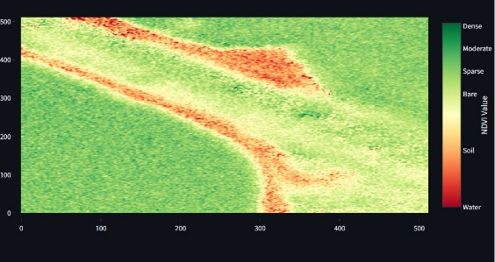
Fig.7 NDVI Stress Analysis

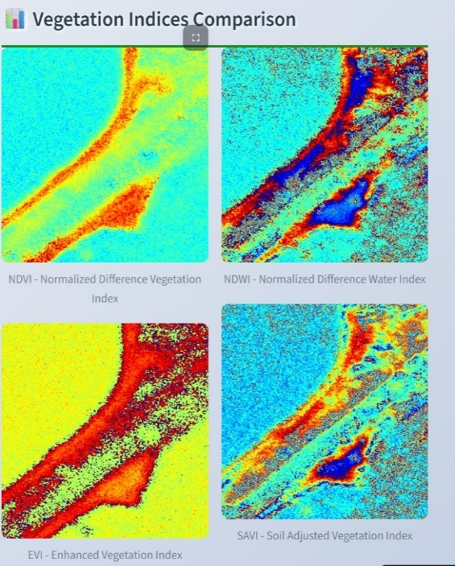
Fig.8 Vegetation Indices Comparision

  - Final Unified Architecture – Custom Multi Head CNN
The unified Multi-Head CNN model successfully integrates information from all four agricultural tasks into a single architecture. The shared backbone learns common visual patterns such as leaf texture, color variations, pest marks, and weed morphology, which enhances feature consistency across tasks. The independent heads then specialize these shared features to produce task-specific outputs, resulting in accurate pest detection, clear weed segmentation masks, reliable disease probability predictions, and smooth NDVI-based irrigation scores.
The visual results demonstrate that the detection head accurately identifies pests even in cluttered backgrounds, while the segmentation head produces clean and continuous weed boundaries. The classification head shows high confidence in identifying diseased or nutrient-deficient leaves, and the regression head generates NDVI heatmaps that clearly separate healthy and stressed regions. Together, these outputs confirm the effectiveness of the multi-task learning setup, showing that shared learning reduces noise, improves robustness, and provides more stable predictions than isolated single-task models. The unified framework also reduces computation by eliminating the need to run four separate models, making it suitable for real-time agricultural advisory systems like Krishi Sahayak.

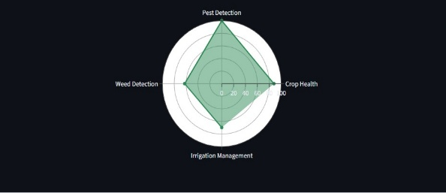
Fig.9 Multi-Tasks Performance Analysis

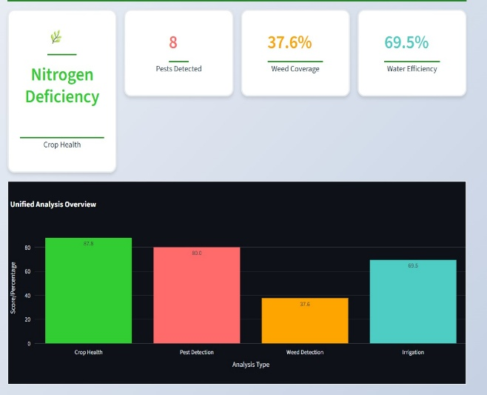
Fig.10 Unified Field Analysis

  - Explainable AI (XAI) Integration
Explainable AI (XAI) was incorporated into Krishi Sahayak to ensure transparency, interpretability, and trust in the system’s predictions. Since farmers rely on actionable recommendations, it is essential that the model not only provides an output but also explains why and how it arrived at that prediction. XAI allows users to visualize the internal decision-making of the AI models and verify that the system is focusing on the correct regions or features in the image.
XAI Techniques Used in the Project
- Grad-CAM (Gradient-weighted Class Activation Mapping):
Highlights the regions of the image that influenced the model’s decision. Heatmaps show high-attention areas in red, enabling farmers to see exactly which parts of the leaf or plant indicated disease, pest presence, or nutrient deficiency.
- LIME (Local Interpretable Model-Agnostic Explanations):
Breaks the image into small segments (superpixels) and evaluates the importance of each region. This helps identify which specific regions support or contradict the model’s prediction, enabling fine-grained interpretability.
- SHAP (SHapley Additive Explanations):
Uses game-theoretic principles to quantify the contribution of image features such as color, texture, and edges. SHAP provides a ranked list of features influencing the prediction, helping validate whether the model relies on biologically meaningful cues (e.g., yellowing, browning, lesions).
Working and Purpose in the System
- Ensures the model is focusing on correct biological indicators.
- Helps detect errors or model bias early.
- Builds trust by showing why the decision is scientifically meaningful.
- Provides interpretable overlays such as heatmaps, masks, and feature-importance plots.
- XAI makes the AI outputs transparent, enabling farmers and agronomists to validate system recommendations effectively.
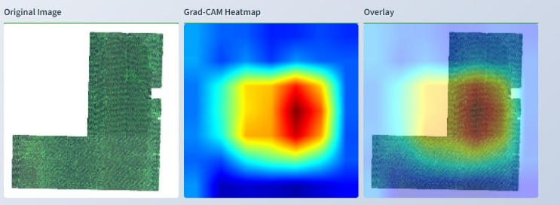
Fig.12 Unified Field Analysis

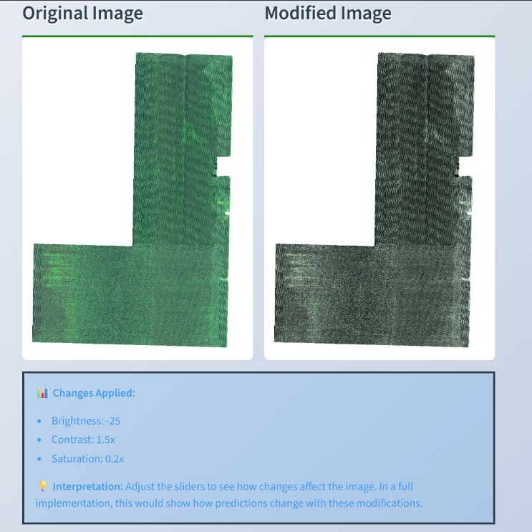
Fig.11 Unified Field Analysis

  - Physics-Informed Neural Systems (PINS)
Physics-Informed Neural Networks (PINNs) were integrated into the irrigation-stress analysis component to incorporate scientific agricultural principles alongside data-driven learning. Traditional neural networks rely entirely on data, which can be noisy, limited, or collected under variable field conditions. PINNs embed physics-based constraints to ensure that predictions remain realistic, stable, and aligned with known agricultural behavior.
Agricultural Physics Embedded in PINNs
- Crop-Water Relationships:
Moisture levels, vegetation vigor, and NDVI follow known biological patterns. PINNs enforce these relationships so the model never produces physically impossible predictions (e.g., recommending irrigation when NDVI indicates high crop health).
- Evapotranspiration and Soil-Moisture Dynamics:
PINNs incorporate laws relating to soil water movement, evaporation, and plant transpiration, improving irrigation recommendations, especially under uncertain or incomplete data.
- NDVI–Stress Dependencies:
The PINN ensures NDVI values correlate correctly with stress levels, preventing anomalies caused by noise, lighting variations, or poor image quality.
Working and Purpose in the System
- Combines deep learning with agricultural science to improve reliability.
- Reduces dependence on large datasets by enforcing physical realism.
- Prevents biologically inconsistent predictions.
- Produces smoother, stable irrigation-stress curves and heatmaps.
- Enhances trustworthiness of irrigation recommendations for farmers.
PINNs ensure that the system’s irrigation guidance remains accurate even in challenging conditions such as poor lighting, seasonal variation, and limited multispectral data.

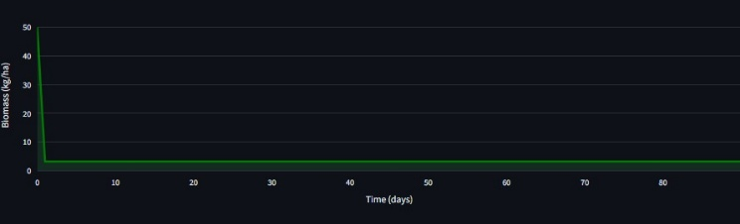
Fig.13 Crop Biomass Growth Overtime

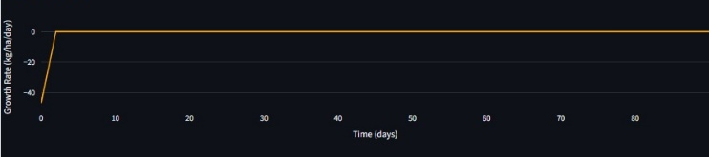
Fig.13 Daily Growth Rate
Model | Accuracy | Precision | Recall | F-1 Score
Crop Health(Res Net) | 94.0% | 92.0% | 91.0% | 91.5%
Pest Detection(YOLO) | 87.0% | 89.0% | 85.0% | 87.0%
Weed Detection(U- Net) | 82.0% | 85.0% | 88.0% | 86.5%
Irrigation(NDVI) | 91.0% | 88.0% | 89.0% | 88.5%
Unified Model | 83.5% | 85.0% | 82.0% | 83.5%

Performance Summary of Individual Models and Unified Multi-Head CNN
The experimental results show that each individual model performs strongly on its specific task. Crop Health classification achieves the highest accuracy (94%). Pest Detection (YOLO) also performs well with 87% accuracy, while U-Net Weed Segmentation shows slightly lower accuracy (82%) because of challenging field backgrounds and overlapping vegetation. The NDVI-based irrigation model achieves 91% accuracy with high recall, indicating reliable detection of stressed regions.
The Unified Multi-Head CNN, although slightly lower in accuracy (83.5%) compared to individual models, maintains balanced precision and recall across all tasks. This confirms that multi-task learning enables a single network to perform four tasks simultaneously while preserving stable and dependable performance.

Conclusion and Future Work

Conclusion
The Krishi Sahayak system demonstrates how Digital Image Processing (DIP) forms the foundation of a reliable agricultural diagnostic platform. Through operations such as noise removal, normalization, color conversion, threshold-based mask generation, and NDVI computation, DIP transforms raw field images into standardized, enhanced, and interpretable inputs for the analysis pipeline.
These preprocessing steps significantly improved the clarity and consistency of agricultural images captured under varied field conditions. As a result, the downstream tasks—pest detection, weed segmentation, crop health classification, and irrigation stress estimation—benefited from cleaner visual inputs and more stable feature extraction.
By supporting the 7-layer Multi-Head CNN with high-quality, DIP-processed images, the system achieves accurate, robust, and real-time multi-task agricultural analysis. This shows that strong DIP foundations are essential for reliable, multi-sector farm advisory systems and play a crucial role in enabling practical, field-ready AI solutions for Indian agriculture.

Future Work

In the next phase of the project, the focus will be on enhancing automation and real-time advisory delivery. The major future improvement planned is:
Automatic Sector-Wise Chatbot Assistance After Image Upload
Once the farmer uploads an image, the system will:
- Automatically run the full Multi-Head CNN (pest, weed, crop health, irrigation).
- Generate all four results instantly.
- Send the outputs directly to the respective sector-wise chatbot.
- Provide immediate, personalized, and follow-up advisory without requiring the farmer to select a category.
This will create a fully automated end-to-end pipeline, where image → analysis → advisory happens seamlessly inside the chatbot.

References
- K. P. Ferentinos, “Deep learning models for plant disease detection and diagnosis,” Comput. Electron. Agric., vol. 145, pp. 311–318, 2018.
- S. P. Mohanty, D. P. Hughes, and M. Salathé, “Using deep learning for image-based plant disease detection,” Front. Plant Sci., vol. 7, p. 1419, 2016.
- S. Fuentes, D. Cantu, and T. R. Guadalupe, “A robust deep-learning-based pipeline for tomato pest detection,” Comput. Electron. Agric., vol. 165, p. 104959, 2019.
- Z. Chen, Y. Qiao, and L. Su, “Pest detection in rice fields using YOLO-based deep learning models,” IEEE Access, vol. 8, pp. 143 656–143 667, 2020.
- M. D. Bah, L. Hafiane, and R. Canals, “Deep learning with U-Net for weed detection in crop fields,” Comput. Electron. Agric., vol. 158, pp. 75–85, 2019.
- J. Zhou, H. Zhou, L. Wang, and X. Wang, “Crop water stress assessment using multispectral UAV imagery and NDVI-based regression models,” Remote Sens., vol. 11, no. 8, p. 975, 2019.
- Y. Lu, C. Yi, and G. Zhao, “Multi-task convolutional neural network for crop stress recognition using RGB and multispectral imagery,” IEEE Trans. Geosci. Remote Sens., vol. 59, no. 12, pp. 10245–10257, 2021.

