

UNIVERSITY INSTITUTE OF COMPUTING

Object Oriented Programming
SUBJECT CODE – 25CAH-201

SUBMITED BY:

Name : Aman UID: 25BCD10061

Branch : BCA-DATA SCIENCE Group: 25BCD-1

Semester : 3 Section: B

SUBMITED TO:

Name : Ms. Shuchi Sharma D.O.SUBMITION :

A PROJECT REPORT
on
RAILWAY RESERVATION SYSTEM
Developed using C++ Programming Language
ABSTRACT
Railway transport is the backbone of public transportation in India, carrying millions of passengers every day. Reserving a seat in a train through manual counters involves long queues, paper work, human errors and delays. A computerised reservation system removes these problems by storing all information electronically and processing requests within seconds.
This project, “Railway Reservation System”, is a console based application developed in C++ using the principles of Object Oriented Programming and File Handling. The system provides two kinds of services. Passengers can view the list of available trains, book tickets, cancel tickets and check the status of a ticket with the help of a PNR number. The administrator can add new trains and view the records of all bookings.
The program is built around two data classes, Train and Ticket, and one controller class, ReservationSystem. Standard Template Library (STL) vectors are used to hold records in memory, while text files (trains.txt and tickets.txt) are used for permanent storage so that the data remains safe after the program is closed. The system automatically generates unique PNR numbers, updates seat availability after every booking or cancellation, gives a concession to senior citizens and calculates the refund amount on cancellation.
The project has been tested with valid as well as invalid inputs and works correctly. It demonstrates how a real-life problem can be solved with core C++ concepts and can be extended in future with features such as user login, seat/berth numbers, waiting list and a graphical interface.
Keywords: C++, Railway Reservation, OOP, File Handling, PNR, STL, Console Application
TABLE OF CONTENTS
Abstract 4
1. INTRODUCTION 6
1.1 Overview 6
1.2 Problem Statement 6
1.3 Objectives of the Project 6
1.4 Scope of the Project 6
1.5 Organisation of the Report 7
2. SYSTEM ANALYSIS 7
2.1 Existing System 7
2.2 Proposed System 7
2.3 Feasibility Study 7
2.4 Development Model 8
3. REQUIREMENT SPECIFICATION 8
3.1 Hardware Requirements 8
3.2 Software Requirements 8
3.3 Functional Requirements 8
3.4 Non-Functional Requirements 9
4. SYSTEM DESIGN 9
4.1 Design Approach 9
4.2 Module Description 9
4.3 Data Flow Diagram (DFD) 10
4.4 ER Diagram 10
4.5 Flowchart of Ticket Booking 11
5. DATA STORAGE DESIGN 11
5.1 File Handling Approach 11
5.2 Structure of trains.txt 11
5.3 Structure of tickets.txt 12
5.4 Sample Records 12
5.5 Business Rules 12
6. IMPLEMENTATION 12
6.1 Tools and Technologies 12
6.2 C++ Concepts Used 13
6.3 Algorithm for Booking a Ticket 13
6.4 Algorithm for Cancelling a Ticket 13
6.5 Complete Source Code 13
7. TESTING 17
7.1 Testing Strategy 17
7.2 Test Cases 17
7.3 Result of Testing 18
8. OUTPUT SCREENS 18
9. LIMITATIONS, FUTURE SCOPE AND CONCLUSION 19
9.1 Limitations 19
9.2 Future Scope 19
9.3 Conclusion 19
BIBLIOGRAPHY 20

1. INTRODUCTION

1.1 Overview
Indian Railways is one of the largest railway networks in the world and millions of people depend on it for daily travel. Because the number of passengers is so large, issuing tickets, keeping track of available seats and handling cancellations manually is slow and error-prone. Computerised reservation systems were introduced to make this work fast, accurate and transparent.
The Railway Reservation System developed in this project is a simplified model of such a system. It is written in C++ and runs in the console window. The program lets a passenger look at the available trains, reserve seats, cancel a booking and check the ticket status using a unique Passenger Name Record (PNR) number. An administrator can add new trains and see all bookings. All the data is saved in files, therefore the information is not lost when the program is closed.

1.2 Problem Statement
In the manual reservation process the clerk has to search registers to find seat availability, write the ticket by hand and update the records separately. This creates the following problems:
- Long waiting queues and a lot of time consumed for a single ticket.
- Chances of human mistakes such as wrong entries, wrong fare calculation or double booking of the same seat.
- Difficulty in searching an old booking or tracing a ticket when the PNR is known.
- Cancellation and refund calculation is done manually, so errors and disputes are common.
- No quick way to know how many seats are still available in a train.

1.3 Objectives of the Project
- To design and develop a simple, user-friendly railway reservation system using C++.
- To apply Object Oriented Programming concepts such as classes, objects and member functions to a real-life problem.
- To store train and ticket information permanently using file handling.
- To generate a unique PNR number for every booking and update seat availability automatically.
- To calculate fare, senior citizen concession and cancellation refund without manual effort.
- To validate user input so that wrong data does not crash the program.

1.4 Scope of the Project
The project covers the core functions of a reservation counter: viewing trains, booking, cancellation, PNR enquiry and train management by the administrator. It works for a single class of seats and assumes that one booking is made for one passenger with the required number of seats. Online payment, travel dates, berth numbers and a graphical interface are outside the scope of the present version, but the code is organised in such a way that these can be added later.

1.5 Organisation of the Report
Chapter 2 describes the existing and proposed system along with the feasibility study. Chapter 3 lists the hardware, software and functional requirements. Chapter 4 explains the design with the help of class table, DFD, ER diagram and flowchart. Chapter 5 gives the design of data files, while Chapter 6 covers implementation, algorithms and the complete source code. Chapter 7 presents the testing, Chapter 8 shows the output screens and Chapter 9 ends the report with limitations, future scope and conclusion.

2. SYSTEM ANALYSIS

2.1 Existing System
In the existing manual system every passenger fills a requisition slip and gives it at the counter. The booking clerk checks the chart, issues a printed ticket and manually reduces the number of available seats. Cancellation also needs a written application and calculation of refund by the clerk. The main drawbacks of this system are:
- It is time consuming and needs a large number of staff.
- Records are kept on paper, so they can be lost, damaged or altered.
- Searching a particular ticket among thousands of entries is very difficult.
- Seat availability is not updated instantly, which leads to overbooking or wastage of seats.
- Preparing reports for the management takes a lot of effort.

2.2 Proposed System
The proposed system is a computer based application that automates all the above activities. The user simply selects an option from the menu, enters the required data and the program performs searching, calculation and updating of records on its own. The advantages of the proposed system are:
- Booking and cancellation are completed in a few seconds.
- Seat availability is updated immediately after every transaction, so overbooking is not possible.
- A unique PNR is generated automatically and any ticket can be found instantly with it.
- Fare, concession and refund are calculated by the program, so there are no calculation mistakes.
- Data is stored in files and can be backed up easily.
- The program is simple, light-weight and runs on any computer having a C++ compiler.

2.3 Feasibility Study
Before starting the development, the feasibility of the project was checked from the following points of view.
Technical feasibility: The project needs only a C++ compiler and a normal computer. All the required features such as classes, vectors and file streams are available in standard C++, so no special hardware or paid software is required. The project is technically feasible.
Economic feasibility: Free compilers such as GCC (MinGW) and Code::Blocks or VS Code are used, therefore the development cost is almost zero. Once developed, the system saves time and paper, so the benefits are greater than the cost.
Operational feasibility: The menu driven interface is easy to understand, and a person with basic computer knowledge can operate it without any special training. Hence the system is operationally feasible.

2.4 Development Model
The Waterfall model was followed for developing this project because the requirements were clear from the beginning. The phases were: (1) Requirement analysis, in which the functions of the system were decided; (2) System design, in which classes, files and diagrams were prepared; (3) Implementation, in which the C++ code was written; (4) Testing, in which each function was checked with valid and invalid data; and (5) Maintenance, in which errors found later are corrected and new features can be added.

3. REQUIREMENT SPECIFICATION

3.1 Hardware Requirements
Component | Minimum | Recommended
Processor | Intel Pentium / Dual Core | Intel Core i3 or higher
RAM | 1 GB | 4 GB or more
Hard disk | 100 MB free space | 1 GB free space
Display | Standard VGA monitor | HD monitor
Input devices | Keyboard | Keyboard and mouse

3.2 Software Requirements
Item | Details
Operating system | Windows 7 / 10 / 11, Linux or macOS
Programming language | C++ (C++11 or later standard)
Compiler | GCC / MinGW (g++), Turbo C++ is not suitable because STL and C++11 features are used
IDE / Editor | Code::Blocks, Dev-C++, Visual Studio Code or any text editor
Data storage | Plain text files (trains.txt and tickets.txt)
Documentation | Microsoft Word

3.3 Functional Requirements
The functional requirements describe what the system must do.
ID | Function | Description
FR1 | View trains | Display train number, name, source, destination, available seats and fare of all trains.
FR2 | Book ticket | Accept passenger details and seats, check availability, calculate fare, generate PNR and save the ticket.
FR3 | Cancel ticket | Cancel a confirmed ticket using the PNR, return seats to the train and show the refund amount.
FR4 | PNR status | Show the complete ticket information and its status (Confirmed / Cancelled).
FR5 | Add train | Allow the administrator to add a new train; duplicate train numbers are rejected.
FR6 | View bookings | Allow the administrator to see all tickets booked so far.
FR7 | Data storage | Save all train and ticket data in files after every change and load it again at start-up.

3.4 Non-Functional Requirements
- Usability: simple numbered menu and clear messages for every action.
- Reliability: invalid input (letters instead of numbers, wrong PNR, wrong train number) must not crash the program.
- Performance: every operation should be completed within a second for normal data size.
- Portability: the program should compile and run on any operating system having a standard C++ compiler.
- Maintainability: the code is divided into classes and small functions so that changes are easy.

4. SYSTEM DESIGN

4.1 Design Approach
The system is designed using the object oriented approach. Real world entities such as a train and a ticket are represented as classes, and the operations of the reservation counter are placed in a controller class. This keeps the data and the functions that work on it together and makes the program easy to understand. The three classes of the project are given below.
Class | Data members | Member functions
Train | number, name, source, destination, totalSeats, availableSeats, fare | toLine(), fromLine()
Ticket | pnr, passenger, age, gender, trainNo, seats, amount, active | toLine(), fromLine()
ReservationSystem | vector<Train> trains, vector<Ticket> tickets | loadData(), saveData(), findTrain(), nextPNR(), showTrains(), addTrain(), bookTicket(), cancelTicket(), searchPNR(), showAllBookings()

4.2 Module Description
- Train Management module: adds new trains and displays the list of trains with the number of seats still available.
- Booking module: takes passenger details, checks seat availability, calculates the amount, generates the PNR and reduces the seats of the train.
- Cancellation module: searches the ticket by PNR, marks it cancelled, adds the seats back to the train and calculates the refund.
- Enquiry module: displays the full ticket (PNR, passenger, train, route, seats, amount and status).
- File handling module: reads data from the files when the program starts and writes it back after every booking, cancellation or addition of train.

4.3 Data Flow Diagram (DFD)
The level 0 DFD (context diagram) shows the system as a single process which interacts with two external entities, the passenger and the administrator, and two data stores.
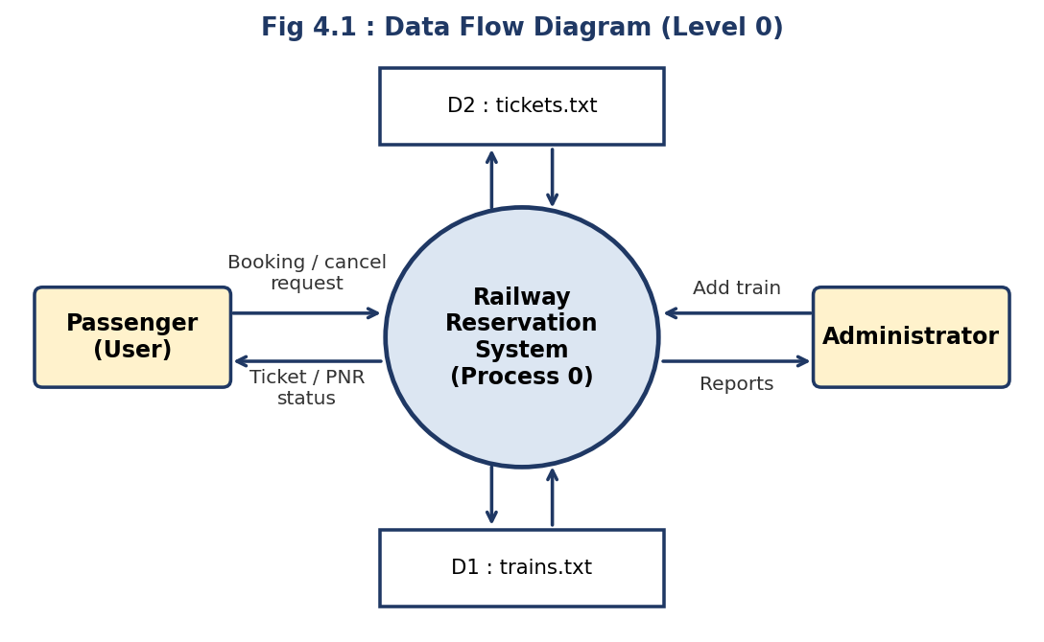

4.4 ER Diagram
There are two main entities, Passenger (Ticket) and Train. One train can be booked by many tickets, whereas every ticket belongs to exactly one train, so the relationship is many-to-one. The PNR and the train number are the key attributes.
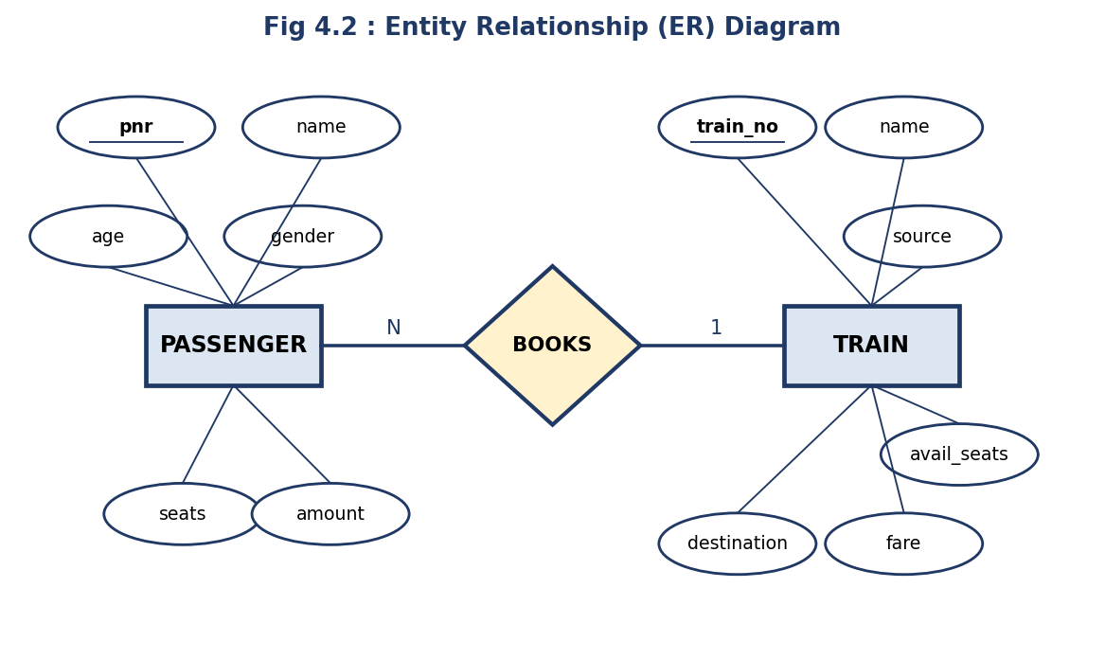

4.5 Flowchart of Ticket Booking
The flowchart explains the logic of the most important function of the project. The booking proceeds only if the train exists and the required seats are available; otherwise an error message is shown and the control returns to the menu.
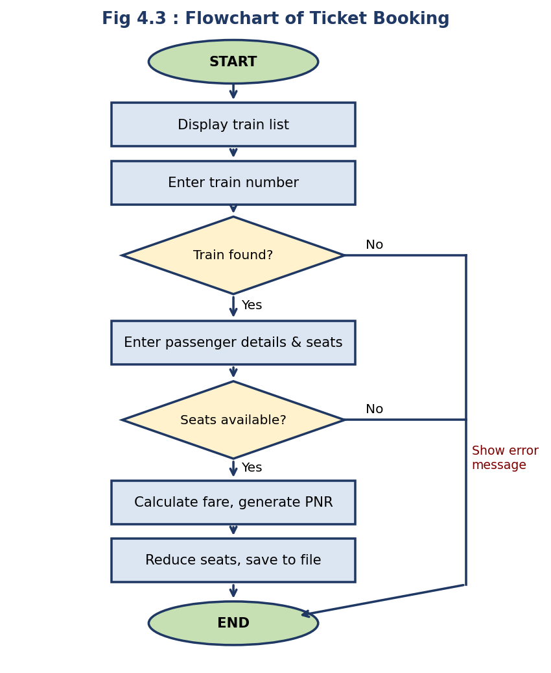

5. DATA STORAGE DESIGN

5.1 File Handling Approach
The program uses two text files for permanent storage. Each record is stored on a separate line and its fields are separated with the pipe symbol ( | ). Text files were chosen instead of binary files because they can be opened in Notepad, are easy to debug and can be edited by hand. When the program starts, the constructor of the ReservationSystem class reads both files into two vectors. After every change (booking, cancellation, new train) the vectors are written back to the files by the function saveData(). If the train file is empty at the first run, three sample trains are inserted automatically.

5.2 Structure of trains.txt
Field | Data type | Description
number | int | Unique train number, used as the primary key
name | string | Name of the train
source | string | Starting station
destination | string | Ending station
totalSeats | int | Total number of seats in the train
availableSeats | int | Seats still available for booking
fare | double | Fare for one seat in rupees

5.3 Structure of tickets.txt
Field | Data type | Description
pnr | int | Unique PNR number, generated automatically starting from 1001
passenger | string | Name of the passenger
age | int | Age of the passenger (60 or above gets concession)
gender | char | M / F / O
trainNo | int | Number of the booked train (foreign key)
seats | int | Number of seats booked
amount | double | Amount paid after concession
active | bool | 1 = confirmed, 0 = cancelled

5.4 Sample Records
Example lines stored in the two files after a few bookings:
trains.txt
12001|Shatabdi Express|Delhi|Bhopal|100|98|1250
12301|Rajdhani Express|Delhi|Kolkata|120|119|2100

tickets.txt
1001|Rahul Sharma|25|M|12001|2|2500|1
1002|Sunita Devi|65|F|12301|1|1260|1

5.5 Business Rules
- PNR = (highest existing PNR + 1); the first ticket gets PNR 1001.
- Amount = number of seats × fare per seat.
- Senior citizen concession: if age ≥ 60, the amount is reduced by 40% (the passenger pays 60%).
- A booking is accepted only if 1 ≤ seats ≤ available seats.
- On cancellation the seats are added back to the train and 80% of the amount is refunded (20% cancellation charge).
- A ticket that is already cancelled cannot be cancelled again.

6. IMPLEMENTATION

6.1 Tools and Technologies
The project was written in standard C++ (C++11) and compiled with the GCC compiler (g++). The source code is kept in a single file, railway_reservation.cpp. The command used to compile and run the program is:
g++ -std=c++11 -o railway railway_reservation.cpp
./railway (on Windows: railway.exe)

6.2 C++ Concepts Used
- Classes and objects: Train, Ticket and ReservationSystem model the real-life entities and operations.
- Constructor: the constructor of ReservationSystem loads data from files and creates default trains.
- STL vector: dynamic arrays that hold all trains and tickets in memory.
- File handling (fstream): ifstream and ofstream are used to read and write the data files.
- String streams (sstream): istringstream and ostringstream convert a record to a line and back.
- Pointers: findTrain() returns a pointer to the train so that its seats can be changed directly.
- Static functions: readInt(), readLine() and fromLine() do not need an object.
- Control statements: do-while loop for the menu, switch-case for choices, for-loops for searching records.
- Input validation: cin.fail(), cin.clear() and cin.ignore() prevent infinite loops on wrong input.
- Formatting: setw() and left from <iomanip> print the train list as a neat table.

6.3 Algorithm for Booking a Ticket
- Display the list of trains and ask for the train number.
- Search the train. If it is not found, display “Train not found” and stop.
- Read the passenger name, age, gender and number of seats.
- If seats ≤ 0 or seats > available seats, display “Booking failed” and stop.
- Amount = seats × fare. If age ≥ 60, amount = amount × 0.60.
- Generate a new PNR, mark the ticket active and reduce the available seats of the train.
- Add the ticket to the vector, save both files and display the PNR and the amount.

6.4 Algorithm for Cancelling a Ticket
- Read the PNR from the user and search it in the ticket list.
- If it is not found, display “PNR not found” and stop.
- If the ticket is already cancelled, display a message and stop.
- Set active = false, add the seats back to the train.
- Refund = 80% of the amount. Save the files and display the refund.

6.5 Complete Source Code
The complete source code of the project is given below.
// Railway Reservation System - C++ (File Handling + OOP)
#include <iostream>
#include <fstream>
#include <sstream>
#include <vector>
#include <string>
#include <iomanip>
#include <limits>
using namespace std;

const string TRAIN_FILE = "trains.txt";
const string TICKET_FILE = "tickets.txt";

// ---------------------------------------------------------------
// Class Train : stores details of one train
// ---------------------------------------------------------------
class Train {
public:
int number;
string name, source, destination;
int totalSeats, availableSeats;
double fare;

string toLine() const {
ostringstream o;
o << number << '|' << name << '|' << source << '|' << destination
<< '|' << totalSeats << '|' << availableSeats << '|' << fare;
return o.str();
}
static Train fromLine(const string &line) {
Train t; string f; istringstream in(line);
getline(in, f, '|'); t.number = stoi(f);
getline(in, t.name, '|');
getline(in, t.source, '|');
getline(in, t.destination, '|');
getline(in, f, '|'); t.totalSeats = stoi(f);
getline(in, f, '|'); t.availableSeats = stoi(f);
getline(in, f, '|'); t.fare = stod(f);
return t;
}
};

// ---------------------------------------------------------------
// Class Ticket : stores details of one booking
// ---------------------------------------------------------------
class Ticket {
public:
int pnr;
string passenger;
int age;
char gender;
int trainNo, seats;
double amount;
bool active;

string toLine() const {
ostringstream o;
o << pnr << '|' << passenger << '|' << age << '|' << gender << '|'
<< trainNo << '|' << seats << '|' << amount << '|' << active;
return o.str();
}
static Ticket fromLine(const string &line) {
Ticket t; string f; istringstream in(line);
getline(in, f, '|'); t.pnr = stoi(f);
getline(in, t.passenger, '|');
getline(in, f, '|'); t.age = stoi(f);
getline(in, f, '|'); t.gender = f[0];
getline(in, f, '|'); t.trainNo = stoi(f);
getline(in, f, '|'); t.seats = stoi(f);
getline(in, f, '|'); t.amount = stod(f);
getline(in, f, '|'); t.active = (f == "1");
return t;
}
};

// ---------------------------------------------------------------
// Class ReservationSystem : all operations of the project
// ---------------------------------------------------------------
class ReservationSystem {
vector<Train> trains;
vector<Ticket> tickets;

void loadData() {
trains.clear(); tickets.clear();
string line;
ifstream tf(TRAIN_FILE);
while (getline(tf, line)) if (!line.empty()) trains.push_back(Train::fromLine(line));
ifstream kf(TICKET_FILE);
while (getline(kf, line)) if (!line.empty()) tickets.push_back(Ticket::fromLine(line));
}
void saveData() {
ofstream tf(TRAIN_FILE), kf(TICKET_FILE);
for (auto &t : trains) tf << t.toLine() << "\n";
for (auto &k : tickets) kf << k.toLine() << "\n";
}
Train* findTrain(int no) {
for (auto &t : trains) if (t.number == no) return &t;
return nullptr;
}
int nextPNR() {
int mx = 1000;
for (auto &k : tickets) if (k.pnr > mx) mx = k.pnr;
return mx + 1;
}
static int readInt(const string &msg) {
int x;
while (true) {
cout << msg;
if (cin >> x) { cin.ignore(numeric_limits<streamsize>::max(), '\n'); return x; }
cin.clear(); cin.ignore(numeric_limits<streamsize>::max(), '\n');
cout << "Invalid input! Please enter a number.\n";
}
}
static string readLine(const string &msg) {
string s; cout << msg; getline(cin, s); return s;
}

public:
ReservationSystem() {
loadData();
if (trains.empty()) { // default data on first run
trains.push_back({12001, "Shatabdi Express", "Delhi", "Bhopal", 100, 100, 1250});
trains.push_back({12301, "Rajdhani Express", "Delhi", "Kolkata", 120, 120, 2100});
trains.push_back({12951, "Mumbai Rajdhani", "Mumbai", "Delhi", 150, 150, 1950});
saveData();
}
}

void showTrains() {
cout << "\n" << left << setw(8) << "No" << setw(20) << "Train Name"
<< setw(12) << "From" << setw(12) << "To"
<< setw(10) << "Seats" << "Fare\n";
cout << string(70, '-') << "\n";
for (auto &t : trains)
cout << left << setw(8) << t.number << setw(20) << t.name
<< setw(12) << t.source << setw(12) << t.destination
<< setw(10) << t.availableSeats << t.fare << "\n";
}

void addTrain() {
Train t;
t.number = readInt("Train number : ");
if (findTrain(t.number)) { cout << "Train already exists!\n"; return; }
t.name = readLine("Train name : ");
t.source = readLine("Source station : ");
t.destination = readLine("Destination : ");
t.totalSeats = readInt("Total seats : ");
t.availableSeats = t.totalSeats;
t.fare = readInt("Fare per seat : ");
trains.push_back(t);
saveData();
cout << "Train added successfully.\n";
}

void bookTicket() {
showTrains();
int no = readInt("\nEnter train number to book: ");
Train *t = findTrain(no);
if (!t) { cout << "Train not found!\n"; return; }

Ticket k;
k.passenger = readLine("Passenger name : ");
k.age = readInt("Age : ");
k.gender = readLine("Gender (M/F/O) : ")[0];
k.seats = readInt("Number of seats: ");

if (k.seats <= 0 || k.seats > t->availableSeats) {
cout << "Booking failed! Seats must be between 1 and "
<< t->availableSeats << ".\n";
return;
}
k.trainNo = no;
k.amount = k.seats * t->fare;
if (k.age >= 60) k.amount *= 0.60; // 40% senior citizen concession
k.pnr = nextPNR();
k.active = true;

t->availableSeats -= k.seats;
tickets.push_back(k);
saveData();
cout << "\nTicket booked successfully!\nYour PNR: " << k.pnr
<< " Amount payable: Rs. " << k.amount << "\n";
}

void showTicket(const Ticket &k) {
Train *t = findTrain(k.trainNo);
string name = t ? t->name : "";
string from = t ? t->source : "";
string to = t ? t->destination : "";
cout << "\n========== TICKET ==========\n"
<< "PNR : " << k.pnr << "\n"
<< "Passenger : " << k.passenger << " (" << k.age << "/" << k.gender << ")\n"
<< "Train : " << k.trainNo << " " << name << "\n"
<< "Route : " << from << " -> " << to << "\n"
<< "Seats : " << k.seats << "\n"
<< "Amount : Rs. " << k.amount << "\n"
<< "Status : " << (k.active ? "CONFIRMED" : "CANCELLED") << "\n"
<< "============================\n";
}

void searchPNR() {
int pnr = readInt("Enter PNR: ");
for (auto &k : tickets) if (k.pnr == pnr) { showTicket(k); return; }
cout << "No ticket found for this PNR.\n";
}

void cancelTicket() {
int pnr = readInt("Enter PNR to cancel: ");
for (auto &k : tickets) {
if (k.pnr == pnr) {
if (!k.active) { cout << "Ticket already cancelled.\n"; return; }
k.active = false;
Train *t = findTrain(k.trainNo);
if (t) t->availableSeats += k.seats;
saveData();
cout << "Ticket cancelled. Refund: Rs. " << k.amount * 0.80
<< " (20% cancellation charge)\n";
return;
}
}
cout << "PNR not found!\n";
}

void showAllBookings() {
if (tickets.empty()) { cout << "No bookings yet.\n"; return; }
for (auto &k : tickets) showTicket(k);
}
};

int main() {
ReservationSystem rs;
int choice;
do {
cout << "\n===== RAILWAY RESERVATION SYSTEM =====\n"
<< "1. View Trains\n2. Book Ticket\n3. Cancel Ticket\n"
<< "4. Check PNR Status\n5. Add Train (Admin)\n"
<< "6. View All Bookings (Admin)\n7. Exit\n"
<< "Enter your choice: ";
if (cin >> choice) cin.ignore(10000, '\n');
else { cin.clear(); cin.ignore(10000, '\n'); choice = 0; }
switch (choice) {
case 1: rs.showTrains(); break;
case 2: rs.bookTicket(); break;
case 3: rs.cancelTicket(); break;
case 4: rs.searchPNR(); break;
case 5: rs.addTrain(); break;
case 6: rs.showAllBookings(); break;
case 7: cout << "Thank you for using the system!\n"; break;
default: cout << "Invalid choice! Try again.\n";
}
} while (choice != 7);
return 0;
}

7. TESTING

7.1 Testing Strategy
Testing was done to make sure that every function gives the correct result and that the program does not fail on wrong input. Each member function was first tested individually (unit testing). After that the complete menu was run with different sequences of operations (integration testing). Since the tester does not look at the internal code while entering the inputs, the method is called black box testing. Both normal data and abnormal data (wrong train number, too many seats, letters instead of numbers) were used.

7.2 Test Cases
No. | Test case | Input | Expected / actual result | Status
1 | View trains | Menu option 1 | List of trains with seats and fare is shown | Pass
2 | Book ticket (normal) | Train 12301, age 25, 1 seat | PNR generated, amount = 2100, seats reduced by 1 | Pass
3 | Senior citizen concession | Train 12301, age 65, 1 seat | Amount = Rs. 1260 (40% concession) | Pass
4 | Invalid train number | Train 99999 | “Train not found!” | Pass
5 | Seats more than available | Train 12001, 500 seats | “Booking failed! Seats must be between 1 and 100.” | Pass
6 | Zero seats | Train 12001, 0 seats | Booking failed message, no change in data | Pass
7 | Cancel ticket | PNR 1001 (amount 1260) | Refund Rs. 1008, seats added back | Pass
8 | Cancel again | PNR 1001 again | “Ticket already cancelled.” | Pass
9 | Wrong PNR | PNR 5555 | “PNR not found!” / “No ticket found” | Pass
10 | Duplicate train | Add train 12001 | “Train already exists!” | Pass
11 | Letters in numeric field | xyz for train number | “Invalid input! Please enter a number.” | Pass
12 | Wrong menu choice | 9 or abc | “Invalid choice! Try again.” | Pass
13 | Data persistence | Close and reopen program | Trains and tickets are loaded from files | Pass

7.3 Result of Testing
All the test cases gave the expected results. During testing one defect was found: after a non-numeric entry in the main menu the next line of input was skipped. It was corrected by calling cin.ignore() only after a successful read and clearing the error state otherwise. After the correction the program works properly for all the cases listed above.

8. OUTPUT SCREENS
The following screens show the working of the program when it is run in the console window.
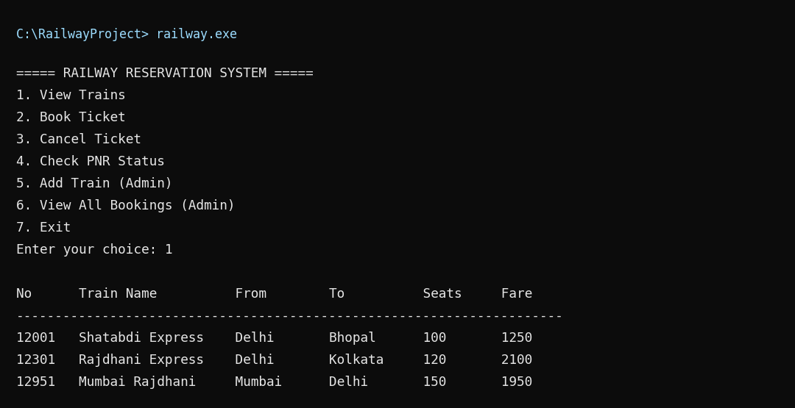
Fig 8.1 : Main menu and list of trains
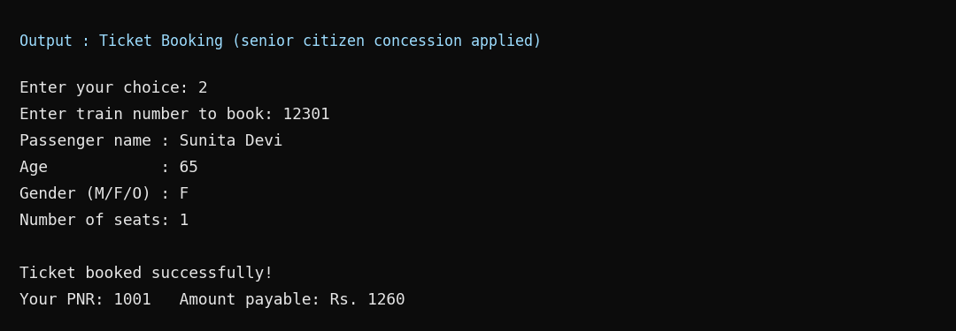
Fig 8.2 : Booking a ticket
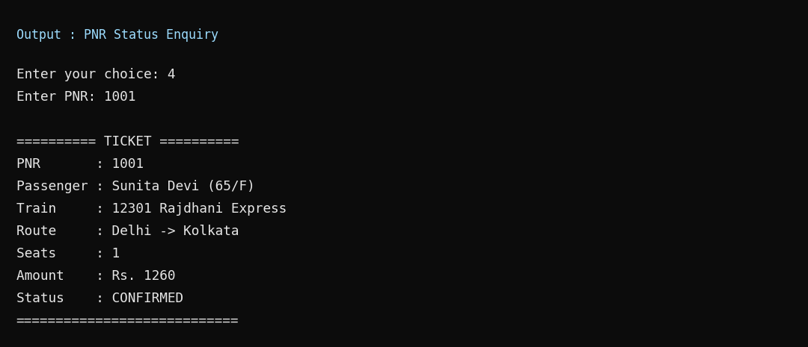
Fig 8.3 : PNR status enquiry
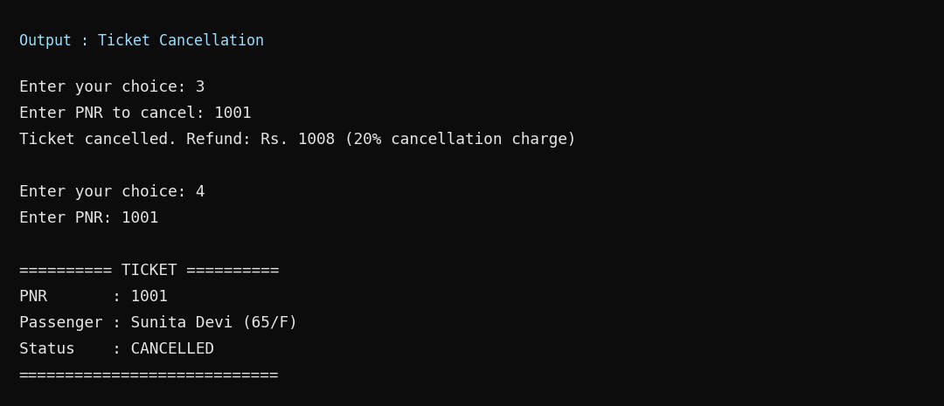
Fig 8.4 : Cancelling a ticket

9. LIMITATIONS, FUTURE SCOPE AND CONCLUSION

9.1 Limitations
- The program is console based and has no graphical user interface.
- There is no login; admin options are available to every user.
- Seat or berth numbers, travel dates and different classes (Sleeper, AC) are not handled.
- A waiting list is not maintained; booking fails when seats are not available.
- Data is stored in simple text files, so it is not suitable for many users at the same time.

9.2 Future Scope
- Adding user and admin login with passwords.
- Adding journey date, class of travel, berth allocation and a waiting / RAC list.
- Searching trains by source and destination station.
- Using a database such as MySQL or SQLite instead of text files.
- Developing a graphical interface using Qt or a web based version.
- Integrating online payment and sending the ticket by e-mail or SMS.

9.3 Conclusion
The Railway Reservation System has been successfully designed, developed and tested using C++. It performs all the basic operations of a reservation counter: showing trains, booking, cancellation, PNR enquiry and train management. The project made use of classes, objects, STL vectors, string streams and file handling, and gave practical experience in analysing a problem, designing the solution, coding and testing it. The system reduces manual work, avoids calculation errors and keeps the data safe in files. With the suggested enhancements it can be developed into a more complete reservation application.

BIBLIOGRAPHY
- E. Balagurusamy, “Object Oriented Programming with C++”, McGraw Hill Education.
- Bjarne Stroustrup, “The C++ Programming Language”, Addison-Wesley.
- Yashavant Kanetkar, “Let Us C++”, BPB Publications.
- Sumita Arora, “Computer Science with C++”, Dhanpat Rai & Co.
- cppreference.com – C++ language and standard library reference.
- IRCTC official website (www.irctc.co.in) – for understanding the reservation process.
- GeeksforGeeks (www.geeksforgeeks.org) – C++ file handling and STL tutorials.

