**Dimension & Measure**

Dimension & Measure you can generate endless amount of amount of insights from any projects from any data sets.

Usually by looking any dataset in any project so you have like multiple columns and rows the data always splitted into two categories either a dimension or a measure.

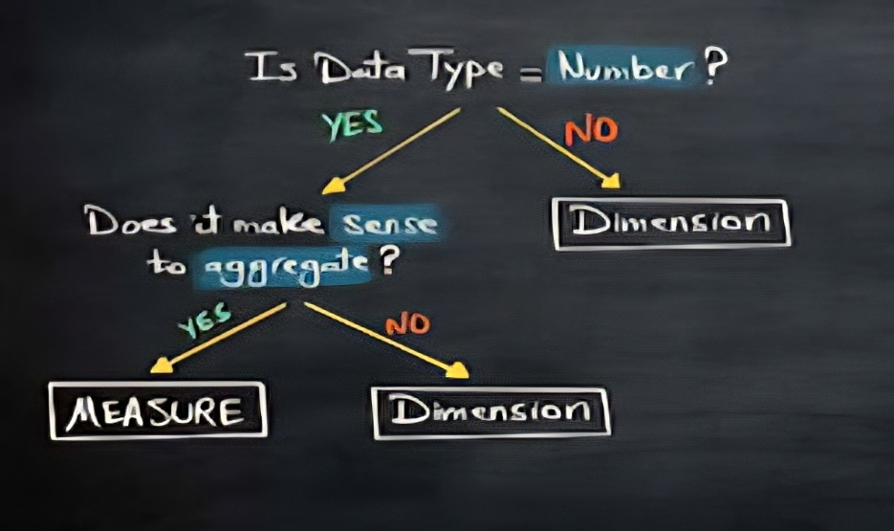

**EDA**

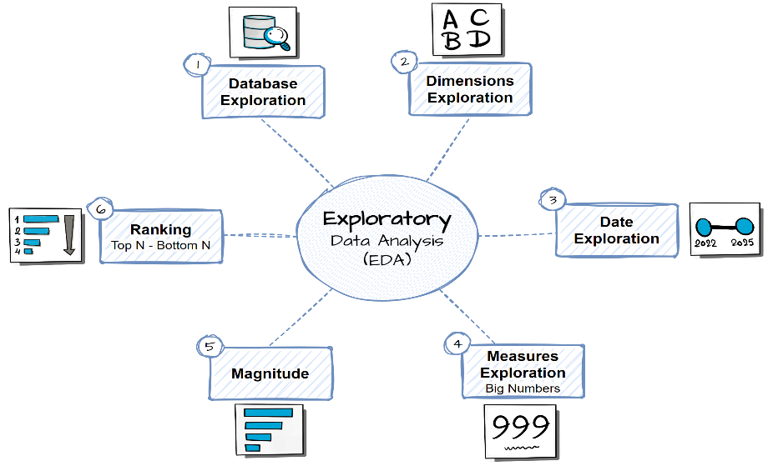

**1 - Database Exploration:-**

First I explore the structure of the database just to have basic understandings about the database tables and the views, columns.

**2 – Dimensions Exploration**

Identifying the unique values (or categories) in each dimension that have inside of our database this can help us what are the categories. Recognizing how data might be grouped or segmented, which is useful for later analysis.

**3- Date Exploration da**

Identify the earliest and latest dates (boundaries). Understand the scope of data and the timespan. By using [MIN/MAX] and DATEDIFF for difference

**4 – Measures Exploration**

Calculate the key metric of the business (Big Numbers). Highest Level of Aggregation | Lowest of Details.

Generate Report that shows all key metrics of the business.

**5 – Magnitude Analyses**

Compare the measure values by categories. It helps us understand the importance of different categories. [Measure] By [Dimension]

**6 – Ranking (Top N – Bottom N)**

Order the value of dimensions by measure in order to identify the “Top N performers | Bottom N performers”. [Dimension] By [Aggregated Measure]

**Advance Analytics**

**7 – Change-Over-Time Trends**

It is a technique in order to analyze how a measure evolves over time this is very important in order to track the trends seasonality in your data.

[Aggregate Measure] By [Date Dimension]

Total Sales By Year | Average Cost By Month

**8 – Cumulative Analysis**

Aggregate the data progressively over time. Helps to understand whether our business is growing or declining. [Cumulative Measure] By [Date Dimension]

Running Total Sales By Year | Moving Average of By Month

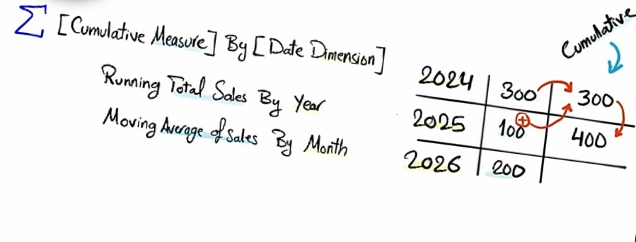

Different between ‘Normal Aggregation’ and ‘Cumulative Aggregation.

We use normal aggregation in order to check the perfomance of each individual row like –

Each year perfoming. But if you eant to see a progression you want to understand hoew your business is growing you have to go and use cumulative aggregation because you can see the progress of business over the years or months.

**9 – Perfomance Anal**

It is process of Comparing the current value to a target value. This can help us in order to measure success and compare performance.

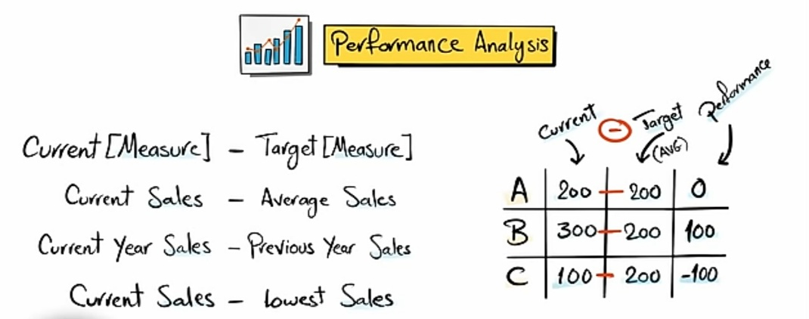

**10 – Part-to-Whole Proportional Analysis**

Analyze how an individual part is performing compared to the overall, allowing us understand which category has the greatest impact on the business.

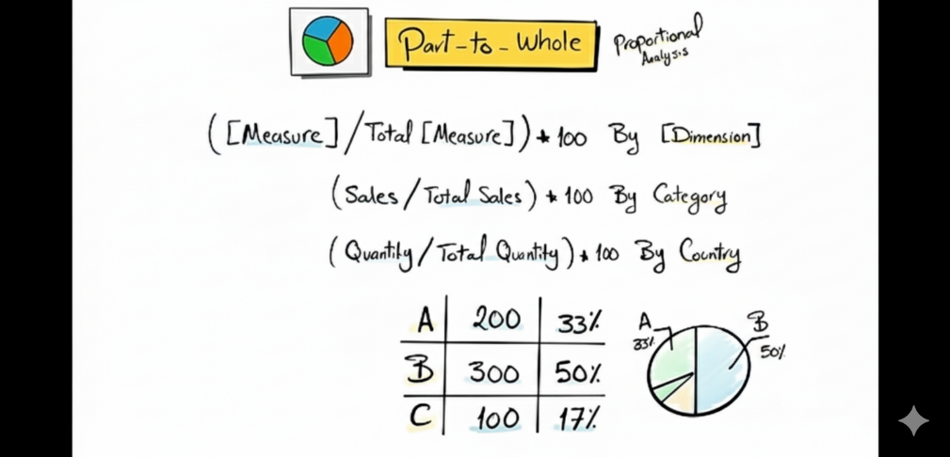

**11 – Data Segmentation**

Group the data based on a specific range. Helps understand the correlation between two measures.

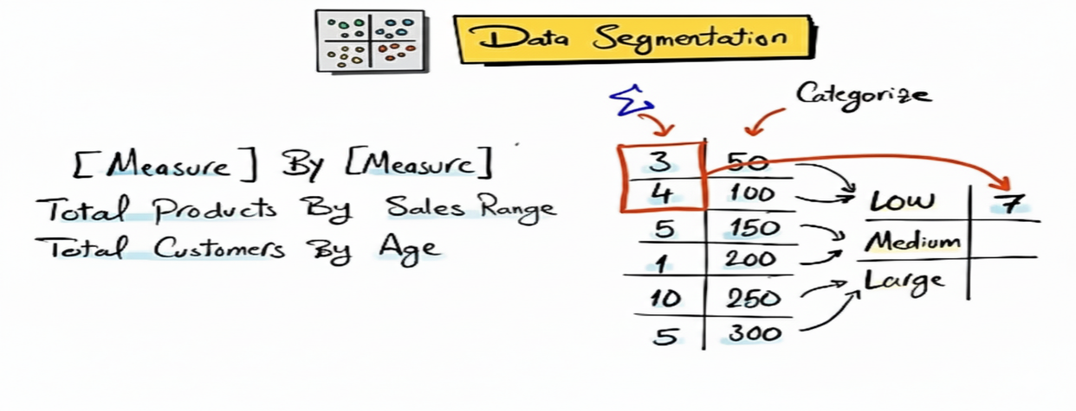

**12 – Reporting**

Collect all the different types of Explorations and analyses that I have done in my dataset. Everything put in one place for e.g. view or table and then offer it to other users.

