About Me

Amanda Cicchino

Table of Contents

# Who I am and where I came from

I grew up in the suburbs about an hour north of Toronto. I was focused and engaged in my schooling throughout high school, but was even more focused and engaged in the sports I was playing. I played club basketball throughout the year and always had at least one Varsity sport going on. Those were the days… But when my friends and former teammates who had moved on and were playing ball in university/college started getting injured, losing their scholarships, and dropping out, I made the decision to go to university for the education and focus all my energy on my studies. No more basketball.

During Orientation at [Queen’s University](https://biology.queensu.ca/), I ran into an older friend from high school and she convinced me (I’m sure that was hard to do) to attend the walk-on tryouts for a Queen’s Varsity team. It was Ultimate, not basketball, so *technically* I wasn’t breaking the rule I made. And just like that I returned to my old ways: focused and engaged in my schooling, but was even more focused and engaged in Ultimate. I played **a lot** of Ultimate. Playing Varsity was great, but as I continued in my degree it became more like off-season training for the club team I was playing on. Cue even more Ultimate. I am grateful for the absolutely amazing experiences I had playing for Queen’s (where we book-ended National golds during my playing career) and for my club team (2 National bronzes and 2 Pan-Am invitations!), but I am even more grateful that I learned the art of ***balance*** during my tenure at Queen’s. I had been offered an Honour’s thesis project in the [Lougheed lab](https://sclougheed.ca/) and developed a project on call evolution of the spring peeper. I continued this project during my Master’s in the Lougheed lab, but became increasingly influenced by the outstanding Fran Bonier, and thus found myself incorporating plasticity in mating behaviors and their physiological consequences into my Master’s. Fran became an important mentor for me, and she ended up connecting my with Chris Funk. As I made the decision to leave my life as I knew it back home and move to the (Scary) USA for (even scarier) PhD, I made myself 1 promise: career comes first. No basketball. No Ultimate. Just ***balance***. So here I am, 5 years in and wondering if I even know what ***balance*** means.

My PhD under Funk’s supervision has been predominantly focused on thermal physiology, but I’m interested in integrating -omic tools into my research and so was motivated to take this class.

Outside of work, I enjoy:

1. Being active through sports
   1. Rock-climbing
   2. Basketball
   3. Ultimate
2. Cooking (not baking)
3. Being outside (when it’s warm)
4. Spending time with other people’s pets (see picture below of me with Jason Dunham’s dog, Moxie)

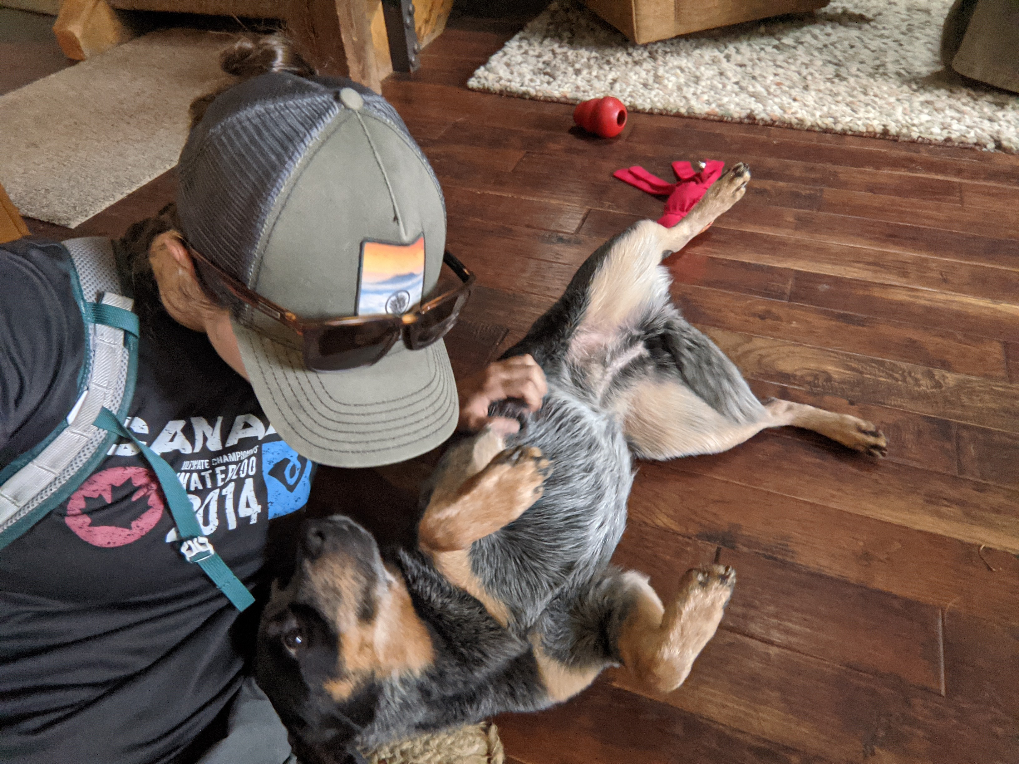

# Research Interests

I am broadly interested in understanding trait evolution using integrative approaches from physiology, genomics, and behaviour.

## Influential papers

In the last year or so, I have thought critically about the research I am doing thanks to an influential TREE paper by Clusella-Trullas et al. (2021) and have been inspired to continue moving into extreme climatic event research due to this Kingsolver, Malinski, and Parker (2021) paper.

## The mathematics behind my research

One of the equations that I often use in my research is that to estimate acclimation capacity of a physiological trait given its dual temporal relationship with temperature. I am pretty certain this is Kristen Ruegg’s favourite equation.

First, acclimation responses are estimated as the slope of the acclimation (holding) reaction norm:

The slope of the reaction norm due to experimental testing treatments (acute temperature effects) is then estimated for each acclimation/holding treatment:

And the absolute of the difference is used as the estimate of acclimation capacity:

## My computing experience

Most of my experience is in R. I dabbled a bit in Unix when I first took this class, but honestly remember very little (it’s not you, it’s Covid).

Here is an R chunk from a script I have to test my code for a leave-one-out cross-validation

#simulate data  
set.seed <- 20  
Npops <- 10  
n <- 15  
pop <- rep(1:Npops, each = n)  
streamT <- runif(Npops, 8, 18)  
streamT <- rep(streamT, each = n)  
#population random effects  
ran_effs <- rnorm(Npops, mean = 0, sd = 1.5)  
ran_effs <- rep(ran_effs, each = n)  
#shared slope and intercept across populations  
slope <- 2  
intercept <- -10  
  
means <- ran_effs + rep(slope, n*Npops) + slope*streamT  
  
random_error <- rnorm(n*Npops, mean = 0, sd = 0.5)  
#create the observed response  
UTL <- means + random_error

In this next chunk, I just grabbed some python code from the internet that says hi and adds two numbers.

print ("Hello there!")  
print("Sum of {0} and {1} is {2}" .format(num1, num2, sum))

## What I hope to get out of this class

* Comfort working in Unix and using SUMMIT
* Background knowledge and skills to be able to lead a genomic study
* Confidence in my ability to learn how to code

# Evaluating some R code

library(tidyverse)  
  
y<- rnorm(4000, 6.6, 0.7)  
x<- rnorm(4000, 8.5, 1.2)  
blue<-tibble(x,y)  
blue

## # A tibble: 4,000 x 2  
## x y  
## <dbl> <dbl>  
## 1 10.0 5.95  
## 2 10.6 5.88  
## 3 7.24 5.86  
## 4 9.32 5.86  
## 5 8.79 6.30  
## 6 10.4 6.20  
## 7 9.60 7.77  
## 8 6.88 8.07  
## 9 9.20 6.39  
## 10 7.59 6.72  
## # ... with 3,990 more rows

ggplot(blue,aes(x,y)) +  
 geom_point(color="blue")+  
 theme_classic()

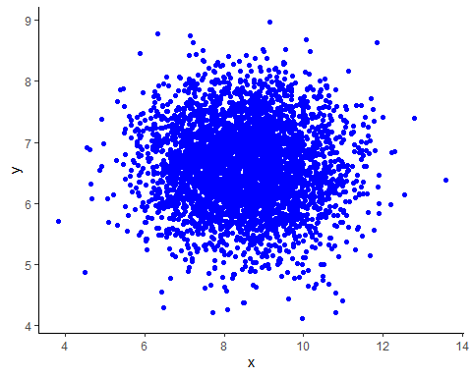 # Citations

Clusella-Trullas, Susana, Raquel A Garcia, John S Terblanche, and Ary A Hoffmann. 2021. “How Useful Are Thermal Vulnerability Indices?” *Trends in Ecology & Evolution* 36 (11): 1000–1010.

Kingsolver, Joel G, Katherine H Malinski, and Anna L Parker. 2021. “Connecting Extreme Climatic Events to Changes in Ecological Interactions.” *Functional Ecology* 35 (7): 1382–84.