[Date]

Amanda Giangiulio Wanderley ID: 2019004927

SSouthern Institute of technology

Easy appointments documentation

backend

Contents

Calendar 2

Customer 6

Services 9

Categories 13

Providers 14

Settings 18

# Calendar

This is the Calendar page, where you can see all the appointments

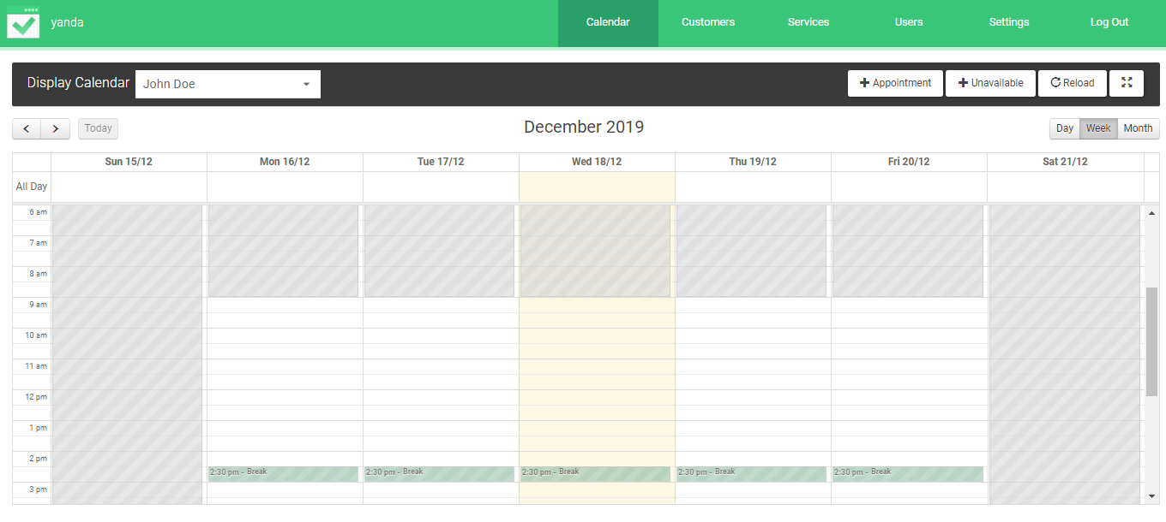

1. The arrow allows you to go to the previous or next day/week/month;
2. When you click on the “today” button, the today`s date is selected
3. The dropdown allows you to see the appointments of the provider or service
4. Gives you the option to see the appointments of the day, week, or month

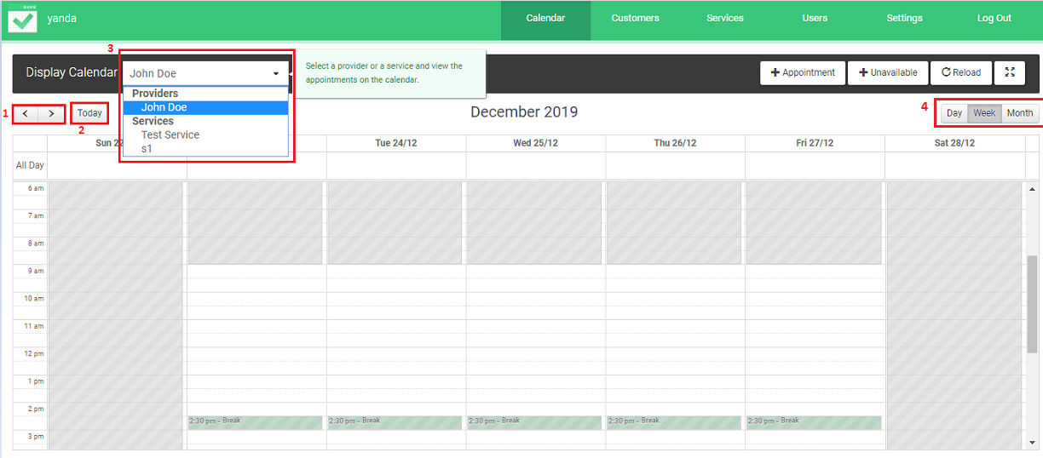

You can edit or delete an appointment by clicking on them through the calendar page:

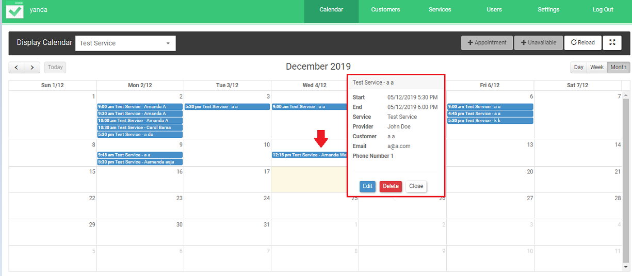

To add and appointment follow the steps bellow

1. Click on Appointments button 

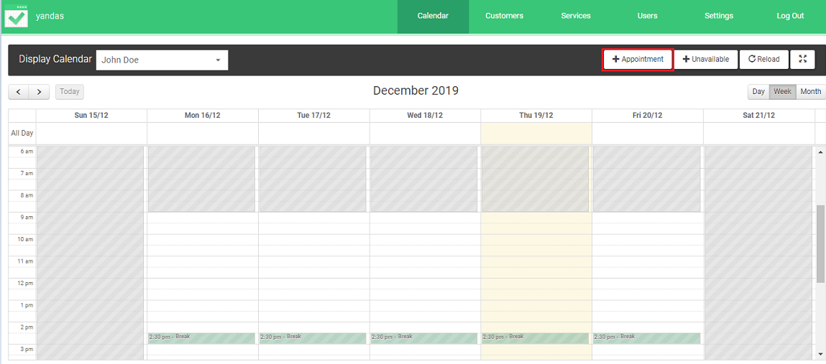

1. Fill all required fields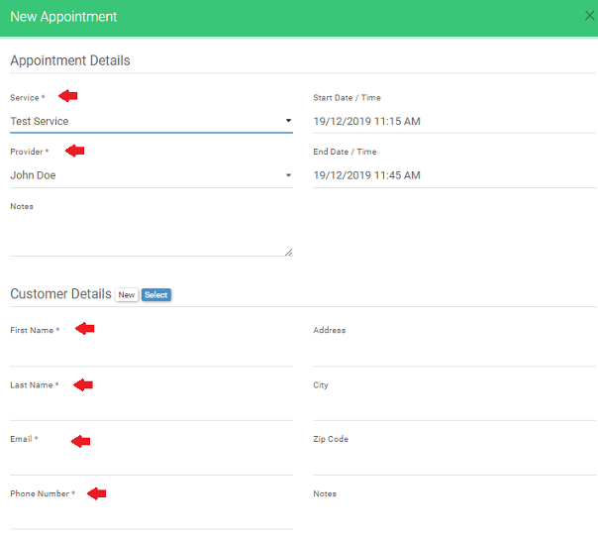
2. If you want to select a customer instead of creating one, click on Select . And then select the customer you want:

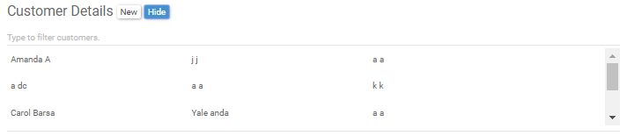

1. Then click on Save button on blue  if you want to save or Cancel button  to cancel the appointment

To select a date you will not be able to work, click on unviable button .

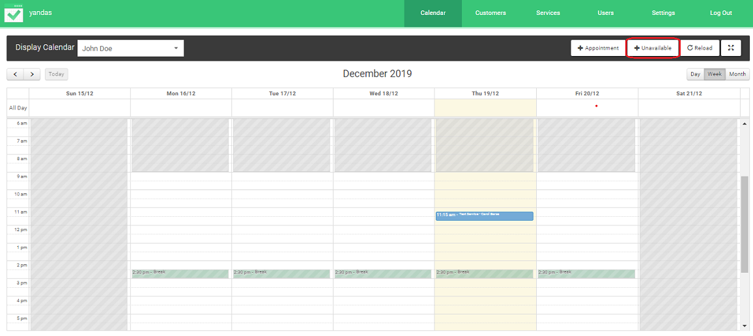

And select the days and write any note if you would like and hit the button Save or Cancel.

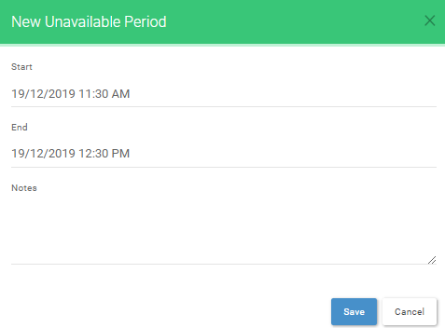

Finally, the Reload button  reloads the page to see if there is any update and if you want full screen just hit this button 

# Customer

On the customers page, you have the option to Add, Edit, Delete or Search a customer:

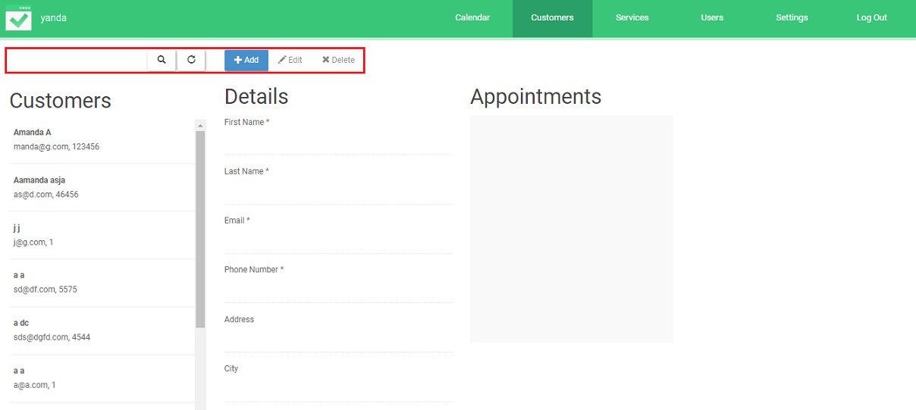

To Add a customer, just click on the Add button on blue and then fill all the requested fields, all the other fields are optional. Then just hit the Save button to finish adding a new customer. Or hit the Cancel button beside it to cancel adding a customer.

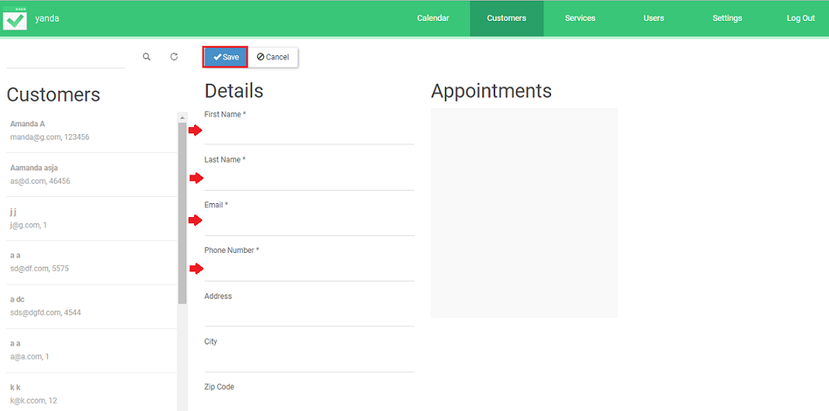

To edit a customer, follow these steps:

1. Select the customer you want to edit;
2. Click on the Edit button next to de Add button
3. Edit the information on the fields
4. Shos all the appointments this customer made

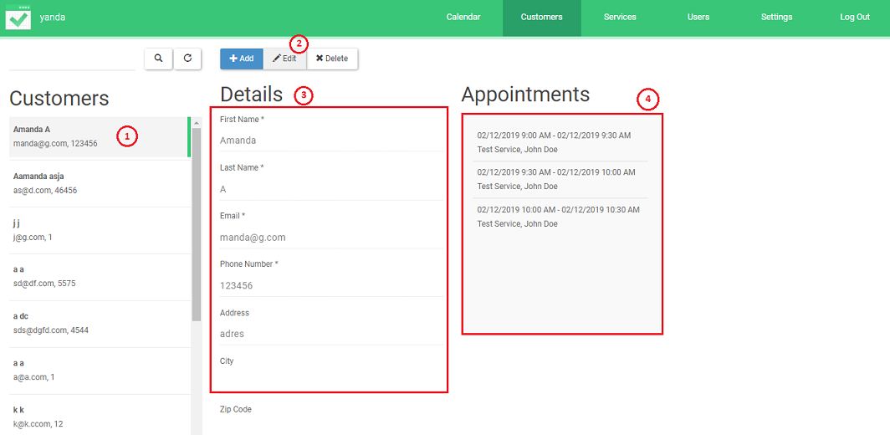

Then just click on Save button on blue or Cancel to stop editing



To delete a customer, click on the customer you want to delete and then hit the delete button

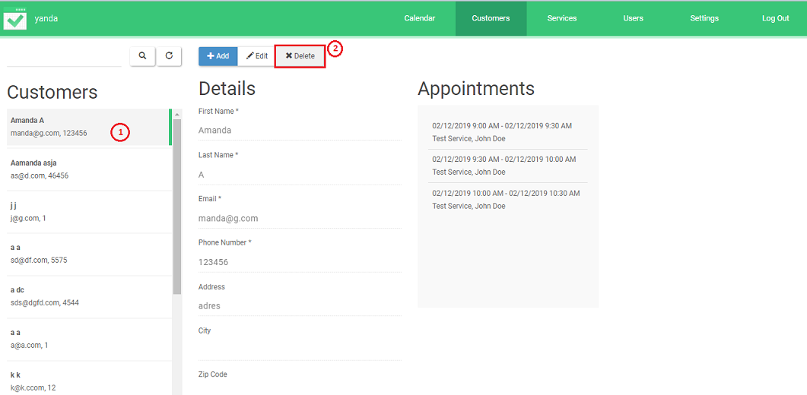

A delete confirmation message will show up. Just click on delete if you are sure you want to delete the customer or click on cancel if you are not sure.

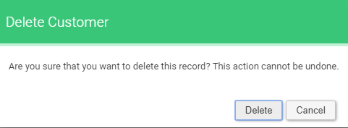

# Services

This is the service page. 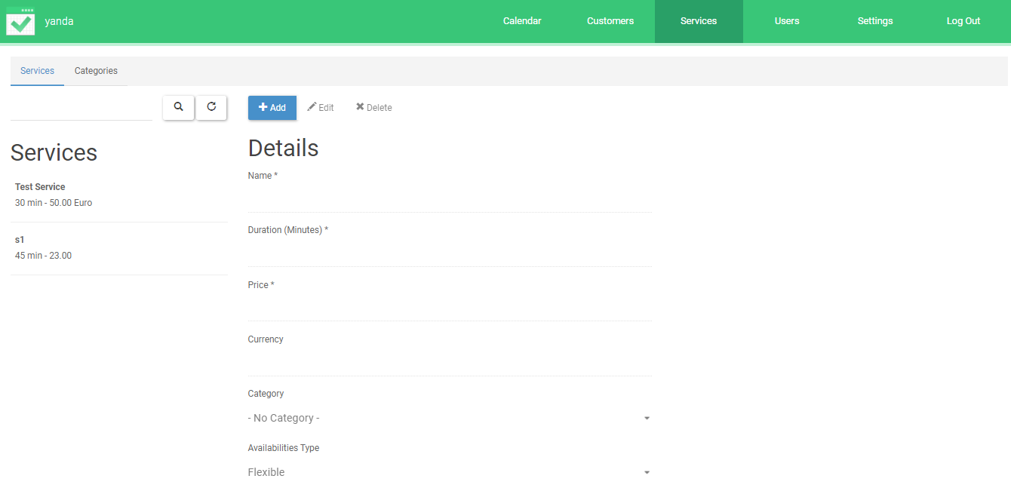

You can Add, Edit, Delete or search for a service using these: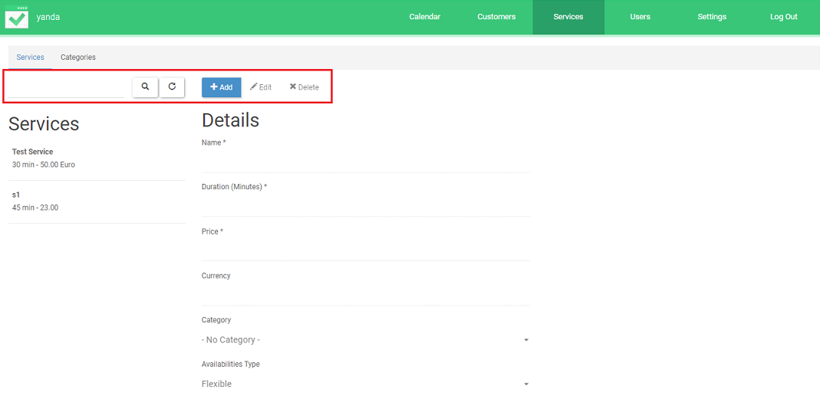

To add a service, click on the Add button on blue and fill all the requested fields

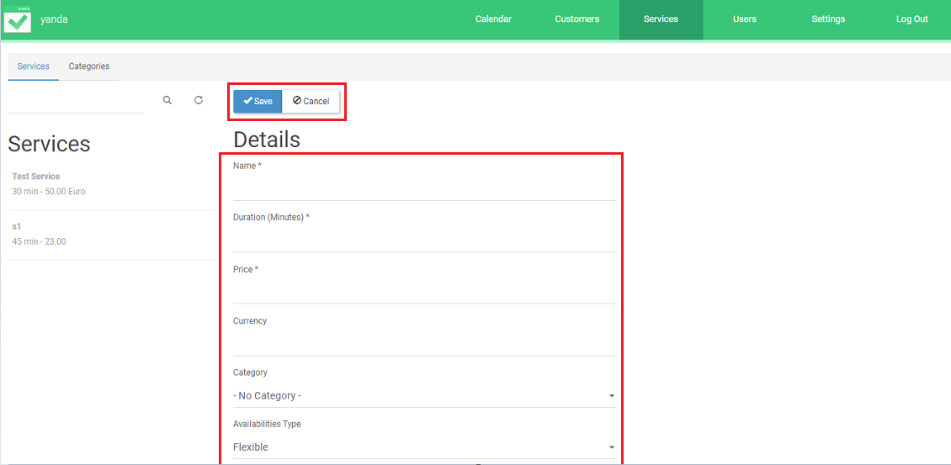

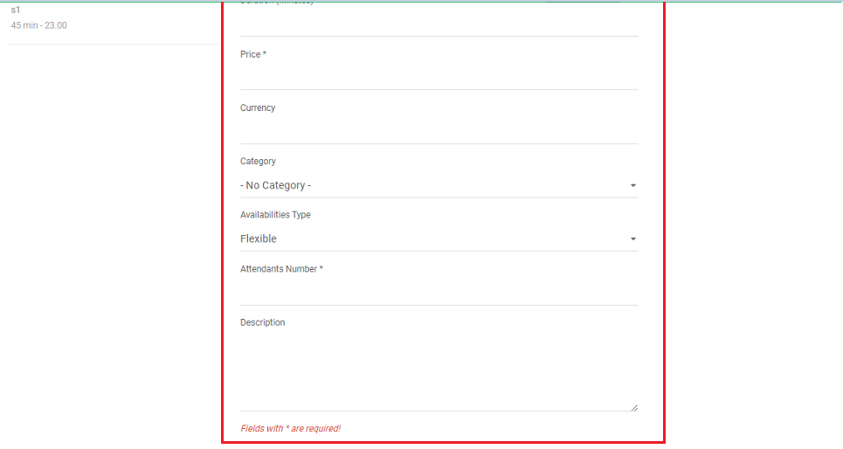

Then if you are happy click on Save button, but if you want to cancel the service just click on Cancel button



To edit a service, follow the steps below

1. Select the service you want to edit
2. Click on the Edit button
3. Edit the information on the fields

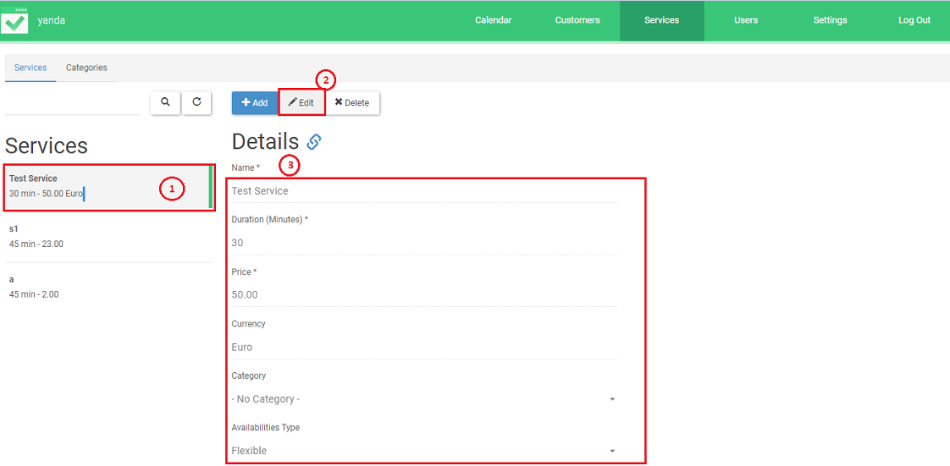

If you are satisfied with the changes click the Save button on blue, if you are not, just click on Cancel button



To delete a service, select the service you want to delete and hit the delete button:

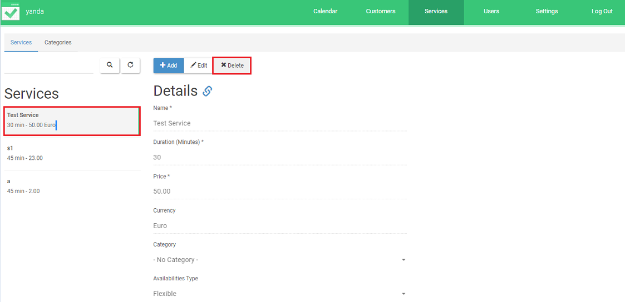

A message will popup. Click on Delete if you are sure you want to delete the service or click on Cancel if you are not sure.

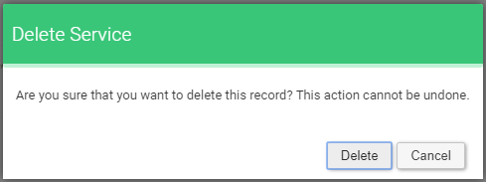

# Categories

This is the categories page.

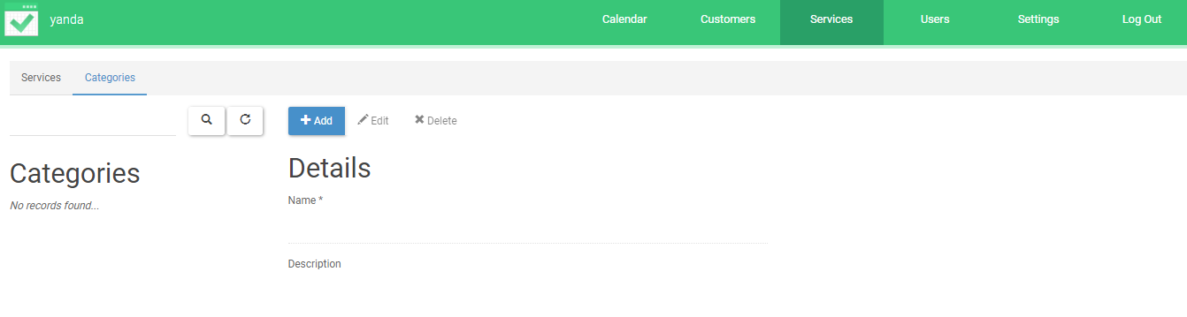

Here you can Add, Edit, Delete and search for a category using these 4 buttons:

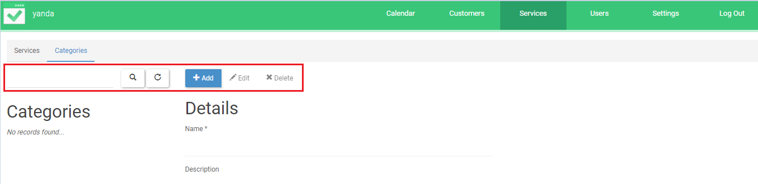

Click on Add button on blue to add a category. Then fill all the required fields (the others are optional) and click on Save button on blue or Cancel button to cancel.

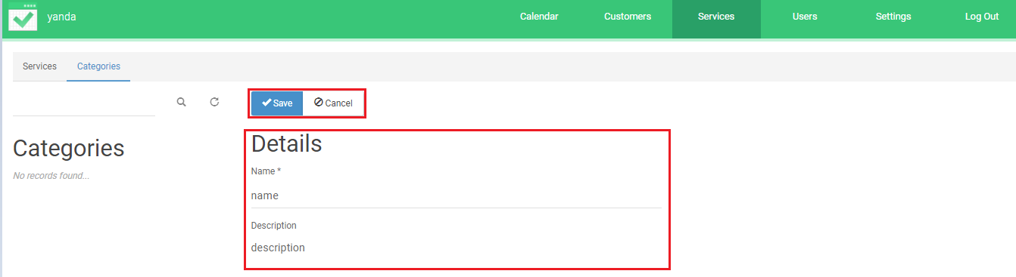

# Providers

The providers page lets you add, edit, delete and search for providers. You can also see the Details of each provider and their working plan

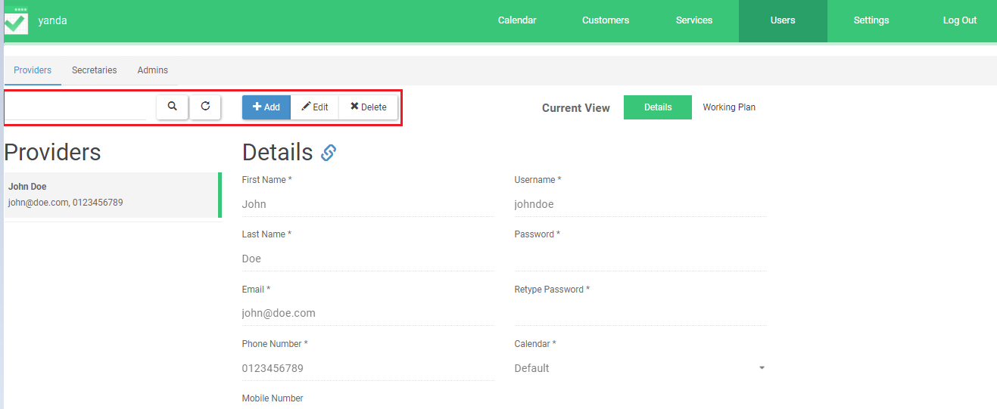

Just like the others, to add a provider just click on the Add button. Fill all the required fields and then scroll down the page to select what services this provider will execute.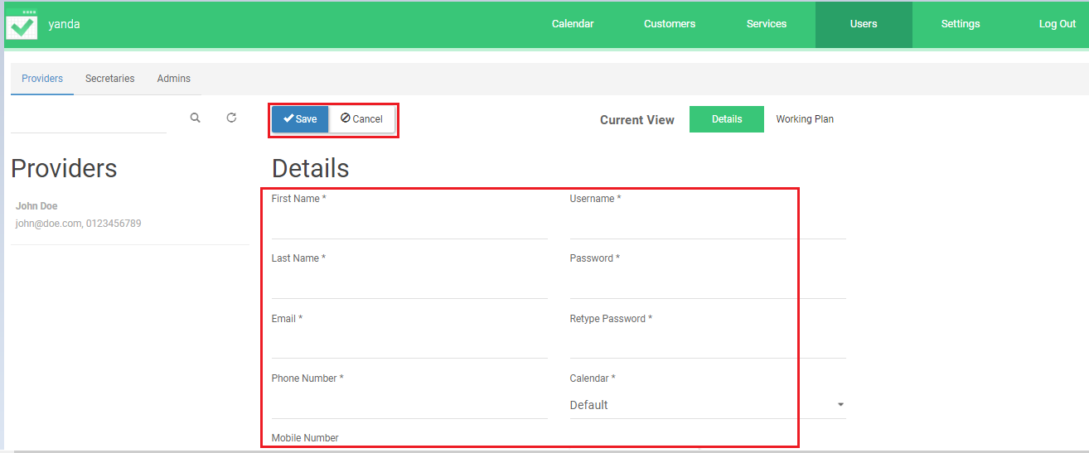 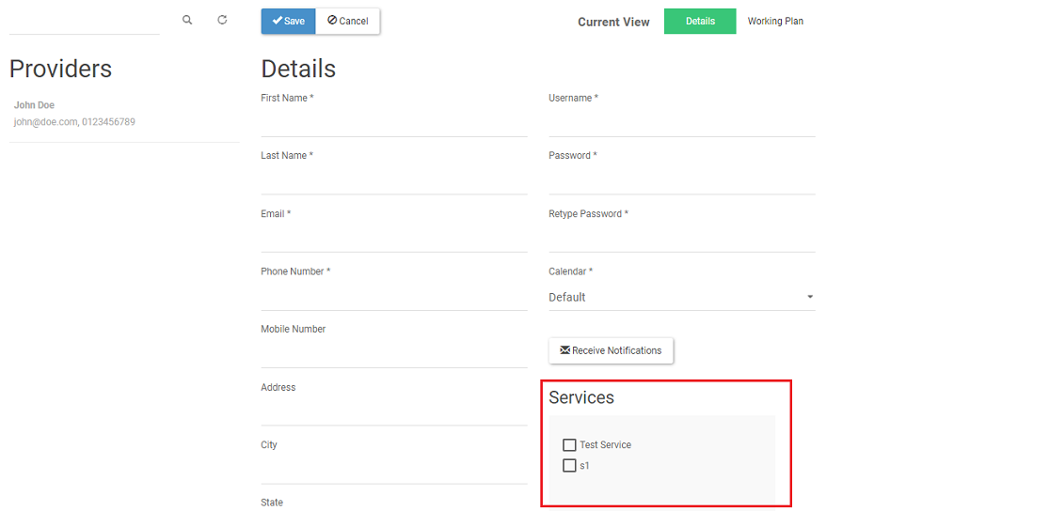

Then click on Working Plan option to select the days this provider will work 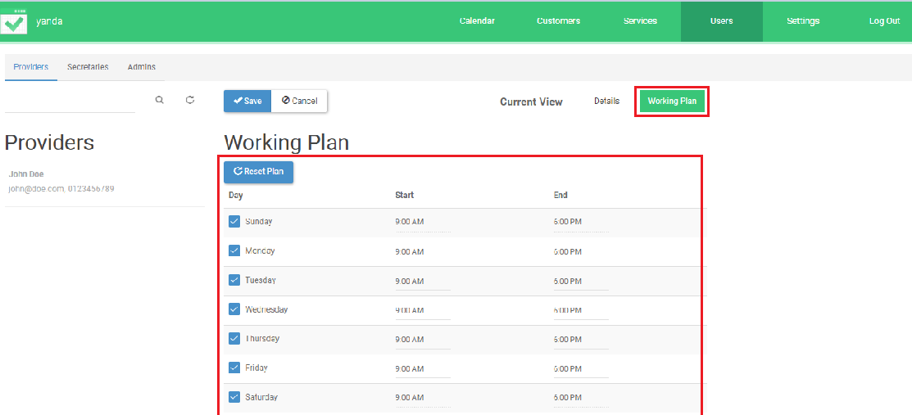

Then scroll down the page to manage the breaks

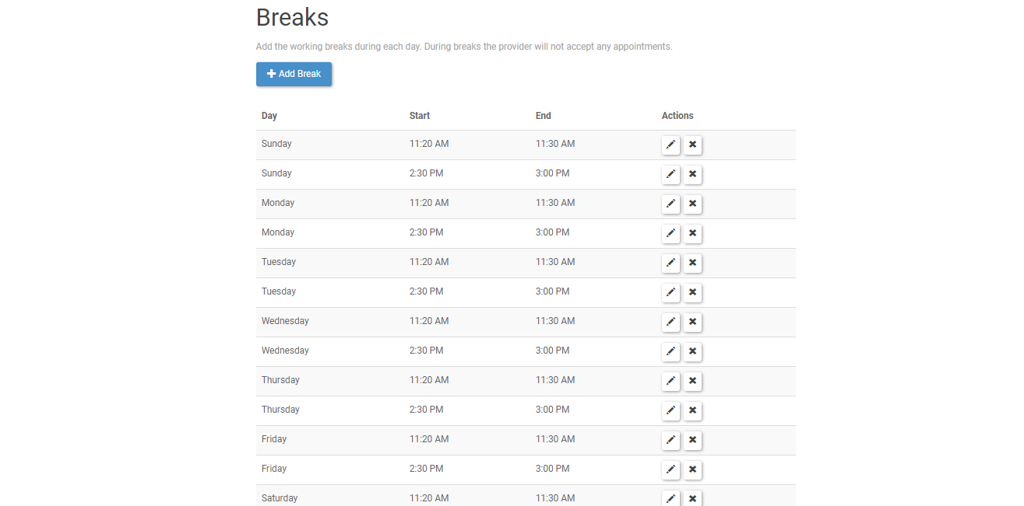

When finish just click on the Save button on blue or the Cancel button



To edit or delete a provider

1. Select the provider
2. Click on Edit if you want to edit it
3. Click on Delete if you want to delete it

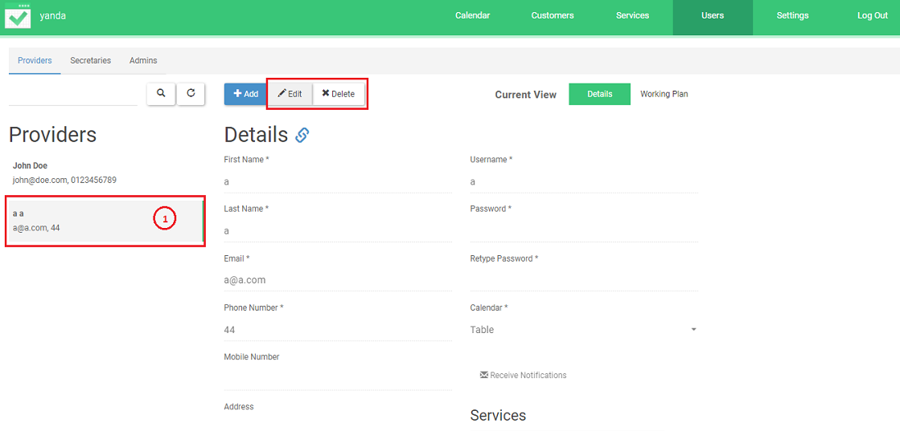

The Secretaries and Admin pages work in the same way as the Provider page



Just make sure when editing or adding a new secretary to select the provider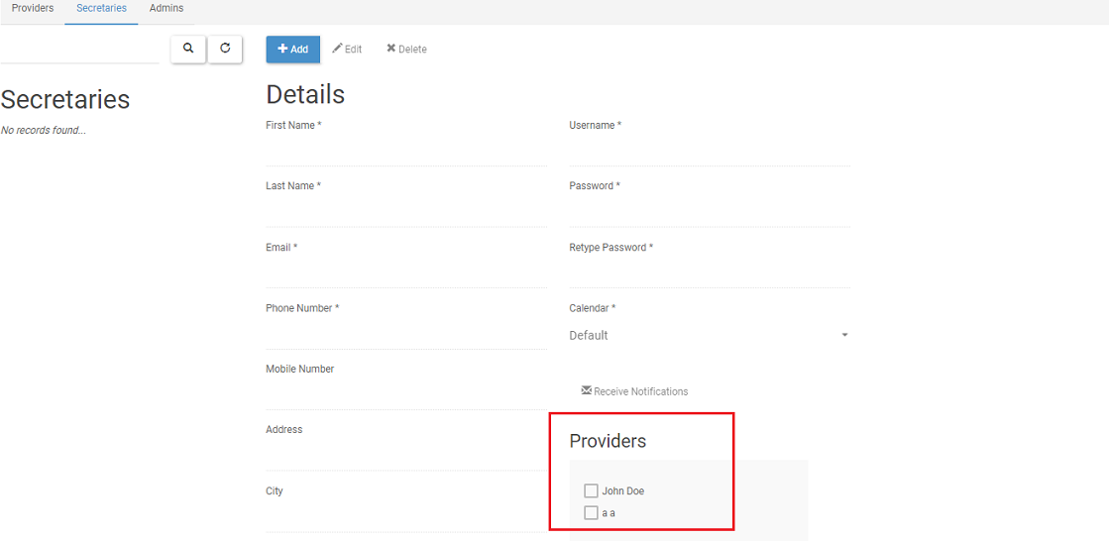

# Settings

General page allows you to change any information and save them. 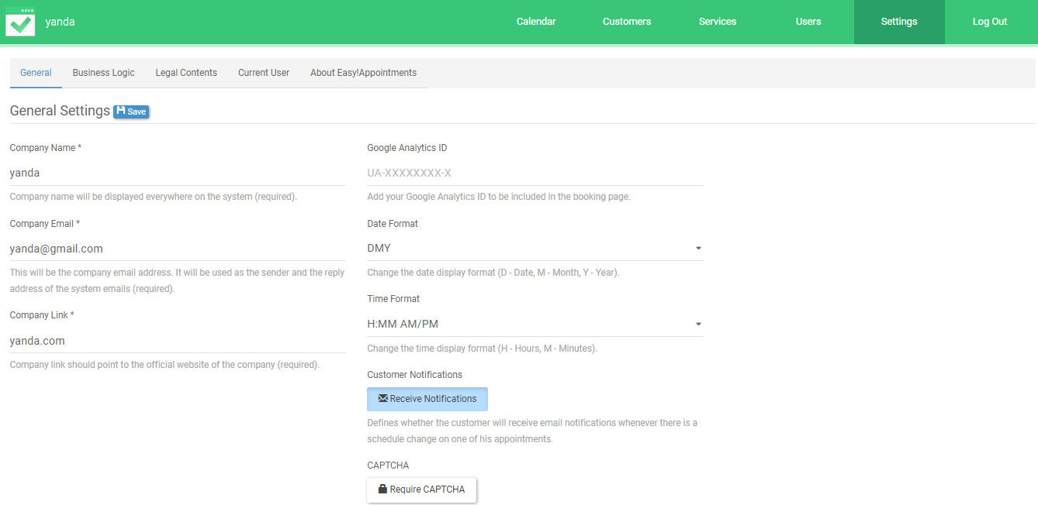

Business Logic lets you decide the working days, schedule and breaks. Click on the blue boxes  to select the days you will work and  if you want to edit the breaks.

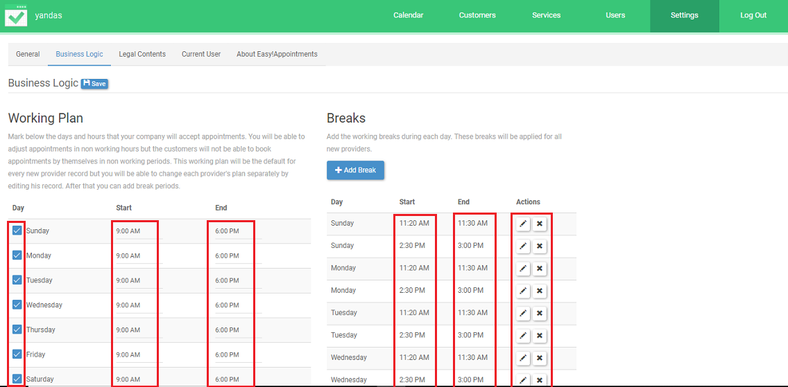

Legal Contents is a page where you can write Cookie Notices, Privacy Policy and Terms & Conditions. To add them, just click on the square  under each title and write what you want in the big box. Then just click on .

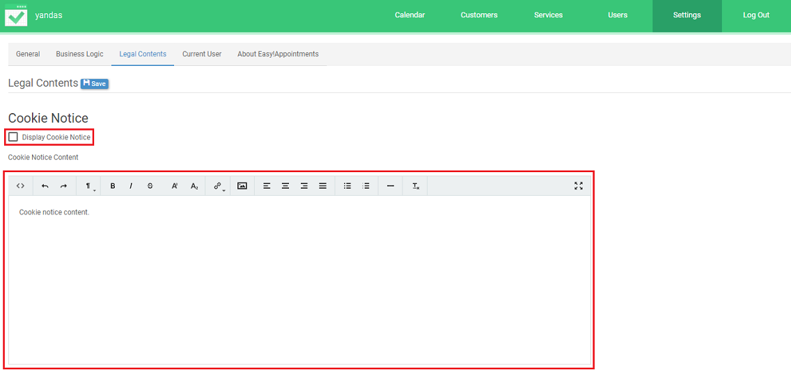

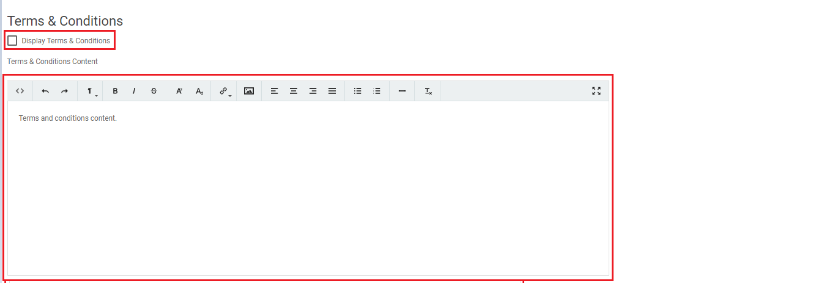

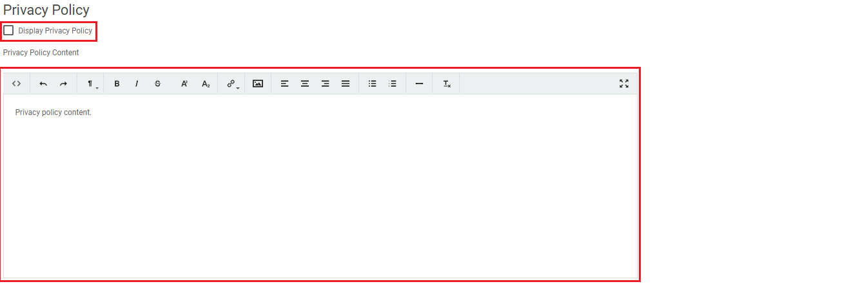

You can change your personal information on Current User. Make all the changes you want then hit the blue button Save 

