Amanda Sherman

11/13/2022

Module 5.2 Assignment

Bellevue University

The MySQL function datediff() returns the number of days between two date values. This could be used when calculating how many days it has been since starting a project, or how much older someone is.

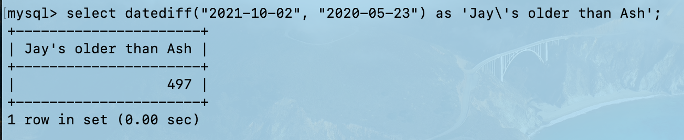

The MySQL function weekofyear() returns the week number for a given date. This could be used to find the week of the year someone was born, or any significant date that you need to know week of the year.

The MySQL function dayname() returns the weekday name for a given date. This can be used to find out what day someone was born, or what day a specific even was held on, or what day a specific holiday is.