Amanda Sherman

11/20/2022

Module 6.2 Assignment

Bellevue University

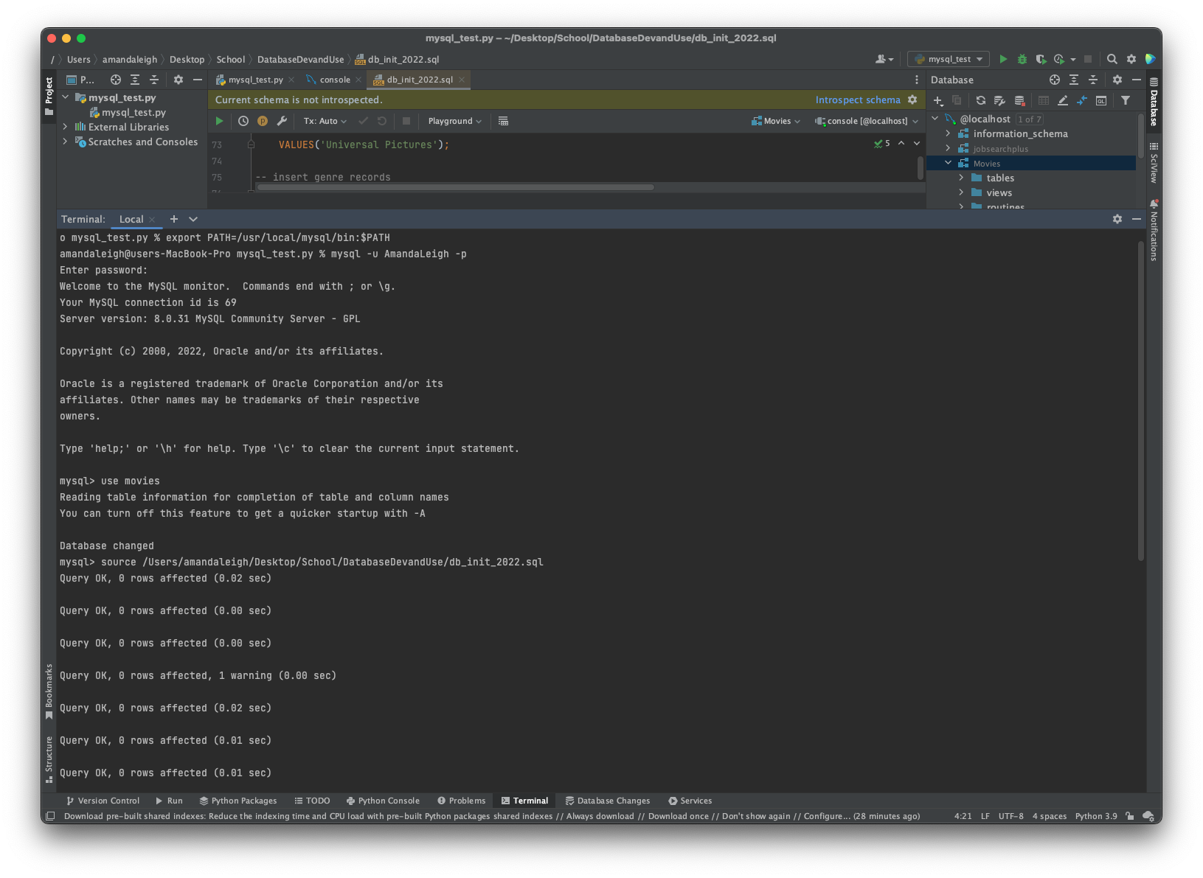

https://github.com/AmandaSherman/csd-310.git