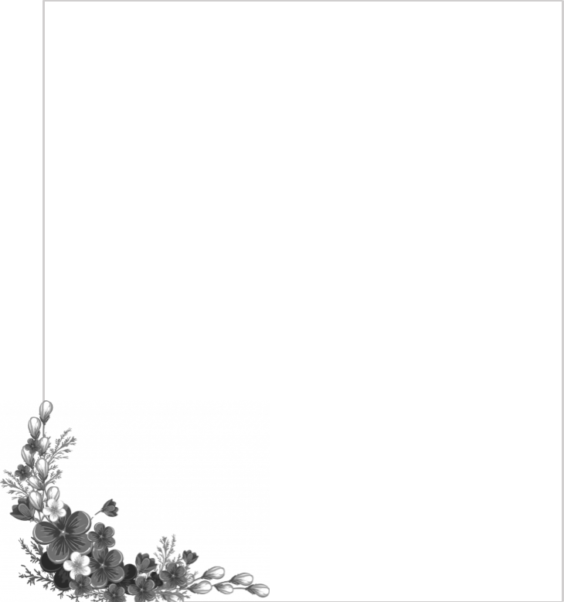


Panduan acara
Akad & Resepsi Pernikahan

{{groom_name}}
{{groom_birth_order}}
{{groom_parents}}

-&-

{{bride_name}}

{{bride_birth_order}}
{{bride_parents}}

{{event_date_label}}
{{venue_label}}
{{event_time_label}}

by JWS Wedding


VENDORS

{{#vendors}}
{{~category}}

{{~vendor}}
{{~spacer}}
{{/vendors}}

ORGANIZED BY
JWS WEDDING
{{wo_contact}}

LIST NAMA

KETERANGAN | NAMA PIC | KET
{{#roles}}{{role_label}} | {{person_name}} | {{note}}{{/roles}}

PANITIA KELUARGA

 | NAMA PIC | KETERANGAN
{{#committees}}{{role_label}} | {{person_text}} | {{job_desc}}{{/committees}}

DATA LAINNYA

{{siblings_groom}}

Adik/Kakak Pengantin Pria

{{siblings_bride}}

Adik/Kakak Pengantin Wanita
*harap diisi dengan penulisan nama lengkap

{{#menuStall}}  {{~heading}}  - {{~numbered}}  - {{~plain}}  {{/menuStall}} | {{#menuBuffet}}  {{~heading}}  - {{~numbered}}  {{~plain}}  {{/menuBuffet}} | {{#menuAfterAkad}}  {{~heading}}  - {{~numbered}}  {{~plain}}  {{/menuAfterAkad}}

Souvenir | {{souvenir_note}}
Table Cloth | {{table_cloth_note}}

LIST & RUANGAN MAKEUP

RUANGAN | KETERANGAN
{{#makeupRooms}}{{room_label}} | {{#makeupLines}}  {{~heading}}  - {{~numbered}}  - {{~dash}}  {{~note}}  {{/makeupLines}}{{/makeupRooms}}

SUSUNAN ACARA AKAD DAN RESEPSI

NO | WAKTU | ITEM | PIC | KETERANGAN
{{#itemsAkad}}{{no_label}} | {{time_label}} | {{item}} | {{pic}} | {{note}}{{/itemsAkad}}

SUSUNAN ACARA RESEPSI

NO | WAKTU | ITEM | PIC | KETERANGAN
{{#itemsResepsi}}{{no_label}} | {{time_label}} | {{item}} | {{pic}} | {{note}}{{/itemsResepsi}}

LAYOUT AKAD



KETERANGAN :
{{#layoutRules}}
- {{~rule}}
{{/layoutRules}}

KETERANGAN LAYOUT AKAD

NOMOR | KETERANGAN
{{#layoutLegend}}{{number_label}} | {{content}}{{/layoutLegend}}

LIST FOTO TAMU
{{couple_title}}
No. | Nama Keluarga/Group/Instansi
{{#photoGroups}}{{number_label}} | {{group_name}}{{/photoGroups}}

LIST TAMU VIP
{{couple_title}}

No. | Nama Lengkap & Gelar | JABATAN
{{#vipGuests}}{{number_label}} | {{full_name}} | {{position}}{{/vipGuests}}

PLAYLIST REQUEST LAGU
{{couple_title}}

No | Judul Lagu | Penyanyi
{{#playlist}}{{number_label}} | {{title}} | {{artist}}{{/playlist}}

{{#playlistNotes}}
{{~note}}
{{/playlistNotes}}

