Task 1:

use database SHOPPING;
Create table shopping_history
( Product varchar not null ,
Quantity int not null,
unit_price int not null
);
Insert into shopping_history (Product, Quantity, unit_price)
values('Milk',3,10),('Bread',7,3),('Bread',5,2);
Select * from shopping_history;
Select Product, sum(Quantity*unit_price) as Total_Price
From shopping_history
Group by Product
Order by Product DESC

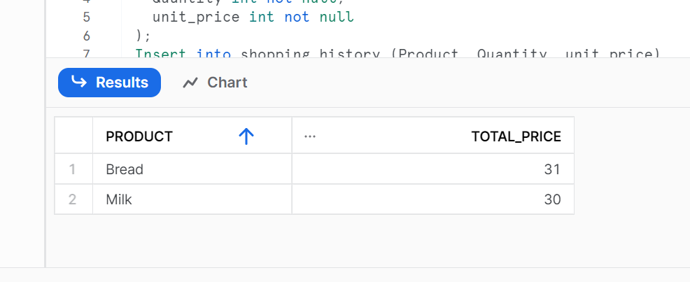
Task 2:

USE DATABASE SHOPPING;
CREATE TABLE phones (
name varchar(20) not null unique,
phone_number int not null unique
);
INSERT INTO phones (name,phone_number)
VALUES('Jack',1234),('Lena',3333),('Mark',9999),('Anna',7582);
SELECT * FROM phones;
CREATE TABLE calls (
id int not null,
caller int not null,
callee int not null,
duration int not null,
unique(id));
INSERT INTO calls (id,caller,callee,duration)
VALUES(25,1234,7582,8),(7,9999,7582,1),(18,9999,3333,4),(2,7582,3333,3),(3,3333,1234,1),(21,3333,1234,1);
SELECT * FROM calls;
Create table caller_calls as
select caller, sum(duration)as caller_duration from calls
group by caller
order by
create table callee_calls as
select callee, sum(duration) as callee_duration from calls
group by callee
order by callee
select * from caller_calls
select * from callee_calls
create table total_duration_table as
select * from caller_calls
left join callee_calls
on caller_calls.caller=callee_calls.callee
create table total_call_duration as
select caller,sum(coalesce(caller_duration,0)+coalesce(callee_duration,0))as total_sum
from total_duration_table
group by caller
select name from total_call_duration
left join phones
on total_call_duration.caller = phones.phone_number
where total_sum>=10
order by name

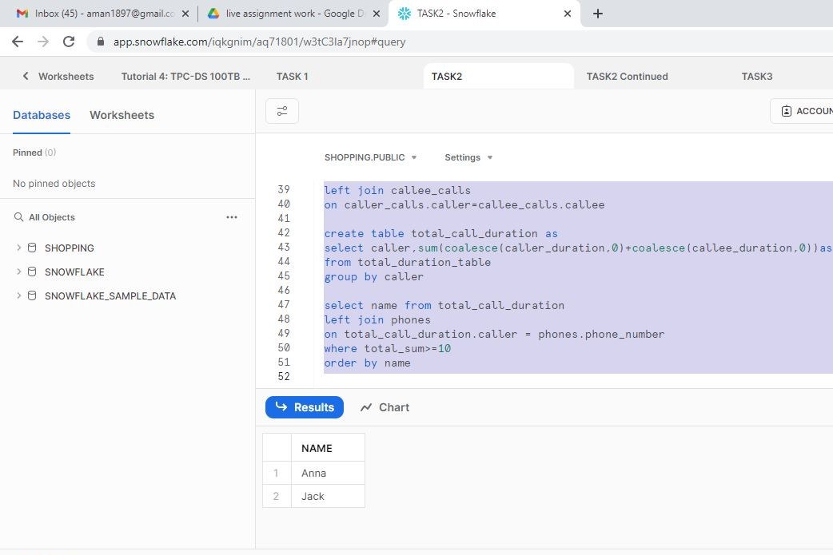
Task 2 Continued:
USE DATABASE SHOPPING;
CREATE TABLE phones_2 (
name varchar(20) not null unique,
phone_number int not null unique
);
INSERT INTO phones_2 (name,phone_number)
VALUES('John',6356),('Addison',4315),('Kate',8003),('Ginny',9831);
SELECT * FROM phones_2;
CREATE TABLE calls_1 (
id int not null,
caller int not null,
callee int not null,
duration int not null,
unique(id));
INSERT INTO calls_1 (id,caller,callee,duration)
VALUES(65,8003,9831,7),(100,9831,8003,3),(145,4315,9831,18);
SELECT * FROM calls_1;
Create table caller_calls_1 as
select caller, sum(duration)as caller_duration from calls_1
group by caller
order by caller
create table callee_calls_1 as
select callee, sum(duration) as callee_duration from calls_1
group by callee
order by callee
select * from caller_calls_1
select * from callee_calls_1
create table total_duration_table_1 as
select * from caller_calls_1
left join callee_calls_1
on caller_calls_1.caller=callee_calls_1.callee
create table total_call_duration_1 as
select caller,sum(coalesce(caller_duration,0)+coalesce(callee_duration,0))as total_sum
from total_duration_table_1
group by caller
select name from total_call_duration_1
left join phones_2
on total_call_duration_1.caller = phones_2.phone_number
where total_sum>=10
order by name
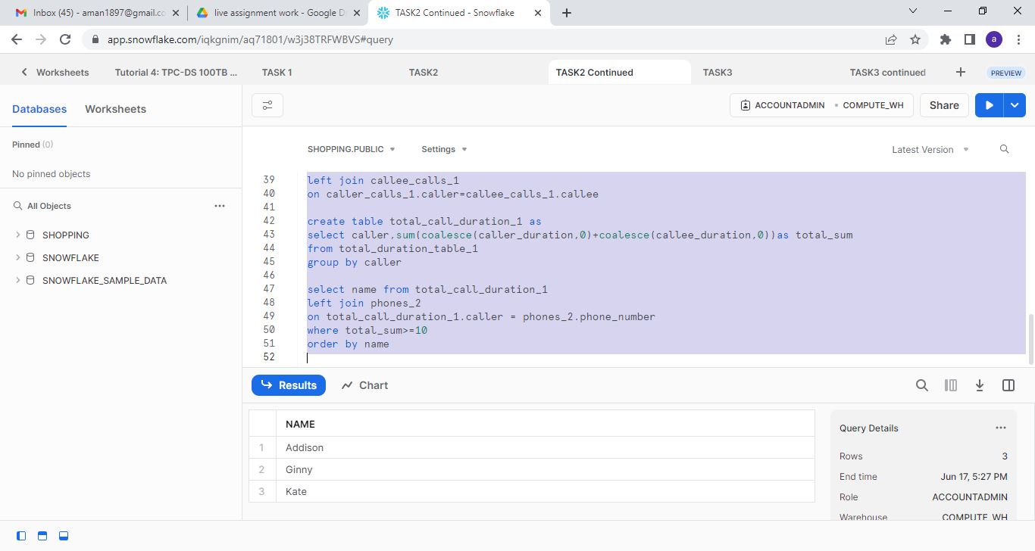

Task 3:

USE DATABASE shopping;
CREATE TABLE transactions
(amount int not null,
Trans_date date not null);
INSERT INTO transactions
VALUES
(1000,'2020-01-06'),
(-10,'2020-01-14'),
(-75,'2020-01-20'),
(-5,'2020-01-25'),
(-4,'2020-01-29'),
(2000,'2020-03-10'),
(-75,'2020-03-12'),
(-20,'2020-03-15'),
(40,'2020-03-15'),
(-50,'2020-03-17'),
(200,'2020-10-10'),
(-200,'2020-10-10');
SELECT * FROM transactions;
CREATE TABLE MONTHS AS
SELECT 1 AS mon UNION
SELECT 2 UNION
SELECT 3 UNION
SELECT 4 UNION
SELECT 5 UNION
SELECT 6 UNION
SELECT 7 UNION
SELECT 8 UNION
SELECT 9 UNION
SELECT 10 UNION
SELECT 11 UNION
SELECT 12;
CREATE TABLE Balance_table as
(SELECT * , month(trans_date) as months,
CASE
WHEN amount < 0 then amount* (-1)
ELSE 0
END as Credit,
CASE
WHEN amount > 0 then amount
ELSE 0
END as Debit
FROM transactions);
select * from balance_table;
Create table trans_date_mon as
select * from balance_table
right join months on months.mon = balance_table.months;
select sum(s_debit-s_credit-fee) as Balance from
(select count(mon),sum(coalesce(credit,0)) s_credit ,sum(coalesce(debit,0)) s_debit ,
case
when count(mon)<3 or sum(coalesce(credit,0))<100 then 5
else 0
end fee
from trans_date_mon
group by mon);

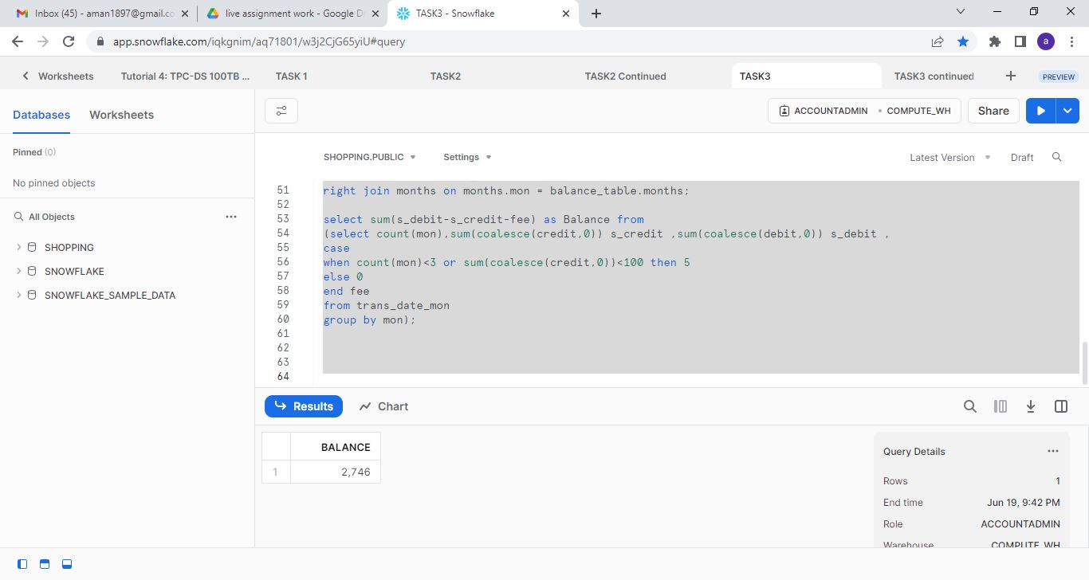

Task 3 continued:
use database shopping
CREATE TABLE transactions_1
(amount int not null,
Trans_date date not null);
INSERT INTO transactions_1
VALUES
(1,'2020-06-29'),
(35,'2020-02-20'),
(-50,'2020-02-03'),
(-1,'2020-02-26'),
(-200,'2020-08-01'),
(-44,'2020-02-07'),
(-5,'2020-02-25'),
(1,'2020-06-29'),
(1,'2020-06-29'),
(-100,'2020-12-29'),
(-100,'2020-12-30'),
(-100,'2020-12-31');
SELECT * from transactions_1;
CREATE TABLE months_1 AS
SELECT 1 AS mon UNION
SELECT 2 UNION
SELECT 3 UNION
SELECT 4 UNION
SELECT 5 UNION
SELECT 6 UNION
SELECT 7 UNION
SELECT 8 UNION
SELECT 9 UNION
SELECT 10 UNION
SELECT 11 UNION
SELECT 12;
CREATE TABLE Balance_table_1 as
(SELECT * , month(Trans_date) as months,
CASE
WHEN amount < 0 then amount*(-1)
ELSE 0
END as Credit,
CASE
WHEN amount > 0 then amount
ELSE 0
END as Debit
FROM transactions_1);
Create table trans_date_mon_1 as
select * from BALANCE_TABLE_1
Right join months_1 on months_1.mon = BALANCE_TABLE_1.months;
select sum(s_debit-s_credit-fee) as Balance from
(select count(mon),sum(coalesce(credit,0)) s_credit ,sum(coalesce(debit,0)) s_debit ,
case
when count(mon)<3 or sum(coalesce(credit,0))<100 then 5
else 0
end fee
from trans_date_mon_1
group by mon);
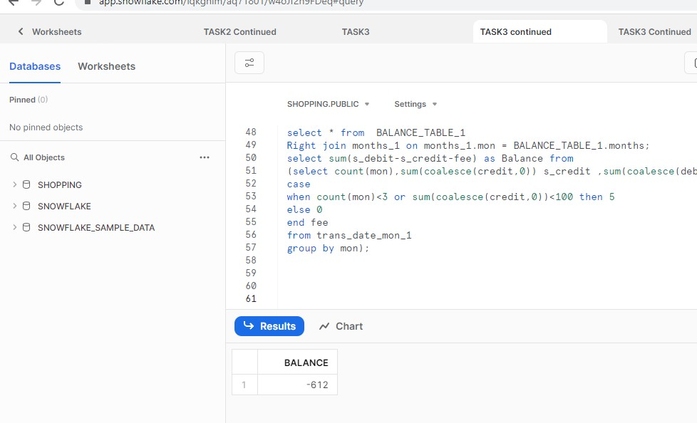

Task 3 continued
USE DATABASE shopping;
CREATE TABLE transactions_2
(amount int not null,
trans_date date not null);
INSERT INTO transactions_2
VALUES
(6000,'2020-04-03'),
(5000,'2020-04-02'),
(4000,'2020-04-01'),
(3000,'2020-03-01'),
(2000,'2020-02-01'),
(1000,'2020-01-01');
SELECT * FROM transactions_2;
CREATE TABLE months_2 AS
SELECT 1 AS mon UNION
SELECT 2 UNION
SELECT 3 UNION
SELECT 4 UNION
SELECT 5 UNION
SELECT 6 UNION
SELECT 7 UNION
SELECT 8 UNION
SELECT 9 UNION
SELECT 10 UNION
SELECT 11 UNION
SELECT 12;
CREATE TABLE Balance_table_2 as
(SELECT * , month(trans_date) as months,
CASE
WHEN amount < 0 then amount* (-1)
ELSE 0
END as Credit,
CASE
WHEN amount > 0 then amount
ELSE 0
END as Debit
FROM transactions_2);
select * from balance_table_2;
Create table trans_date_mon_2 as
select * from balance_table_2
right join months_2 on months_2.mon = balance_table_2.months;
select sum(s_debit-s_credit-fee) as Balance from
(select count(mon),sum(coalesce(credit,0)) s_credit ,sum(coalesce(debit,0)) s_debit ,
case
when count(mon)<3 or sum(coalesce(credit,0))<100 then 5
else 0
end fee
from trans_date_mon_2
group by mon);
