LAB-1
(DIGITAL SIGNAL PROCESSING)

STUDENT ID :748434
STUDENT NAME: Amandeep Kaur

Lab 1
Question no. 1: Create a vector
Ans: vector is created with number of elements enclosed in square brackets and separated by spaces.
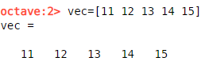

Question no. 2: Create a matrix
Ans: The given matrix has 6 rows and 2 columns.
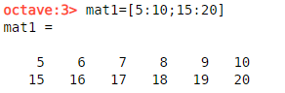
Question no. 3: Create a 5x1 vectors of zeros. Create a 1x5 vectors of random numbers
Ans: a) The given matrix shows the five rows and one column of zeros.
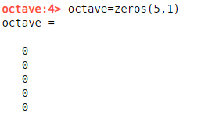
b) Random numbers are generated with rand name followed by one row and five columns.
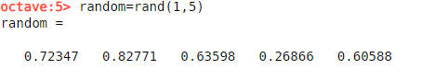

Question no. 4: find out transpose of matrix in question no.2.
Ans: When we take a transpose of matrix then rows and columns are exchange with each other.
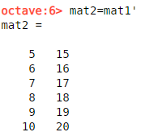
Question no. 5: Calculate the inner product and Cross product of two matrices. calculate the inverse of matrix.
Ans: a) The inner product of matrices is also known as dot product. The dot product of two square matrices called p and q is r which multiply each element of columns and added them.
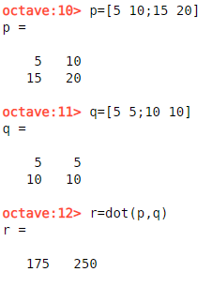

b) The main condition of cross product is that matrices should of similar sizes. The given cross product of i and j is k matrix.
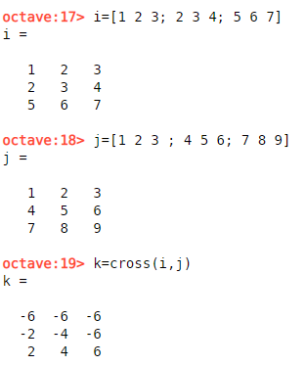
c)In an inverse matrix, each element of matrix is divided by one.
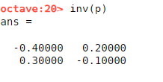
Question no. 6: Compute the element wise multiplication of a matrix and a scalar.
Ans: A scalar that is single number like a is multiply with matrix like b to get following product that is c.

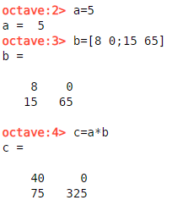
Question no.7: Concatenate two matrices.
Ans: Combination two matrices is known as concatenation. There are two type of concatenation horizontal and vertical. n is horizontal concatenation of l and m whereas o is vertical.

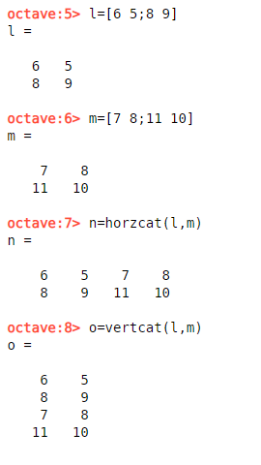
Question no.8: Create a vector of complex numbers.
Ans: complex numbers has real as well as imaginary part. c is vector of a a and b complex numbers.
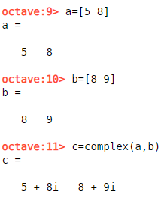
Question no.9: Multiply a row of a matrix with an element of that same matrix.
Ans: Each element of matrix A is multiplying itself and required result is shown in B matrix.
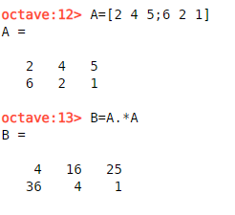
Question no.10. Generate a vector of values ranging from 1 to 500 with 100 elements.
Ans: The following vector is ranging from 1 to 500 with 100 elements.
