**Software Requirements**

**Specification**

**for**

**FareBlend(React)**

**Version 1.0 approved**

**Prepared by:**

**22SOECE13012 – Aman Dhanesha**

**22SOECE13031 - Ashutosh Ramanuj**

**22SOECE13013 –Raj Dharaiya**

**RK University**

**06/03/2024**

# Table of Contents

Table of Contents 2

Revision History 3

1. Introduction 4
   1. Purpose 4
   2. Document Conventions 4
   3. Intended Audience and Reading Suggestions 4
   4. Project Scope 4
   5. References 4
2. Overall Description 5
   1. Product Perspective 5
   2. Product Features 5
   3. User Classes and Characteristics 5
   4. Operating Environment 5
   5. Design and Implementation Constraints 5
   6. User Documentation 6
   7. Assumptions and Dependencies 6
3. System Features 7
   1. System Feature 1 7
   2. System Feature 2 (and so on) 8
4. External Interface Requirements 9
   1. User Interfaces 9
   2. Hardware Interfaces 9
   3. Software Interfaces 9
   4. Communications Interfaces 9
5. Other Nonfunctional Requirements 10
   1. Performance Requirements 10
   2. Safety Requirements 10
   3. Security Requirements 10
   4. Software Quality Attributes 10
6. Other Requirements 11

Appendix A: Glossary 11

Appendix B: Analysis Models 12

Appendix C: Issues List 15

# Revision History

|  |  |  |  |
| --- | --- | --- | --- |
| **Name** | **Date** | **Reason For Changes** | **Version** |
|  |  |  |  |
|  |  |  |  |

# Introduction

## Purpose

The purpose of an expense tracker is to efficiently monitor and manage financial transactions, enabling users to maintain a clear overview of their spending habits. By recording expenses in real-time, users can categorize and analyze their expenditures, facilitating budget planning and financial goal-setting. Additionally, expense trackers often include features for splitting expenses among multiple users, fostering transparency and fairness in shared expenditures. Ultimately, these tools empower individuals and groups to make informed financial decisions and cultivate healthier spending habits.

## Document Conventions

This document follows MLA format. Bold-faced text has been used to emphasize section and subsection headings. Italicized text is used to label and recognize diagrams.

## Intended Audience and Reading Suggestions

**Intended Audience:** Individuals or groups seeking efficient financial management solutions, including personal budgeting enthusiasts, small business owners, roommates, and travel companions.

##### Reading Suggestions:

1. "The Total Money Makeover" by Dave Ramsey for personal finance insights.
2. "Profit First" by Mike Michalowicz for small business financial strategies.
3. "Your Money or Your Life" by Vicki Robin and Joe Dominguez for a holistic approach to financial independence.
4. "Roommate Survival Guide" by Karen Horcher for practical tips on shared living arrangements.
5. "Lonely Planet's Ultimate Travelist" for inspiration on budget-friendly travel destinations.

## Project Scope

Develop an intuitive expense tracking application with robust budgeting features and seamless expense splitting functionality to cater to the diverse financial management needs of individuals and groups.

## References

IEEE, IEEE Standard 830-1998 IEEE Recommended Practice for Software Requirements Specifications, IEEE Computer Society, 1998.

# Overall Description

## Product Perspective

The expense tracking application will serve as a user-centric solution, providing intuitive interfaces for both individual and group financial management. It aims to integrate seamlessly with existing personal finance tools while offering additional features tailored for collaborative expense tracking and splitting. The product will prioritize user experience, scalability, and compatibility with various devices and platforms to ensure widespread adoption and long-term usability.

## Product Features

* + 1. Login: Secure user authentication to access personalized financial data and settings.
    2. Registration: Simple and intuitive sign-up process to create a new user account.
    3. Add Income: Easily input various income sources, including salaries, bonuses, or other earnings.
    4. Add Expenses: Conveniently record expenses with detailed descriptions, categories, and amounts.
    5. Graphical Representation: Dynamic graphs and charts to visualize income, expenses, and budgeting trends over time, providing valuable insights into financial habits and goals.

## User Classes and Characteristics

#### 1 : End Users/Customers : The end user will be the one who visits the application.

## Operating Environment

### Hardware Requirements

#### A PC with proper speed and memory.

### Software Requirements

#### Front End : Figma for UI UX, ReactJs & Tailwind Css Back End : MongoDb using API

## Design and Implementation Constraints

* + 1. Security: Implement robust encryption and authentication.
    2. Platform Compatibility: Ensure compatibility across various devices.
    3. Scalability: Design architecture to handle growth effectively.
    4. Usability: Prioritize user-friendly interface and navigation.
    5. Integration: Facilitate integration with third-party services.
    6. Data Accuracy: Enforce data validation and error handling.
    7. Regulatory Compliance: Adhere to relevant financial regulations.
    8. Offline Functionality: Provide offline access and synchronization.
    9. Performance Optimization: Optimize code and database queries.
    10. Resource Limitations: Consider server capacity and bandwidth.

#### .

## User Documentation

#### For user documents please refer to Section 3.

## Assumptions and Dependencies

In developing an expense tracking application, it's assumed users will have stable internet for real-time sync, provide accurate financial data, and comply with updates. Dependencies on third-party APIs, reliable server hosting, and legal adherence underscore key aspects. Additionally, supporting multiple languages and device compatibility enhances accessibility. Access to development tools and user support channels ensures smooth implementation and assistance, forming the backbone of the application's functionality and user experience

# System Features

* 1. **Register and Log In**

#### Description and Priority

#### This feature creates an account for a new user in the system. For a user to be able to post a Expense/Income, he/she must have an account and must be logged into it. Thisfeatures enlists the user details in the database. This is an important feature so it has high priority.

#### Stimulus/Response Sequences

#### Customer ﬁrst clicks on the button or link to initiate the registration process. The system then prompts the customer to ﬁll out his/her ﬁrst name, last name, email id. Customers enter the ﬁelds. System validates the customer’s information and creates a new account for the customer.

#### Functional Requirements

#### REQ-1: A button for register and login must be available REQ-2: A table in the database must be created for all users

* 1. **Apply Expense/Income and Information Related to Expense/Income**

#### Title

#### This feature enables for a user to give title to the money spent or how the money is earned.

#### Amount

#### This feature enables for a user to give the amount of money spent or earned.

#### Date

#### This feature enables for a user to give the date of when the money was spent or earned.

* 1. **View Transaction Details**

#### 3.3.1 Description

#### This feature enables for a user to view the transactions of money spent or earned.

# External Interface Requirements

## User Interfaces

#### Each part of the user interface intends to be as user friendly as possible. The fonts and buttons used will be intended to be very fast and easy to load on website. The pages will be kept light in space so that it won't take a long time for the pages to load.

#### The starting page will be the homepage of the website. All the features available are displayed. An ‘Expense/Income' button is available which will add the Expense/Income by the speciﬁed quantity given in the text box only if the user is logged into his/her account.

## Hardware Interfaces

#### Processor - Pentium I or above. RAM - 128 MB or above.

#### HD - 20GB or above. NIC - for each party.

## Software Interfaces

#### The following are needed requirements: Operating System : Unix, Linux, Mac, Windows.

#### Application : Xampp Application Database : MySql Database Server

## Communications Interfaces

#### ReactJs uses session variables to communicate between pages of the application.

# Other Nonfunctional Requirements

## Performance Requirements

#### Maximum possible quick response to the input is required, also should provide fast updatation of records. The changes if any made should be reﬂected automatically in the next screens. In order to maintain an acceptable speed at maximum number of uploads allowed from a particular customer as any number of users can access to the system at any time.

## Safety Requirements

#### The application is password protected and also any updatation of new product entries and Order processing is done by only privileged users.

## Security Requirements

#### The necessary qualities of software products are

#### Security:

#### The application is password protected and also any updation of new Expense/Income entries is done by only privileged users.

#### Maintainability:

#### The application is to be designed so that it is easily maintained. Also it should allow incorporating new requirements in any module of the system.

#### Reliability:

#### The application will be able to handle two orders. When a user conﬁrms his/her

#### order the database will be updated immediately and the next user will not face any issues.

#### Portability

#### The application will be easily portable on any window based system.

* 1. **Business Rules**

#### Only the admin can make changes in the database.

# 

# Appendix B: Analysis Models

**B1 : Use Case Diagram**

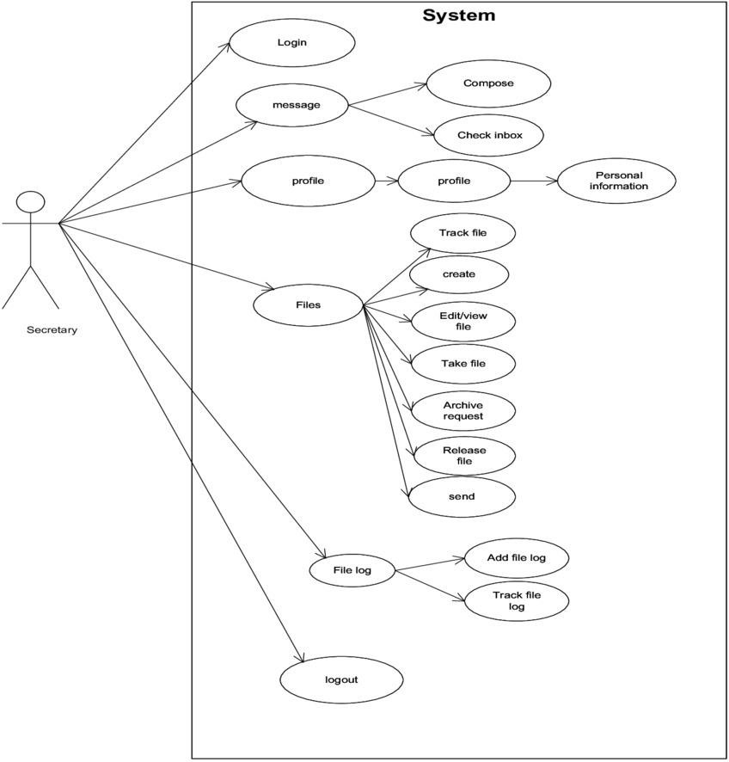

**B3 - Sequence Diagram**

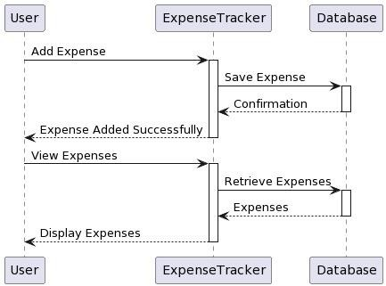

**Appendix C: UI UX Photos**



