GOVERNMENT POLYTECHNIC KASHIPUR
(U.S NAGAR)


Semester: - 5th
Session (2025-2026) Winter
Subject: - JAVA Programming
Branch: -Information Technology
Batch (2023-2026)

Submitted By:
Submitted To:
MR. J.C. Pandey

Aman Diktiya
Head of Department

23009120017

S.  NO. | Name of the Practical | Page NO. | Issue  date | Submission date | Grade | Signature
01. | Write a Java program to display the count of all commands line arguments and list each in a line
02. | Write a program to find out sum of digits of given number.
03. | Write a program to display multiplication table in row, column format.
04. | Write a program to  a) To find whether the given number is prime or not.
04. | b) To display all prime numbers in a given range of numbers.
05. | Write a program to create an array of integers and accept a number. Check whether it exits in the array. Create your own exception with appropriate error message and raise the exception when the element is not found in the array.
06. | Write a program to copy a file to another file using java.io package Classes.
07. | Write a program to get a file at runtime and display the number of lines, words and characters in that file.
08. | Programming exercise on Arrays and String
09. | Programming exercise on inheritance
10. | Write Program for exception handling
11. | Write programs for Multithreading
12. | Programming exercise on Java applets
13. | Write program for Java Data base connectivity
index

PRACTICAL: 01
AIM: Write a Java program to display the count of all commands line arguments and list each in a line.
CmdArgsList.java :-
public class CmdArgsList {
public static void main(String[] args) {
System.out.println("Count: " + args.length);
for (int i = 0; i < args.length; i++) {
System.out.println((i + 1) + ": " + args[i]);
}
}
}

OUTPUT :-
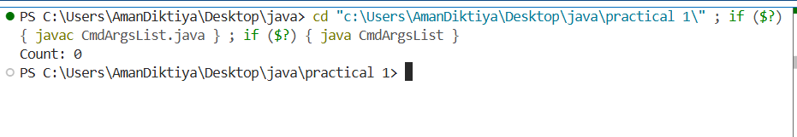

PRACTICAL: 02
AIM: Write a program to find out sum of digits of given number.
SumOfDigits.java :-
import java.util.Scanner;

public class SumOfDigits {
public static void main(String[] args) {
Scanner sc = new Scanner(System.in);
System.out.print("Enter integer: ");
long n = sc.nextLong();
n = Math.abs(n);
long sum = 0;
while (n > 0) { sum += n % 10; n /= 10; }
System.out.println("Sum of digits = " + sum);
sc.close();
}
}

OUTPUT :-
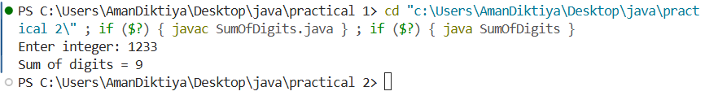

PRACTICAL: 03
AIM: Write a program to display multiplication table in row, column format.
MultiplicationTable.java :-
public class MultiplicationTable {
public static void main(String[] args) {
int upto = 10;
// header
System.out.printf("%4s", "x");
for (int j = 1; j <= upto; j++) System.out.printf("%4d", j);
System.out.println();
for (int j = 0; j <= upto; j++) System.out.print("----");
System.out.println();
// body
for (int i = 1; i <= upto; i++) {
System.out.printf("%4d", i);
for (int j = 1; j <= upto; j++) System.out.printf("%4d", i * j);
System.out.println();
}
}

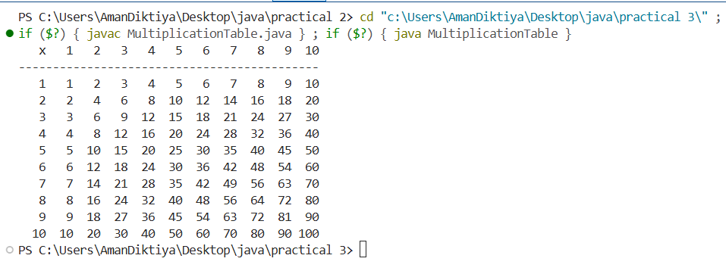
OUTPUT :-

PRACTICAL: 04
AIM: Write a program
a) To find whether the given number is prime or not.
PrimeCheck.java :-

import java.util.Scanner;

public class PrimeCheck {
static boolean isPrime(long n) {
if (n < 2) return false;
if (n % 2 == 0) return n == 2;
for (long d = 3; d * d <= n; d += 2)
if (n % d == 0) return false;
return true;
}
public static void main(String[] args) {
Scanner sc = new Scanner(System.in);
System.out.print("Enter number: ");
long n = sc.nextLong();
System.out.println(n + (isPrime(n) ? " is prime" : " is not prime"));
sc.close();
}
}
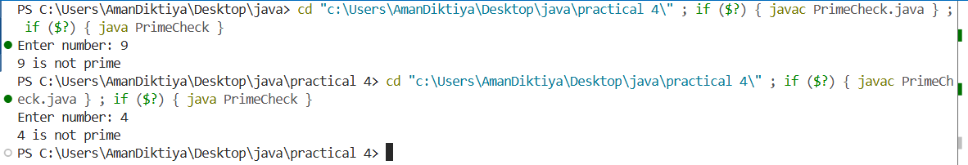
OUTPUT :-
b) To display all prime numbers in a given range of numbers.
PrimesInRange.java:-
import java.util.Scanner;

public class PrimesInRange {
static boolean isPrime(int n) {
if (n < 2) return false;
if (n % 2 == 0) return n == 2;
for (int d = 3; d * d <= n; d += 2)
if (n % d == 0) return false;
return true;
}
public static void main(String[] args) {
Scanner sc = new Scanner(System.in);
System.out.print("From: "); int a = sc.nextInt();
System.out.print("To : "); int b = sc.nextInt();
if (a > b) { int t = a; a = b; b = t; }
System.out.println("Primes in [" + a + ", " + b + "]:");
for (int n = a; n <= b; n++) if (isPrime(n)) System.out.print(n + " ");
System.out.println();
sc.close();
}
}

OUTPUT :-
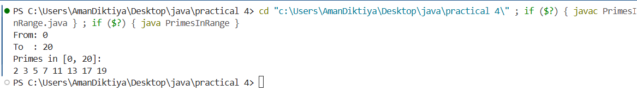
PRACTICAL: 05
AIM:- Write a program to create an array of integers and accept a number. Check whether it exits in the array. Create your own exception with appropriate error message and raise the exception when the element is not found in the array.
ArraySearchWithException.java :-
import java.util.*;
class ElementNotFoundException extends Exception {
public ElementNotFoundException(String msg) { super(msg); }
}
public class ArraySearchWithException {
public static int indexOf(int[] arr, int key) throws ElementNotFoundException {
for (int i = 0; i < arr.length; i++) if (arr[i] == key) return i;
throw new ElementNotFoundException("Element " + key + " not found in array.");
}
public static void main(String[] args) {
Scanner sc = new Scanner(System.in);
System.out.print("Array size: ");
int n = sc.nextInt();
int[] arr = new int[n];
System.out.println("Enter " + n + " integers:");
for (int i = 0; i < n; i++) arr[i] = sc.nextInt();
System.out.print("Enter number to search: ");
int key = sc.nextInt();
try {
int pos = indexOf(arr, key);
System.out.println("Found at index " + pos);
} catch (ElementNotFoundException e) {
System.out.println("Error: " + e.getMessage());
}
sc.close();
}
}

OUTPUT :-
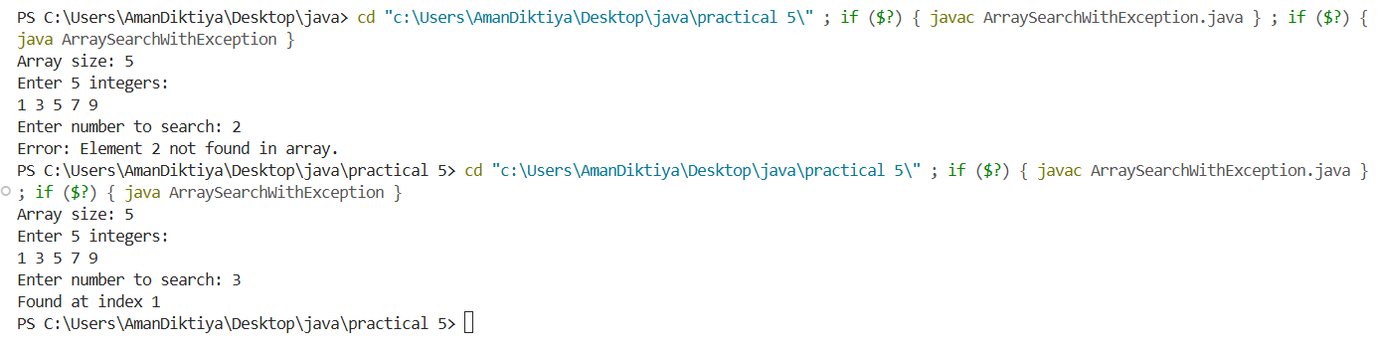

PRACTICAL: 06
AIM:- Write a program to copy a file to another file using java.io package Classes.
FileCopy.java:-
import java.io.*;

public class FileCopy {
public static void main(String[] args) {
String sourceFile = "C:\\Users\\AmanDiktiya\\Desktop\\java\\practical 6\\source.txt";
String destFile = "C:\\Users\\AmanDiktiya\\Desktop\\java\\practical 6\\destination.txt";

try (FileInputStream in = new FileInputStream(sourceFile);
FileOutputStream out = new FileOutputStream(destFile)) {
byte[] buffer = new byte[1024];
int length;

while ((length = in.read(buffer)) > 0) {
out.write(buffer, 0, length);
}

System.out.println("File copied successfully from " + sourceFile + " to " + destFile);

} catch (IOException e) {
System.out.println("Error occurred: " + e.getMessage());
}
}
}

OUTPUT :-
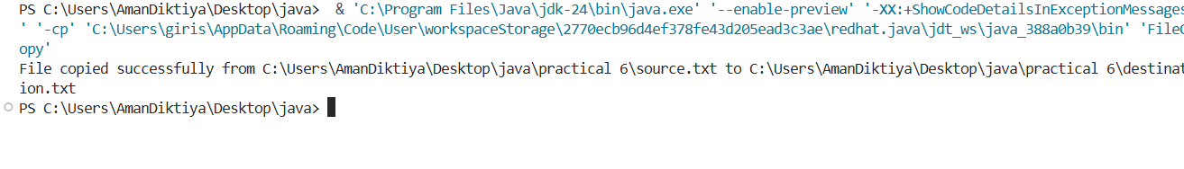
PRACTICAL: 07
AIM:- Write a program to copy a file to another file using java.io package Classes.
FileStats.java:-
import java.io.*;

public class FileStats {
public static void main(String[] args) {
// Hardcoded file path
String filename = "sample.txt";
long lines = 0, words = 0, chars = 0;

try (BufferedReader br = new BufferedReader(new FileReader(filename))) {
String line;

while ((line = br.readLine()) != null) {
lines++; // Line count
chars += line.length(); // Character count (excluding newline)
words += line.trim().isEmpty() ? 0 : line.trim().split("\\s+").length; // Word count
}

System.out.println("Lines: " + lines);
System.out.println("Words: " + words);
System.out.println("Characters: " + chars);

} catch (IOException e) {
System.out.println("Error: " + e.getMessage());
}
}
}
OUTPUT :-
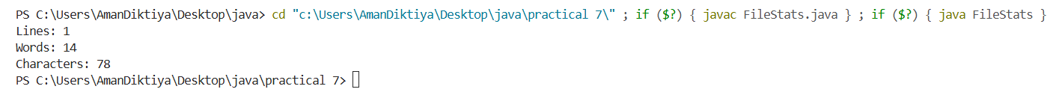

PRACTICAL: 08
AIM:- Programming exercise on Arrays and String.
ArraysAndStringsDemo.java :-
import java.util.*;

public class ArraysAndStringsDemo {
public static void main(String[] args) {
// Array: min, max, average
int[] arr = {7, 2, 9, 4, 5, 10};
int min = arr[0], max = arr[0], sum = 0;
for (int x : arr) { if (x < min) min = x; if (x > max) max = x; sum += x; }
double avg = sum / (double) arr.length;
System.out.println("Array: " + Arrays.toString(arr));
System.out.printf("Min=%d, Max=%d, Avg=%.2f%n", min, max, avg);

// String: reverse, vowel count, palindrome check
String s = "naman";
String rev = new StringBuilder(s).reverse().toString();
long vowels = s.toLowerCase().chars().filter(c -> "aeiou".indexOf(c) >= 0).count();
boolean palindrome = s.equals(rev);
System.out.println("String: " + s);
System.out.println("Reversed: " + rev + ", Vowels: " + vowels + ", Palindrome: " + palindrome);
}
}

OUTPUT :-
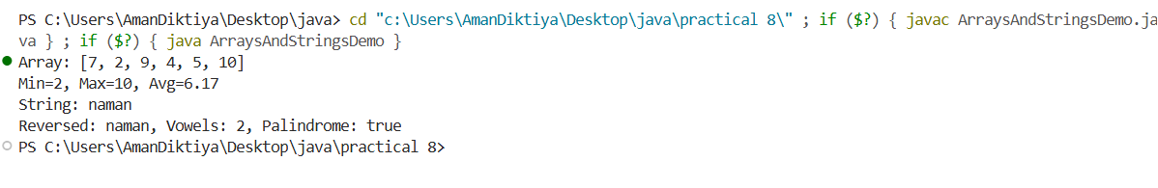

PRACTICAL: 09
AIM:- Programming exercise on inheritance.
InheritanceDemo.java :-
class Shape {
String name;
Shape(String name) { this.name = name; }
double area() { return 0.0; }
}
class Rectangle extends Shape {
double w, h;
Rectangle(double w, double h) { super("Rectangle"); this.w = w; this.h = h; }
@Override double area() { return w * h; }
}
class Circle extends Shape {
double r;
Circle(double r) { super("Circle"); this.r = r; }
@Override double area() { return Math.PI * r * r; }
}
public class InheritanceDemo {
public static void main(String[] args) {
Shape[] shapes = { new Rectangle(5, 3), new Circle(2.5) };
for (Shape s : shapes)
System.out.printf("%s area = %.2f%n", s.name, s.area());
}
}

OUTPUT :-
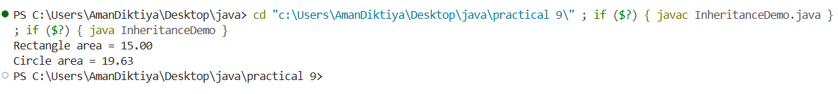

PRACTICAL: 10
AIM:- Write Program for exception handling.
ExceptionHandlingDemo.java :-
import java.util.Scanner;

public class ExceptionHandlingDemo {
public static void main(String[] args) {
Scanner sc = new Scanner(System.in);
try {
System.out.print("Enter numerator: ");
int a = Integer.parseInt(sc.nextLine().trim());
System.out.print("Enter denominator: ");
int b = Integer.parseInt(sc.nextLine().trim());
int c = a / b;
System.out.println("Result: " + c);
} catch (NumberFormatException e) {
System.out.println("Please enter valid integers.");
} catch (ArithmeticException e) {
System.out.println("Cannot divide by zero.");
} finally {
sc.close();
System.out.println("Done.");
}
}
}

OUTPUT :-
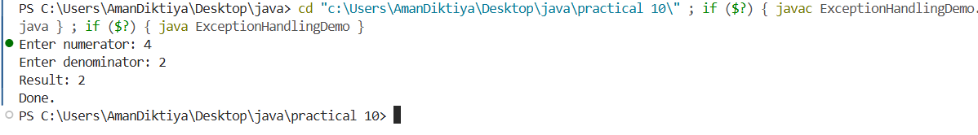

PRACTICAL: 11
AIM:- Write programs for Multithreading .
MultithreadingDemo.java :-
class Task implements Runnable {
String name;

Task(String n) {
name = n;
}

public void run() {
for (int i = 1; i <= 5; i++) {
System.out.println(name + " -> " + i);
try {
Thread.sleep(500); // 0.5 second pause to show interleaving
} catch (InterruptedException e) {
System.out.println(name + " interrupted");
}
}
}
}

public class MultithreadingDemo {
public static void main(String[] args) {
Thread t1 = new Thread(new Task("Thread A"));
Thread t2 = new Thread(new Task("Thread B"));
Thread t3 = new Thread(new Task("Thread C"));

t1.start();
t2.start();
t3.start();
}
}

OUTPUT :-
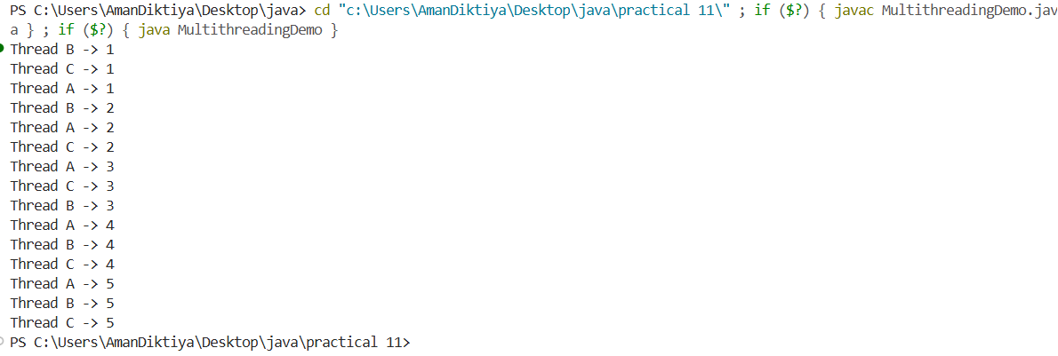

PRACTICAL: 12
AIM:- Programming exercise on Java applets.
SimpleSwingApp.java:-
import javax.swing.*;
import java.awt.*;

public class SimpleSwingApp {
public static void main(String[] args) {
JFrame frame = new JFrame("Simple Swing App");
frame.setSize(400, 200);
frame.setDefaultCloseOperation(JFrame.EXIT_ON_CLOSE);

JLabel label = new JLabel("Hello, This is a Simple Java Swing Application.", JLabel.CENTER);
frame.add(label);

frame.setVisible(true);
}
}

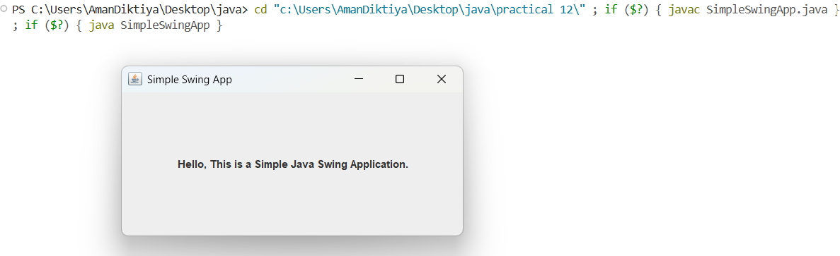
OUTPUT :-
PRACTICAL: 13
AIM:- Write program for Java Data base connectivity.
SQLiteExample.java:-
import java.sql.*;

public class SQLiteExample {
public static void main(String[] args) {
Connection conn = null;
try {
// Driver load
Class.forName("org.sqlite.JDBC");

// SQLite DB connect
conn = DriverManager.getConnection("jdbc:sqlite:students.db");
System.out.println("✅ Connected to SQLite database.");

Statement stmt = conn.createStatement();

// Table create
stmt.execute("CREATE TABLE IF NOT EXISTS students (" +
"id INTEGER PRIMARY KEY AUTOINCREMENT, " +
"name TEXT, " +
"age INTEGER)");

// Insert records
stmt.execute("INSERT INTO students (name, age) VALUES ('Aman Diktiya', 20)");
stmt.execute("INSERT INTO students (name, age) VALUES ('Shivank', 22)");

// Select and display
ResultSet rs = stmt.executeQuery("SELECT * FROM students");
while (rs.next()) {
System.out.println(
rs.getInt("id") + " | " +
rs.getString("name") + " | " +
rs.getInt("age")
);
}

// Close resources
rs.close();
stmt.close();
conn.close();

} catch (Exception e) {
System.out.println("❌ Error: " + e.getMessage());
}
}
}

