**ASSIGNMENT-3**

**NAME : MAHAMMADAMAN GANDHI**

**1) TABLE1 : Department**

**CREATE** TABLE Department (

dept_id decimal(2,0) NOT NULL PRIMARY KEY,

dept_name varchar(14) default NULL,

);

**INSERT** INTO Department VALUES ('10','ACCOUNTING');

INSERT INTO Department VALUES ('20','RESEARCH');

INSERT INTO Department VALUES ('30','SALES');

INSERT INTO Department VALUES ('40','OPERATIONS');

SELECT * FROM Department

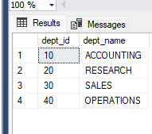

**2) TABLE2 : Employee**

**CREATE** TABLE Employee (

emp_id decimal(4,0) NOT NULL PRIMARY KEY,

emp_name varchar(10) default NULL,

mngr_id decimal(4,0) default NULL,

salary decimal(7,2) default NULL,

dept_id decimal(2,0) default NULL

);

ALTER TABLE Employee

ADD CONSTRAINT FK_Employee_dept_id FOREIGN KEY (dept_id)

REFERENCES Department (dept_id);

**INSERT** INTO Employee VALUES ('7369','SMITH','7902','800.00','20');

INSERT INTO Employee VALUES ('7499','ALLEN','7698','1600.00','30');

INSERT INTO Employee VALUES ('7521','WARD','7698','1250.00','30');

INSERT INTO Employee VALUES ('7566','JONES','7839','2975.00','20');

INSERT INTO Employee VALUES ('7654','MARTIN','7698','1250.00','30');

INSERT INTO Employee VALUES ('7698','BLAKE','7839','2850.00','30');

INSERT INTO Employee VALUES ('7782','CLARK','7839','2450.00','10');

INSERT INTO Employee VALUES ('7788','SCOTT','7566','3000.00','20');

INSERT INTO Employee VALUES ('7839','KING',NULL,'5000.00','10');

INSERT INTO Employee VALUES ('7844','TURNER','7698','1500.00','30');

INSERT INTO Employee VALUES ('7876','ADAMS','7788','1100.00','20');

INSERT INTO Employee VALUES ('7900','JAMES','7698','950.00','30');

INSERT INTO Employee VALUES ('7902','FORD','7566','3000.00','20');

INSERT INTO Employee VALUES ('7934','MILLER','7782','1300.00','10');

**SELECT** * FROM Employee

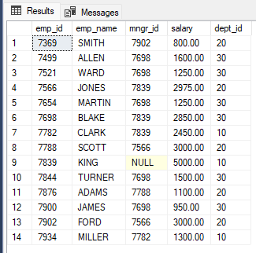

**1) Write a SQL query to find Employees who have the biggest salary in their Department .**

**SELECT** d.dept_name,e.emp_name,salary

FROM Employee as e

left join Department as d

on e.dept_id = d.dept_id

WHERE salary in(

SELECT MAX(salary)

FROM Employee

group by dept_id

)

order by d.dept_id

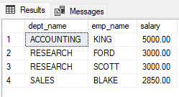

**2) Write a SQL query to find Departments that have less than 3 people in it.**

SELECT dept_name,department.dept_id,count(employee.dept_id)

FROM Employee

full JOIN Department

on Employee.dept_id = Department.dept_id

GROUP BY Department.dept_id,dept_name

HAVING COUNT(employee.dept_id)<=3;

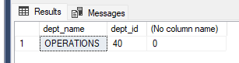

**3) Write a SQL query to find All Department along with the number of people there.**

SELECT dept_name,department.dept_id,count(employee.dept_id) as total_employee

FROM Employee

full JOIN Department

on Employee.dept_id = Department.dept_id

GROUP BY Department.dept_id,dept_name

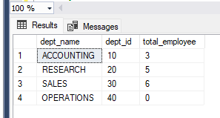

**4) Write a SQL query to find All Department along with the total salary there.**

SELECT dept_name,department.dept_id,sum(salary) as total_salary

FROM Employee

full JOIN Department

on Employee.dept_id = Department.dept_id

GROUP BY Department.dept_id,dept_name

