ASSIGNMENT-4

1. Create a stored procedure in the Northwind database that will calculate the average value of Freight for a specified customer.Then, a business rule will be added that will be triggered before every Update and Insert command in the Orders controller,and will use the stored procedure to verify that the Freight does not exceed the average freight. If it does, a message will be displayed and the command will be cancelled.

CREATE PROCEDURE que1

AS

SELECT CustomerID, AVG(Freight) as AvgFreight

FROM Orders

GROUP BY CustomerID

GO

Insert :

CREATE TRIGGER tr_que1_insert

ON orders

INSTEAD OF INSERT

AS

BEGIN

Declare @OrderID int

Declare @CustomerID varchar(50)

Declare @Freight money

Declare @AvgFreight money

Declare @t_ave TABLE(CustomerID nchar(5), AvgFreight money)

INSERT @t_ave

exec que1

Select * Into #Temptable FROM Inserted

While(Exists(Select OrderID from #TempTable))

Begin

Select TOP 1 @OrderID = OrderID, @CustomerID = CustomerID, @Freight=Freight

FROM #Temptable

SET @AvgFreight = (SELECT AvgFreight FROM @t_ave WHERE CustomerID = @CustomerID)

IF @Freight > @AvgFreight

BEGIN

RAISERROR ('ABOVE AVERAGE',16,1)

END

ELSE

BEGIN

INSERT INTO Orders (CustomerID,EmployeeID,OrderDate,RequiredDate,ShippedDate,ShipVia,Freight,ShipName,ShipAddress,ShipCity,ShipRegion,ShipPostalCode,ShipCountry)

SELECT CustomerID,EmployeeID,OrderDate,RequiredDate,ShippedDate,ShipVia,Freight,ShipName,ShipAddress,ShipCity,ShipRegion,ShipPostalCode,ShipCountry

From Inserted

END

Delete from #TempTable where OrderID = @OrderID

End

END

NOW we check the out put:

if we add Freight value above avg(Freight) value the not add else add.

exec que1

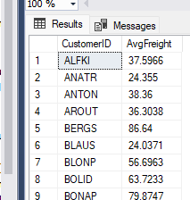

now insert greater value

insert into orders values ( 'AROUT', 8,'1997-08-25 00:00:00.000', '1997-08-01 00:00:00.000','1997-01-01 00:00:00.000', 1,80, 'Wolski Zajazd', 'ul. Filtrowa 68',

'Warszawa', 'Tachira', 24100, 'brazil')

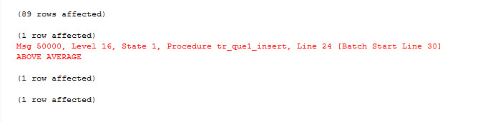

now insert less value

insert into orders values ( 'AROUT', 8,'1997-08-25 00:00:00.000', '1997-08-01 00:00:00.000','1997-01-01 00:00:00.000', 1,80, 'Wolski Zajazd', 'ul. Filtrowa 68',

'Warszawa', 'Tachira', 24100, 'brazil')

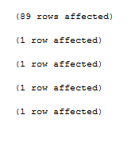

Update:

CREATE TRIGGER tr_que1_update

ON orders

INSTEAD OF UPDATE

AS

BEGIN

Declare @OrderID int

Declare @CustomerID varchar(50)

Declare @Freight money

Declare @AvgFreight money

Declare @t_ave TABLE(CustomerID nchar(5), AvgFreight money)

INSERT @t_ave

exec que1

Select * Into #Temptable FROM Inserted

While(Exists(Select OrderID from #TempTable))

Begin

Select TOP 1 @OrderID = OrderID, @CustomerID = CustomerID, @Freight=Freight

FROM #Temptable

SET @AvgFreight = (SELECT AvgFreight FROM @t_ave WHERE CustomerID = @CustomerID)

Print @Freight

Print @AvgFreight

IF @Freight > @AvgFreight

BEGIN

RAISERROR ('ABOVE AVERAGE',16,1)

END

ELSE

BEGIN

UPDATE Orders SET Freight = @Freight WHERE OrderID=@OrderID

END

Delete from #TempTable where OrderID = @OrderID

End

END

NOW we check the out put:

if we update and add Freight value above avg(Freight) value the not add else add.

exec que1

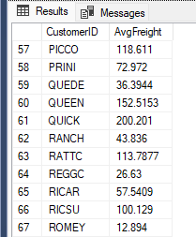

now insert greater value

UPDATE Orders SET Freight=120 WHERE OrderID = 10272

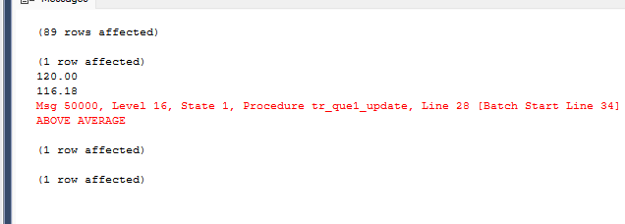

now insert less value

UPDATE Orders SET Freight=12 WHERE OrderID = 10272

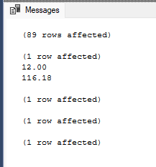

2. write a SQL query to Create Stored procedure in the Northwind database to retrieve Employee Sales by Country

ALTER proc Proc_Employee_sales_bycountry

@ShipCountry nvarchar(10)

as

begin

SELECT Employees.EmployeeID,Employees.[LastName],Employees.[FirstName],sum(UnitPrice) as Sales,COUNT(Orders.EmployeeID) as [Orders],Orders.ShipCountry

FROM Employees

INNER JOIN Orders

ON Orders.EmployeeID = Employees.EmployeeID

INNER JOIN [Order Details]

ON [Order Details].orderID = Orders.orderID

Where ShipCountry = @ShipCountry

GROUP BY Employees.EmployeeID, Orders.ShipCountry,Employees.[LastName],Employees.[FirstName]

end

Execute Proc_Employee_sales_bycountry 'UK'

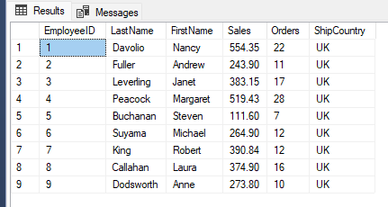

3. write a SQL query to Create Stored procedure in the Northwind database to retrieve Sales by Year

ALTER PROC Proc_sales_by_year

@year int

as

begin

SELECT year(ShippedDate) as Year ,sum(UnitPrice) as Sales, COUNT(Orders.EmployeeID) as Orders

FROM Orders

INNER JOIN [Order Details]

ON [Order Details].orderID = Orders.orderID

/* LEFT JOIN Employees

ON Orders.EmployeeID = Employees.EmployeeID */

Where year(ShippedDate) = @year

GROUP BY year(ShippedDate)

end

execute sp_rename 'Proc_Employee_sales_by' , 'Proc_sales_by_year';

execute Proc_sales_by_year '1998'

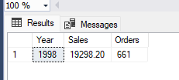

4. write a SQL query to Create Stored procedure in the Northwind database to retrieve Sales By Category

ALTER PROC Proc_sales_by_Categories

@categoriename varchar(50)

as

begin

SELECT CategoryName ,sum([Order Details].UnitPrice) as Sales, COUNT(Orders.EmployeeID) as Orders

FROM Orders , [Order Details], Products,Categories

Where CategoryName = @categoriename

and [Order Details].ProductID = Products.ProductID

and [Order Details].OrderID = Orders.OrderID

and Products.CategoryID = Categories.CategoryID

GROUP BY CategoryName

end

execute Proc_sales_by_Categories 'Dairy Products'

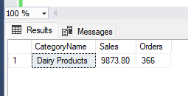

5. write a SQL query to Create Stored procedure in the Northwind database to retrieve Ten Most Expensive Products

ALTER PROC Proc_10_most_expensive_products

as

begin

SELECT TOP(10) ProductName , UnitPrice

FROM Products

Order BY UnitPrice desc

end

execute Proc_10_most_expensive_products

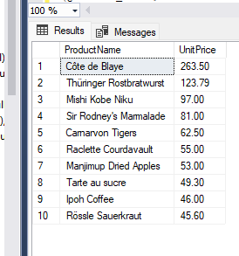

6. write a SQL query to Create Stored procedure in the Northwind database to insert Customer Order Details

ALTER PROCEDURE [insert_Order Details_1]

(@OrderID_1 int,

@ProductID_2 int,

@UnitPrice_3 money = NULL,

@Quantity_4 smallint,

@Discount_5 real = 0)

AS

INSERT INTO [Northwind].[dbo].[Order Details]

( [OrderID], [ProductID], [UnitPrice], [Quantity], [Discount])

VALUES ( @OrderID_1, @ProductID_2, @UnitPrice_3, @Quantity_4, @Discount_5)

execute [insert_Order Details_1] 10248,51,12.34,2,0

SELECT * FROM [Order Details]

WHERE OrderID = 10248 and ProductID = 51

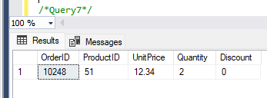

7. write a SQL query to Create Stored procedure in the Northwind databaseto update Customer Order Details

CREATE PROCEDURE [update_Order Details_1]

(

@OrderID_1 int,

@ProductID_2 int,

@NewQuantity_4 smallint= NULL,

@NewUnitPrice_3 money = NULL,

@NewDiscount_5 real = NULL

)

AS

UPDATE [Northwind].[dbo].[Order Details]

SET [Quantity] = @NewQuantity_4, [UnitPrice] = @NewUnitPrice_3, [Discount] = @NewDiscount_5

WHERE ( [OrderID] = @OrderID_1 AND

[ProductID] = @ProductID_2 )

execute [update_Order Details_1] 10248,11,12.00,12,0

SELECT * FROM [Order Details]

WHERE OrderID = 10248 and ProductID = 11

