ASSIGNMENT - 1

MAIN TABLE :

SELECT \* FROM Products;

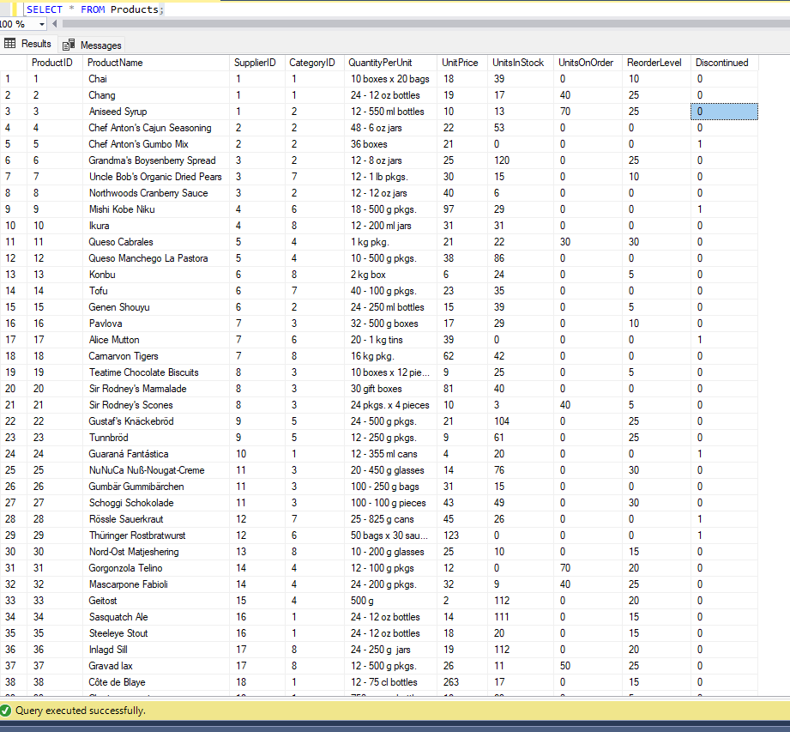

1. Write a query to get a Product list (id, name, unit price) where current products cost less than $20.

SELECT ProductID,ProductName,UnitPrice

FROM Products

Where UnitPrice < 20;

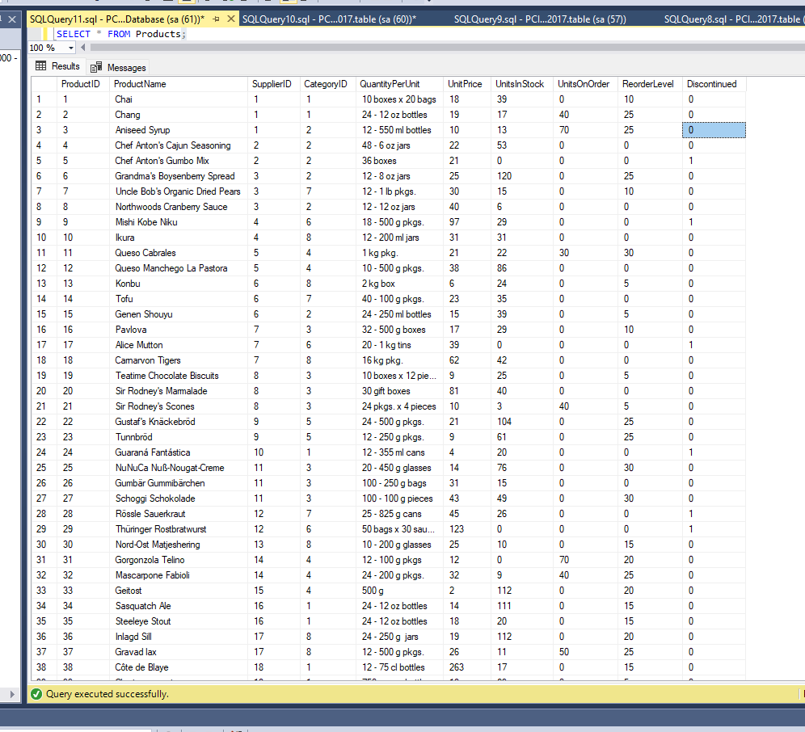

2. Write a query to get Product list (id, name, unit price) where products cost between $15 and $25

SELECT ProductID,ProductName,UnitPrice

FROM Products

Where UnitPrice BETWEEN 15 AND 25;

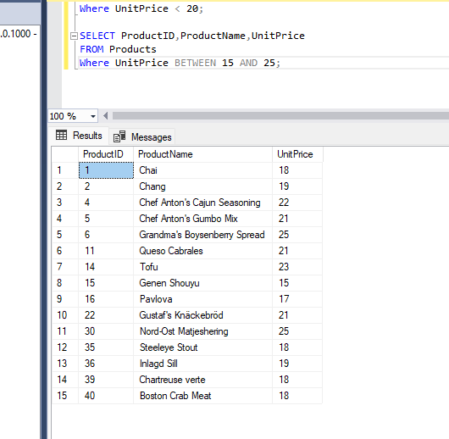

3. Write a query to get Product list (name, unit price) of above average price.

SELECT ProductName,UnitPrice

FROM Products

Where UnitPrice > ( SELECT AVG(UnitPrice) FROM Products);

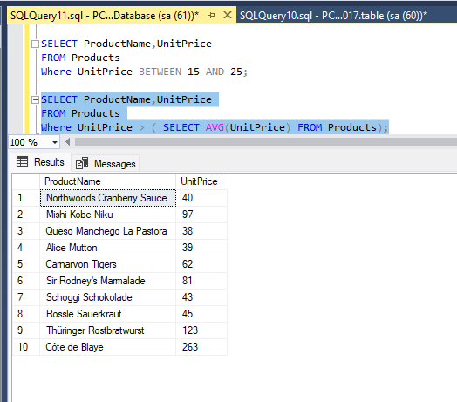

4. Write a query to get Product list (name, unit price) of ten most expensive products

SELECT TOP 10 ProductName,UnitPrice

FROM Products

ORDER BY UnitPrice DESC;

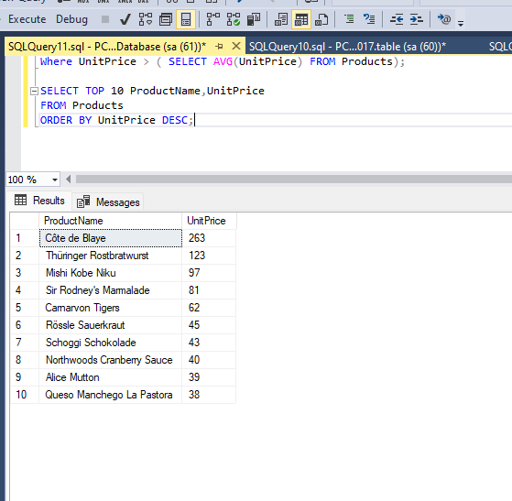

5. Write a query to count current and discontinued products

SELECT COUNT(ProductName)

FROM Products

GROUP BY Discontinued;

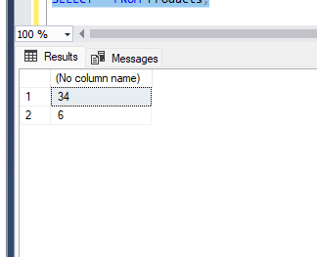

6. Write a query to get Product list (name, units on order , units in stock) of stock is less than the quantity on order .

SELECT ProductName,UnitsOnOrder,UnitsInStock

FROM Products

WHERE UnitsInStock < UnitsOnOrder;

