**Loading page**

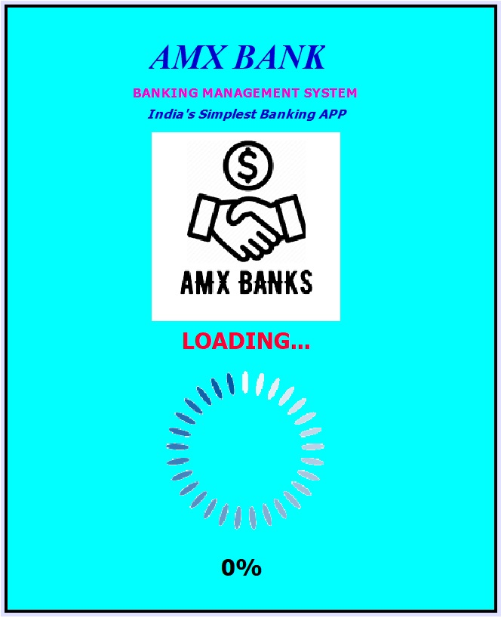

**WELCOME PAGE OF PROJECT**

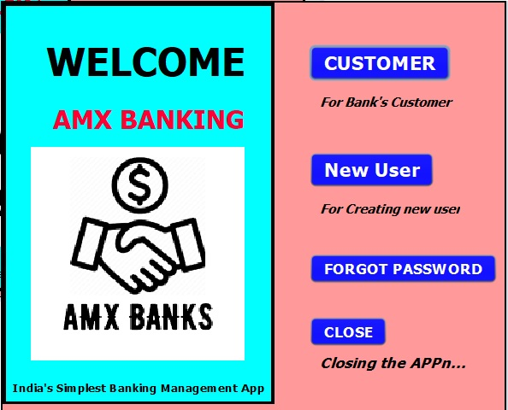

**CUSTOMER SIGN IN**

**PAGE**

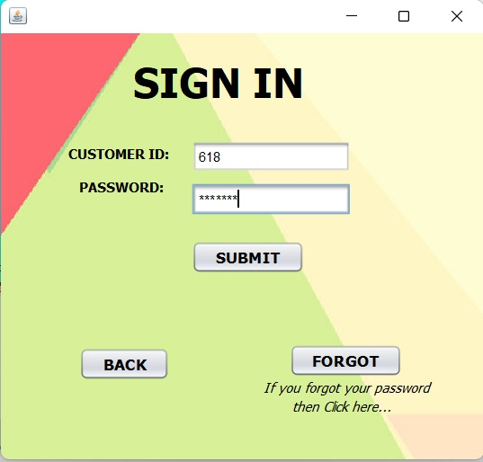

**SIGN UP FORM**

**PAGE**

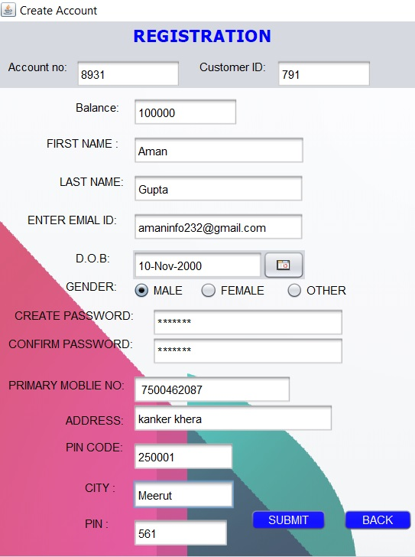

**FORGOT PAGE**

This page for recovering password.

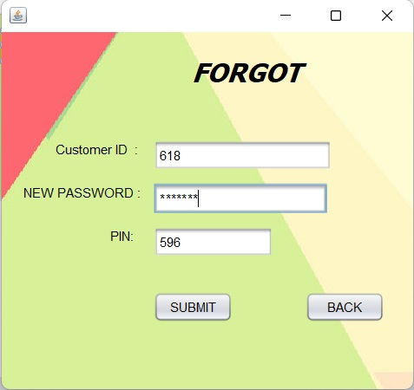

**MENU PAGE 1st**

You can see the Profile of user

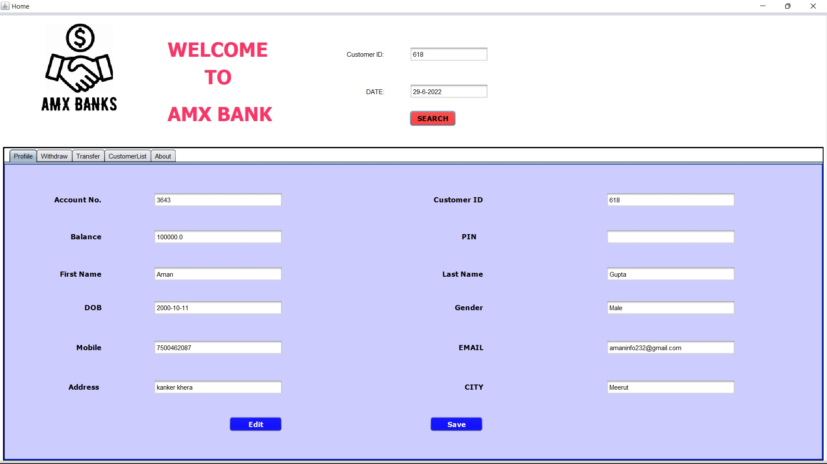

**MENU PAGE 2nd**

You can withdraw the money

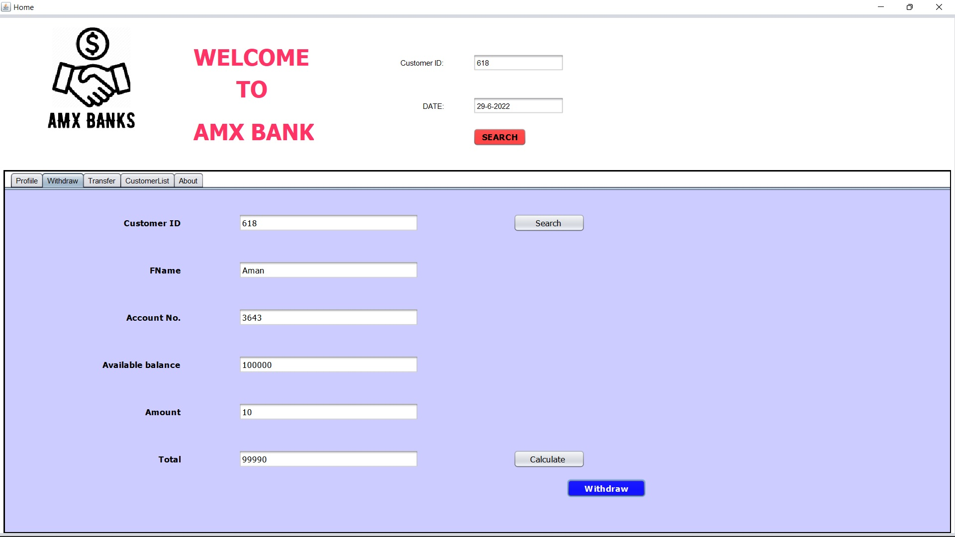

**MENU PAGE 3rd**

You can transfer the Money

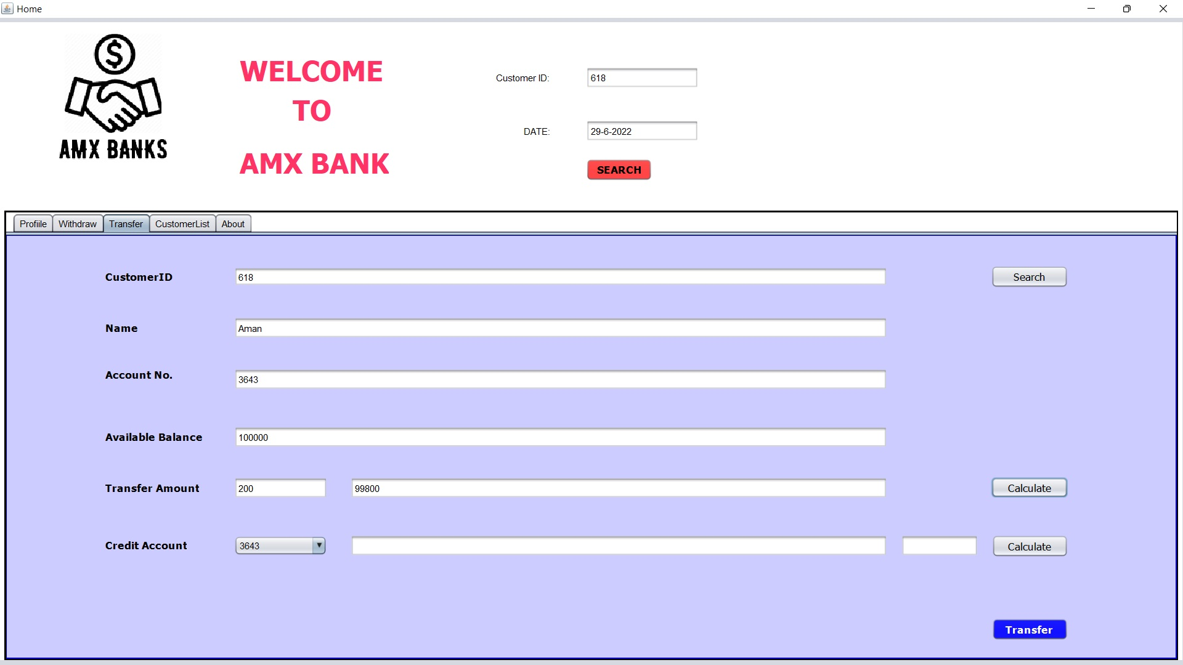

**MENU 4th**

You can see information about Customers.

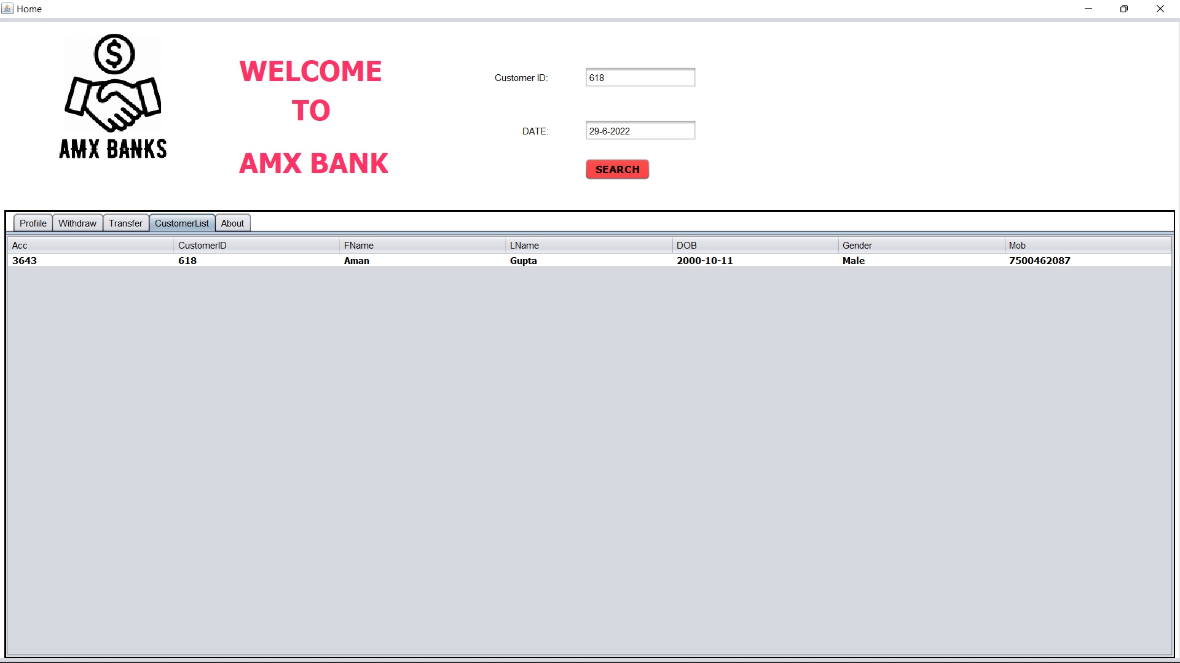

**MENU 5th**

You can about the Application

