|  |  |  |  |  |  |
| --- | --- | --- | --- | --- | --- |
| |  |  |  | | --- | --- | --- | | **المــمـــــــــلكــــة العـربية الســــــعودية**  **بــينبع الـــــــهـــــــــــيـــــئة الملــــــكـــــــية**  **قــــطـــاع الـكــــــــــــلــيات والـمــعــاهـد** | Description: YUC | **Kingdom of Saudi Arabia**  **Royal Commission at Yanbu**  **Colleges & Institutes Division** | | **كـــــلية ينبع الجــــــــــــــــامـــــــــــعية**  **قسم علوم وهندسة الحاسب الألي**  **قسم تقنية المعلومات والحاسب الآلي** | **Yanbu University College**  **Computer Science & Engineering Dept.**  **Information & Computer Technology Dept.** |   ASSIGNMENT 2 |
| **ACADEMIC YEAR**  1442/1443 H(2021/2022 G)**,** SEMESTER II (212) |

|  |
| --- |
| **OBJECT ORIENTED WEB DEVELOPMENT**  CS 382 |

|  |  |  |  |
| --- | --- | --- | --- |
| **DATE:** | **Sunday, March 27, 2022** | **START TIME:** | 10:00 AM |
| **FINISH TIME:** | 10-04-22 (1:05 PM) |

|  |  |  |  |
| --- | --- | --- | --- |
| **STUDENT NAME:** | Assail khalid Almajnouni | | |
| **STUDENT ID:** | |  |  |  |  |  |  |  |  |  |  | | --- | --- | --- | --- | --- | --- | --- | --- | --- | --- | | 3 | 9 | 1 | 0 | 8 | 6 | 3 |  |  |  | | **SECTION:** | 1 |

|  |  |
| --- | --- |
| **FOR INSTRUCTOR USE ONLY** | **GENERAL INSTRUCTIONS** |

|  |  |  |  |  |
| --- | --- | --- | --- | --- |
| **Q. No.** | **CLOs** | **MAX MARK** | **MARKS OBTAINED** | * Write your name and I.D. number in the space provided above. * Support materials are not allowed in the examination Hall except those provided by instructor. * Do not use digital or printed dictionary. * Do not use pencils for answering except for drawing. * Read each question carefully before answering. * Number shown on the right-hand side against each question is the mark allocated. |
| **1** | **2.01** | **10** |  |
| **2** |  |  |  |
| **3** |  |  |  |
| **4** |  |  |  |
| **5** |  |  |  |
| **TOTAL MARKS** | |  |  |

|  |  |
| --- | --- |
| **MARKED BY:** | **Signature: KAJAL NUSRATULLAH** |
| **CHECKED BY:** | **Signature:** |

Student is supposed to visit the following link.

<https://www.tutsmake.com/how-to-fetch-data-from-database-in-php-using-ajax/>

Follow the link and create a plugin that can retrieve the data from the database via jQuery Ajax function.

* Students are supposed to submit the assignment in word format.
* Take the snapshot of code and output and paste it in word document.
* Do include the title page of Assignment with your name and id.

THE DATABASE:

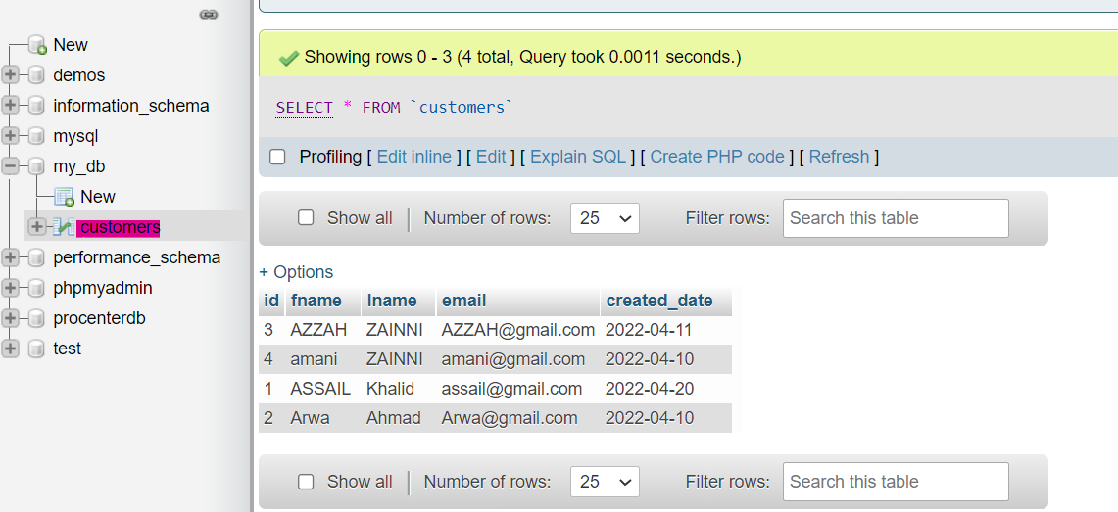

customers.php page:

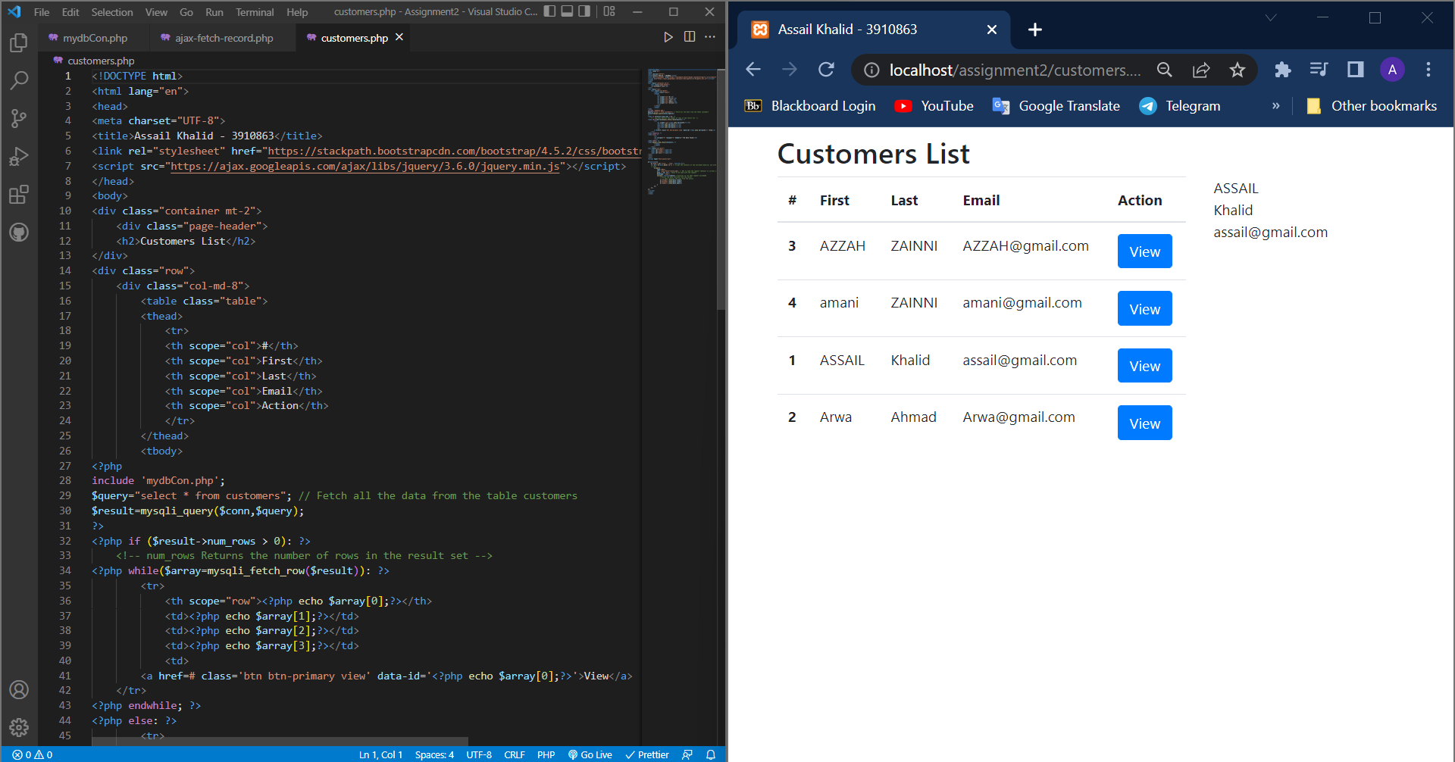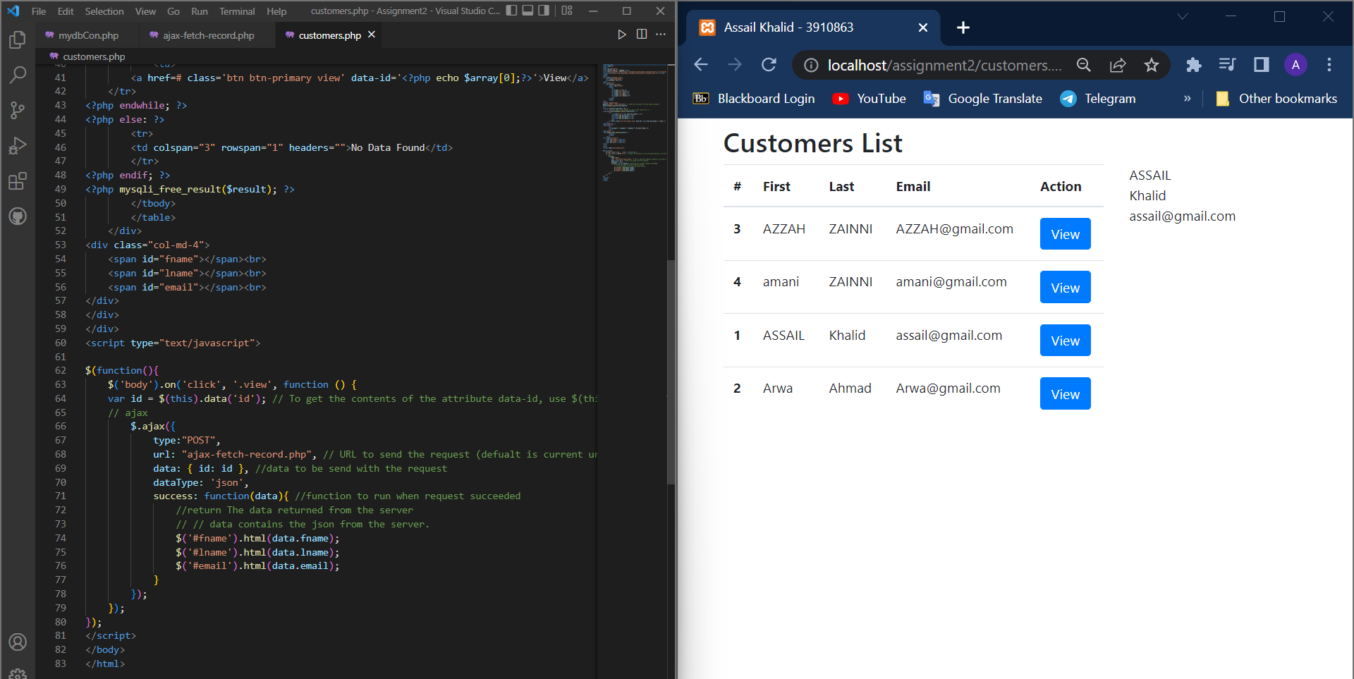

ajax-fetch-record.php page:

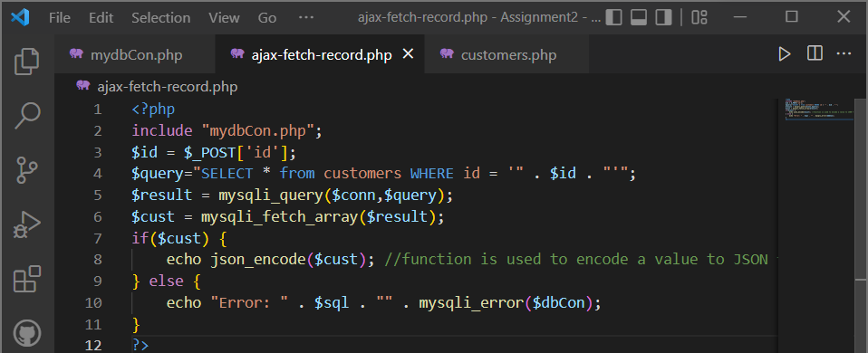

mydbCon.php page:

