**Software Requirements**

**Specification**

Team No. 4

**Table of Contents**

1. **Introduction**
   1. **Purpose.**
   2. **Intended Audience**

# Primitive requirements

* 1. **Diagram**
  2. **Data flow for visitor**
  3. **Programming languages**

# External Interface Requirements

* 1. **User Interface**
  2. **User Case.**
  3. **Hardware Interfaces.**

# Other Nonfunctional Requirements

* 1. **Performance Requirements.**

**1. Introduction**

The Horror Dosage is to provide a single platform to collect the preferences that its user wants from all teaching, launching and selling products for horror making technical.

1.1 Purpose

**1. Introduction**

The site serves the interested groups with ephemeris representation and amateurs that want to learn, companies and trainers.

1.2 Intended Audience

* 1. 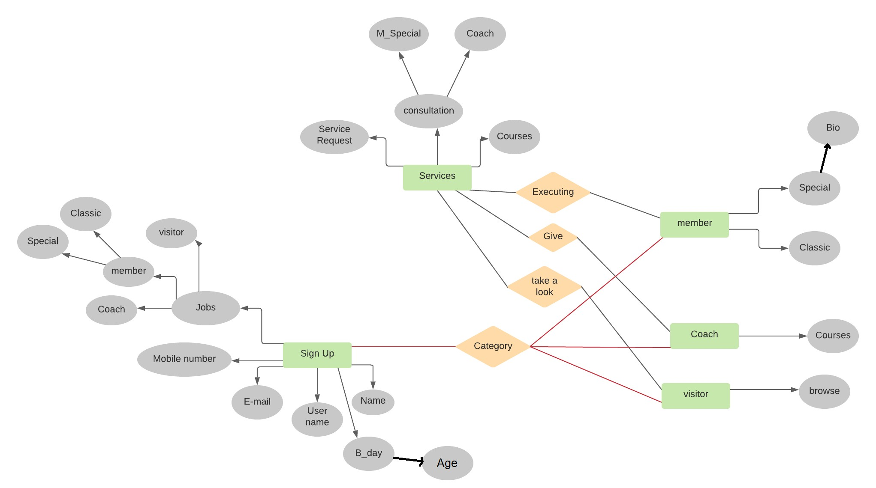**Diagram**

**2. Primitive requirements**



* 1. **Data flow for visitor:-**

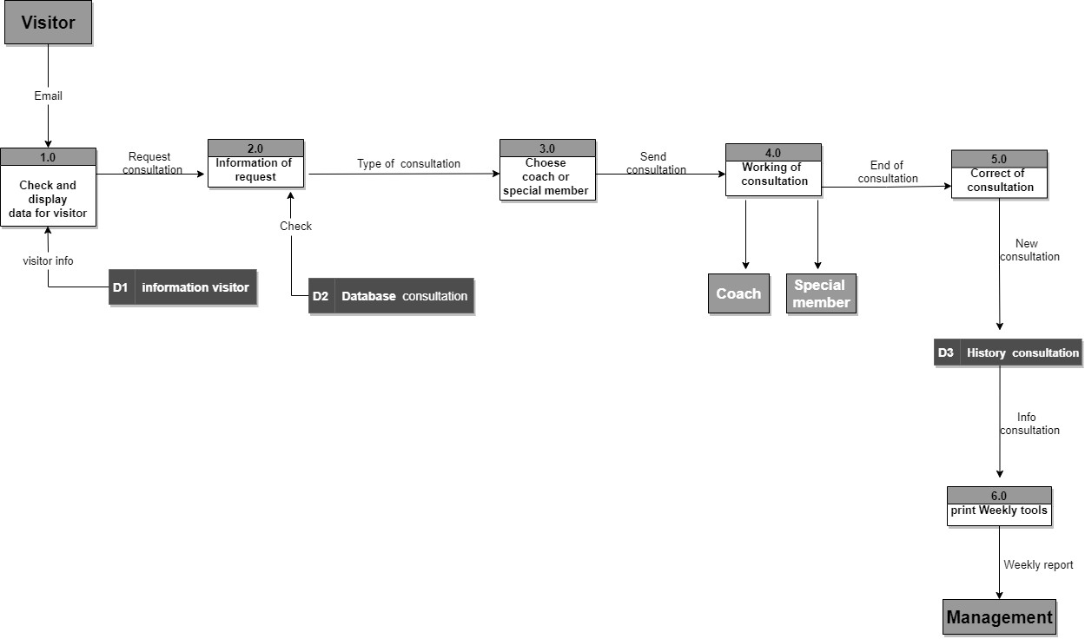

**2. Primitive requirements**

**2. Primitive requirements**

In our project, we used languages of programming which in turn has built user interfaces and recent operations, HTML, PHP.

2.3 Programming

languages

**3. External Interface Requirements**

A very rudimentary user interface was designed in order to see how the system works, which is creating a new account or entering a previous account with the ability to change the password when forgetting it.

3.1

User Interfaces

When entering data, the user is directed to the other page, which is the contents of the program with the addition of examples of sections with the presence of the boxes.

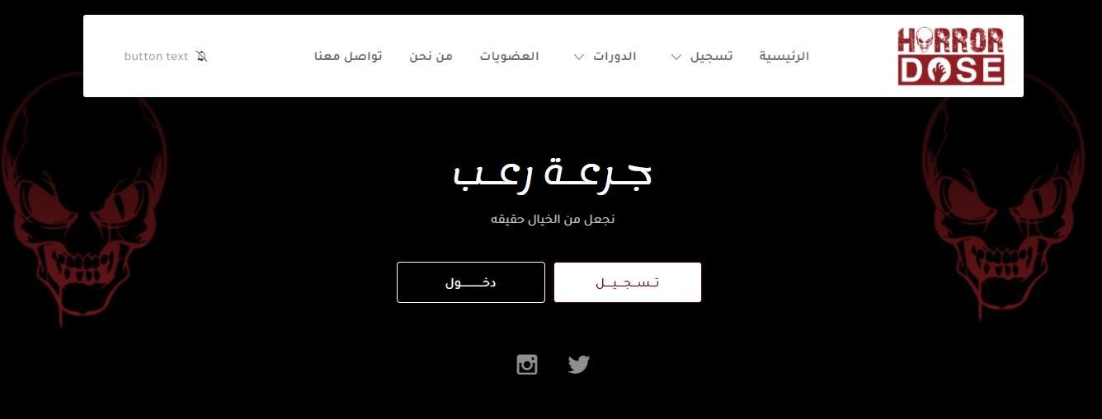**User Interfaces**



**3.2User case**

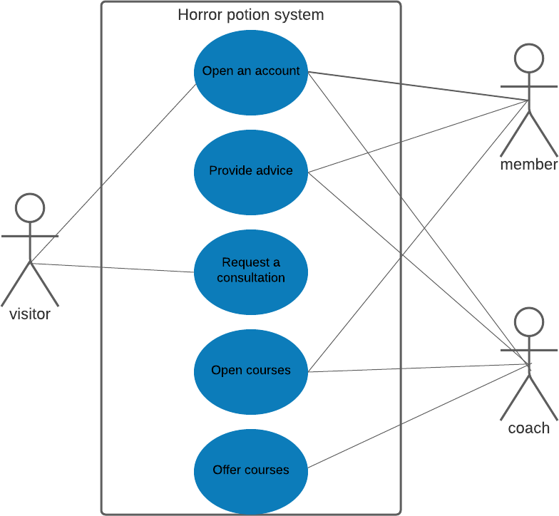



**3. External Interface Requirements**

The programs are designed as a website, with all the different screens, computers and phone devices compatible with the ability to connect and move to social networking sites when adding content from them, it works on all search engines Google Firefox and others as well.

3.3 Hardware Interfaces.

**4. Other Nonfunctional Requirements**

The system performance is not suitable for all ages, a flexible and easy navigation and movement between sections, does not need permanent development to avoid any performance problems

4.1 Performance Requirements