Script_InsectSprays_-R.R

Usuario

2025-05-30

# Tamara Martinez Martinez  
# 2067694  
# 30/05/2025  
  
# Examen  
  
data("InsectSprays")  
  
boxplot(InsectSprays$count ~ InsectSprays$spray,  
 main = "Conteo de insectos por tipo de spray",  
 xlab = "Spray",  
 ylab= "Conteo de insectos",  
 col= "Skyblue")

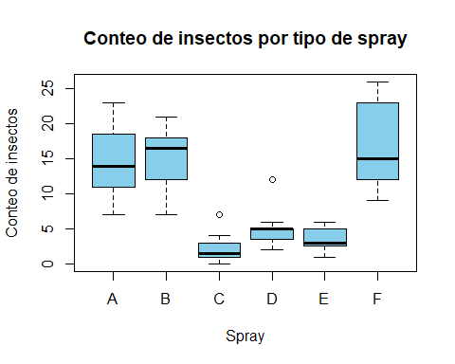

tapply(InsectSprays$count, InsectSprays$spray, mean)

## A B C D E F   
## 14.500000 15.333333 2.083333 4.916667 3.500000 16.666667

tapply(InsectSprays$count, InsectSprays$spray, length)

## A B C D E F   
## 12 12 12 12 12 12

bartlett.test(InsectSprays$count ~ InsectSprays$spray)

##   
## Bartlett test of homogeneity of variances  
##   
## data: InsectSprays$count by InsectSprays$spray  
## Bartlett's K-squared = 25.96, df = 5, p-value = 9.085e-05

shapiro.test(InsectSprays$count)

##   
## Shapiro-Wilk normality test  
##   
## data: InsectSprays$count  
## W = 0.9216, p-value = 0.0002525

InsectSprays$Coun.sqrt <- sqrt(InsectSprays$count)  
 shapiro.test(InsectSprays$Coun.sqrt)

##   
## Shapiro-Wilk normality test  
##   
## data: InsectSprays$Coun.sqrt  
## W = 0.96728, p-value = 0.05765

InsectSprays.aov <- aov(InsectSprays$Coun.sqrt ~ InsectSprays$spray)  
summary(InsectSprays.aov)

## Df Sum Sq Mean Sq F value Pr(>F)   
## InsectSprays$spray 5 88.44 17.688 44.8 <2e-16 ***  
## Residuals 66 26.06 0.395   
## ---  
## Signif. codes: 0 '***' 0.001 '**' 0.01 '*' 0.05 '.' 0.1 ' ' 1