Script_2_-importada_-R.R

Usuario

2025-05-30

# Tamara Martinez Martinez   
# 2067694  
# 31/03/2025  
  
# La funcion read sirve para importar datos  
trees <- read.csv ("Practica 2.csv", header = T)  
  
# La funcion as.factor sirve para convertir caracteres a factores  
trees$Especies <- as.factor(trees$Especies)  
trees$Crown <- as.factor(trees$Crown)   
  
# Grafica  
boxplot(trees$Diameter~ trees$Especies,  
 xlab = "Especies", # etiqueta del eje x  
 ylab = "Dbh (cm)", # etiqueta del eje y  
 col = "blue", # color de las cajas   
 main = "Inventario", # Titulo de grafica   
 ylim = c(5,25)) # Ampliar limites eje

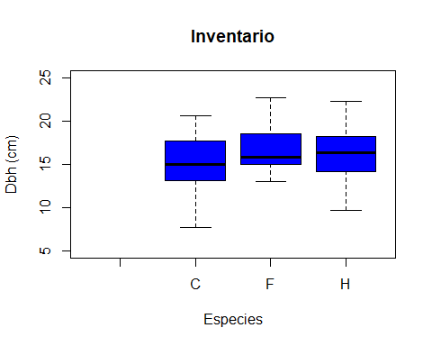

# Grafica de altura   
boxplot(trees$Height..m. ~ trees$Especies,  
 xlab = "Especies",  
 ylab = "Height (m)",  
 col= "yellow",  
 main ="Inventario",  
 ylim = c(5,25))

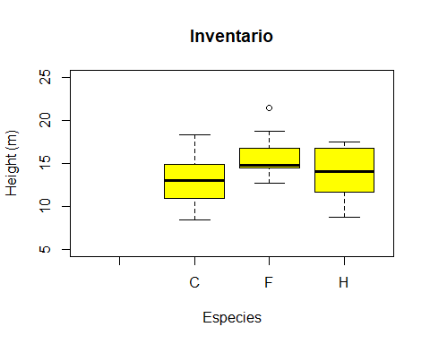

# Histograma de altura  
hist(trees$Height..m.,  
 xlab = "Height (m)",  
 ylab = "Frecuencia",  
 main = "Categorias de altura",  
 col = "violet")

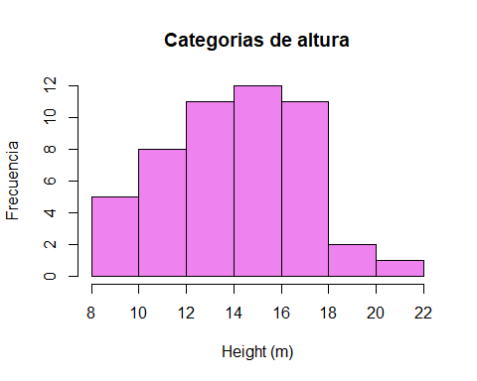

# Hoja y tallo   
stem(trees$Height..m.)

##   
## The decimal point is at the |  
##   
## 8 | 5578  
## 10 | 024923457  
## 12 | 03678224889  
## 14 | 235566788923  
## 16 | 01378812458  
## 18 | 37  
## 20 | 5