**Name : Aman Jakhetiya**

**Enrollment: 9918103209**

**Batch: F8**

**Week 3**

Github Link: <https://github.com/Amanjakhetiya/OSS_LAB_3>

**Q1.**

characters_count = {}

paragraph="A paragraph is a series of related sentences developing a central idea, called the topic. Try to think about paragraphs in terms of thematic unity: a paragraph is a sentence or a group of sentences that supports one central, unified idea. Paragraphs add one idea at a time to your broader argument."

paragraph=paragraph.lower()

for i in paragraph:

if i not in characters_count:

characters_count[i]=1

else:

characters_count[i]+=1

print(characters_count)

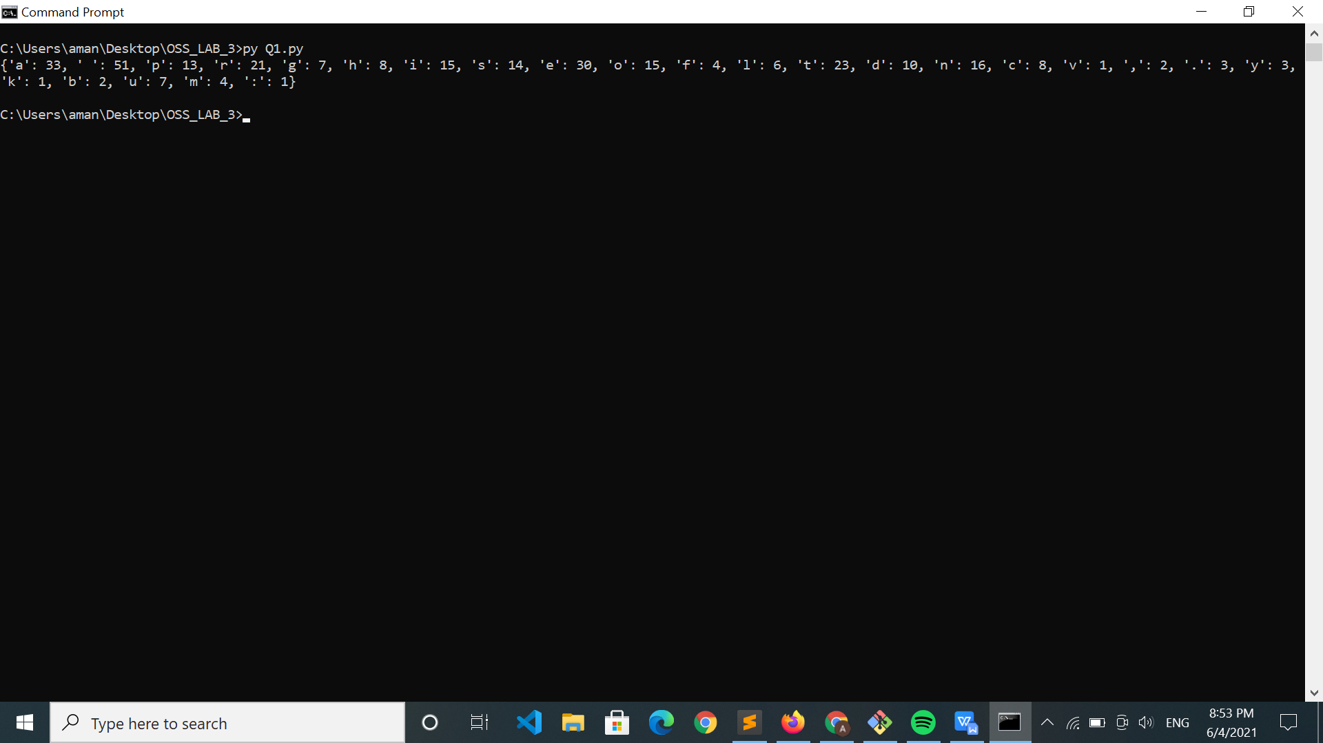

**Q3.**

l1=[1,2,3,4]

#list comprehension

print([i**2 for i in l1],end='\n')

#using map

def func(x):

return x**2

print(list(map(func,l1,)))

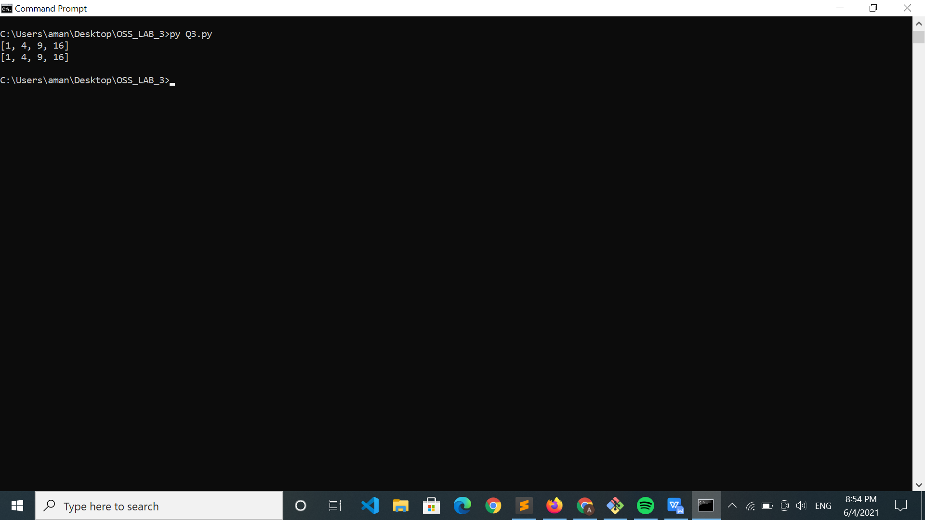

**Q4.**

l1=[1,2,3,4]

#list Comprehension

print([x for x in l1 if x%2==0])

#filter

print(list(filter(lambda x:x%2==0,l1)))

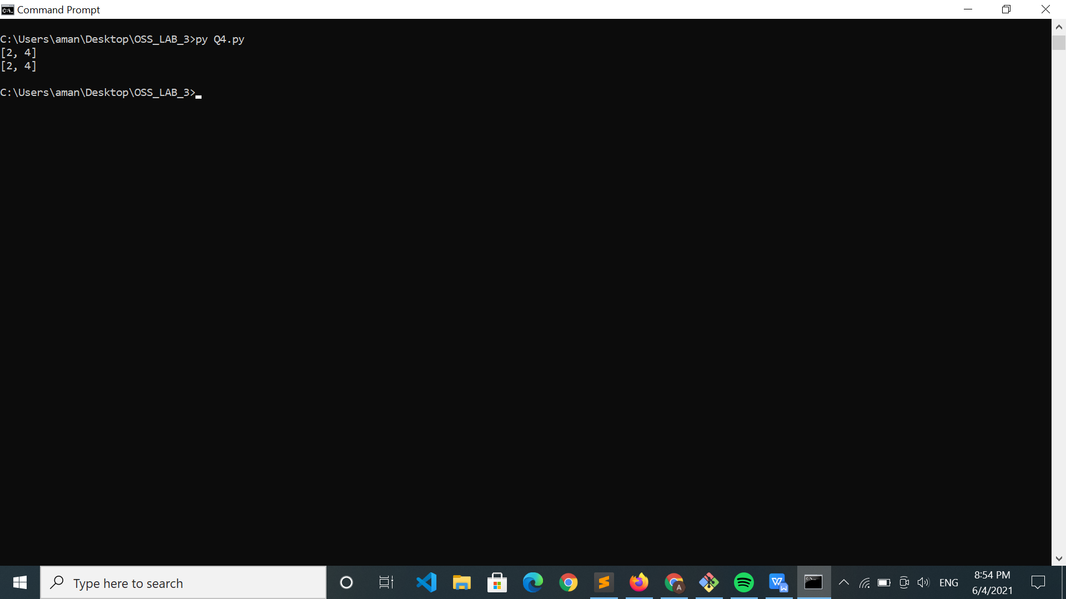

**Q5.**

def triplets(n):

ans=[]

for i in range(1,n):

for j in range(i+1,n):

if i+j<=n:

ans.append([i,j,i+j])

print(ans)

triplets(8)

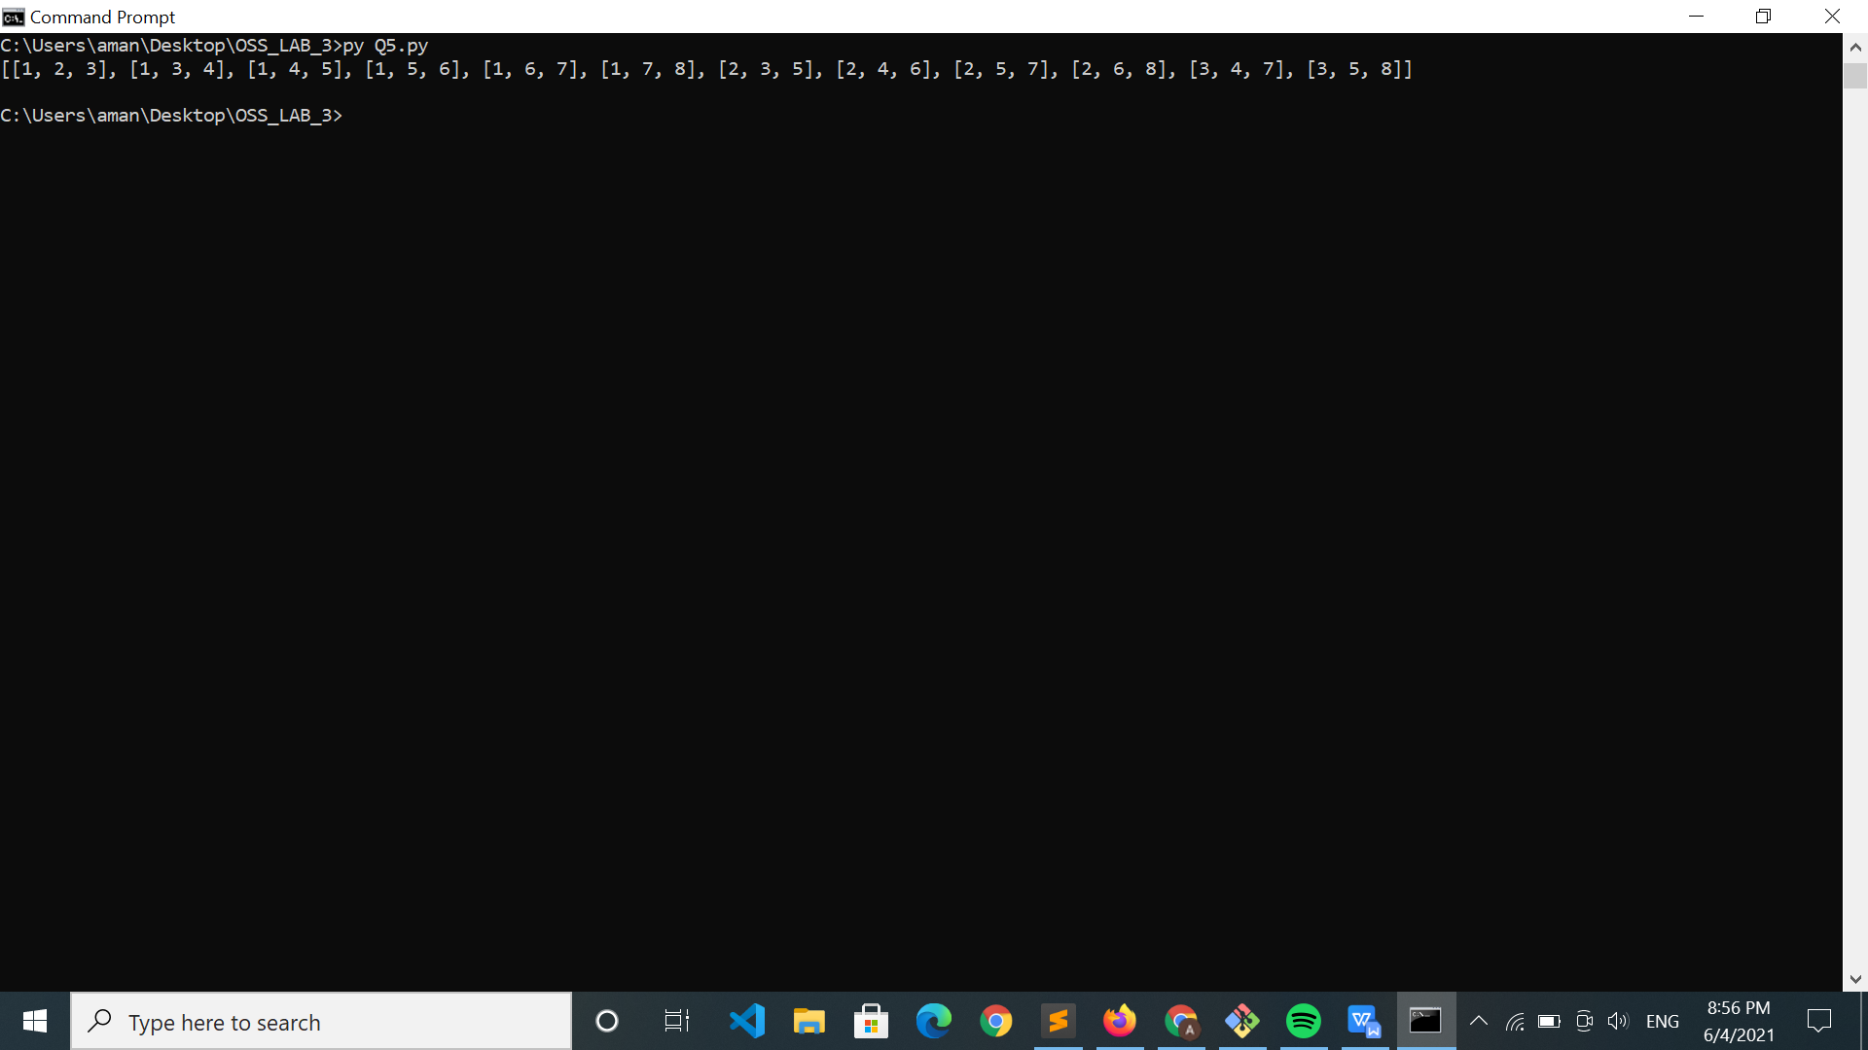

**Q6.**

def parse_csv(a):

return list(a.split(','))

a="My,name,is,aman,jakhetiya"

print(parse_csv(a))

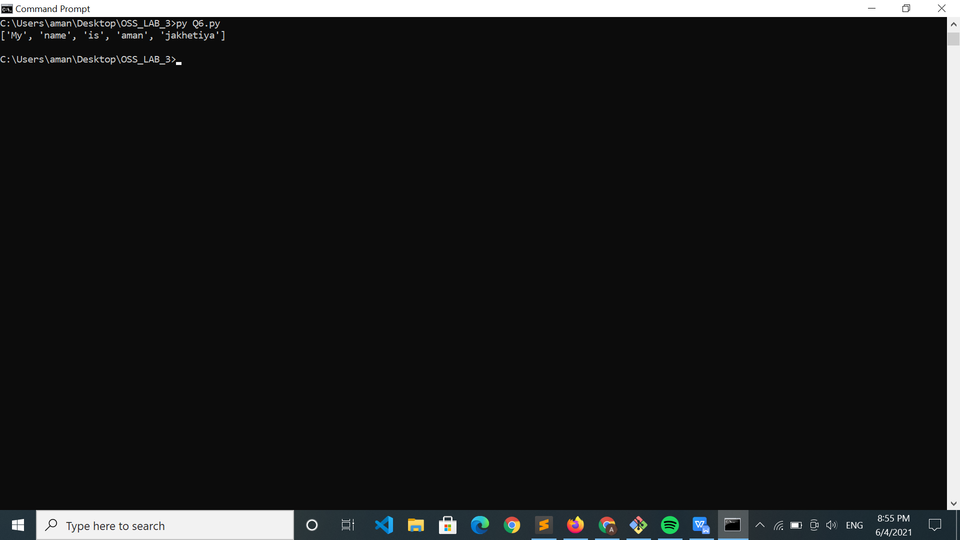

**Q7.**

import re

def parse_csv(a,delim):

return list(re.split('['+(" ".join(delim))+']',a))

a="My;name;is,aman!jakhetiya"

print(parse_csv(a,[';',',','!']))

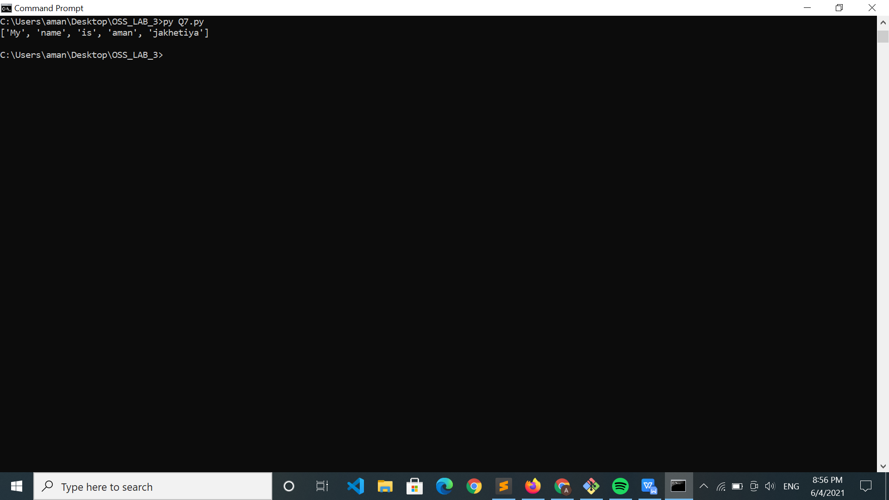

**Q9.**

def nearly_equal(a,b):

if (abs(len(a)-len(b))>=2): return False

if a==b: return True

c=0

a="".join(sorted(a))

b="".join(sorted(b))

for i,j in zip(a,b):

if i!=j:

c+=1

return c<=1

print(nearly_equal("abcd","abcs"))

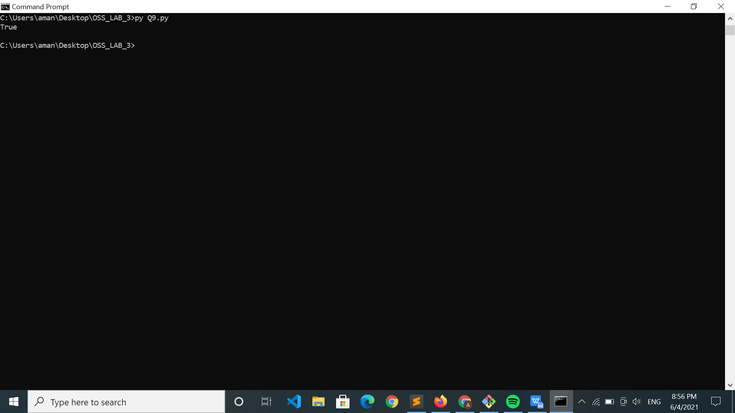

**Q10.**

ana = {}

l = ["owl","ate","tea","arm","ram","low","kol","eat",]

for i in l:

comp="".join(sorted(i))

if comp in ana:

ana[comp].append(i)

else:

ana[comp]=[]

ana[comp].append(i)

print(list(ana.values()))

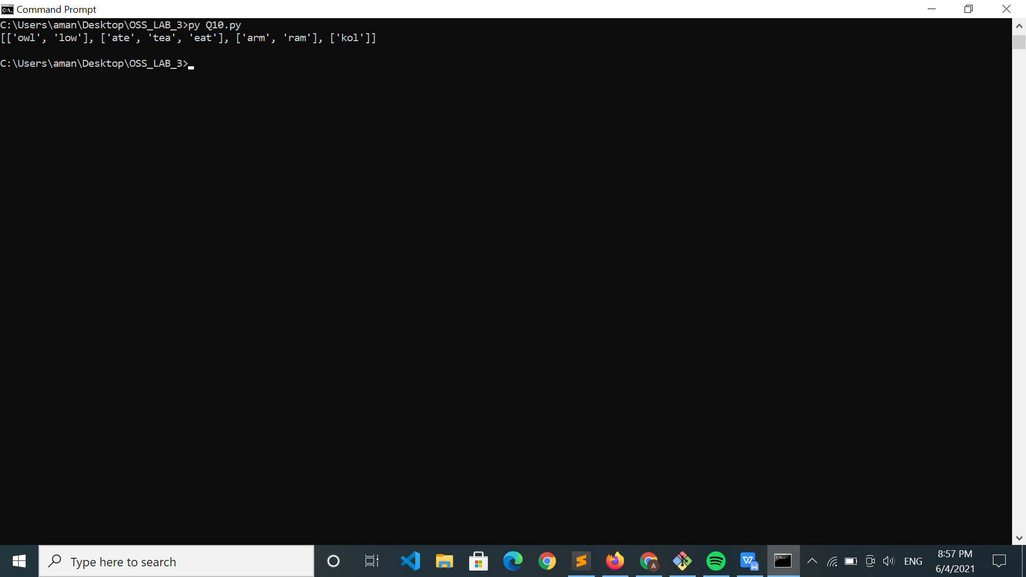

Q8. & Q2. Not Done