**Name : Aman Jakhetiya**

**Enroll: 9918103209**

**Batch: F8**

**Week 4**

**Q1.**

import numpy as np

A = np.array([0,10,20,40,60,80])

B = np.array([10,30,40,50,70])

ans=np.setxor1d(A,B)

print(ans)

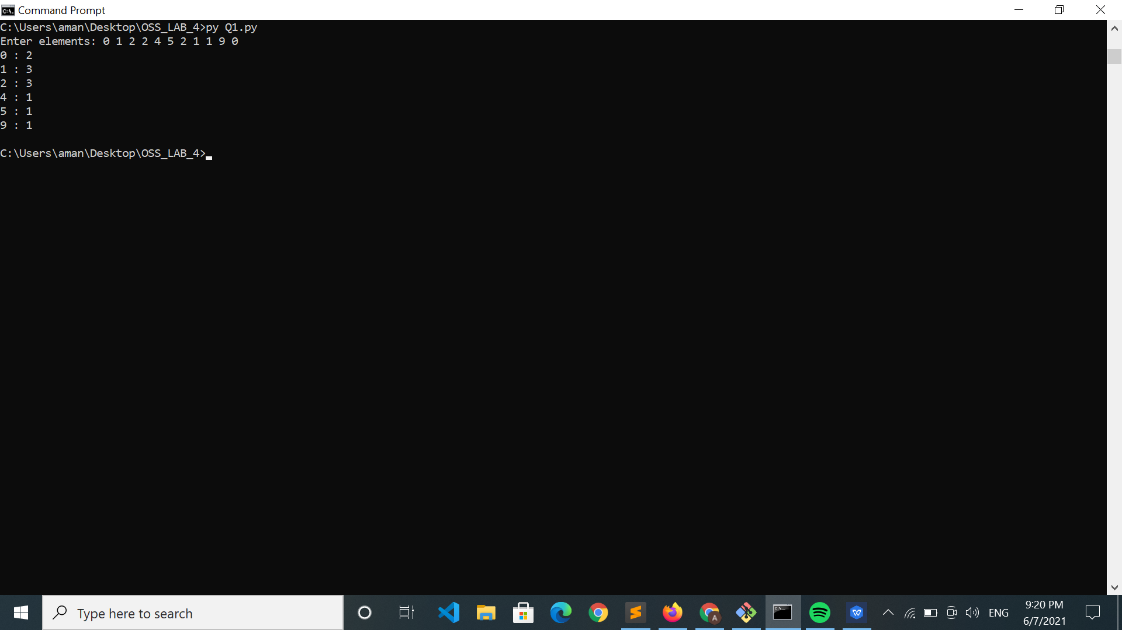

**Q2.**

import numpy as np

a = input("Enter the binary string : ")

l1 = list(map(int,a))

l1=np.array(l1)

ans=np.sum(l1)

# print(ans)

l1[:ans]=1

l1[ans:]=0

# l1=list(l1)

# print(''.join(l1))

# print("".join(l1))

print(l1)

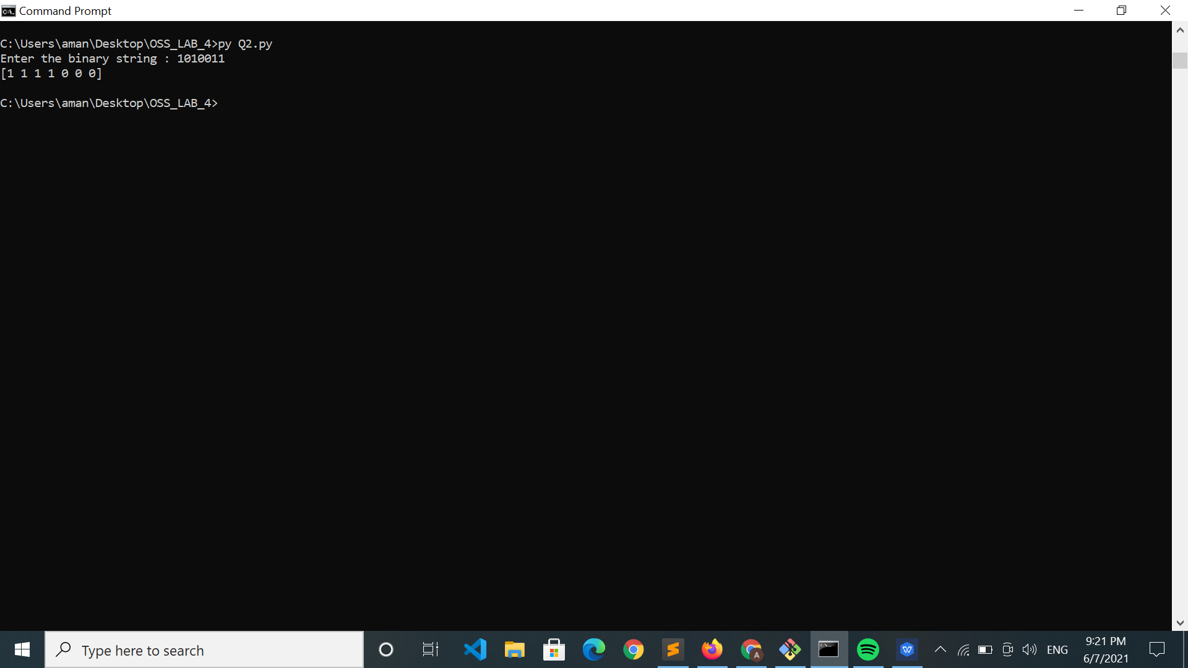

**Q3.**

import numpy as np

a = input("Enter string : ")

nth = int(input("Enter nth: "))

if len(a)<nth:

print("Not Possible")

else:

f=np.array([a[:nth]])

l=np.array([a[nth+1:]])

print(np.concatenate((f,l),axis=0))

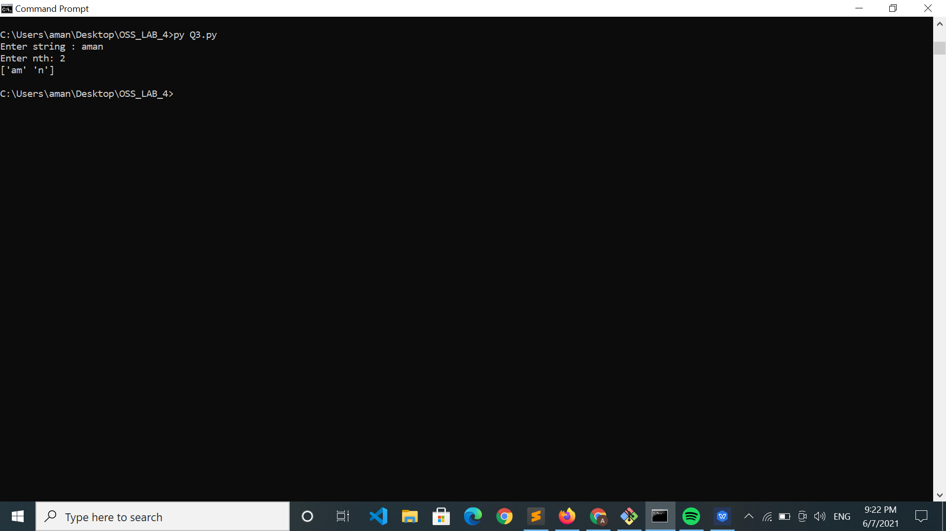

**Q4.**

import numpy as np

A = np.array([0,10,20,40,60])

B = np.array([0,40])

ans = np.in1d(A,B)

print(ans)

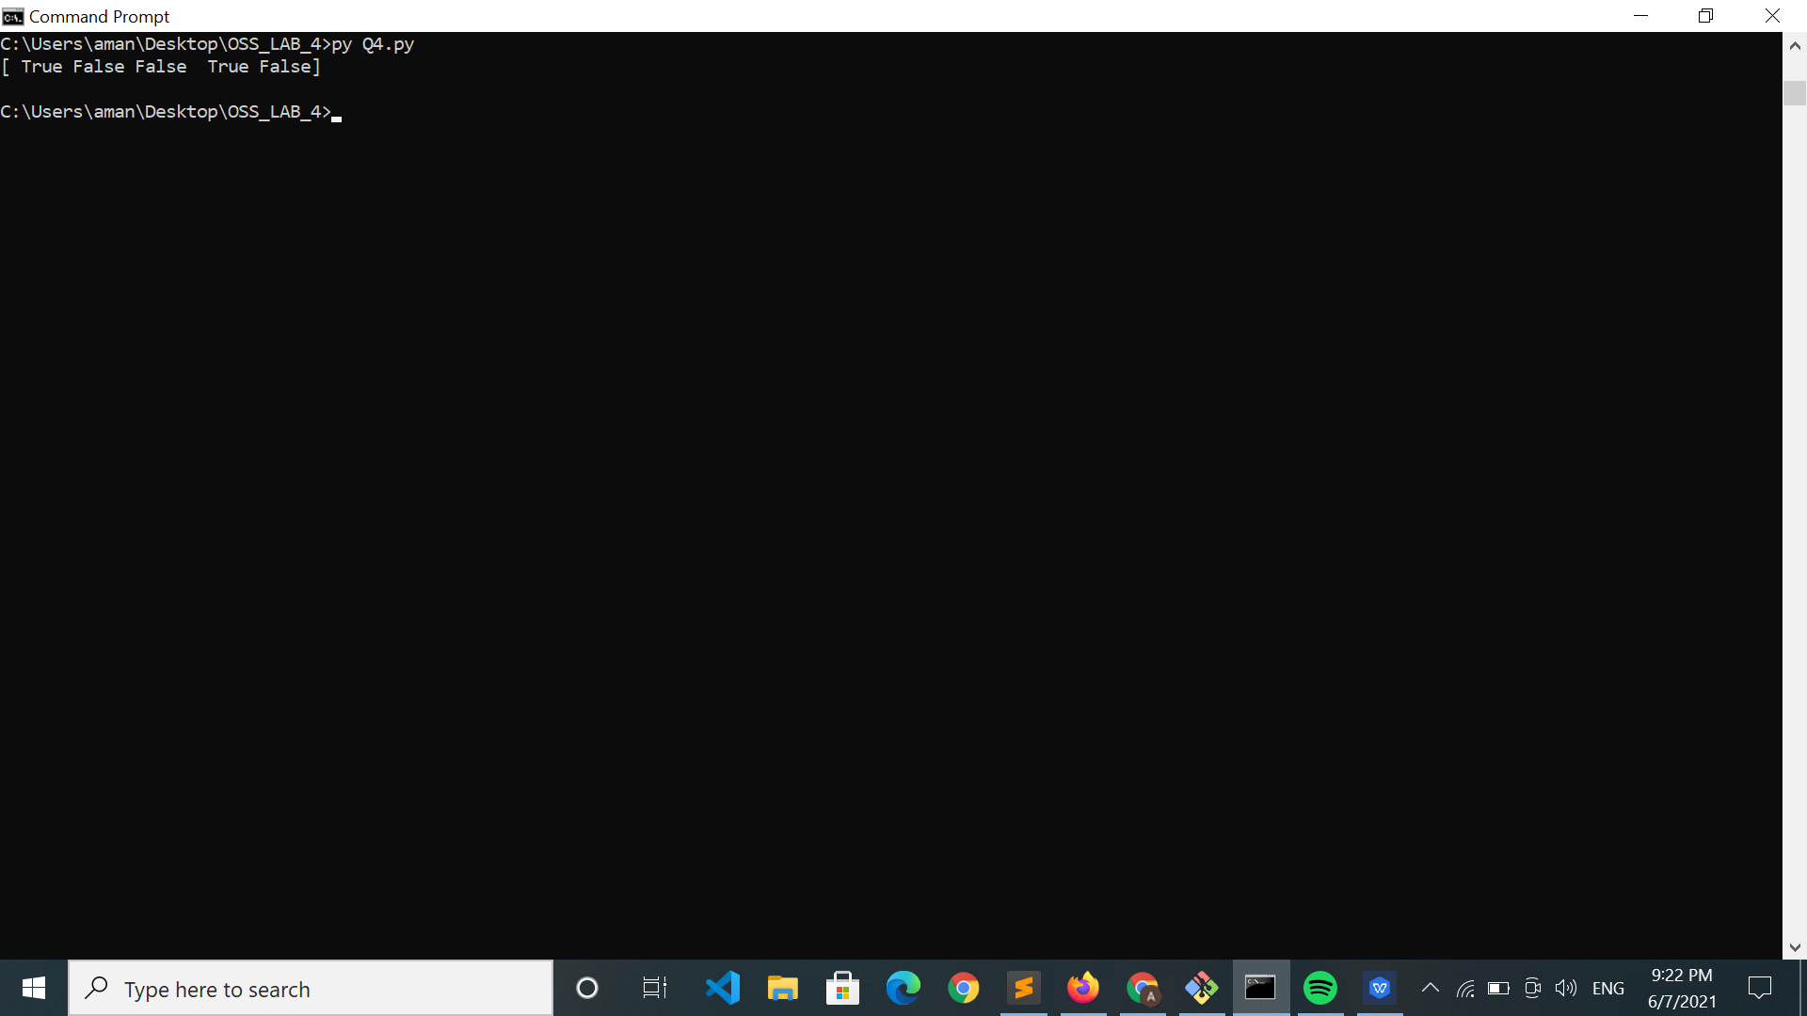

**Q5.**

import numpy as np

A = np.array([0,10,20,40,60,80])

B = np.array([10,30,40,50,70])

ans=np.setxor1d(A,B)

print(ans)

