**Name : Aman Jakhetiya**

**Enroll: 9918103209**

**Batch: F8**

**Week 5**

**Github Link:** <https://github.com/Amanjakhetiya/OSS_LAB_5>

Q1.

X = np.linspace(-np.pi,np.pi,7,endpoint=True)

SIN=np.sin(X)

COS=np.cos(X)

TAN=np.tan(X)

COT=np.arctan(TAN)

SEC=np.arccos(COS)

COSEC=np.arcsin(SIN)

plt.figure(figsize=(8,5),dpi=80)

plt.plot(X,TAN,color='blue',linewidth=2.5,linestyle='-',label='tan')

plt.plot(X,COT,color='green',linewidth=2.5,linestyle='--',label='cot')

plt.plot(X,SEC,color='red',linewidth=2.5,linestyle='-.',label='sec')

plt.plot(X,COSEC,color='black',linewidth=2.5,linestyle=':',label='cosec')

plt.legend(loc='upper center')

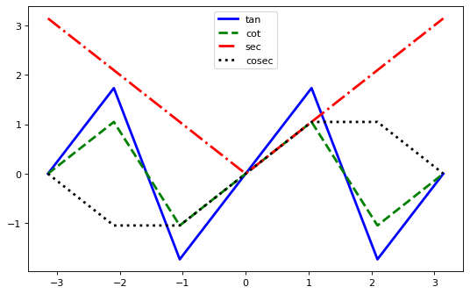

Q2.

A=np.array([2,5,8,5])

B=np.array([3,2,5,7])

lab=['A','B','C','D']

x1 = np.arange(len(A))

x2 = [x + 0.25 for x in x1]

plt.bar(x1,A,width=0.25,label='result1')

plt.bar(x2,B,width=0.25,label='result2')

plt.xticks(x2,lab)

plt.show()

