Indian Institute of Information Technology, Allahabad

Department of Information Technology
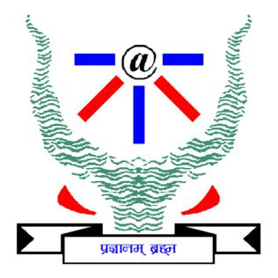

Image and Video Processing Course 2021
 | Progress Report
 | on
 | Smart Agro Kit
 | as
 | part of C1 assessment
 | by
Name |  | Enrollment Number
Mrityunjaya Tiwari |  | IIT2019239
Raunak Singh Rathore |  | IIT2019222
Amanjeet kumar |  | IIB2019006
Jyoti Verma |  | IIT2019202
Noonsavath Sravana Samyukta |  | IIT2019236
Raj Chandra |  | IIT2019200

Contents

1 | Abstract |  | 1
2 | Introduction |  | 1
3 | Literature Survey |  | 1
4 | Methodology being used |  | 1
 | 4.1 | Image Acquisition : . . . . . . . . . . . . . . . . . . . . . . . . . . . . . . . . . . . . . . . . . . . . . . | 1
 | 4.2 | Image Segmentation: . . . . . . . . . . . . . . . . . . . . . . . . . . . . . . . . . . . . . . . . . . . . . | 2
 | 4.3 | Classi cation: . . . . . . . . . . . . . . . . . . . . . . . . . . . . . . . . . . . . . . . . . . . . . . . . . | 2
 | 4.4 | Sending alerts: . . . . . . . . . . . . . . . . . . . . . . . . . . . . . . . . . . . . . . . . . . . . . . . . | 2
5 | Datasets being used |  | 3
6 | Results and Discussion |  | 4
7 | Conclusion |  | 4
8 | Individuals contribution |  | 5
 | 8.1 | IIT2019239: Mrityunjaya Tiwari . . . . . . . . . . . . . . . . . . . . . . . . . . . . . . . . . . . . . . | 5
 | 8.2 | IIB2019006: Amanjeet Kumar . . . . . . . . . . . . . . . . . . . . . . . . . . . . . . . . . . . . . . . . | 5
 | 8.3 | IIT2019222: Raunak Singh Rathore . . . . . . . . . . . . . . . . . . . . . . . . . . . . . . . . . . . . | 5
 | 8.4 | IIT2019202: Jyoti Verma . . . . . . . . . . . . . . . . . . . . . . . . . . . . . . . . . . . . . . . . . . | 5
 | 8.5 | IIT2019236: N Samyukta . . . . . . . . . . . . . . . . . . . . . . . . . . . . . . . . . . . . . . . . . . | 5
 | 8.6 | IIT2019200: Raj Chandra . . . . . . . . . . . . . . . . . . . . . . . . . . . . . . . . . . . . . . . . . . | 5
9 | References |  | 5

i

- Abstract

One of the important and tedious tasks in agricultural practices is detection of disease on crops. It requires a huge amount of time as well as skilled labor. So for detection of diseases on crops we propose a smart and e cient technique which uses image processing and IoT techniques that analyse crops and send alerts with disease names and how to prevent as well to the farmers.

- Introduction

we know Mostly Farmers live long distance from their eld, they have to walk everyday to see the status of the crop and also Farmers owns multiple elds, but are away from each-other,being updated at all time for Farmers about the rainfall status, humidity and climatic conditions priory isn’t possible many times This is the reason for many crops failure. As a solution the aim of our project work is to develop a reliable and easy to use system for use by farmers. The major goal of the project is to make farmers update about their crops anytime. What we are gonna do is We’ll set a camera in our kit that clicks photos of crops that will take readings continuously through the micro controller and send them to the cloud . We’ll train a deep learning model for detection of diseases of crops. If any disease will be detected by our model, then it will send alerts with disease names and how to prevent as well. and also manually farmers can take pictures of crops and then the system will check whether everything in crops is ok or not then will notify farmers about it.

- Literature Survey

Plant diseases are generally caused by infectious agents such as fungi, bacteria, and viruses. Signs of plant disease are observable evidence of infection and symptoms are the visible e ects of these kinds of disease.

Fungal infections cause signs like visible spores, mildew, or mold and the basic symptoms are like leaf spot and yellowing. Fungal diseases are plant infections caused by fungi. Fungi can be single or multicellular, but either way infect plants by stealing nutrients and breaking down tissue. Fungal diseases are the most common infection in plants.

Fungi infections can be recognized by symptoms like spots on plant leaves, yellowing of leaves, and birds-eye spots on berries. With some fungal diseases, the organism itself can actually be viewed on the leaves as a growth and as a mold .

- Methodology being used

The process of developing Smart Agro kit basically involves four phase:

4.1 Image Acquisition :

In this phase, images of plant leaves are gathered using digital media with desired resolution and size. Smart Agro kit consists of a camera system to capture real time photos of crops at some interval and this camera is connected to a micro controller that will send images to the cloud for disease detection . Users can also upload crop images on the web .

1

4.2 Image Segmentation:

This phase aims at simplifying the representation of an image such that it becomes more meaningful and easier to Analyze. There are various methods using which images can be segmented such as k-means clustering, Otsu’s algorithm and thresholding etc. The k-means clustering classi es objects or pixels based on a set of features into K number of classes. The classi cation is done by minimizing the sum of squares of distances between the objects and their corresponding clusters.

4.3 Classi cation:

This classi cation phase implies to determine if the input image is healthy or diseased. We are training a model to detect crop diseases with di erent di erent data sets . We are currently working on model training .
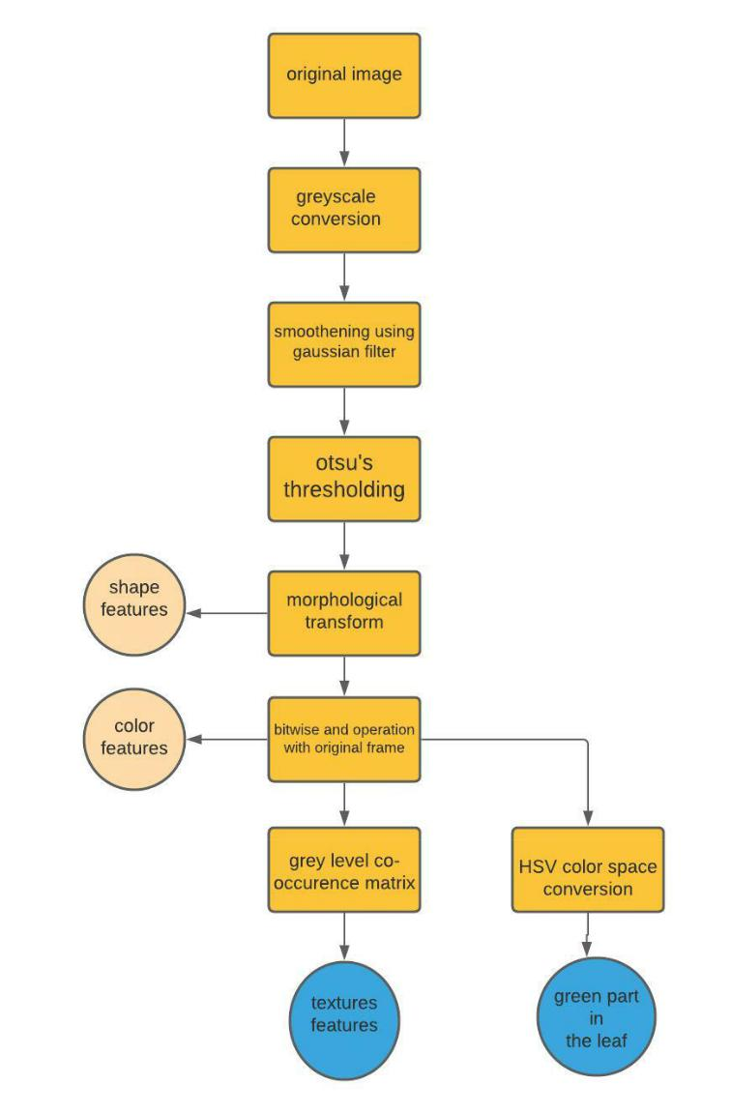

4.4 Sending alerts:

Crop’s images are clicked by camera system and sent by microcontroller to cloud for disease detec-tion. If there is any disease detected then SMS/mail will be sent out to the farmers with disease

2

names as well as prevention methods of that particular disease . We are using Twilio API for sending text alerts and Mailgun API for sending emails .
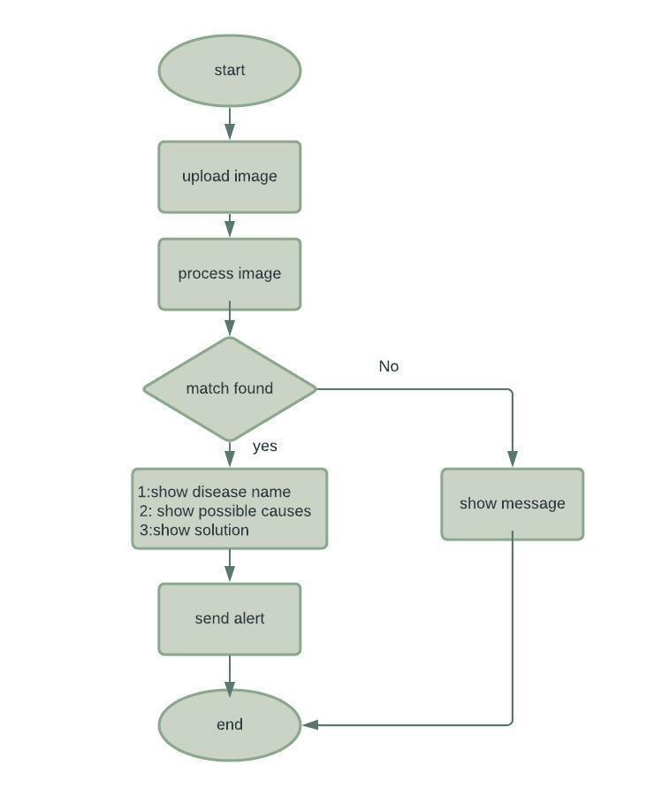

- Datasets being used

For this project we have used a public data set for plant leaf disease detection.

Kaggle Link of datasets:
https://www.kaggle.com/vipoooool/new-plant-diseases-dataset

3

Sample images of datasets:
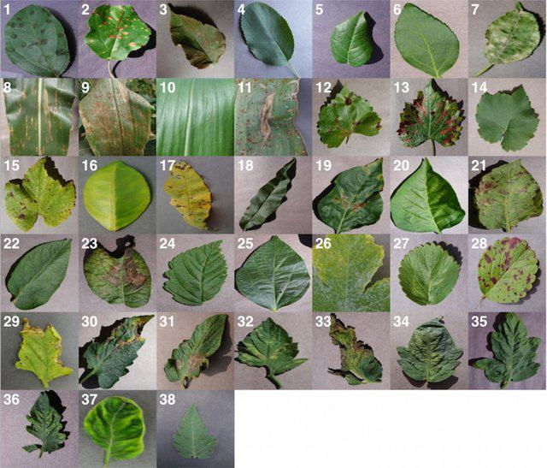

- Results and Discussion

There are two di erent conditions for training and testing. One is under the lab conditions, which means that the model is tested with the images from the same dataset from which it is used for both training and testing. The other condition is that eld condition; this means that our model has been tested with the images taken from the real world conditions (land). Since the lighting conditions and background properties of the images are totally di erent when we take samples from the real eld, there is a chance that our model to produce a very low accuracy, when comparing to the accuracy values acquired during the lab conditions.

So to overcome this impact, we had an idea of having a mixed variety of images during the training phase .

- Conclusion

So in the proposed project system, by using image processing and IoT techniques that are capable of monitoring the crops, analysing the disease names and also sending alerts to the farmers. The system consists of both hardware and software parts. Di erent Argo sensors are used to detect

4

the diseases and take readings continuously through micro controller and send data to the cloud.

If readings are not in range of threshold values then the system will send alerts via sms.

- Individuals contribution

8.1 IIT2019239: Mrityunjaya Tiwari

My contribution on this project is to connect micro controller with cloud and deploying model on Amazon AWS . I also contributed in documentation and designing the webpages.

8.2 IIB2019006: Amanjeet Kumar

My contribution on this project is to train model for disease detection , linking model with Twillo

- Mailgun APIs and contributed in documentation. I also designed the UML diagrams for the project.

8.3 IIT2019222: Raunak Singh Rathore

My contribution on this project is to train ML model and deploying model on Amazon AWS . I also contributed in documentation .

8.4 IIT2019202: Jyoti Verma

My contribution on this project is to train model for disease detection , linking model with Bolt clouds APIs and I also contributed in documentation.

8.5 IIT2019236: N Samyukta

My contribution on this project is to nd out datasets project development . I also contributed in documentation and designing the webpages.

8.6 IIT2019200: Raj Chandra

My contribution on this project is to develop webpages and I also contributed in documentation.

- References

  - https://ieeexplore.ieee.org/document/8697390

  - S. D.M., Akhilesh, S. A. Kumar, R. M.G. and P. C., "Image based Plant Disease Detection in Pomegranate Plant for Bacterial Blight," 2019 International Conference on Communication and Signal

  - Identifying two tomato leaf viruses using a support vector machine, in: Information Systems

Design and Intelligent Applications : U. Mokhtar, M.A. Ali, A.E. Hassanien, H. Hefny,

  - Bashish, D.A., Braik, M., Ahmad, S.B., ‘A Framework for Detection and Classi cation of Plant Leaf and Stem Diseases’, International Conference on Signal and Image Processing, pp. 113-118, 201

5

