INFO6053 – Automated Test Tools

In Class Exercise 1

Marks 20

Name: ______Amanjot kaur_______________________ Student ID#: ___0914790____________

Time of submission to FOL drop box: _______________

Students MUST DO THIS ASSIGNMENT IN-CLASS to receive marks for it.

Write your name, student number and the time you submitted your answers to the drop box in the space provided on the paper copy of this assignment when complete and hand it in (page 1 only) before leaving the class room. You will receive a mark of zero (0) if you do not hand in the paper.

Download the files for this assignment from the assignment’s FOL drop box. There are 2 Java class files and a Word document containing the electronic version of the assignment instructions.

Answer each question below in the electronic version of this document and submit it to the FOL drop box for this assignment. Place your answers beside or immediately below each question.

You must submit your answers in this document electronically in the dropbox by the end of the class in which this assignment is given. No late submissions will be accepted.

This exercise illustrates many of the key reasons that automated testing is beneficial.

As a tester on this project we will pay you $65 an hour. (not really)

**Assignment Objectives:**

1. To understand and describe how it can be beneficial to automate.

**Requirements:**

1. You must follow the instructions in the practical portion of this exercise and record your results.
2. You must also answer the questions in this document and submit it electronically to FOL dropbox.
3. You must hand in the first page of the paper copy of this assignment with your name / student number. Failure to hand in paper copy will result in a grade of zero.

**Practical instructions**

1. Some test data needs to be created for a specific set of tests. For this exercise, you will be creating some of this data using both manual and automated methods. This part of the instructions describes the format of the entire set of test data, specific instructions on what should be done is in next section below.

Description of the test data is described below.

The format of the complete set of test data is as follows.

1. 1000 text files containing 5 fields of data. Each field will be on a new line in the text file, formatted as follows:
   1. fname#
   2. lname#
   3. address1#
   4. address2#
   5. phone – format 1-111-111-1111

Where the number sign is replaced with the number of the data file starting at 0 to 999.

Here is a sample of the content for test data file # 5:

fname5

lname5

address15

address25

1-222-333-4444

The number used in the data must match the number assigned to the text file.

Each text file follows this naming convention. user-data-file-#.txt

So the file for the above data will be named user-data-file-5.txt

# Section A

You will first create 10 of these files manually and time how long this takes using a watch or cellphone. Before you start creating files, you should understand format description above so timing reflects how long to create 10 text files in above format. You will also create files using a program (automated data generator). Specific instructions on how to do this are as follows:

1. Start your timing device (watch / cellphone).
2. Manually create 10 of the files described above.
3. **Record the time it took to do this. :**
4. Now take the Java class called GenDataFiles.class and put it in an empty folder.
5. Execute this program (automated data generator) from the command line. If executed correctly you will find it has created all text files for you. You must execute command below from the same folder created in step 4 above. For this to work it must be typed EXACTLY as shown below, including a period and spaces after the word java as well as before and after the period. Exact syntax is as follows:

java –cp . GenDataFiles : (within 60 seconds)

1. **Record how long that this command took to execute.**

# Section A - Questions – 3 marks

Q1 :How long did it take to create the 10 files manually?

**ANS : (11:15 to 11:29 AM) = 14 minutes.**

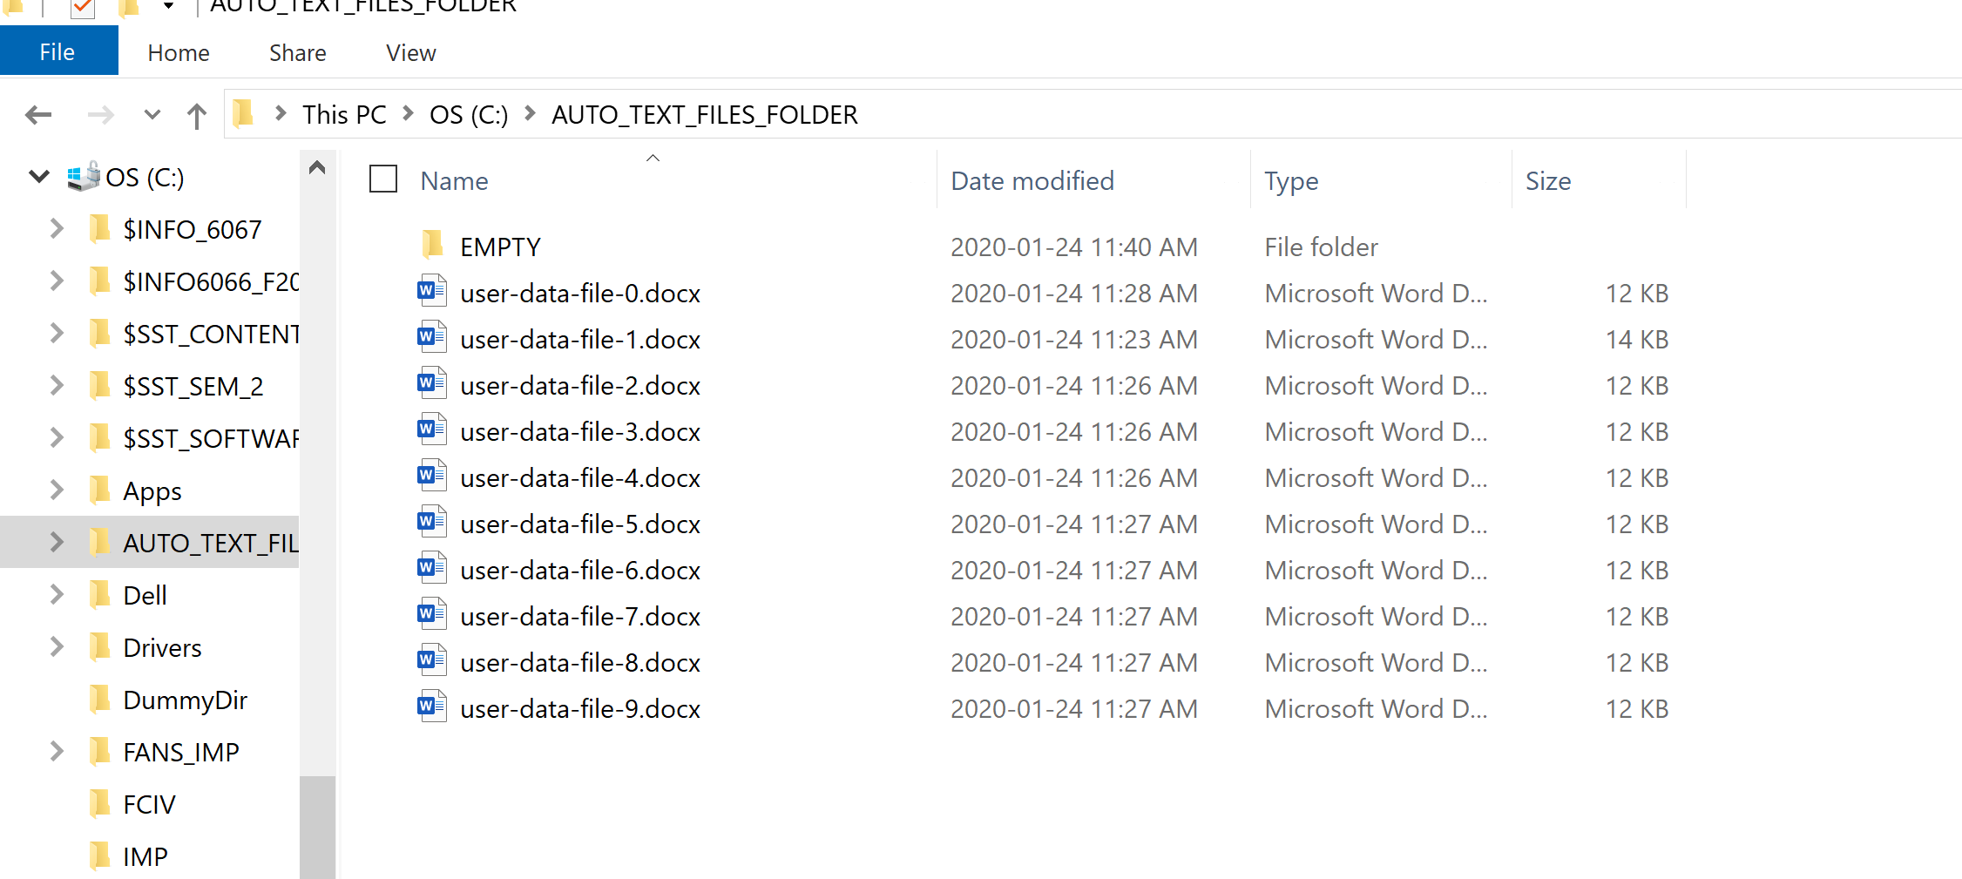**User create 10 text files in Auto_text_files folder manually**

Q 2:How long would it take to create 1000 files? To determine this take time above and multiply by 100.

**ANS 2: 14 min * 100 = 1400 minutes**

How long did it take to create all files with the automated data generator?

**ANS 3 : 30 minutes**

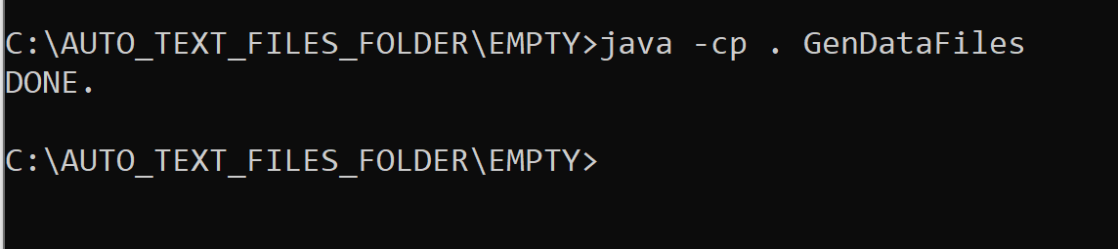

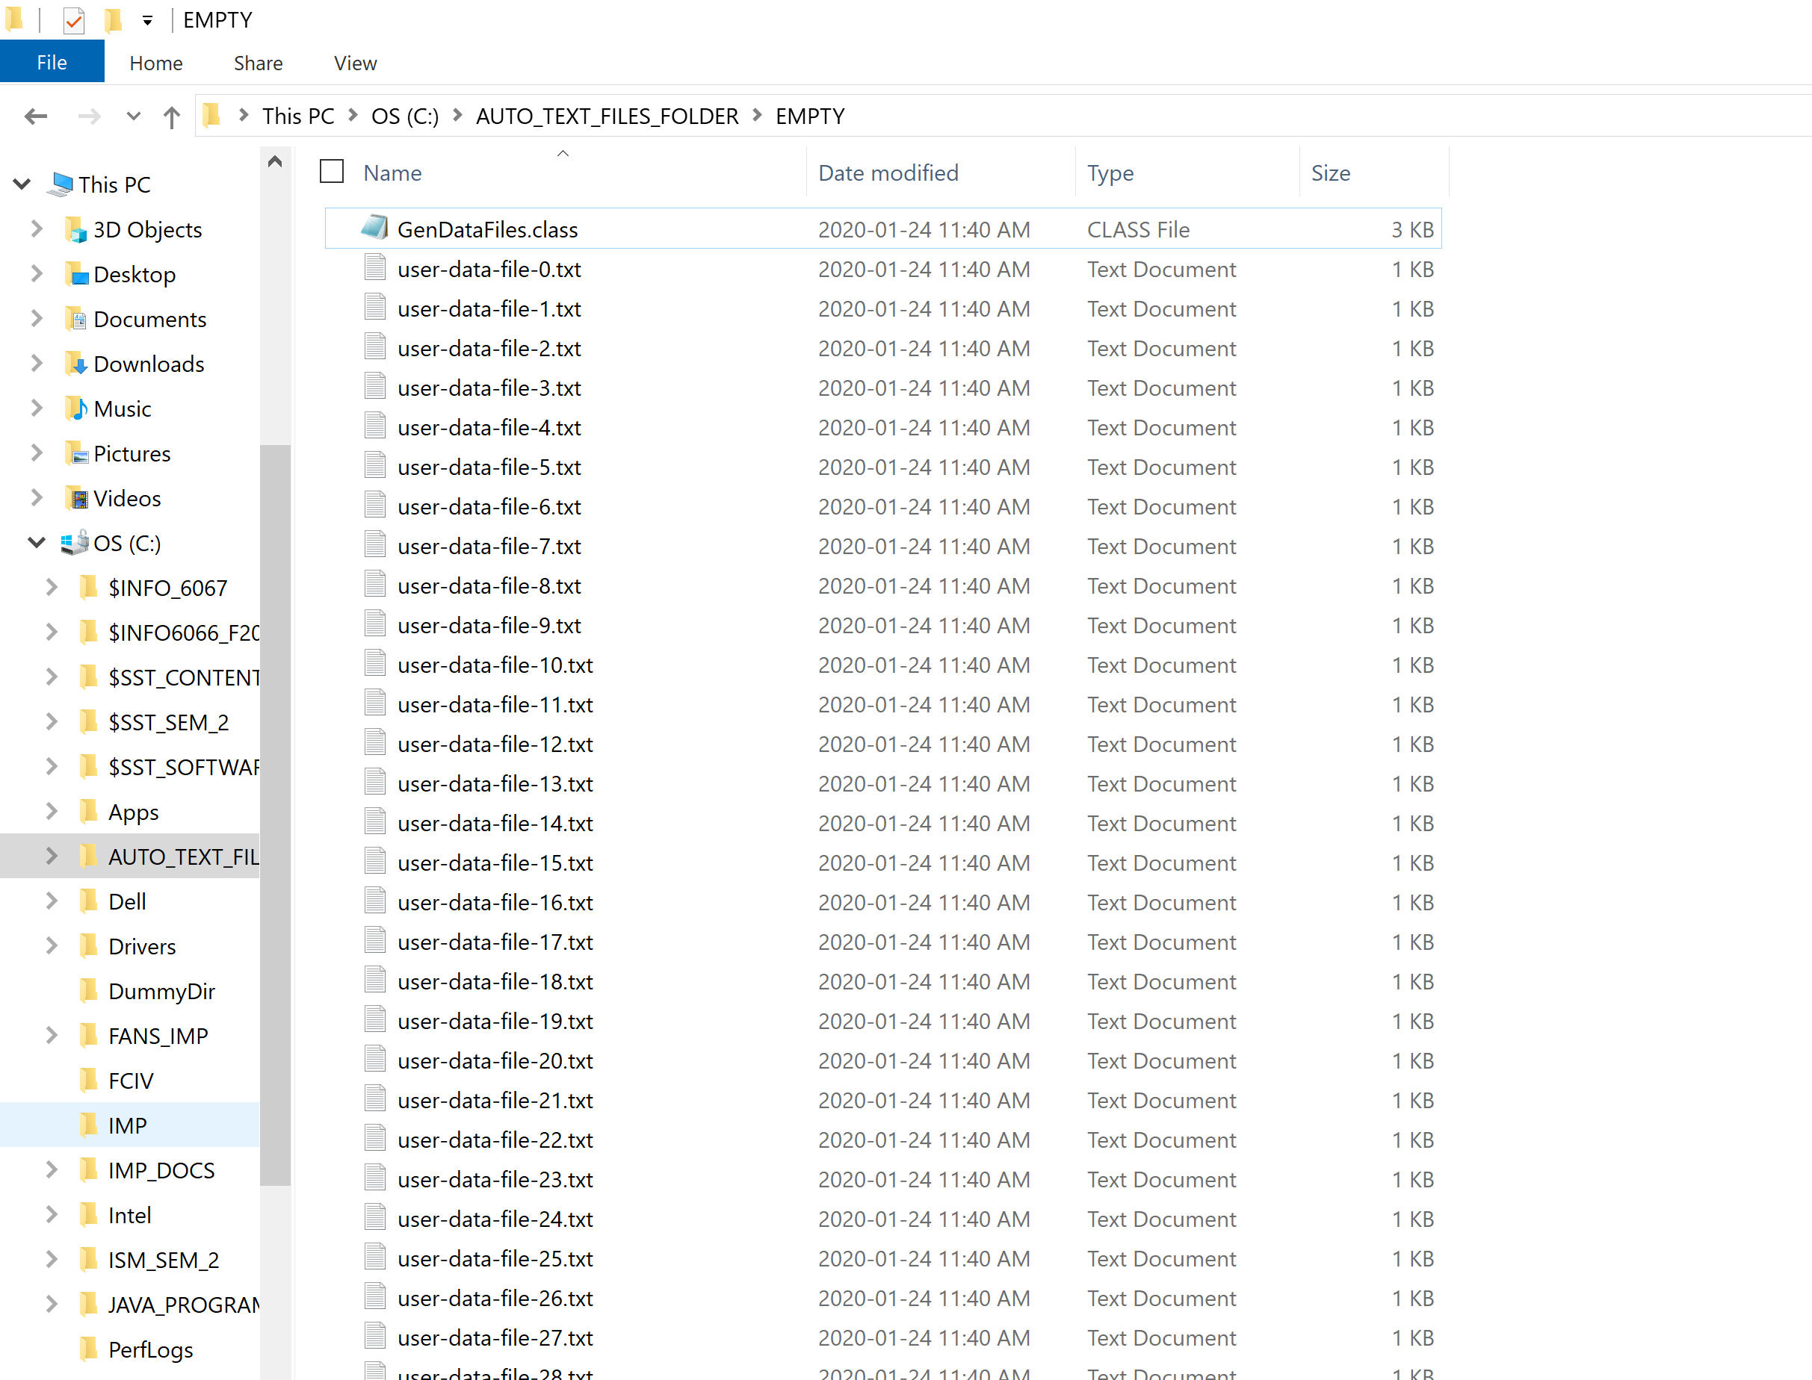

**Create files from file -0 to 999.txt**

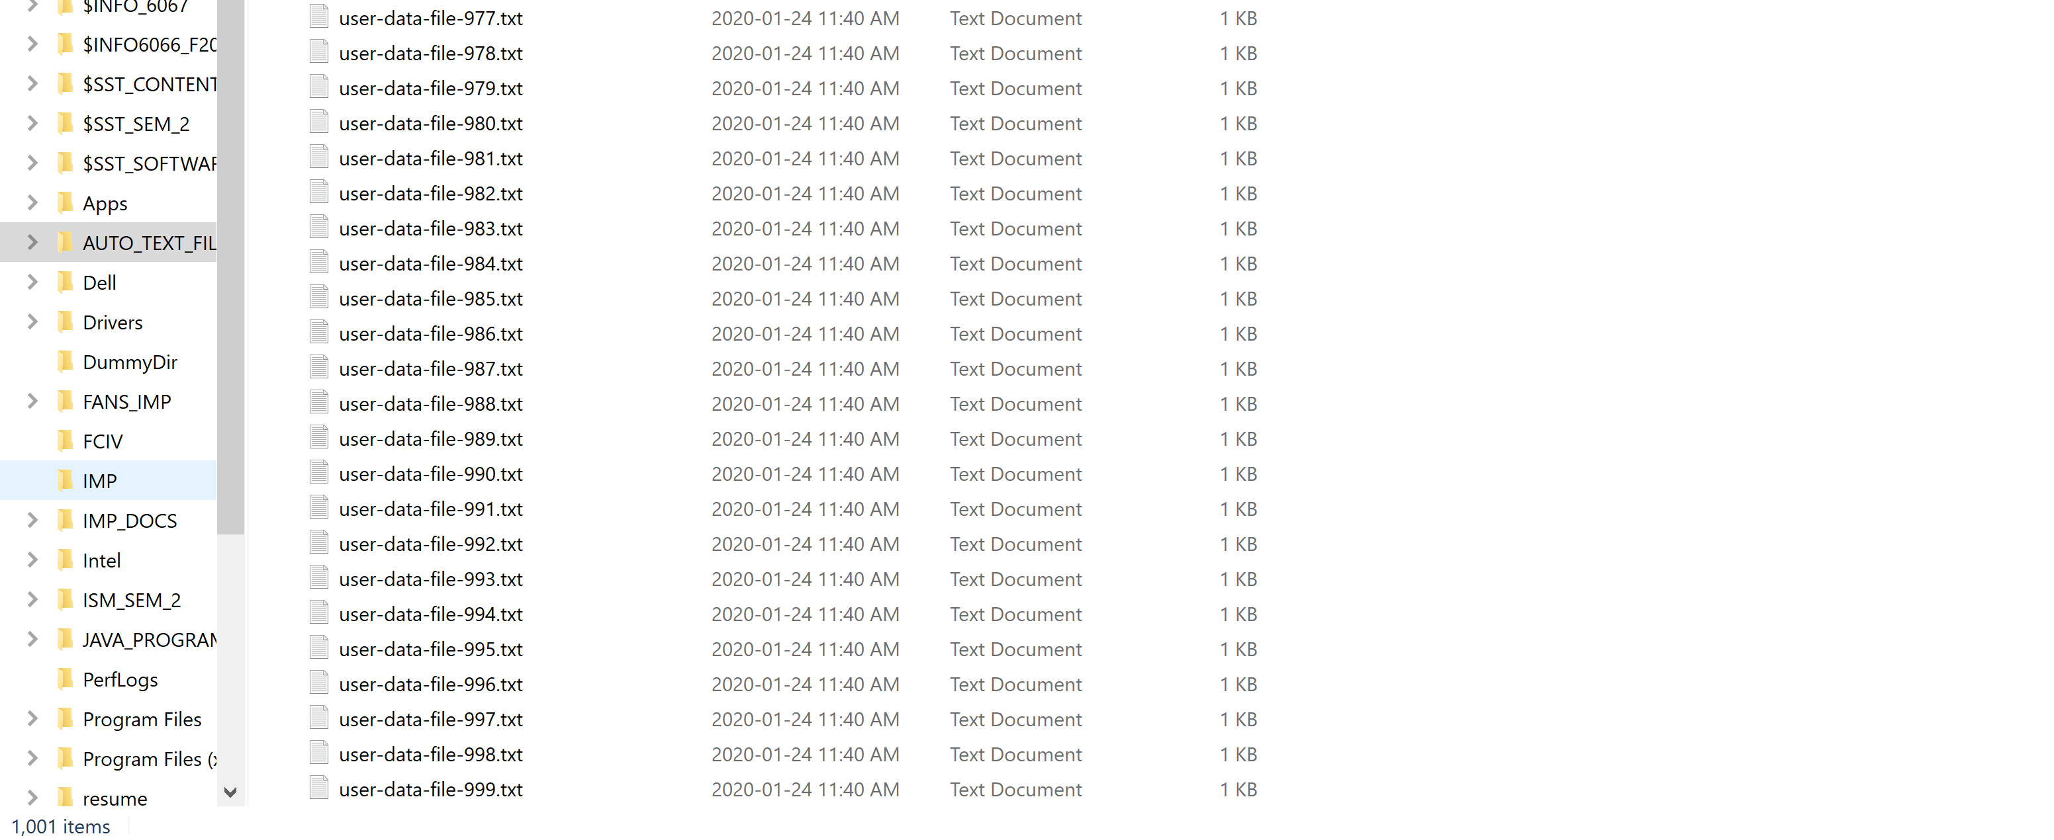**1000th txt file created by automated tool**

# Section B

Looking at the 1000 generated text files we may find that some of the files contain “corrupt data”. For our purposes we will define data as corrupt if it is not in the format we have defined for the data.

**Time the following exercise:**

Search the first 100 generated files (ie. user-data-file-0.txt to user-data-file-100.txt) and identify which files have bad data (ie files not formatted properly as per earlier description). To do so you need to open each of the 100 files individually and verify if format is the same as we have defined.

Include in timing time taken to record the files which have corrupt data if any.

**a) Record your results. : 11: 57 to 12:12 i.e. ( 16 minutes).**

**Corrupted files are 77 ,83 and 91**

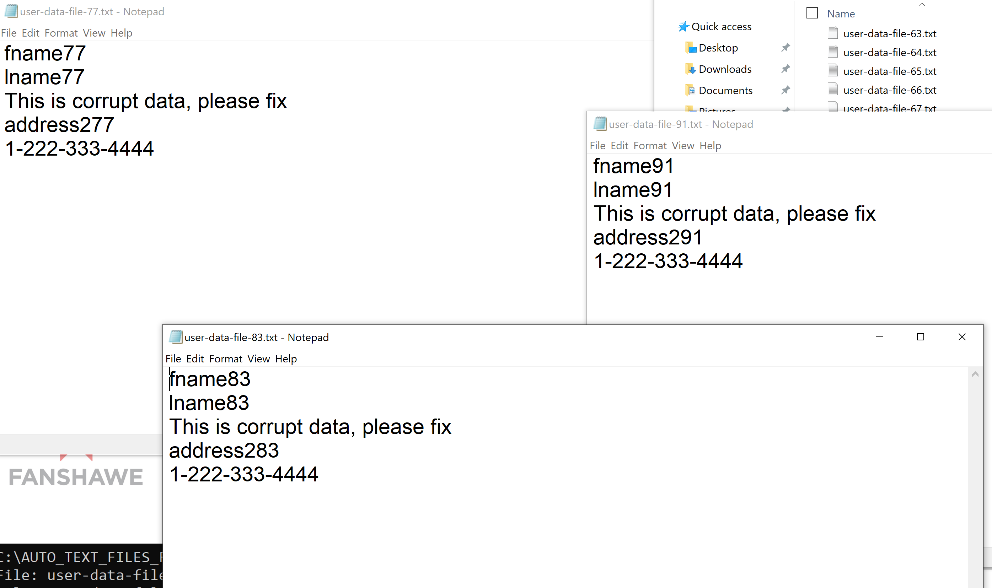

Now take the Java class called FindBadData.class and put it in the same folder where the data files are. Run the FindBadData class (use same syntax as you did to execute GenDataFiles but replace program name GenDataFiles with FindBadData). This tool (automated data validator) searches text files for any corrupt data.

**Record how long it took to run.:**

# Section B – Questions – 3 marks

Q1:How long would it take to manually search all 1000 files for corrupt data based on your time recorded above to search 100 files? (ie. your time above multiplied by 10)? 1 mark

Ans :1 )For 100 files , it took 16 minutes

Therefore, for 1000 files, it would take 16 * 10 = 160 minutes

Q2 :How long did the automated search for bad data using the automated data validator take? 1 mark

**ANS : 30 second**

Q 3 :According to the automated data validator, which files were corrupt? 1 mark

A : 3 File No : 77, 83 and 91.

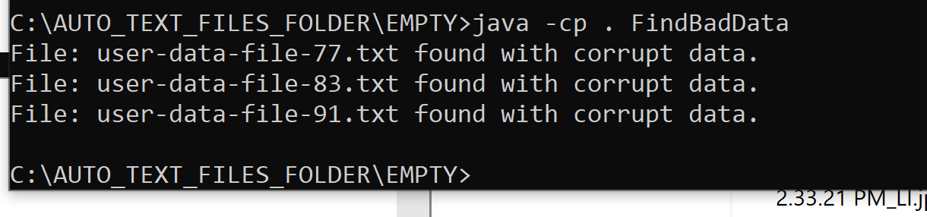

# Section C – Short Answer Questions – 14 marks

Start this section only after completing Sections A and B including answering the questions for these sections. Once you are ready to answer this section, put up your hand to let your professor know you have completed the first 2 sections and they will provide you with the 3 questions. Your professor will ask you to put your cellphone that you may have been previously using as a timing device away as access to cellphone is not permitted for this portion of the in class assignment.

These questions can be answered in point form but your points should be clearly explained. As well as answering the questions here, you must hand back to your professor your question sheet provided with your name on it in order to get marks for this section.

1. *See paper copy for question 1 – write down your answer to question 1 here.*

*Ans :****1)Challenges and risks of creating these files manually*** *:*

*a)While creating 10 files it take a lot of time .just like first I need to create 1 word file and write the content in proper format .*

*2.)secondly , it take 3 to 4 minutes to copy all 9 more text files and rename those by copying and paste.*

*3)Then each and every file opened and filled with data by changing the numbers.*

*b) Also, there would be errors while entering data by copy and paste and editing features.*

1. *See paper copy for question 2 – write down your answer to question 2 here.*

***ANS :2 Benefits of automated generated and validation tools***

*a)It take time in seconds as compare to minutes via manually.*

*b)There is very less possibility of errors and it is very effective method as it save human resource from doing repetitive tasks again and again.*

*c) Automated tools do not get tired just like humans.*

1. *See paper copy for question 3 – write down your answer to question 3 here.*

***Ans: 3 Drawbacks of automated generated and validation tools***

*a)If automated tools crashes, there is a huge loss to organization.*

*b)for eg : If amazon online website goes down for 5 minutes ,then company face loss in millions.*

*c)Only Automated tools d’nt fulfill the requirements of business , it also require manual work.*