INFO6053 – Automated Test Tools

In Class Exercise 2

Marks 30

[**http://newtours.demoaut.com/**](http://newtours.demoaut.com/)

**and**

[**http://www.ontario.ca/page/order-drivers-record**](http://www.ontario.ca/page/order-drivers-record)

**Name:**

**Assignment Objectives:**

1. To understand how to use available online tools to evaluate usability.  
   As a Quality Assurance Specialist you will be asked to evaluate applications for usability. This means you will need to understand the metrics and information from the tests and them provide an assessment or evaluation. Assessments are professional “opinions”. You use your knowledge and experience to assess evaluate and report.
2. This exercise asks you to provide an assessment of two websites using two online tools.
3. You must provide your thoughts and recommendations. Do not “skimp” on your assessment. Some point form is acceptable but do not use it exclusively.

**Requirements:**

Using the two URLs at the top of this page use the following tools to test and evaluate the usability of the Mercury Tours website (Site 1) and the Service Ontario website (Site 2).

You must read the description of the tool on its homepage to understand how to interpret the results.

At the end of each test you must write a paragraph describing your findings/interpretations and making any recommendations to improve the site.

**Instructions**

1. **Readability**
   1. This test determines how easy it is to understand the site being tested

Go to <http://juicystudio.com/services/readability.php>

* 1. Read through the site. Enter the urls to be tested.
  2. Copy the two results (table that appears under Readability Results section entitled Reading Level Results) and paste below in the Results section.
  3. Note the 3 metrics found in your results.
     1. Gunning Fog Index
     2. Flesch Reading Ease
     3. Flesch-Kincaid Grade

1. **Colours**
   1. This site tests the contrast colour of the foreground you have against the site’s background colour
   2. Go to <http://www.checkmycolours.com/>
   3. Run a test on both URLs.
   4. Review the results, click on each row for specifics to help you interpret the results.
   5. Paste only the errors below.
   6. Write your interpretation of what the results mean and your recommendations.

# Your Results Below

### Question 1 (Readability):

paste your results here site 1 (Mercury tours):

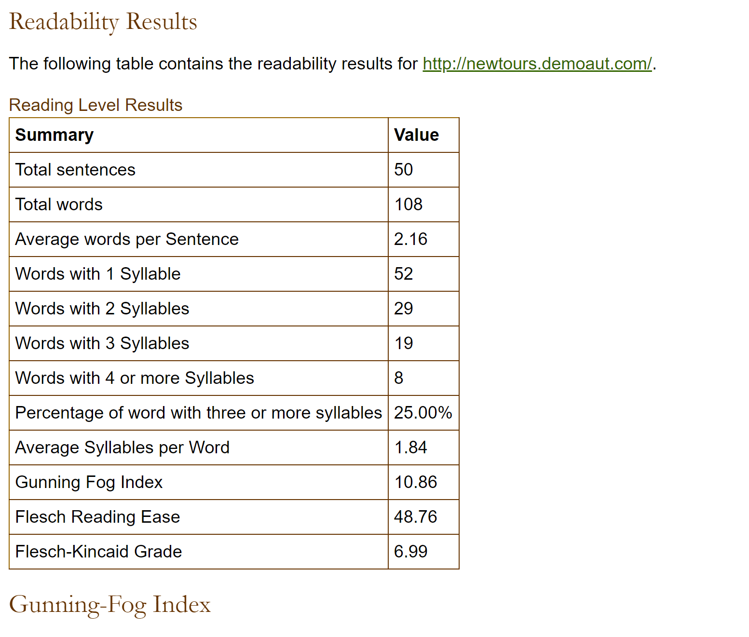

your findings here site 1 (mercury tours):

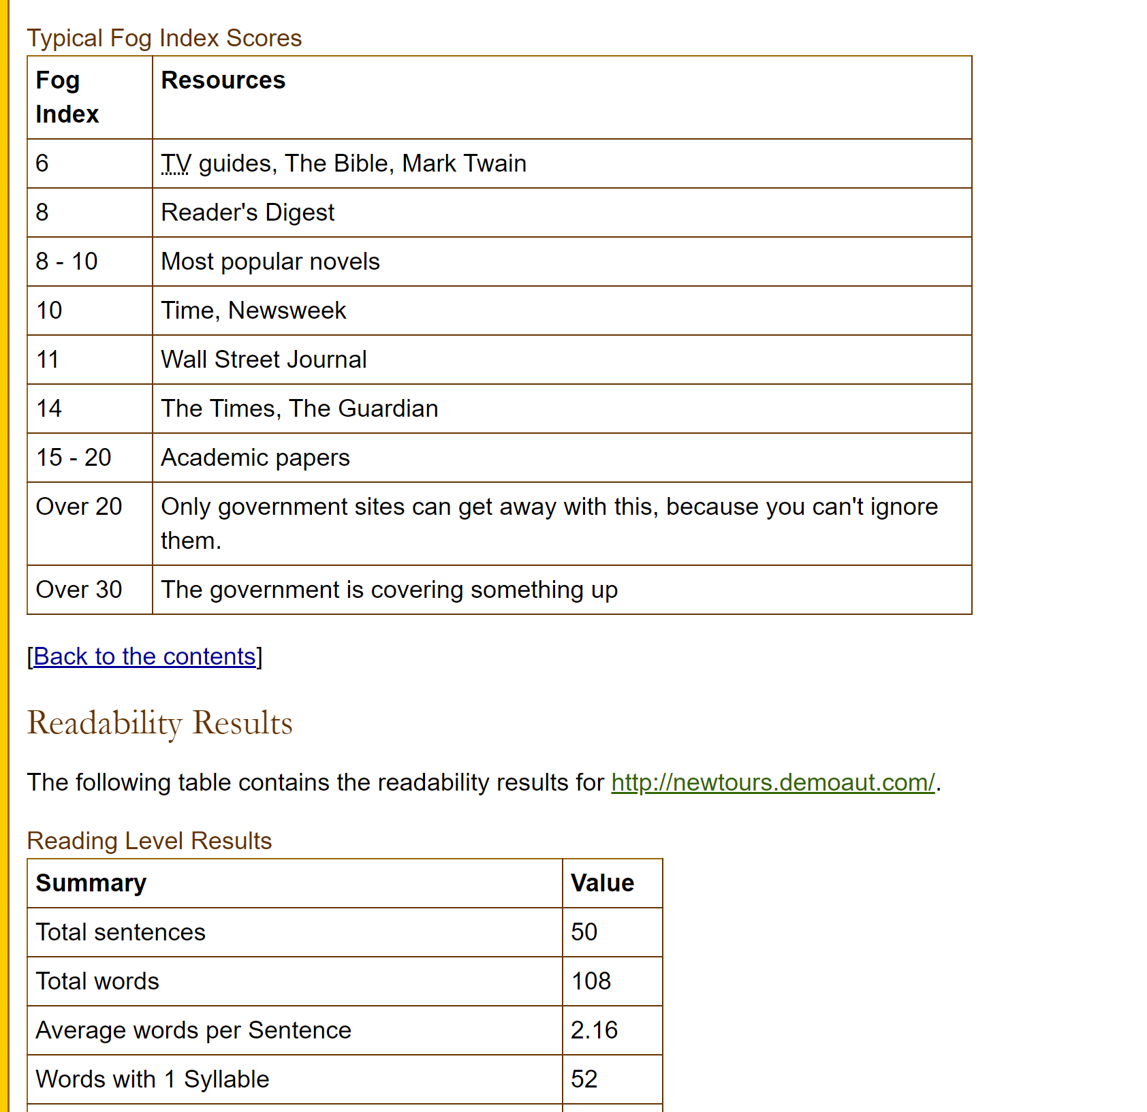  
paste your results here site 2 (service ontario):

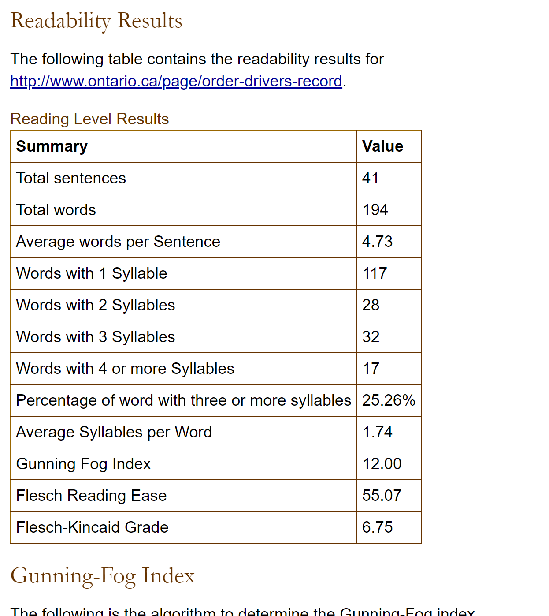

your findings here site 2 (service ontario):

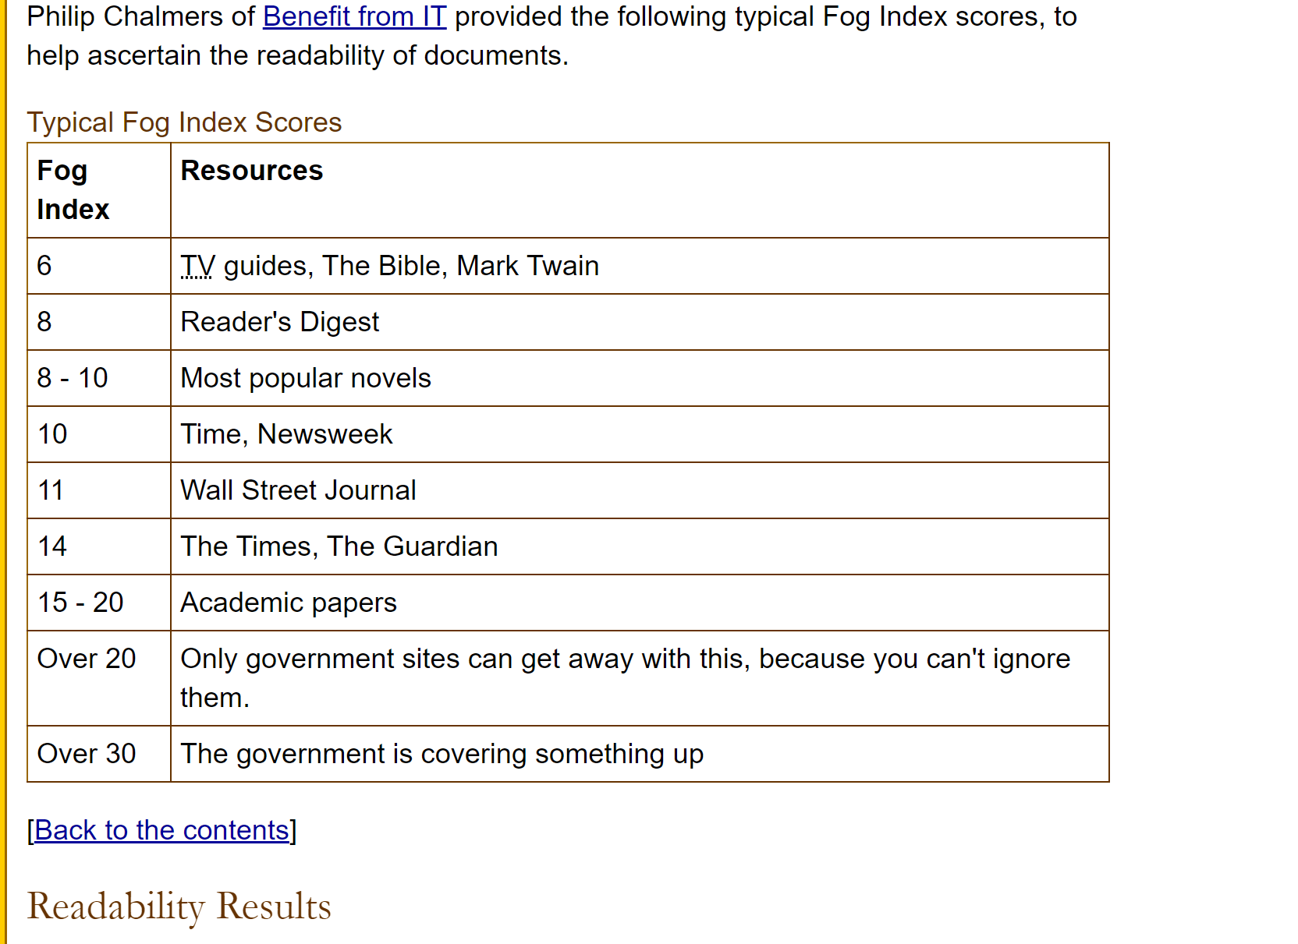

### Question 2 (Colours):

paste your results here site 1 (Mercury tours):

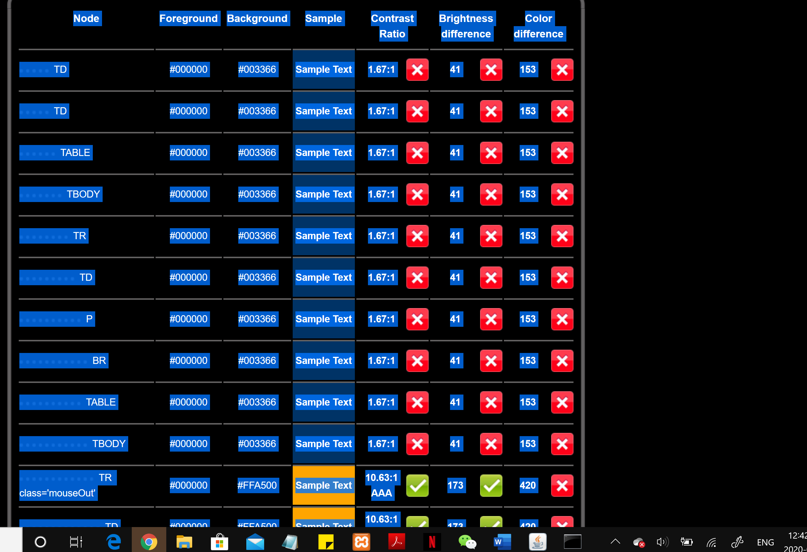

your findings here site 1 (mercury tours):

paste your results here site 2 (service ontario):

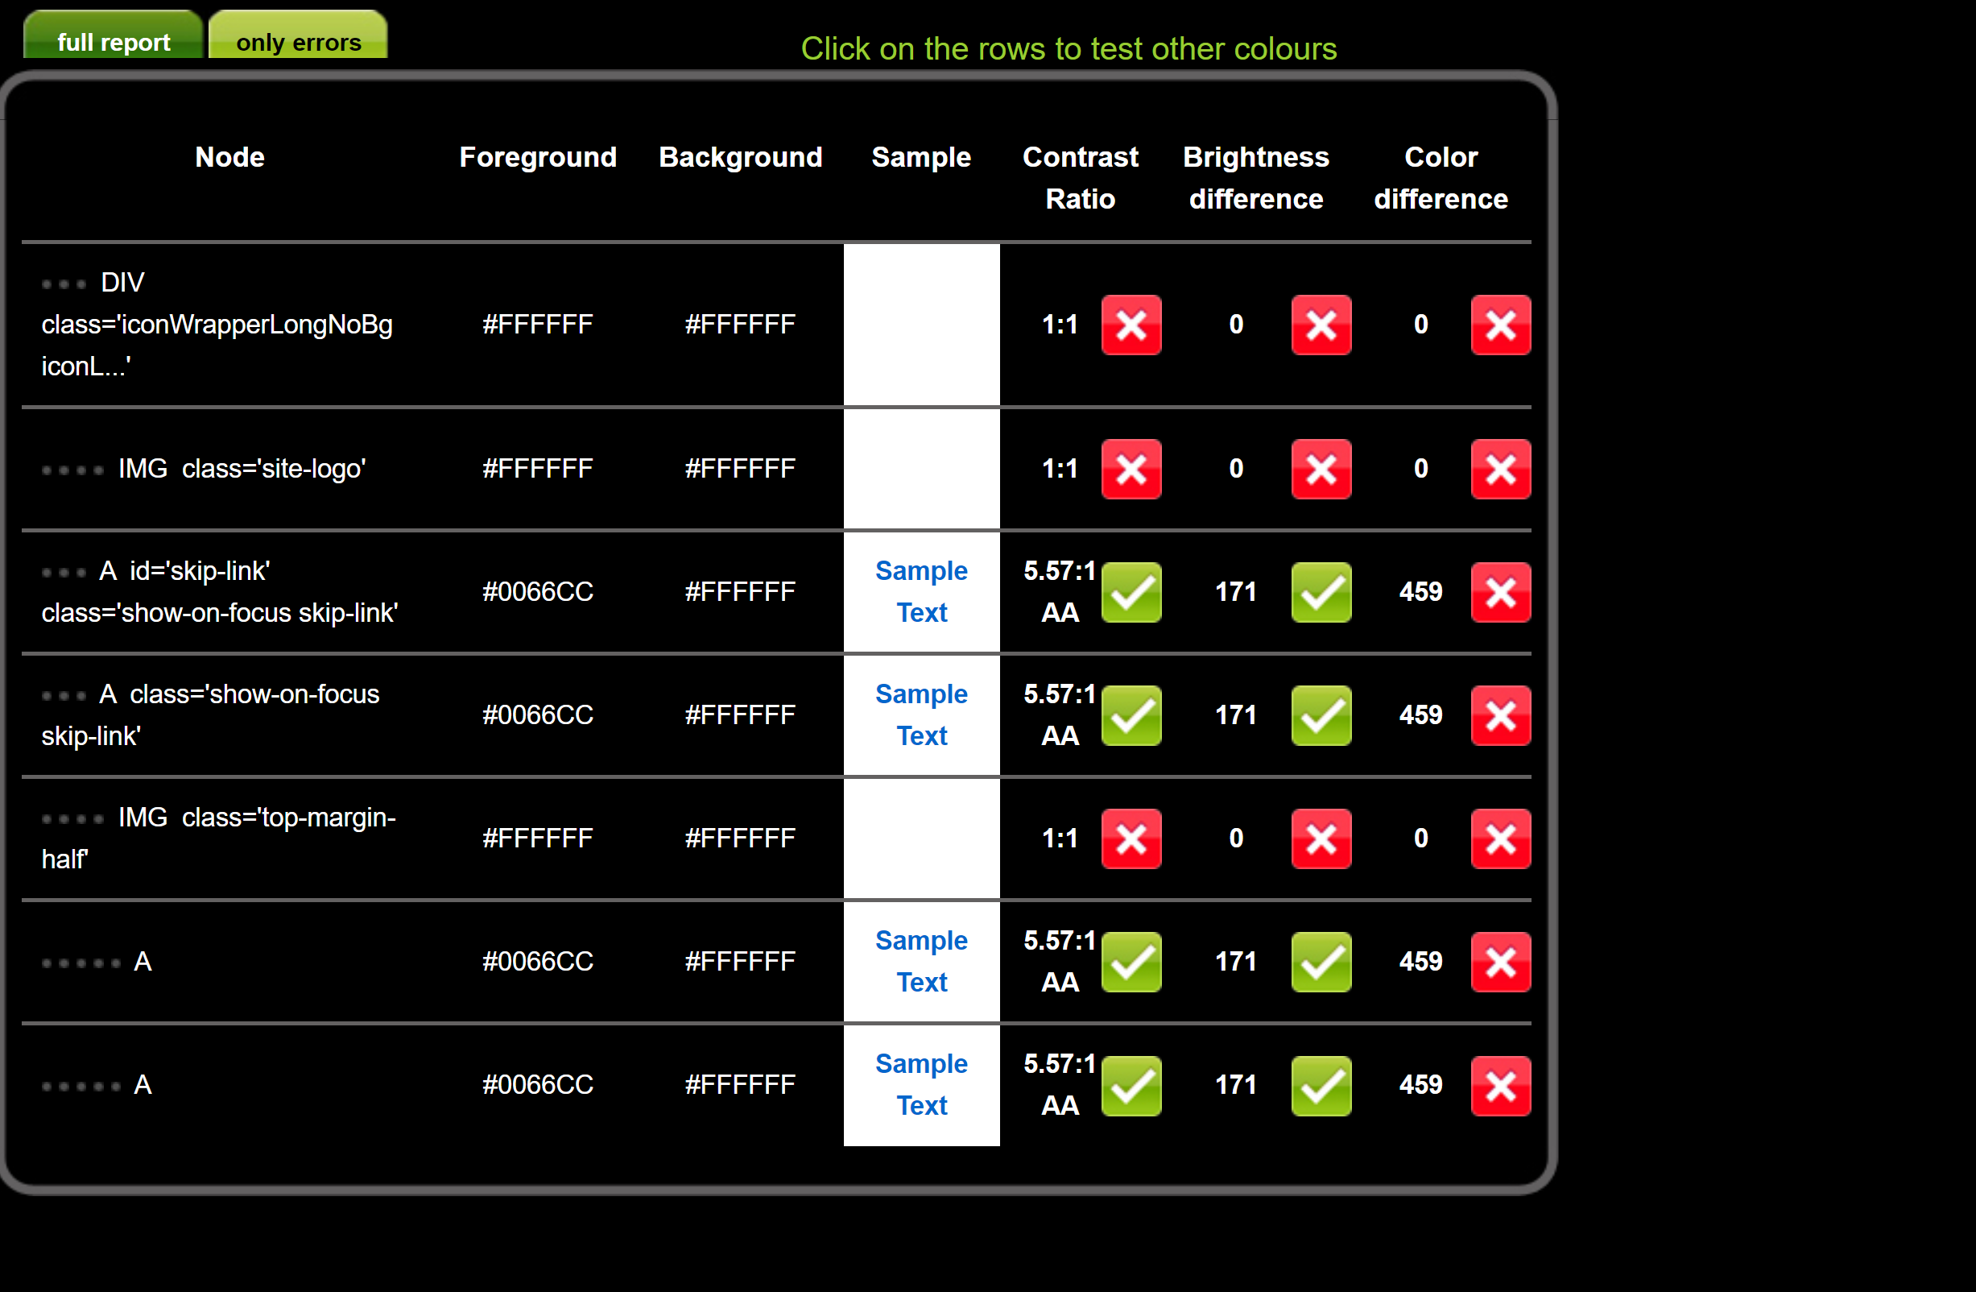

your findings here site 2 (service ontario):

### Marking Scheme

|  |  |  |
| --- | --- | --- |
| **Assessment** | **Mark** | **Mark Earned** |
| Pasted Results Question 1 | 4 |  |
| Assessment Question 1 | 10 |  |
| Pasted Results Question 2 | 4 |  |
| Assessment Question 2 | 10 |  |
| Instructions were followed | 2 |  |
|  | 30 |  |

**Submission – upload this word document to the in-class assignment 3 drop box.**

**Make sure you put your name in this document.**