INFO6053 – Automated Test Tools

Test 2

Practical component

Name: Amanjot kaur ID: 0914790

**Objectives:**

Assess that you are able to install, configure, and utilize an open source tool for automated testing.

**Requirements:**

We are going to exercise automated testing using Selenium IDE. Tomcat Manager Dashboard is going to be our SUT.

**Pre-requisites before starting automation:**

**Step 1: points: 1**

Download Apache tomcat that is attached with this exercise, and unzip the folder.

Ensure the examples folder is shown under your webapps directory.

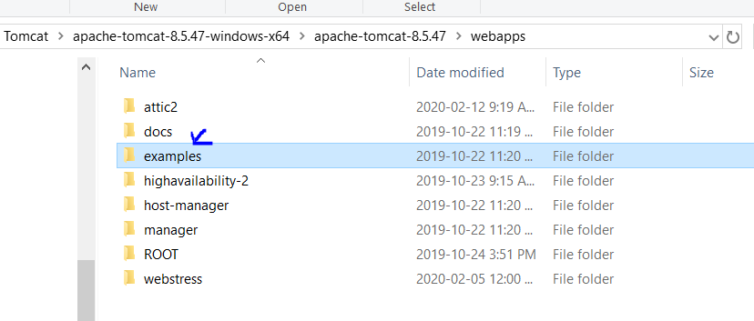



**Step 2:**

Ensure your JAVA_HOME environment variable is set to JAVA_JDK Folder. For instance, the following is setup of my machine, but you may need to update it based on the Java directory location of your machine.

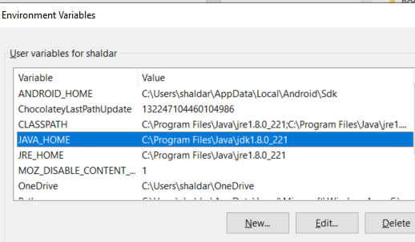

**Step 2 Points: 1**

**Troubleshooting:**

In order to make sure no other applications are going to prevent you from running tomcat properly, go to task manager, and stop instances of other command line windows as well as ensure there is no active mysqld instance. If you have vmware, you should stop that task.

**Step 3 Points: 1**

Navigate to the apache tomcat bin directory, and start tomcat by double-clicking the startup.bat file.

If you see error when double clicking the startup.bat file, from the same directory open a command line window, and type startup.

This should show you if any other preliminary steps need to be completed before starting your tomcat server.

**Step 4**

You are going to record your script from the following page:

<http://localhost:8080/manager/html>

Click on this link, and take a screenshot of this page.

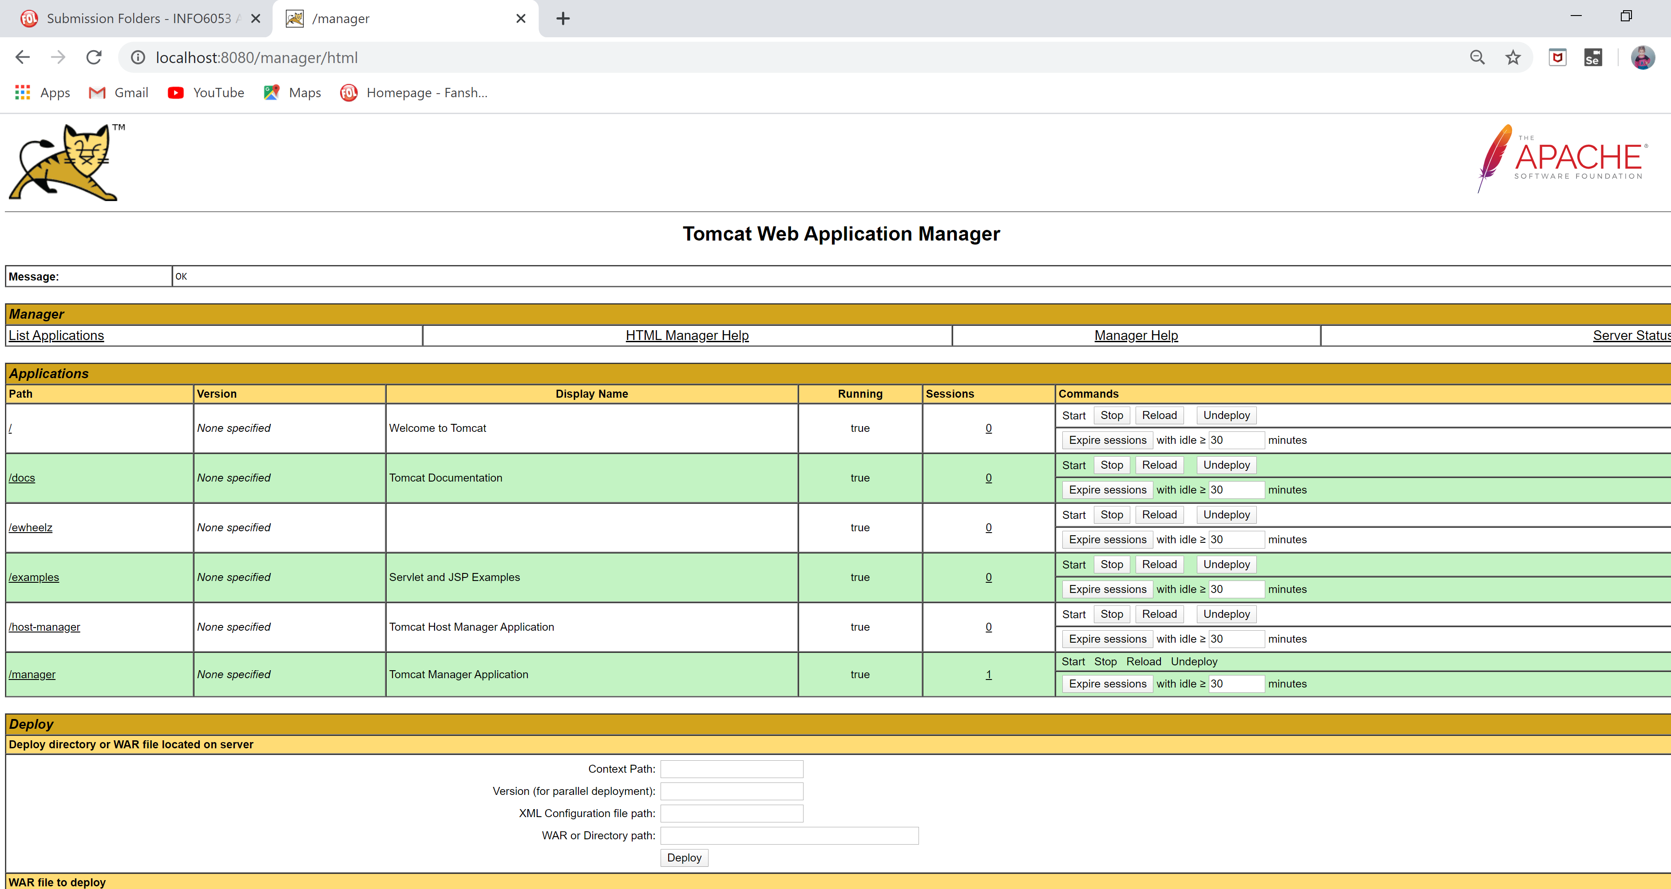

**Step 5 Manually analyze the SUT**

Take few minutes to analyze the application manually. Click on the /[examples](http://localhost:8080/examples/) link from this page, and navigate to “JSP examples link”. Click on this link, and analyze what features this page has. In addition tomcat manager Dashboard, this page will be used for creating your automated test case. We are going to target the calendar functionality from this page

**Step 5 Points 17**

**Automating test case**

Open Selenium IDE, and create a new project. This project would have multiple test cases.

**Please assertions, control statements, use of variables etc. based on what you think may enhance the test cases as necessary.**

Test Case 1

Record a test case and name it as Tomcat_manager_page

<http://localhost:8080/manager/html>

You may assert title, and assert text etc.

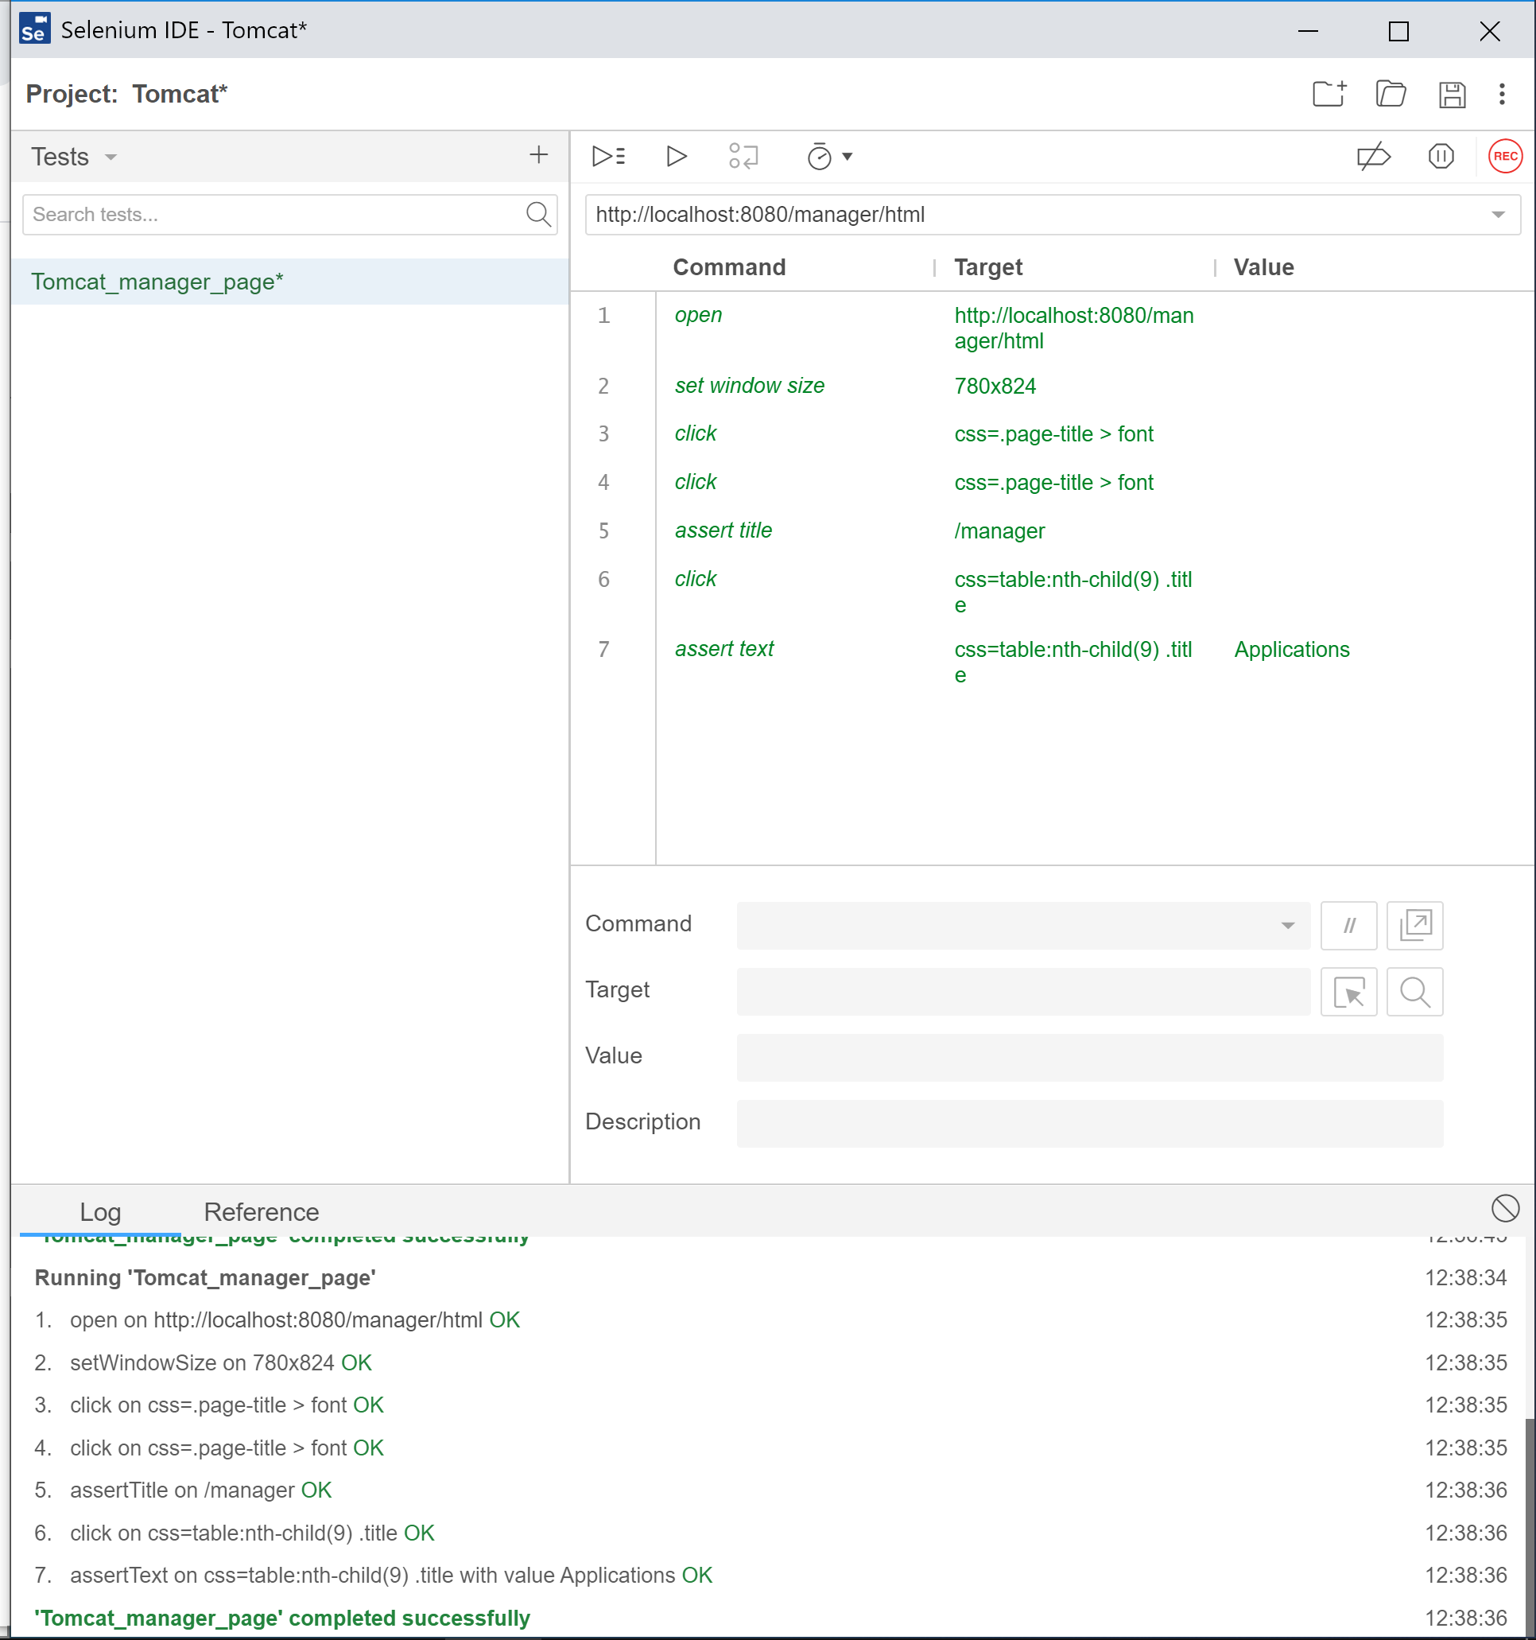

Test Case 2

Next test case would be to validate that clicking on /example path works. Name this case as ValidateExampleLink. After Clicking on this link, navigate to JSP Page.

Add assertions as necessary

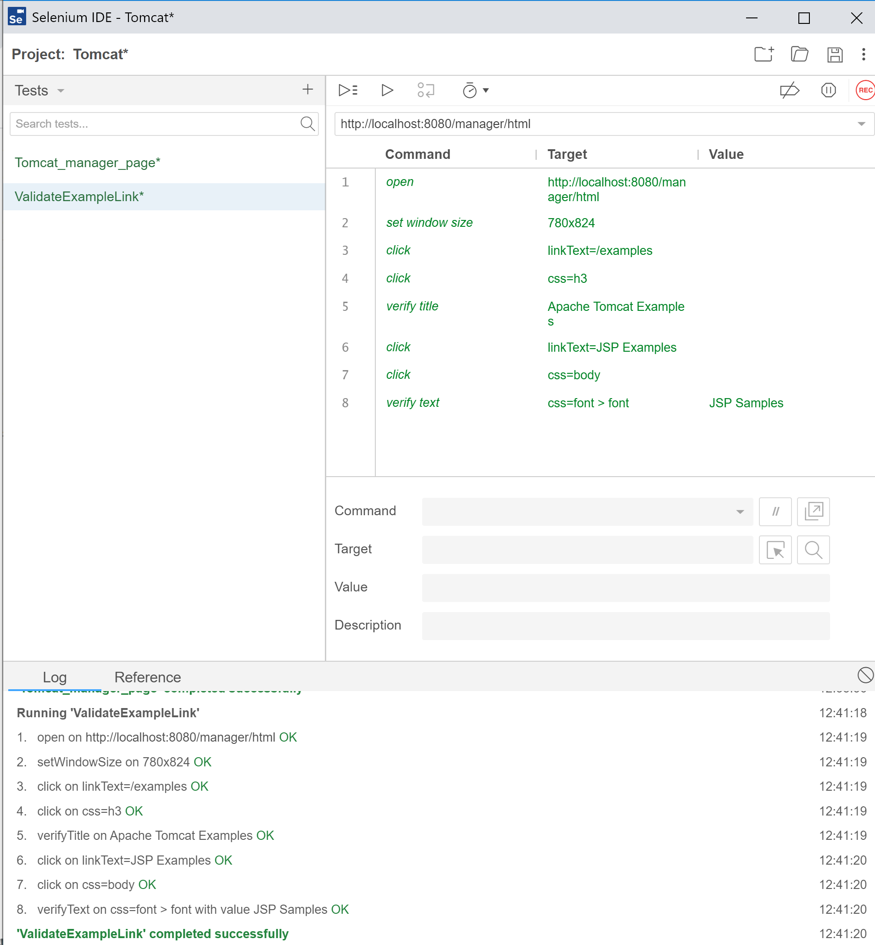

Test Case 3

Click on the <http://localhost:8080/examples/jsp/> page which you navigated during Test Case 2. Click on Calendar -> Execute link and create an appointment.

**Next test cases will be based on:**

**Starting and stopping applications using tomcat, and verify if the same examples link is running or not.**

Test Case 4

Go to Tomcat manager, and click on “stop” button for /examples



Clicking on /examples should display 404 not found error. You should assert this text.

Test Case 5

Next, you are going to start this webserver for this app by clicking on Start button, and the /examples link should navigate to the correct page again. Use assertions as necessary.

A test case can be written as if “/examples” link is giving you 404 error, you are going to call start_server page.

**Step 6**

Add all these test cases under a test suite, rename the test suite, and all the test cases developed under this test suite.

Take screenshots of your Test suite

Each test cases

Result Log

Assert statements

Demonstration of control flow if used.

Marking Scheme

|  |  |  |
| --- | --- | --- |
| **Assessment** | **Mark** | **Mark Earned** |
| Prerequisite – setup of SUT | 3 |  |
| Selenium IDE setup | 1 |  |
| Test case creations | 10 |  |
| Creation of test suite, and incorporating all test cases | 2 |  |
| Use of assertion, variables, control flow etc. | 3 |  |
| Playback of test cases, and proper screenshots | 6 |  |

**Submission – upload this word document to the**

**Test 2 - W02 Practical component submission folder**



**Test 1**



Test case 2

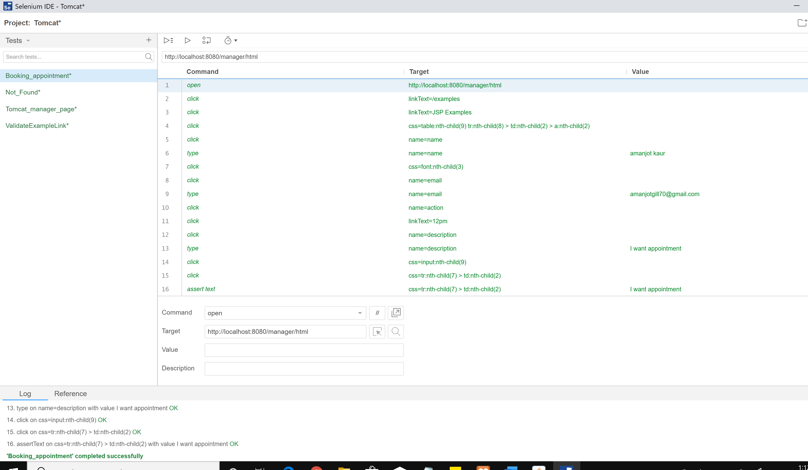

Test case 3

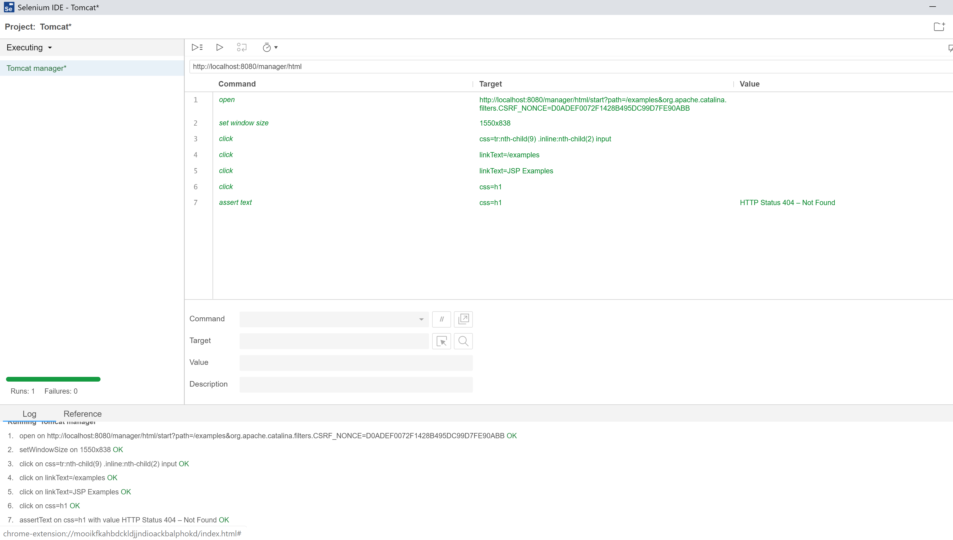

Test case 4

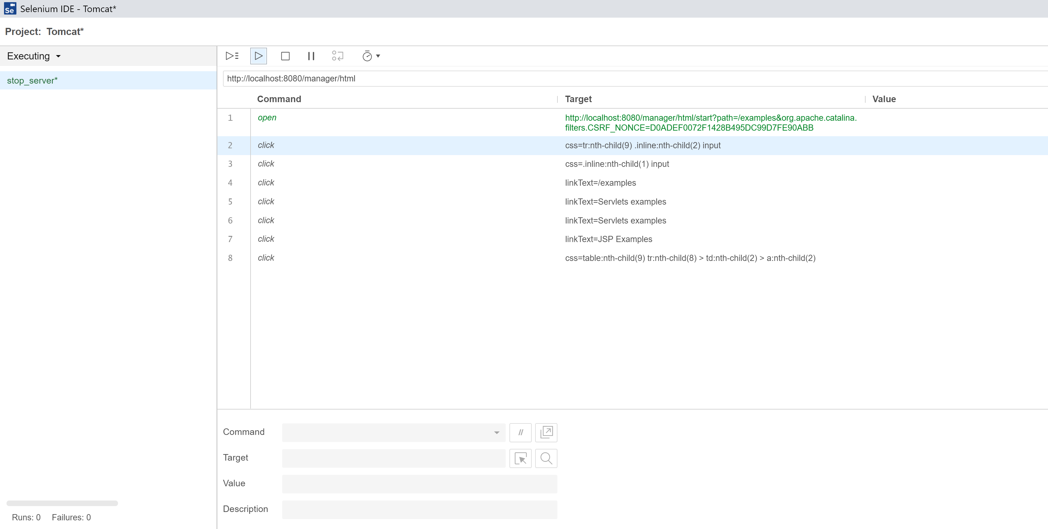

TEST 5

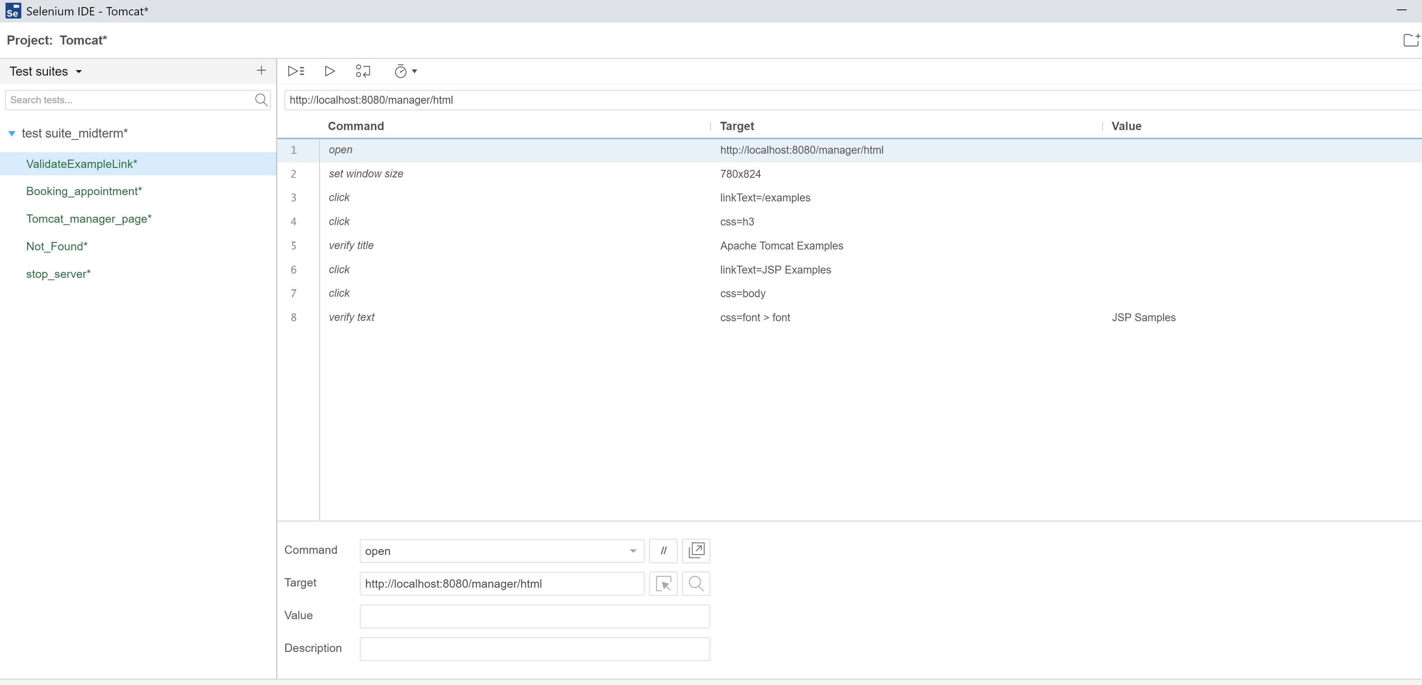

Test suite (step 6)