INFO 6055 Non-functional Testing

JMeter Exercise

## Description – JMeter exercise

A little exercise to give you more familiarity with the JMeter tool

Instructions

Follow these instructions closely.

* The first step you want to do with every JMeter Test Plan is to add a Thread Group element. The Thread Group tells JMeter
  + the number of users you want to simulate,
  + how often the users should send requests,
  + and how many requests they should send.
* Now we add an HTTP Request Defaults.
  + Now that we have defined our users, we specify the default settings for your HTTP requests.
  + you will add HTTP Request elements that use some of the default settings you specified here.
* We then add HTTP Requests for each page we need to visit during the test.
  + our requests will include data for fields on the page if required
* The final element you need to add to your Test Plan is a Listener. This element is responsible for storing all of the results of your HTTP requests in a file and presenting a visual model of the data.

Let’s do one together.

* Start JMeter – “jmeter.bat” located in the “bin’ folder of your JMeter installation
* You can change how your interface looks by using the following menu.

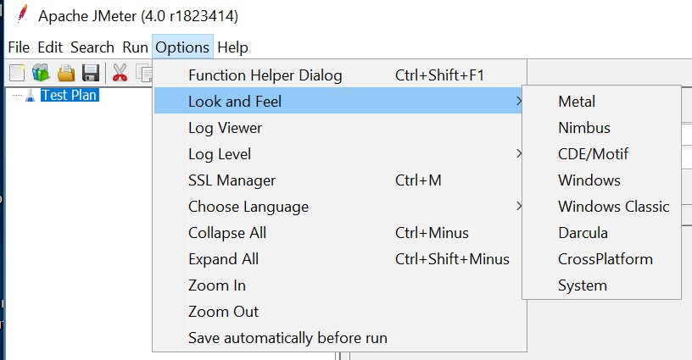

After starting JMeter, you should see the graphical user interface with an empty Test Plan:

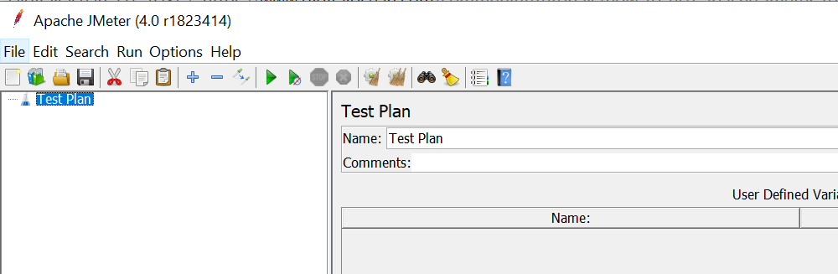

A test plan is composed of a sequence of test components that determine how the load test will be simulated.

* Add a Thread Group
* First, add a Thread Group to Test Plan:
  + Right-click on Test Plan
  + Mouse over Add >
  + Mouse over Threads (Users) >
  + Click on Thread Group
  + The Thread Group has three particularly important properties influence the load test:
    - Number of Threads (users): The number of users that JMeter will attempt to simulate. Set this to 50
    - Ramp-Up Period (in seconds): The duration of time that JMeter will distribute the start of the threads over. Set this to 10.
    - Loop Count: The number of times to execute the test. Leave this set to 1.

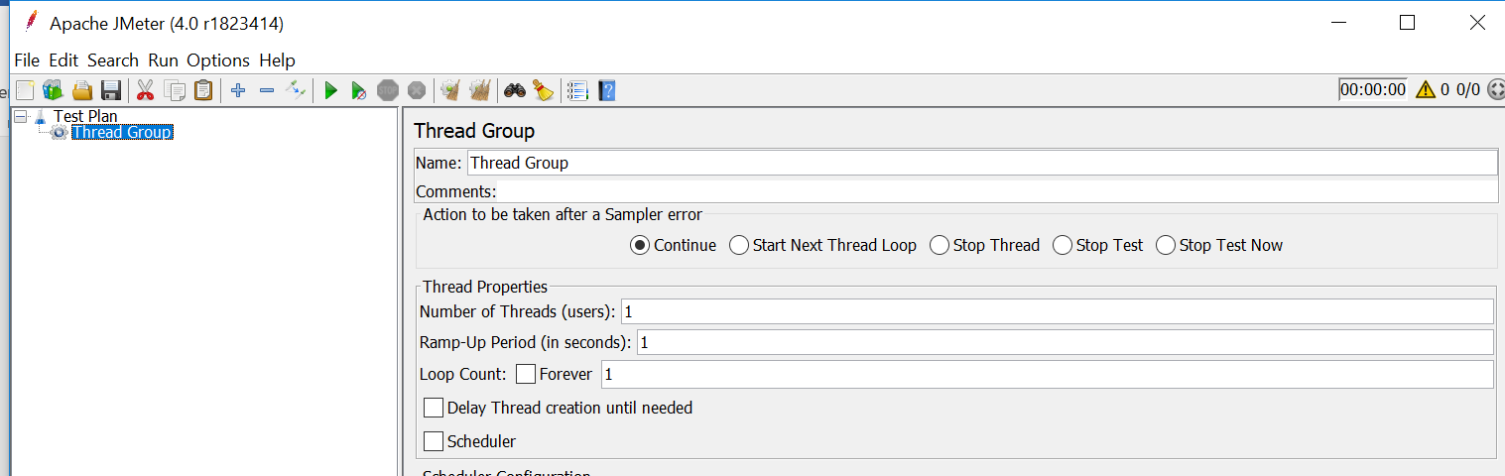

* Add an HTTP Request Defaults
* The HTTP Request Defaults Config Element is used to set default values for HTTP Requests in our test plan. This is particularly useful if we want to send multiple HTTP requests to the same server as part of our test. Now let's add HTTP Request Defaults to Thread Group:
  + Select Thread Group, then Right-click it
  + Mouse over Add >
  + Mouse over Config Element >
  + Click on HTTP Request Defaults
  + In HTTP Request Defaults, under the Web Server section,
    - fill in the Server Name or IP field with the name or IP address of the web server you want to test. Setting the server here makes it the default server for the rest of the items in this thread group.
    - enter localhost:8080 into the server name field
      * path would be the specific default page request such as

/attic2

* + - * port would be a specific port such as 8080.
      * we wont need these for this simple test

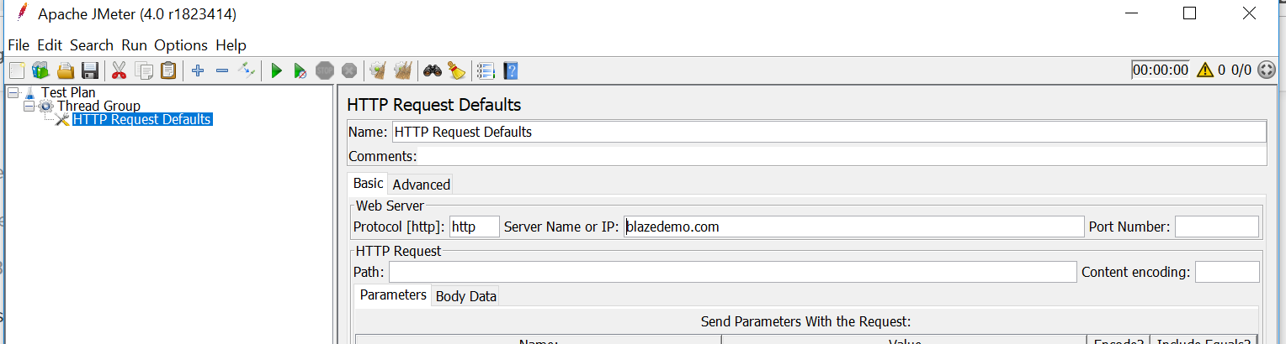

* Add an HTTP Request Sampler
* this represents a page request that each thread (user) will access:
  + Select Thread Group, then Right-click it
  + Mouse over Add >
  + Mouse over Sampler >
  + Click on HTTP Request
  + In HTTP Request, under the HTTP Request section, fill in the Path with the item that you want each thread (user) to request. We will set this to /, so each thread will access the homepage of this server.
  + Note that you do not need to specify the server in this item because it was already specified in the HTTP Request Defaults item.
* Note: If you want to add more HTTP Requests as part of your test, repeat this step. Every thread will perform all of the requests in this test plan.

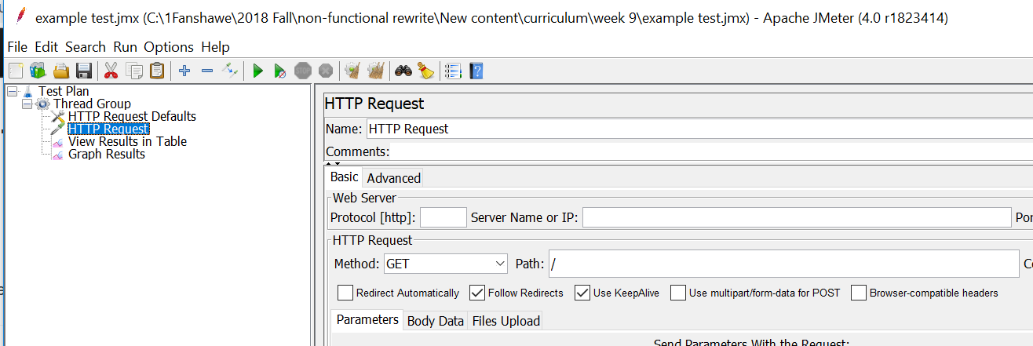

* Add a View Results in Table Listener
* In JMeter, listeners are used to output the results of a load test. There are a variety of listeners available, and the other listeners can be added by installing plugins. We will use the Table and a graph.
  + Select Thread Group, then Right-click it
  + Mouse over Add >
  + Mouse over Listener >
  + Click on “View Results in Table”
  + Select Thread Group, then Right-click it
  + Mouse over Add >
  + Mouse over Listener >
  + Click on “Graph Results” in Table
* You may also type in a value for Filename to output the results to a CSV file.

Table Results

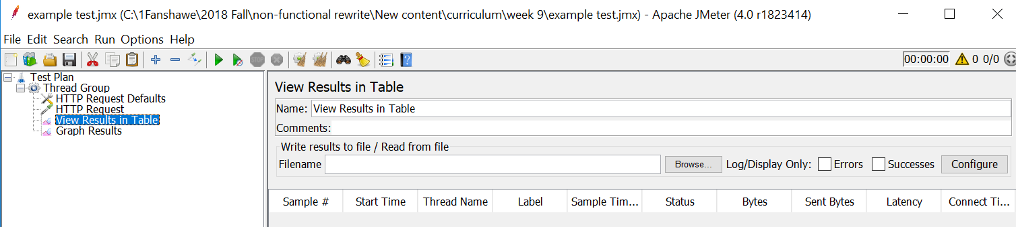

Graph Results

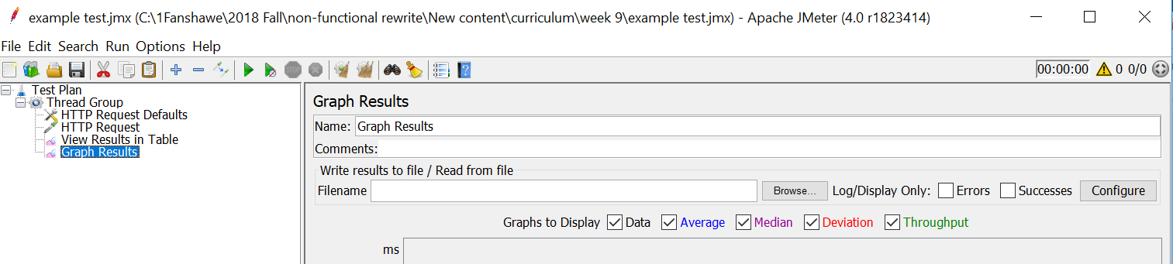

Let’s Run the test.

* Click on the green arrow for run.
* When it completes
  + click on the “View Results in table” observe the results
  + click on the “Graph Results”

Tables results

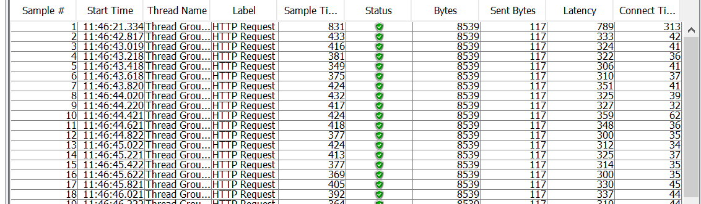

**Interpreting the Results**

You will probably see that the Status of all the requests is "Success" (indicated by a green triangle with a checkmark in it). After that, the columns that you are probably most interested in are the *Sample Time (ms)*and *Latency* (not displayed in example) columns.

* **Latency**: The number of milliseconds that elapsed between when JMeter sent the request and when an initial response was received
* **Sample Time**: The number of milliseconds that the server took to fully serve the request (response + latency)

You will need to run your test several times to get enough data to see a useful graph.

Graph Results

After 10 executions

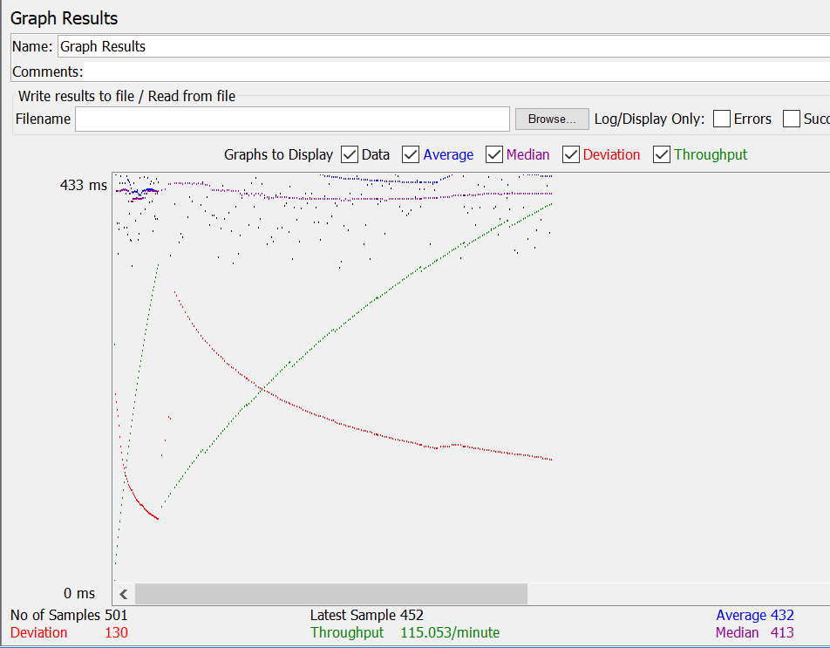

What is your conclusion from the result?

How can you add parameter to your test?

How can you run the localhost\index.php file using jmeter?

