INFO 6053 Automated Test Tools

Project # 1: Selenium Installation and Assessment

**Submitted To: - Submitted By: -**

Professor Susmita Haldar Amanjot Kaur(0914790)

Amandeep Kaur Brar(0949470)

Manpreet Kaur(0962955)

Aman Chhabra(0961874)

**(Group : 12)**

**1.)Introduction :**

Selenium integrated development environment ( IDE) is an open source Automated testing tool for web applications. It is not limited to recording and playing but also used for scripting, debugging ,reporting, etc. It is quite efficient in terms of usability as no need to download and configure and implemented as a extension on various browsers.

In our project, we use **Urban Planet** as a website to record and create our test cases and test suites .

**Ques : 2.)Screenshots to indicate Selenium IDE was successfully installed ?**

**Machine 1 : Amandeep kaur Brar**

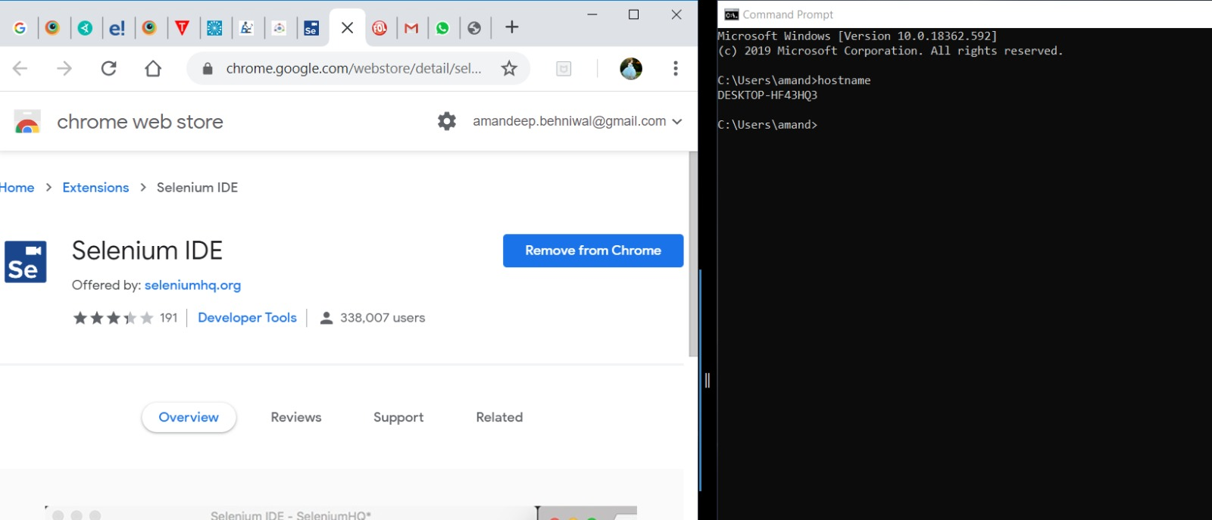**Machine 2 : Manpreet kaur**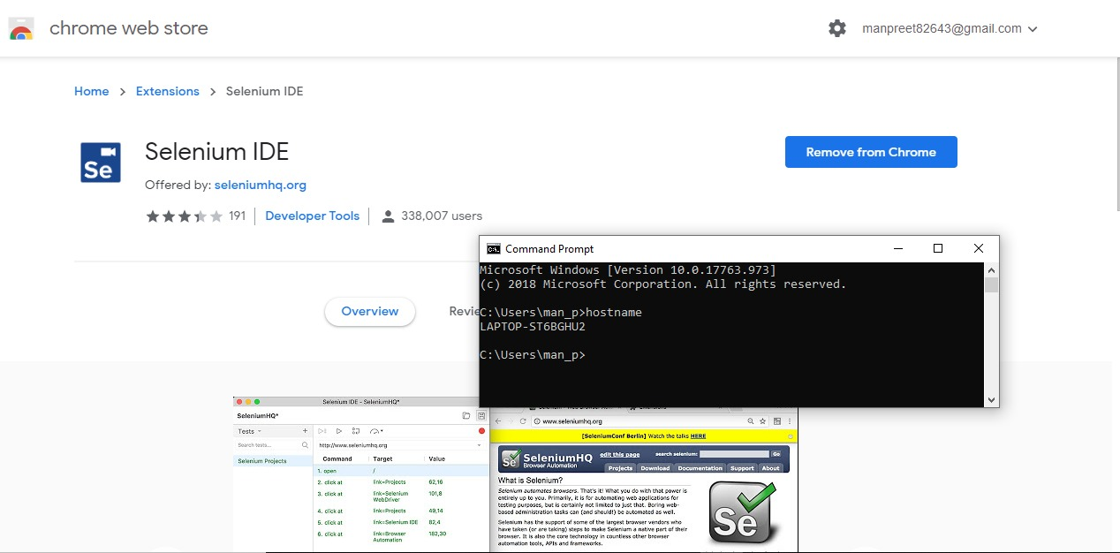

**Machine 3 : Amanjot kaur**

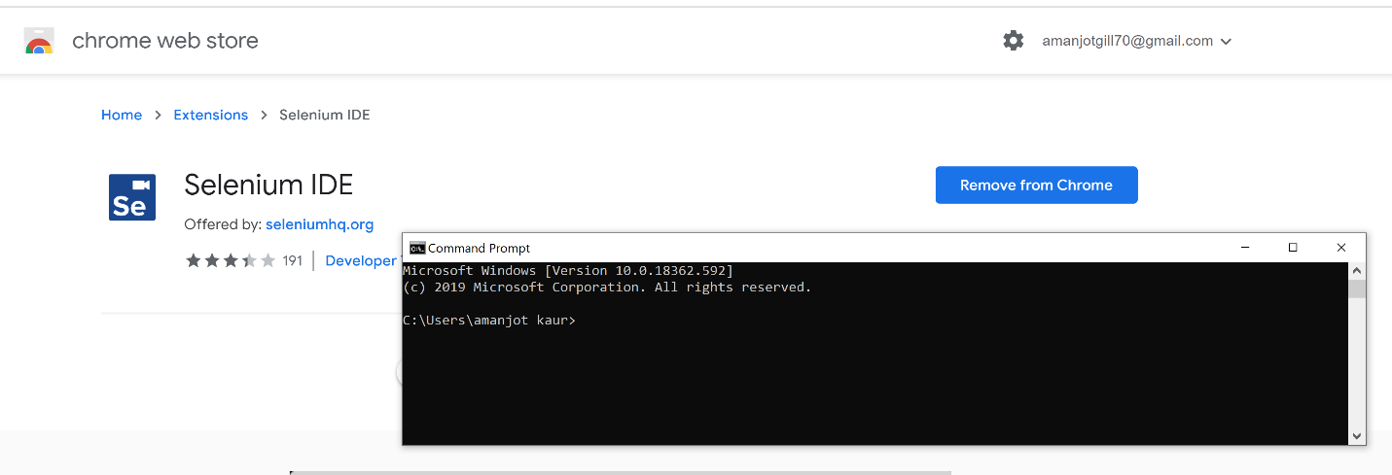

**Machine 4: Aman Chhabra**

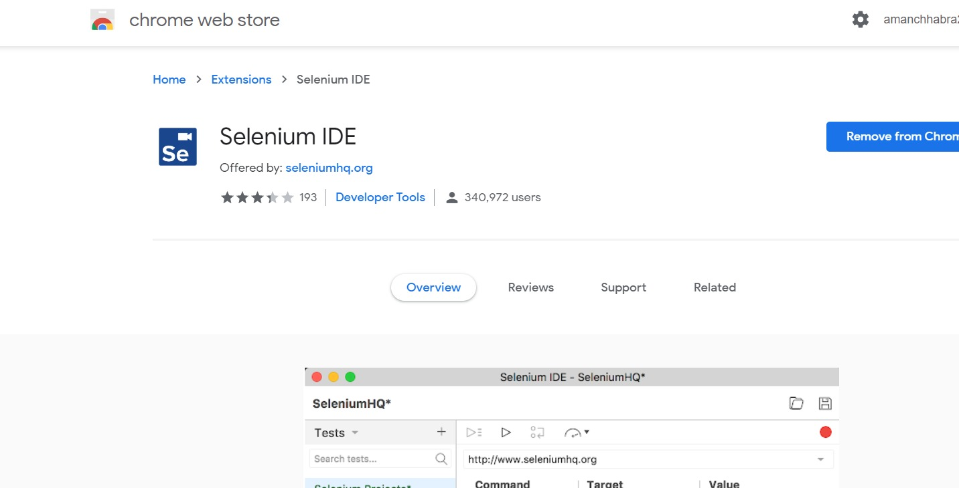

**Working of Selenium IDE in Laptop**

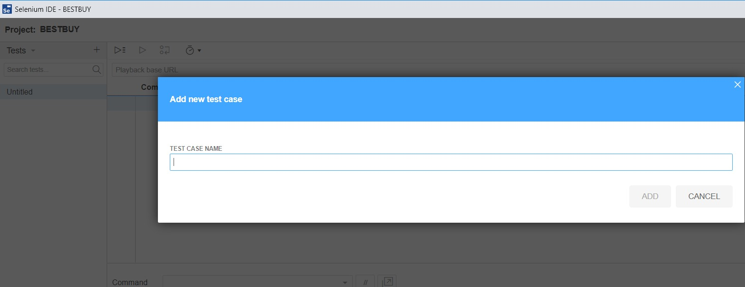

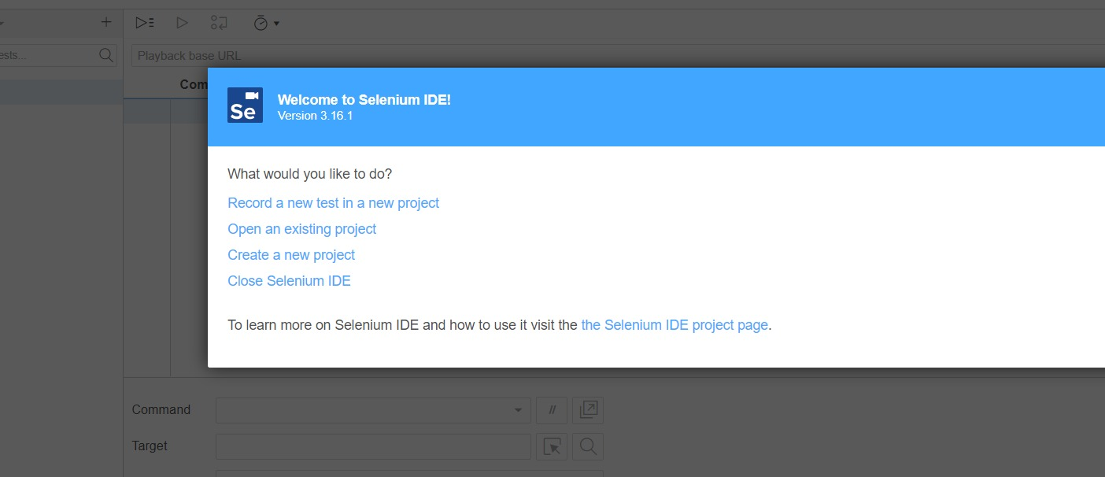

**Ques : 3.)Selenium IDE plugin features**:

1. **Selenium IDE is now cross browser** - Selenium IDE first introduced in 2006 when Firefox was shiny browser and chrome would not come for two years more. So, selenium IDE Hitched its wagon to Firefox on that time and remained 10 years, which was frustrating because of its single browser support but now it is available on Chrome and Firefox.
2. **Selenium IDE tests are not Brittle now-** Brittle tests were big issue for tester to perform functional testing when they wrote or record their code by hand. The main problem was object locator. But now developers adding new features due to which UI code automatically changes and when UI changes object locater also changes automatically. Selenium IDE fetches multiple object locaters when we write our script and it find object locaters until it did not find an object locator which work. Test failed only when no object locater works.
3. **It supports modular test scripts** – Selenium IDE make it possible to run one script by another. So, there is no need create those steps again and again. For example , we have login script which will automatically calls another steps. We can insert this step into selenium IDE.
4. **Ready to Use IDE: -** Installation of Selenium IDE on system is quite easy as the installation can be done by just installing the extension on our browser.
5. **Easy Debugging:** - Selenium IDE offers an easy debugging by providing the options of breakpoints etcetera.
6. **Reuse of Test Cases:** - with the use of Selenium IDE, test cases can be re-used, inside of another test case, with the help of Run command.
7. **Control Flow: -** Selenium IDE provides control flow structure with commands such as if, while etcetera.
8. **Plugins:** - with the use of Plugins, Selenium IDE can be extended. For example, by writing own code or installing the pre-existing code by third-party.

**Ques : 4.)Screenshots and description of the tests performed against the team’s chosen target website?**

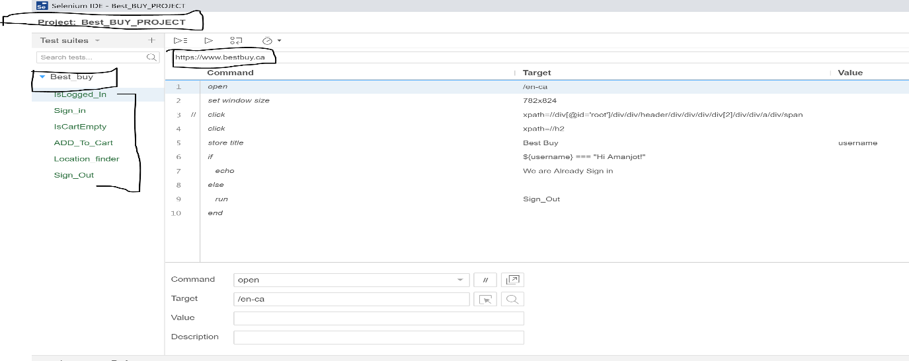

**Main Page** : **Shows URL of project, Name of the project, tests and test suits**

Name of the project is **Best_Buy_Project.** It creates six tests that is combined into a test suite called as Best_Buy. It works in sequential way .The description of these test cases are given below with screenshots.

**1)IsLoggedIn** : This test check whether the page is login or not, If it is login , it prints message or If it is not , it call Sign_Out . Sign_out is called here to ensure the functionality of Sign_in

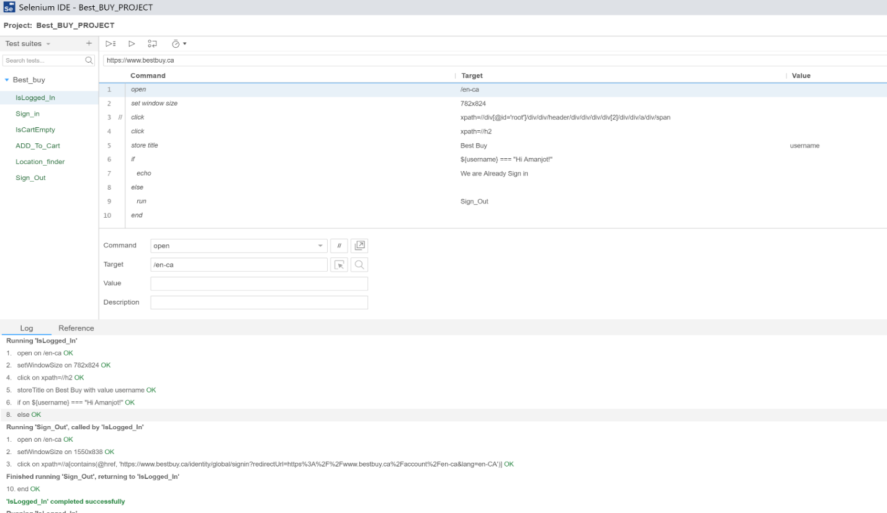

**2)Sign_In** : The test used to Sign_in the best buy account with username and password and give assertion text as “Hi Amanjot !”.

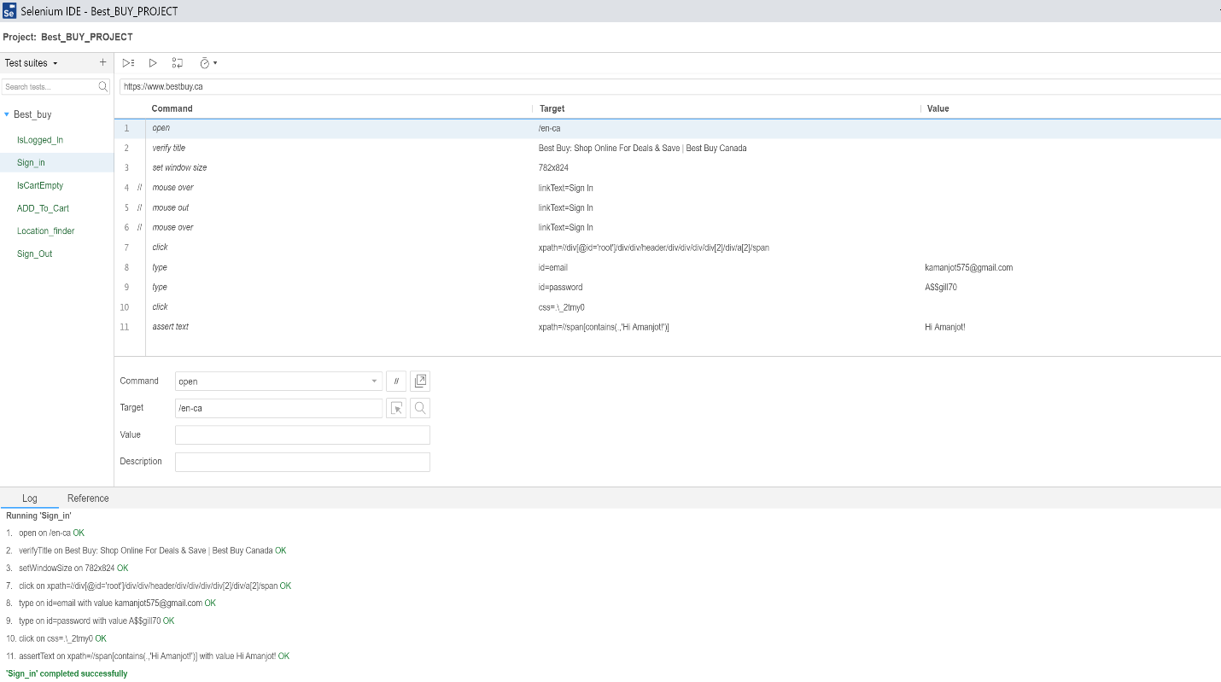

**3.)IsCartEmpty :** This function use ”if else” statement and compare if cart is empty or not .

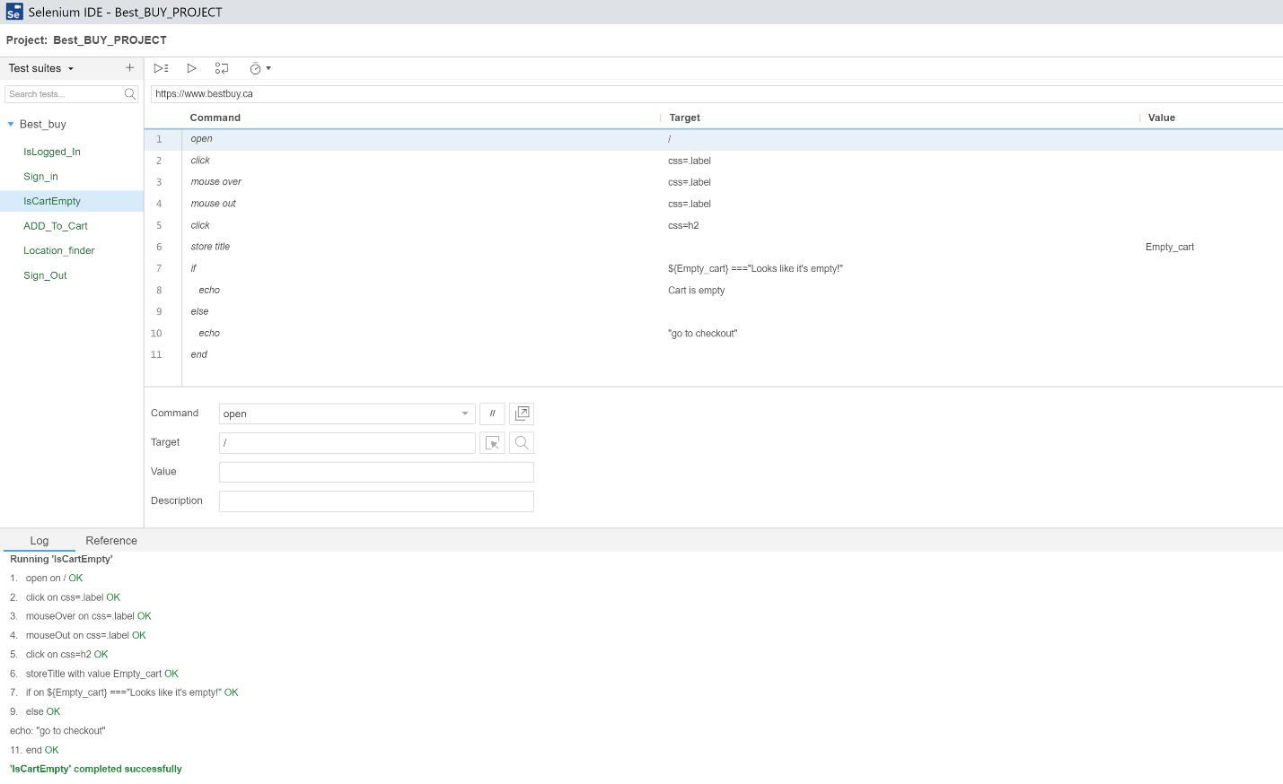

**4.)AddToCart :** This function add products to cart.

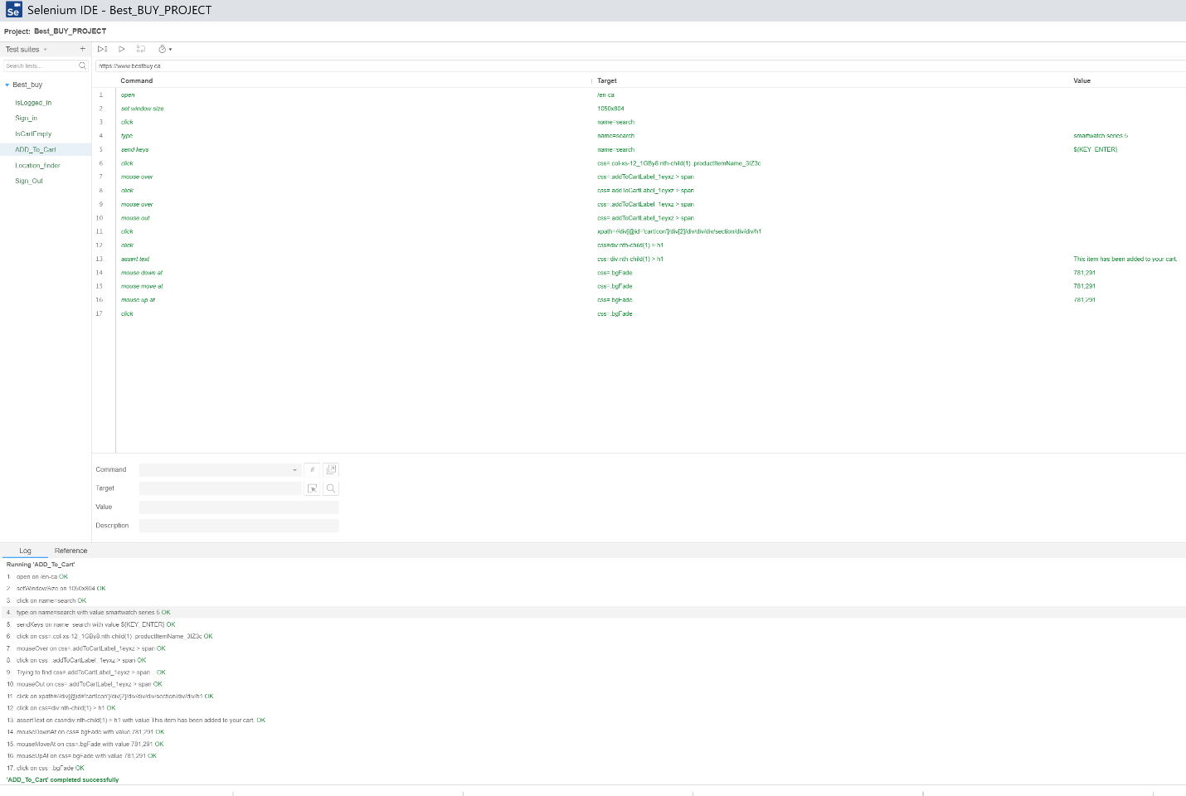

**AddToCart(commands)**

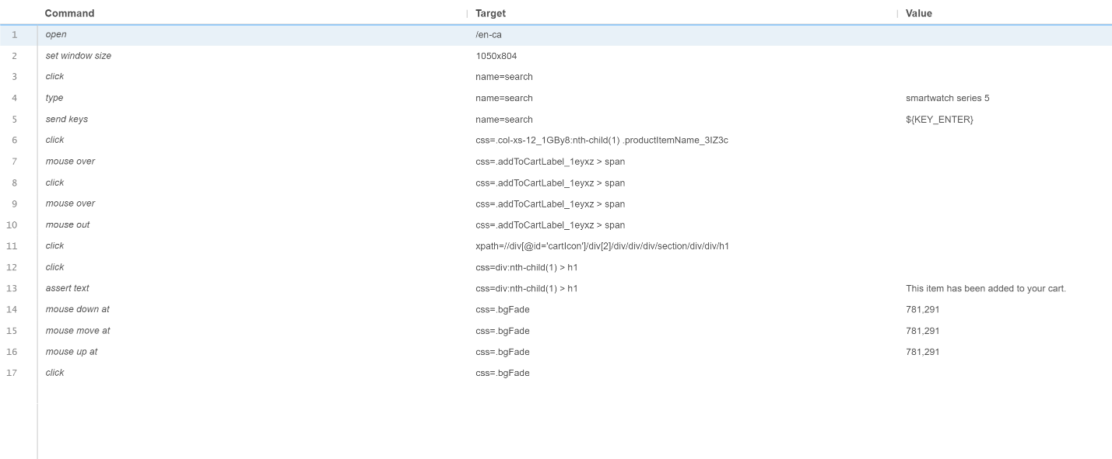

**5) (a) InStore_Pickup_Location_Iphone11_Pro :** It shows Location pick up features

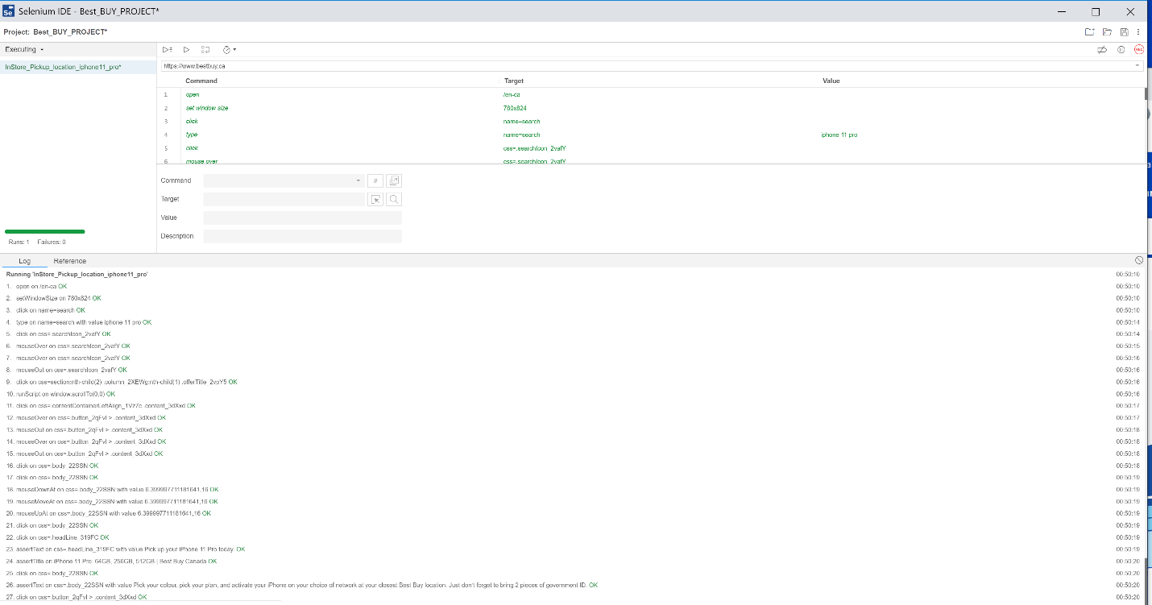

**5) (b) InStore_Pickup_Location_Iphone11_Pro**

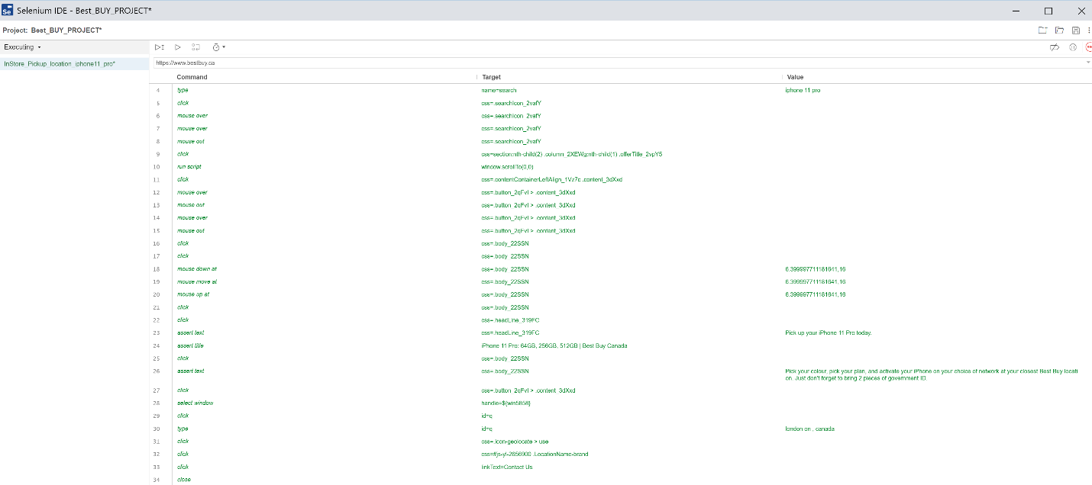

**5)©InStore_Pickup_Location_Iphone11_Pro**

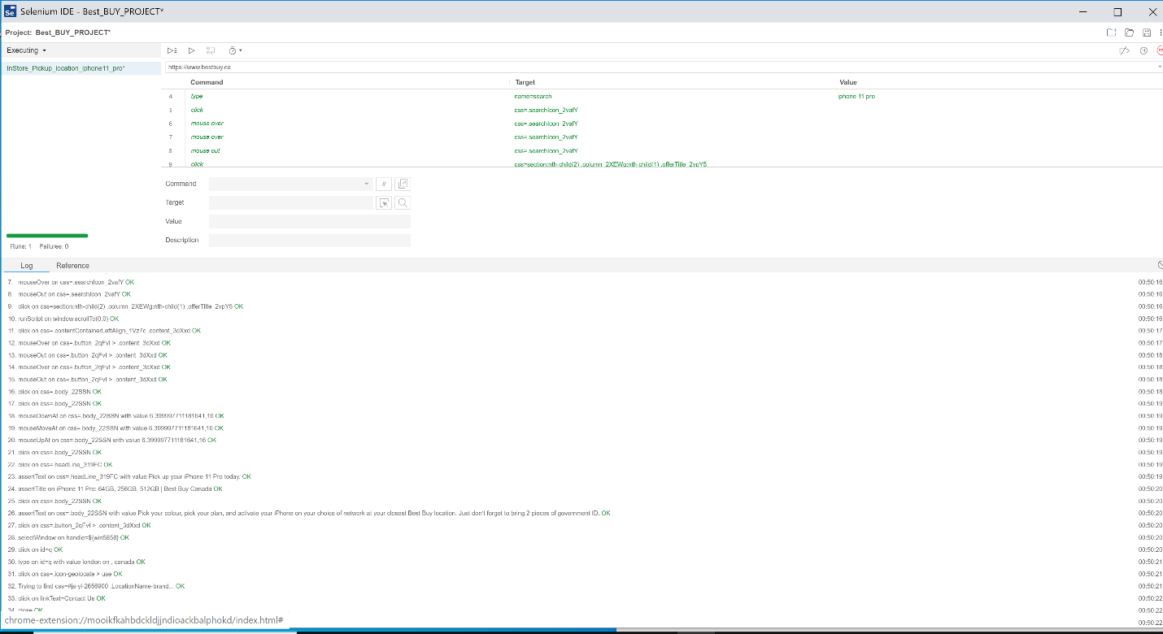

**InStore_Pickup_Location_Iphone11_Pro (commands)**

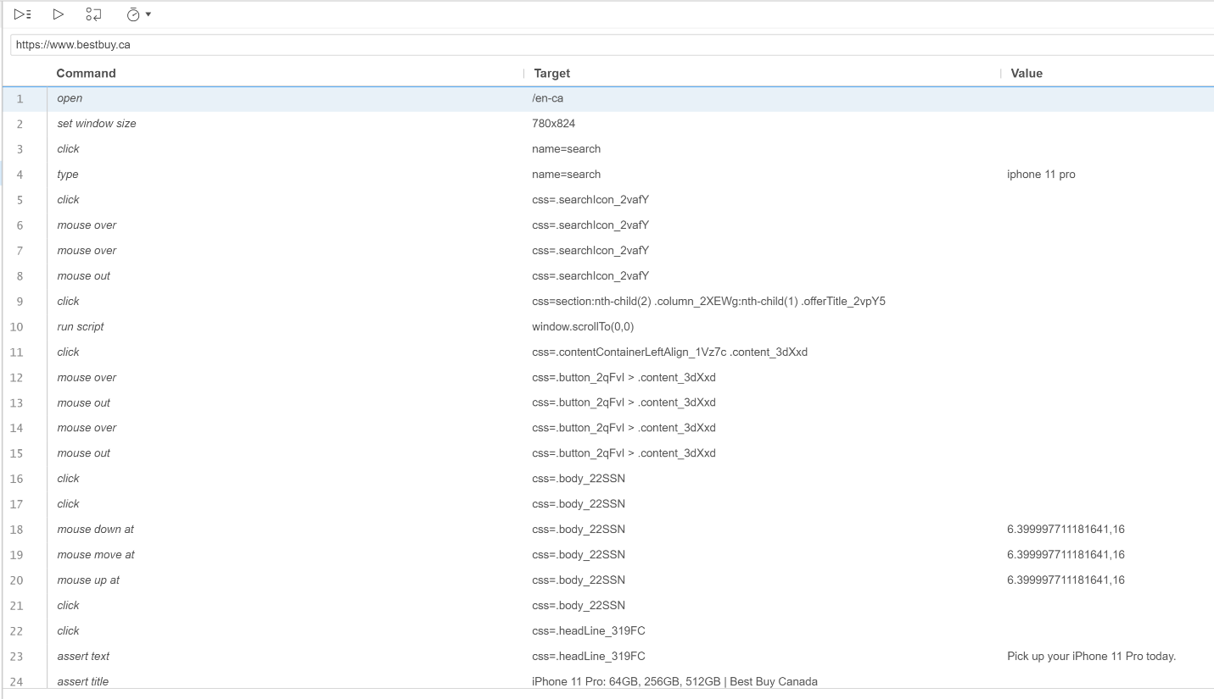

**InStore_Pickup_Location_Iphone11_Pro (commands)**

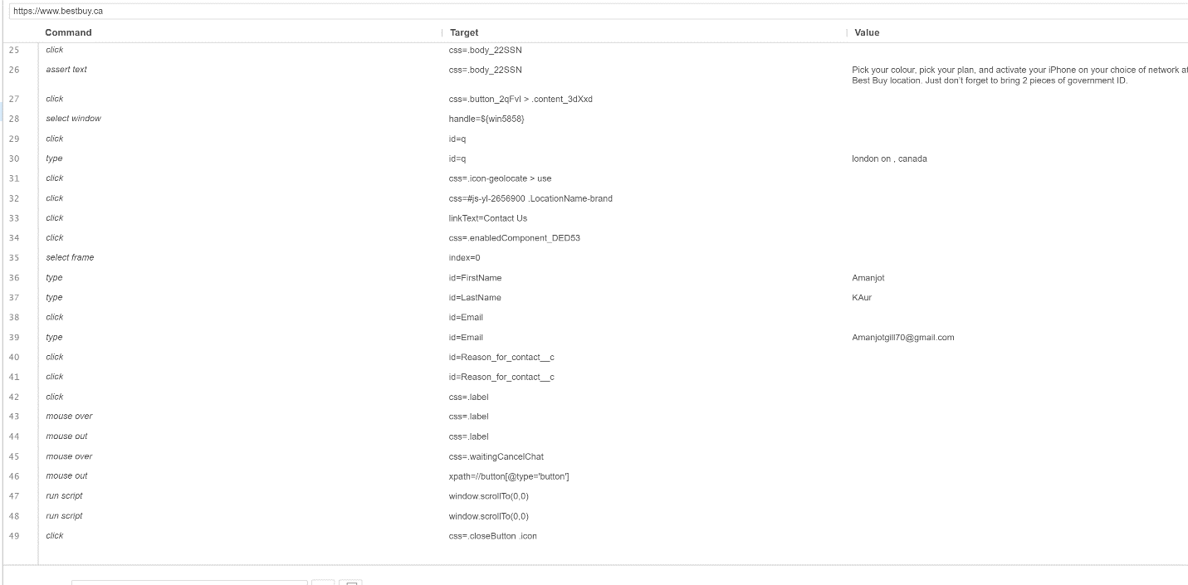

**6)You_tube_connection :** open you tube from best buy site.

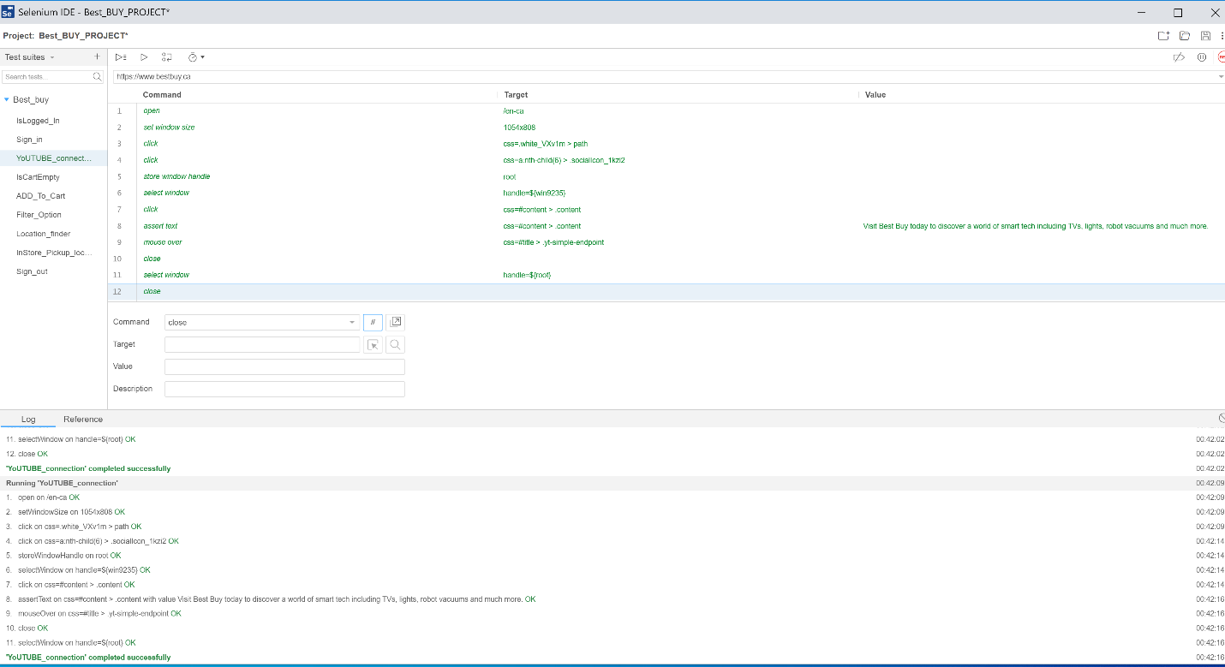

**Youtube(commands):**

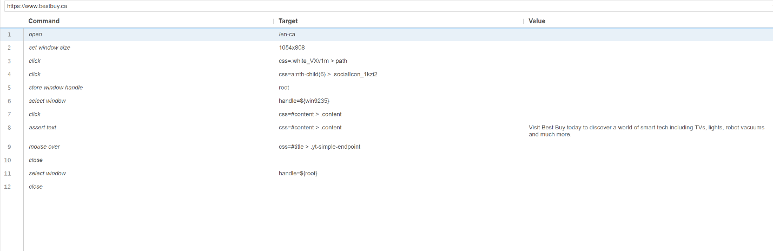

**7.)Filter_option : Find products according to desired requirements**

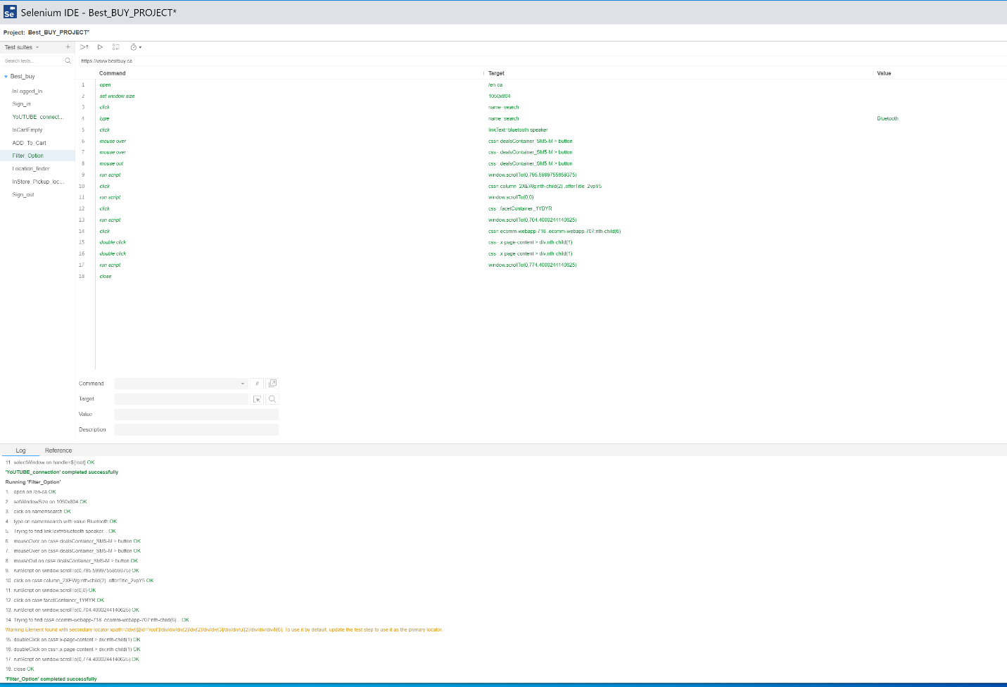

**(8.)Location finder** :Use navigator and map while executing.

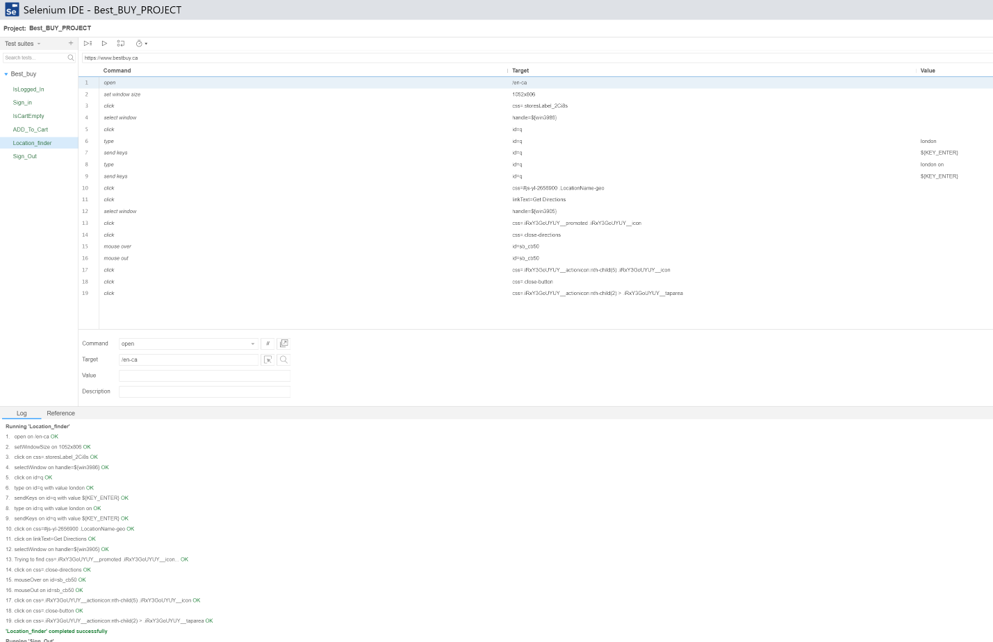

**Location_finder (Commands):**

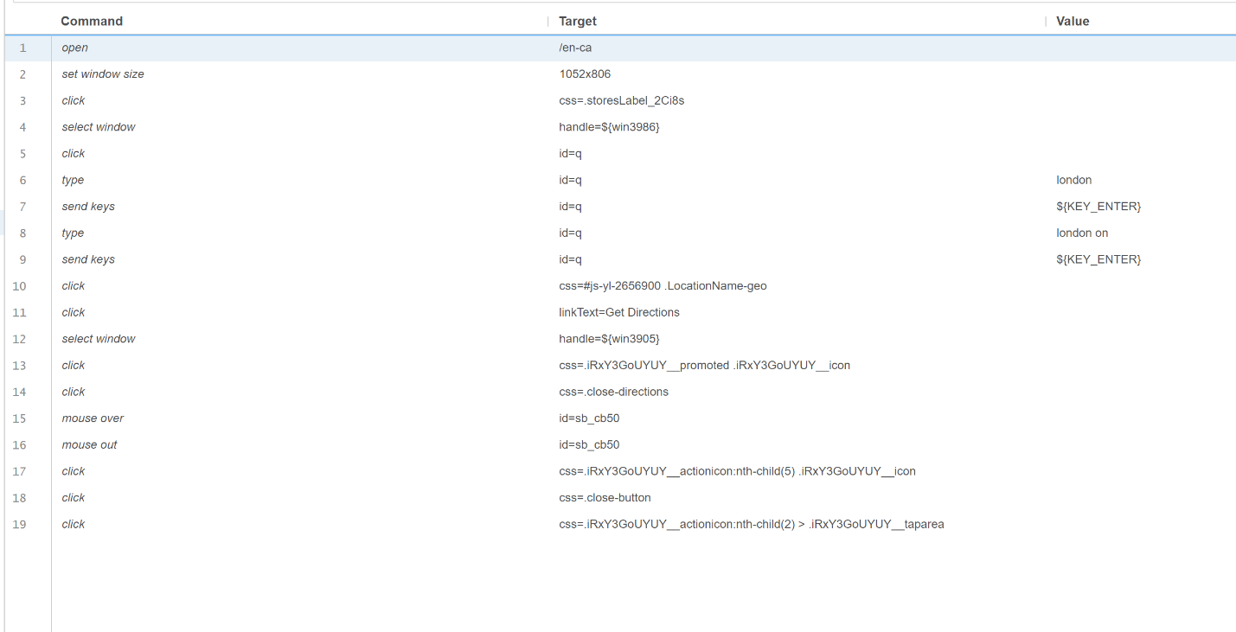

**9.)Sign_out :** It simply sign out from opened window by clicking on cross button

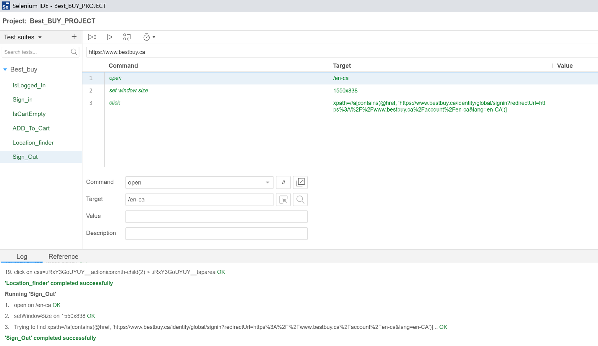

.

**Ques : 5.)Summary evaluation of the Selenium plugin based on the tests performed**

**Ans :** Our project is based on a website called Best buy that contains both dynamic as well as static pages . We create nine tests based on specific functionality, we evaluate positive as well as negative things :

**Positive Evaluation :**

**🡪**Easy to install, there is no need to configureand download setups as it is easily available on browsers.

**🡪**There is reuse feature, with the help of it, we can execute run command to call a test from another tests. We run Sign out test from isloggedIn tests .

🡪 The stop and record feature allow us to customize our tests as we faced any error while recording, we stopped and check error and removed and execute the tests again.

**Negative Evaluation:**

**🡪**Import : There is difficulty in importing test cases in another test project in selenium ide as we faced in our project.

🡪 Emojis, search field and feedback functions of best buy is not automated . Whenever we clicked on emojis or search field to store text, it pop up a message , “this feature do not apply on this area”. It mean that fields do not accomplish automation.

🡪Problem in finding XPath whenever we try to execute same tests again in another session.

**REFERENCES :**

<https://opensource.com/article/19/4/features-selenium-ide>

<https://selenium.dev/selenium-ide/>