Aman Kumar

2020CSB1153

Assignment 2:

I chose the value of K to be 128 by the elbow method. I chose the value of k at the “elbow” (the point after which the inertia start decreasing in a linear fashion). I also predicted the performance of different values of K and 128 came out to be most optimal.

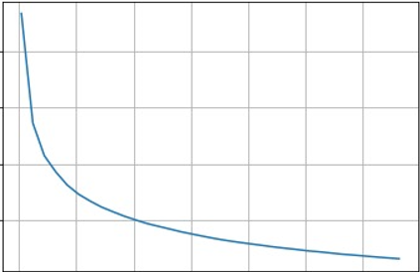

My graph of Elbow Method