**Amazon application using Selenium Webdriver**

**(WRITE UP)**

1.

> Go to Eclipse → Go to file→ New project → Maven project → Select checkbox-  Create a simple project -> pls make sure your workspace location is your default workspace location

If it is not default → uncheck the second checkbox→ from the drop down select the workspace.

2. . Press Next → enter group id : Phase1-SeleniumScripts → enter artifact id = Phase1-SeleniumScripts -> click on Finish button

You will see your project on the left side:

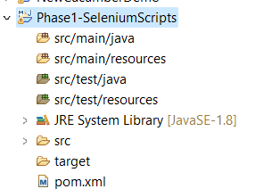

3. Double click on POM.xml file and open it

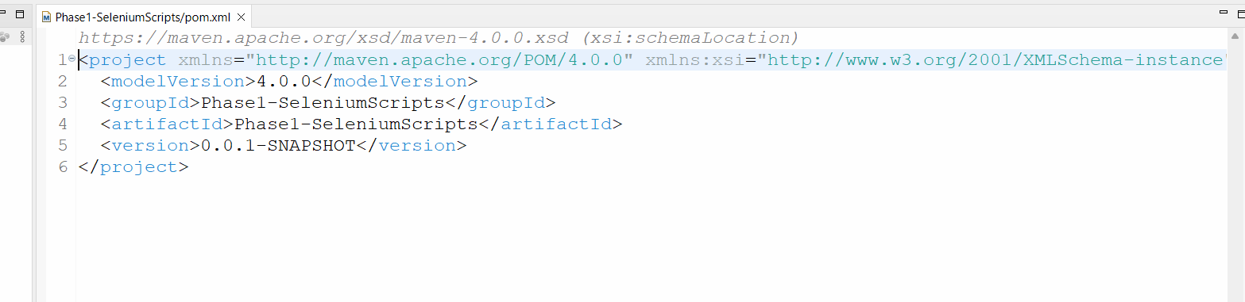

4. In the Pom file add below dependencies after line number 5 or before the tag </project>

Save the file after adding the dependencies.

**<dependencies>**

**<dependency>**

**<groupId>org.seleniumhq.selenium</groupId>**

**<artifactId>selenium-java</artifactId>**

**<version>4.11.0</version>**

**</dependency>**

**<!-- https://mvnrepository.com/artifact/io.github.bonigarcia/webdrivermanager -->**

**<dependency>**

**<groupId>io.github.bonigarcia</groupId>**

**<artifactId>webdrivermanager</artifactId>**

**<version>5.4.1</version>**

**</dependency>**

<dependency>

<groupId>commons-io</groupId>

<artifactId>commons-io</artifactId>

<version>2.11.0</version>

</dependency>

**</dependencies>**

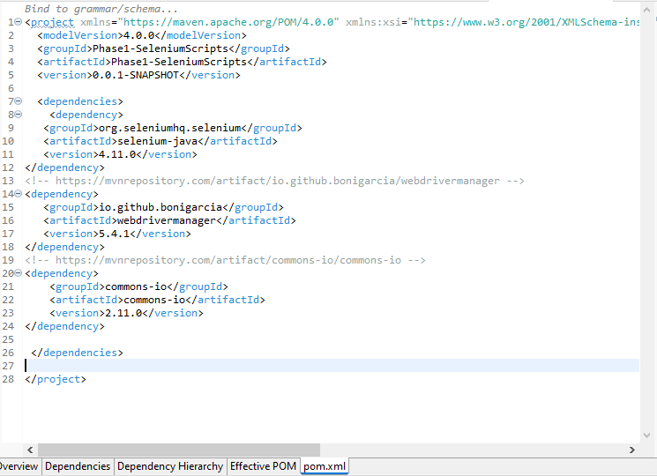

Your setup for selenium is now complete.

5. Create a Java class in the src/test/java folder

6. Create a Java class with name “class TestSearchPage” .

(source code and Screen shot of output are present in there respective files)

7. Create a Java class with name “class TestMobilePage” .

(source code and Screen shot of output are present in there respective files)

8. Create a Java class with name “class TestSignInPage” .

(source code and Screen shot of output are present in there respective files)

9.

1. Go to Java project --> right click--> go to properties --> go to Java build path --> libraries path
2. Click on Add external jars --> browse to downloads folder -->go to jdbc extracted folder--> select the file with name
3. mysql-connector-j-8.1.0.jar
4. Clickon apply and close.
5. Step 1: Register JDBC Driver
6. Before you use or execute java program it is important to register JDBC driver.
7. By this process mysql driver class is loaded in the memory, so that it can be utilized for implementation of jDBC interfaces.

10. Create a Java class with name “class SeleniumJDBCTrasaction” .

(source code and Screen shot of output are present in there respective files)