electronic supplementary material

LCIA of impacts on human health and ecosystems

A taste of the new ReCiPe for life cycle assessment: consequences of the updated impact assessment method on food product LCAs

Erik Dekker^{1, 2} • Michiel C. Zijp² • Mirjam E. van de Kamp² • Elisabeth H.M. Temme² • Rosalie van Zelm¹

Received: 29 October 2018 / Accepted: 13 June 2019
© Springer-Verlag GmbH Germany, part of Springer Nature 2019

Responsible editor: Serenella Sala

¹Department of Environmental Science, Institute for Water and Wetland Research, Faculty of Science, Radboud University, Nijmegen, The Netherlands
²National Institute for Public Health and the Environment, Bilthoven, The Netherlands

 Rosalie van Zelm
r.vanzelm@science.ru.nl

1 Introduction

The choice of LCIA method influences the outcomes of the LCA and should therefore be selected well-considered and transparently. For example, most LCIA methods are orientated on one specific geographic region, e.g. USA (TRACI), Japan (LIME), Canada (LUCAS) and Europe (ReCiPe 2008) (Itsubo and Inaba 2003; Goedkoop et al. 2009; Bare 2011; Hauschild et al. 2013). In 2016, an updated version of ReCiPe was released, which is now globally orientated (Huijbregts et al. 2016). Also, LC-IMPACT and IMPACTWorld+ are globally orientated methods, but as relatively new methods, have not been used often yet (Bulle et al. 2018; LC-Impact 2018).

ReCiPe provides characterization factors (CFs) that allow translation of emissions to the environment and deprivation of resources into midpoint and endpoint impacts through a variety of environmental damage pathways (Goedkoop et al. 2009; Huijbregts et al. 2016). A variety of studies has been performed with ReCiPe 2008, both on midpoint and on endpoint level, and it has often been used for assessment of foods (e.g. Manfredi & Vignali (2014); Smetana et al. (2015); Goldstein et al. (2016)). Where ReCiPe 2008 was based on European data, ReCiPe2016 presents CFs that are applicable on a global scale and offers the possibility for country-specific impact assessment for a selection of impact categories, i.e. fine particulate matter formation, freshwater eutrophication, terrestrial acidification, water use and ozone formation. ReCiPe 2016 includes new damage pathways, compared to the 2008 version. These are: damage to human health through diseases other than cancer from stratospheric ozone depletion, damage to freshwater species from global warming, damage to human health and ecosystems from water use and damage to terrestrial species from tropospheric ozone formation (Fig. S1). Other damage pathways were improved, for example ReCiPe 2016 includes a larger set of greenhouse gasses (Huijbregts et al. 2017). ReCiPe 2008 and 2016 use different equivalents for fine particulate matter, PM₁₀ and PM_{2.5} , and base their effect calculations on these different substances. As there is no CF available in ReCiPe to convert these to similar equivalents they were compared with different equivalents. Where ReCiPe 2008 had different impact categories for agricultural land occupation, urban land occupation and natural land transformation, ReCiPe 2016 has all of these incorporated in the generic impact category land use.
Furthermore, ReCiPe 2008 and 2016 offer the possibility to calculate environmental impacts from three different perspectives, or value choices: Individualist, Hierarchist and Egalitarian. These three different value choices correspond to three different time frames for environmental impact (20 years, 100 years or 1000 years in ReCiPe 2016), and differ in their use of damage uncertainty. The Individualist perspective only includes damage pathways that have a high level of evidence and the Egalitarian perspective incorporates all reported effects (Huijbregts et al. 2017). These value choices have changed in ReCiPe 2016 compared to ReCiPe 2008, as the Egalitarian perspective had a time frame of 500 years in ReCiPe 2008 and there are larger differences between the three value choices with regard to damage uncertainty.

Fig. S1.Overview of the impact categories covered in ReCiPe 2016 and differences with ReCiPe 2008. Dashed lines indicates there is no constant mid to endpoint factor, green lines show new connections in ReCiPe 2016, red lines show connections that are no longer present in ReCiPe 2016. Derived from Huijbregts et al. (2016) and Goedkoop et al. (2009).

2 Methods

Ionizing radiation has a different unit in ReCiPe 2008 compared to ReCiPe 2016. To be able to compare predicted impacts for ionizing radiation from ReCiPe 2008 and ReCiPe 2016, ReCiPe 2016 results were converted to kBq U235 eq.

2.1 About the Dutch National Food consumption Survey (DNFCS)
The RIVM monitors the food consumption in the Netherlands. Participants were chosen to form a representative dataset of which several characteristics were known. The panel consisted of residents between the age of 7-69 that formed a representable dataset for the Netherlands. Within each household only one person is allowed to participate. Participants were asked to report their food intake based on a 24-hour recall, this was done twice with an interval of two to six weeks. These surveys are done on a yearly basis (Van Rossum et al. 2011).

2.2 Different product groups
Products were divided in groups based on the EPIC-soft [Van Rossum, 2011]. Table s1 list the different product that were used in this study with the corresponding product category they were aggregated.

Table S1. List of products and corresponding product category based on the GloboDiet groups (Slimani et al. 2000)
Category | Aggregated groups | Products
Beverages | Alcoholic beverages, non-alcoholic beverages, soy milk | Beer pilsner, Coffee Cappuccino freshly made, Coffee prepared, Drink soya natural, Gin young Dutch, Ice tea, Juice apple, Juice drink Dubbelfrisss, Juice drink Wicky, Juice orange freshly squeezed, Juice orange pasteurized, Mineral water average, Mineral water Bar le Duc, Mineral water Spa, Soft drink cola w caffeine, Tea, Wine dry white, Wine red, Wine rose
Cereals | Cereals and cereal products,  Cakes and snacks | Baguette white, Bread multigrain average w seeds, Bread rye average, Bread white water based, Bread wholemeal average, Bun currant/raisin, Chips pre-fried, Croissant, Dough for pizza and savoury pie, Flour wheat-, Pasta white boiled, Roll white hard, Roll white soft, Snack sausage roll puff pastry
Dairy | Dairy, ice cream, butter | Butter salted, Butter unsalted, Buttermilk, Cheese 20+, Cheese Edam 40+, Cheese goat fresh, Cheese Gouda 48+ average, Cheese Old Amsterdam 48+, Cheese spread 48+, Cream whipping, Custard several flavours full fat, Custard vanilla full fat, Fromage frais full fat, Ice cream dairy cream based, Milk chocolate-flavoured full fat, Milk chocolate-flavoured semi-skimmed, Milk semi-skimmed, Milk skimmed, Milk whole, Yoghurt drink Optimel with sweetners, Yoghurt full fat, Yoghurt half fat, Yoghurt low fat, Yoghurt low fat with fruit
Fat |  | Frying fat horeca, Low fat margarine 40% fat <17 g saturated, Margarine 80% fat <24 g saturated, Oil olive-, Oil sunflower-
Fish |  | Alaska Pollack fillet, Claresse fillet (catfish), Cod fillet, Fish fingers, Herring in tomato sauce, Herring marinated, Herring soused, Kibbeling, Lekkerbekje, Mackerel, Pangasius fillet, Plaice fillet, Salmon fillet, from aquaculture, Salmon fillet, wild caught, Shrimps Dutch peeled boiled, Tilapia fillet, Trout, Tuna
Fruit | Fruits, Nuts and Seeds | Apple with skin average, Apple without skin average, Banana, Cashew nuts unsalted, Grapes with skin average, Kiwi fruit, Manderins, Orange, Peach without skin, Peanuts unsalted, Pineapple, Strawberries, greenhouse, Strawberries, open field, Strawberries, Walnuts
Meat | Egg | Bacon rashers streaky, Beef frying steak prepared, Beef roast prepared, Beef rump steak prepared, Beef smoke-dried, Beef steak tartare spiced filet americ, Chicken fillet prepared, Chicken with skin prepared, Croquette meat ragout deep-fried, Eggs chicken boiled average, Ham lean boiled, Ham shoulder medium fat boiled, Hamburger prepared, Lamb >10 g fat raw average, Liver pate sausage, Minced beef shallow fried, Minced beef/pork shallow fried, Minced meat loaf fried, Pork <5% fat raw, Pork 5-14% fat raw, Pork shoulder chop prepared, Salami sausage saveloy, Sandwich meat chicken, Sausage cooked, Sausage Dutch Frikandel deep-fried, Sausage frankfurter tinned, Sausage luncheon meat, Sausage pork Braadworst prepared, Sausage raw beef, Sausage smoked beef cooked
Vegetables | Vegetables  Potatoes  Legumes | Beans French boiled, Beans French frozen boiled, Beans French tinned, Broccoli boiled, Brown beans tinned/glas, Carrots boiled average, Cauliflower boiled, Chicory boiled, Courgettes boiled, Crisps potato average, Cucumber w skin raw, Cucumber wo skin raw, Kale curly boiled, Lettuce average raw, Lettuce head raw, Mashed potatoes made with semi-skimed milk, Mushroom boiled, Onions boiled, Peas and carrots tinned, Peas frozen boiled, Potatoes wo skins boiled average, Spinach frozen boiled, Sweetcorn glas, Sweetcorn tinned, Tomato average boiled, Tomato average raw
Other |  | Sugar granulated

3 Results

This section provides additional results of the analyses.
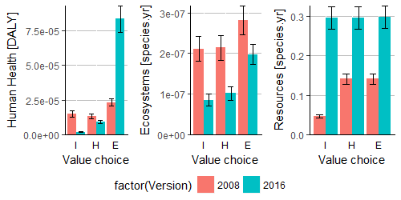
Fig. S2 Predicted environmental damage to human health, ecosystems and resources in ReCiPe 2008 and ReCiPe 2016 for three different value choices.
The effect of different value choices is different for ReCiPe 2008 compared to ReCiPe 2016 (Fig. S2). Within ReCiPe 2008 there is no significant difference between damage predicted to human health from an hierarchist perspective and from an individualist perspective (p=0.53). Damage to human health predicted from an egalitarian perspective is significantly different from both other perspectives (p<0.05). Within ReCiPe 2016 the three different perspectives predict significantly different impacts. ReCiPe 2008 predicts no significantly different impacts with the three different value choices. Within ReCiPe 2016 the egalitarian perspective predicts significantly different impacts than those from an individualist (p<0.001) or hierarchist perspective (p<0.05). Damage to resources is predicted to be equal in ReCiPe 2008 for a hierarchist and an egalitarian (p=1), while significantly differing from the damage predicted from an individualist perspective (p<0.001). ReCiPe 2016 predicts there to be no significant differences between the three value choices.

There is no significant difference in ranking of product categories in ReCiPe 2016 compared to ReCiPe 2008. However, there are large differences in absolute values and the difference between categories changes with ReCiPe 2016 (Fig. S3). From an individualist perspective, product categories are predicted to have a more similar impact om human health and ecosystems in ReCiPe 2016. Meat products, for example, are predicted to have 2.6 times more impact on human health from an individualist perspective in ReCiPe 2008, while fish products have a slightly higher impact in ReCiPe 2016. This levelling of predicted impacts cause there to be less significant differences between different product categories. From a hierarchist perspective, the difference between ReCiPe 2008 and ReCiPe 2016 is smaller and levelling of predicted impacts is less. From an egalitarian perspective, ReCiPe 2016 predicts higher impacts on human health than in ReCiPe 2008.
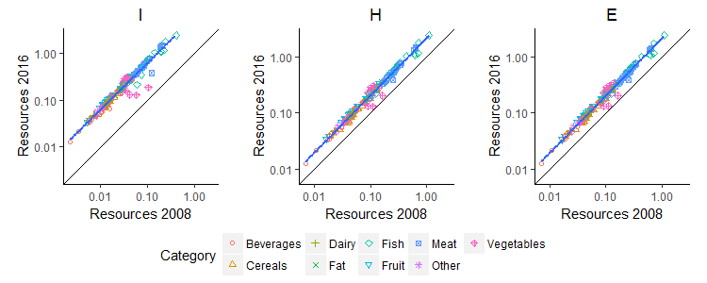
Fig. S3. Impact per kg of food for 152 foods using ReCiPe 2016 versus ReCiPe 2008. Impacts for resource depletion from three different perspectives (Individualist (I), Hierarchist (H) and Egalitarian (E). Line for best fit in blue, black line indicates the 1:1 line.

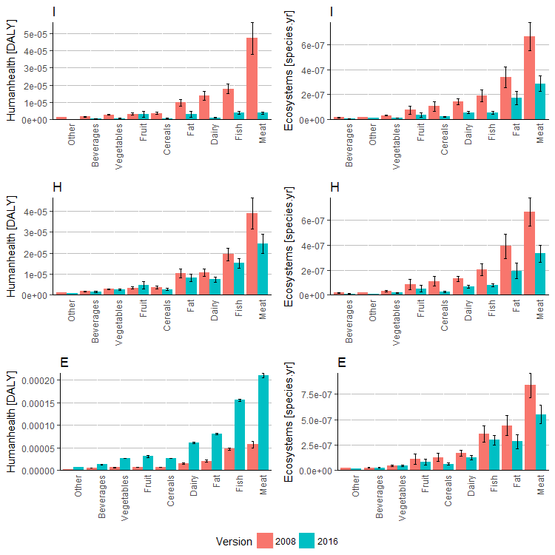
Fig. S4. Average impact for each product category in ReCiPe 2008 and ReCiPe 2016, averages with standard error.
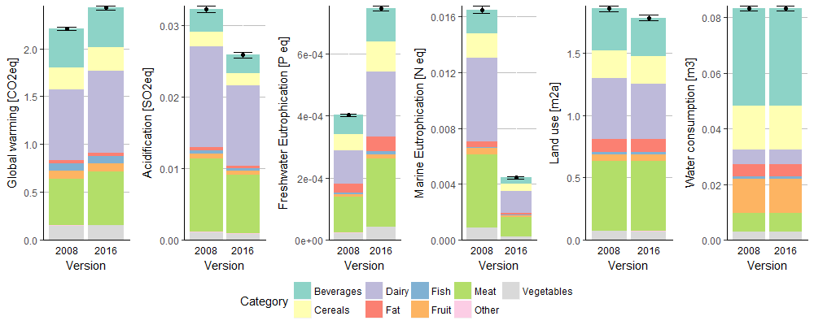
Fig. S5. Average dietary impact per person per day in the Netherlands in ReCiPe 2008 and ReCiPe 2016 for persons aged between 7-69 based on selected foods. Average impact split out per product category with standard error. Consumption data from Van Rossum et al (2011). All impacts are from an hierarchist perspective. n=7628
Although there is no significant difference in the ranking of products on a per kg basis, there is a significant difference between the average impact of the Dutch diet form selected foods calculated with ReCiPe 2008 and ReCiPe 2016 (Fig. S3). Average impact on greenhouse gas emissions, terrestrial acidification, freshwater eutrophication, land use and water consumption are significantly different between ReCiPe 2008 and ReCiPe 2016 (p<0.05). Not all product categories change equally with the update to ReCiPe 2016. The predicted daily greenhouse gas emissions from meat and dairy products differed significantly between ReCiPe 2008 and ReCiPe 2016, with a higher impact predicted with ReCiPe 2016. The predicted impact on acidification and eutrophication changed significantly for all product categories. Beverages, dairy and fish were predicted significantly lower for land use with ReCiPe 2016. Beverages is the only food category that changes significantly between ReCiPe 2008 and 2016 for water use.

Within product categories there are few change in ranking of products on endpoint level (Fig. S4a: S9b). None of the changes in ranking causes a significant difference in ranking within the product category. There is however a change in the composition of the endpoint impact. Changes of composition are discussed in the main text.

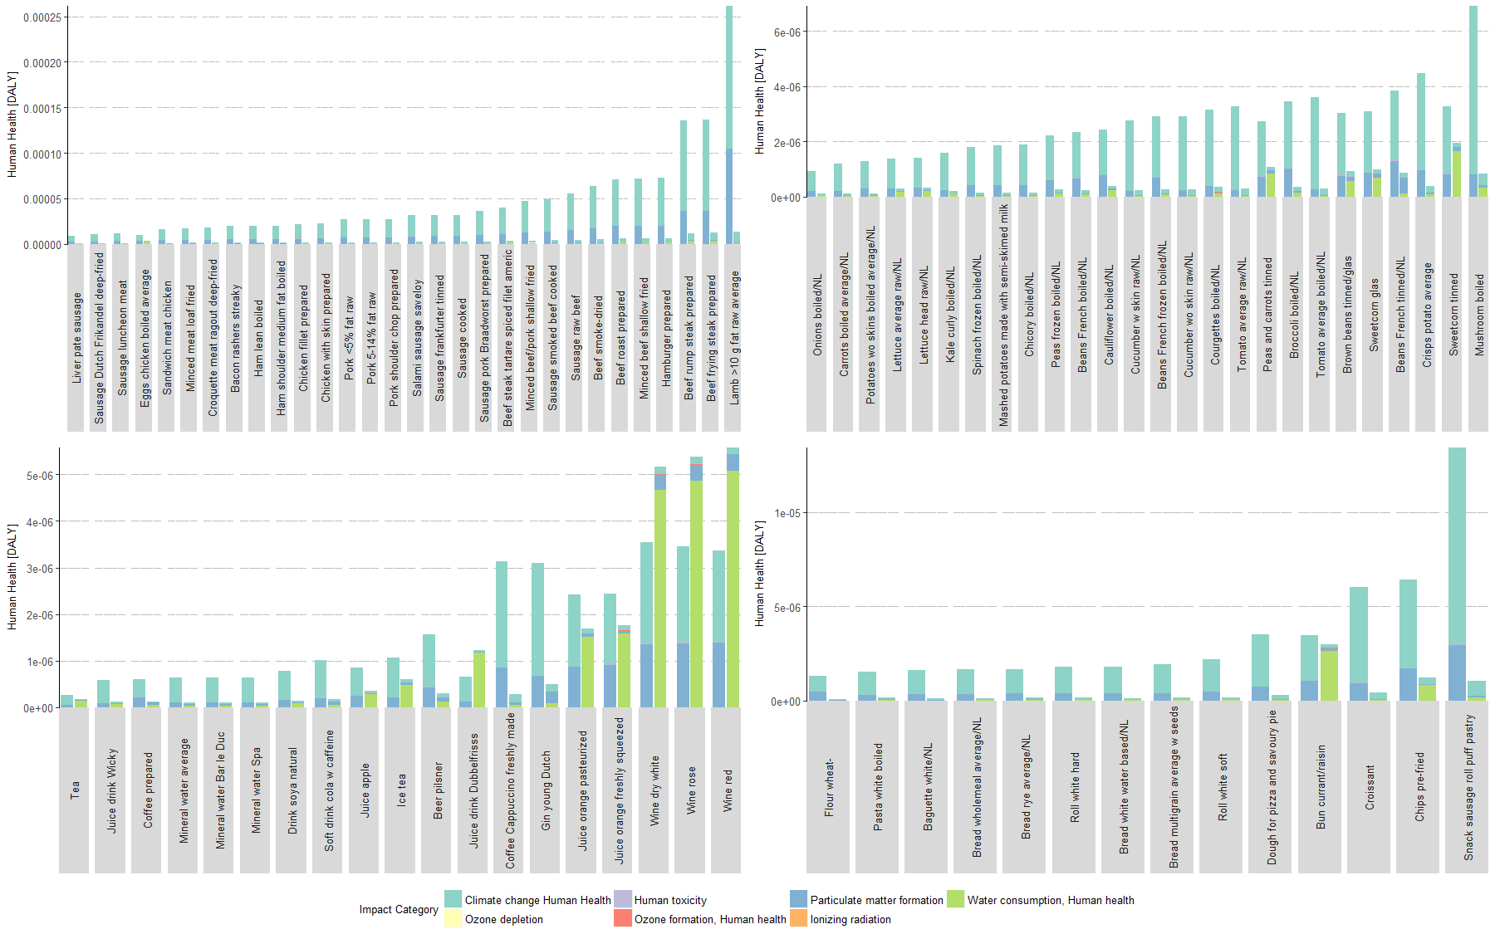
Fig. S6a. The impact of food products on human health from an Individualist perspective
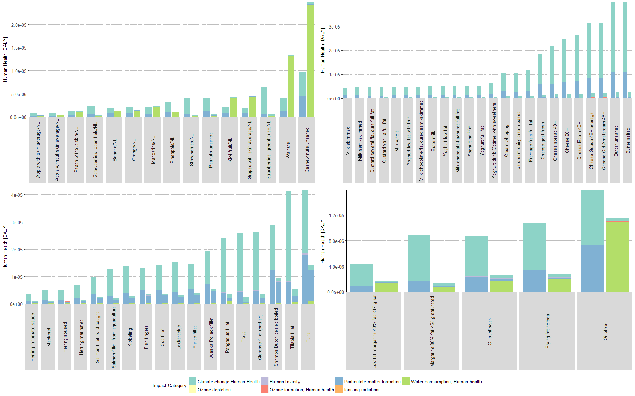
Fig. S6b. The impact of food products on human health from an Individualist perspective
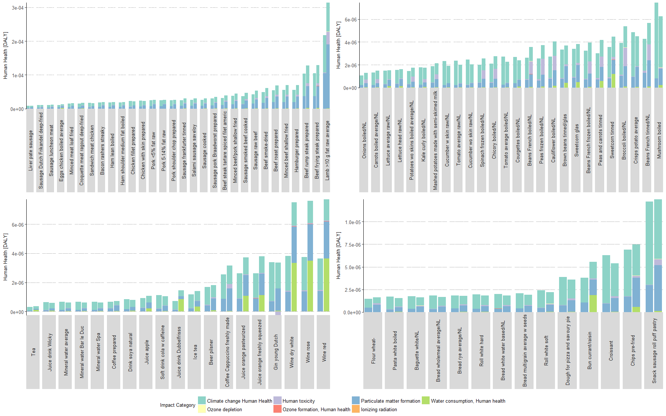
Fig. S7a. The impact of food products on human health from a Hierarchist perspective
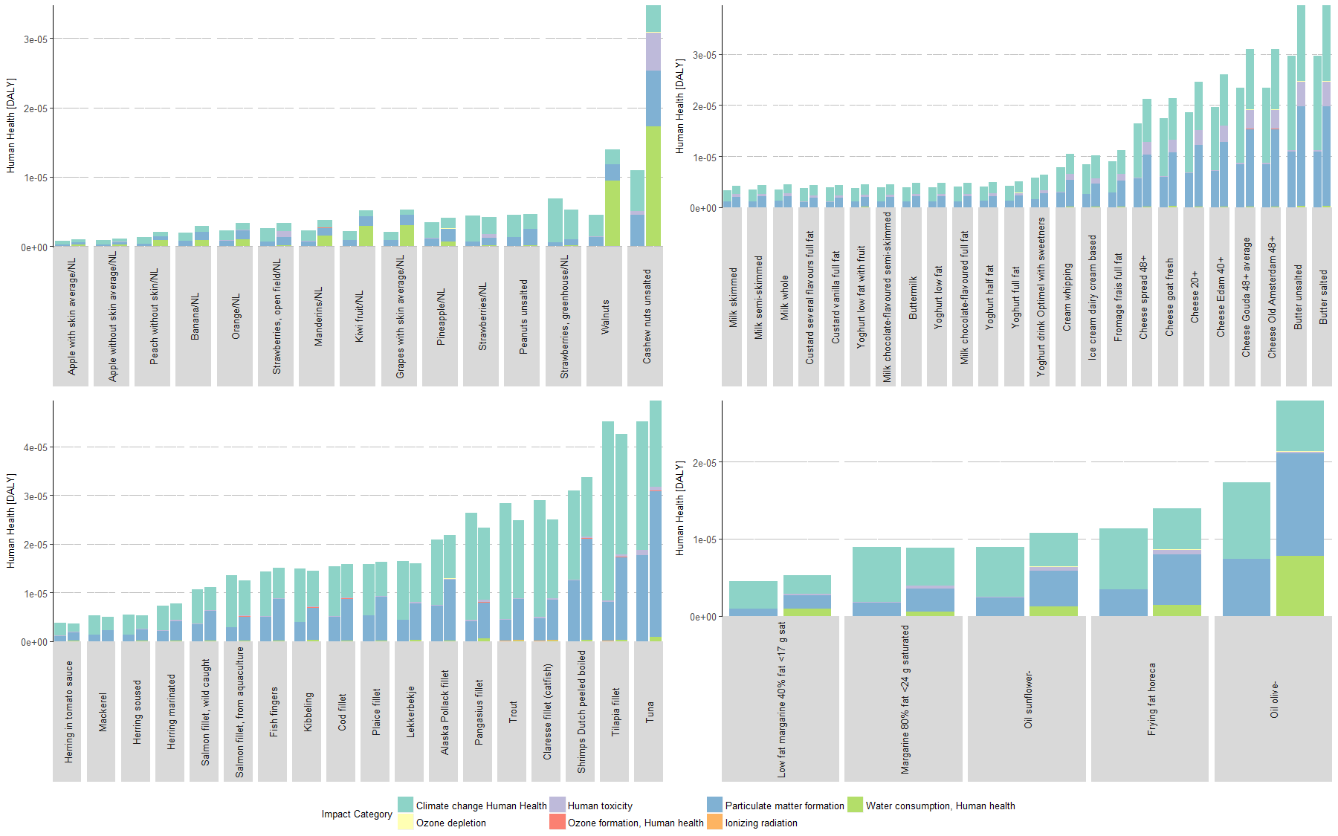
Fig. S7b. The impact of food products on human health from a Hierarchist perspective
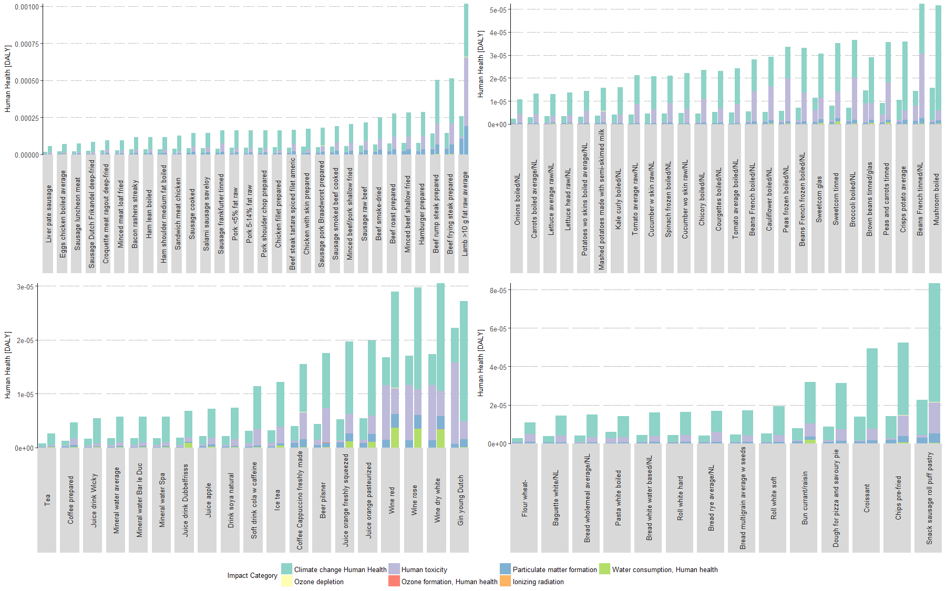
Fig. S8a. The impact of food products on human health from an Egalitarian perspective
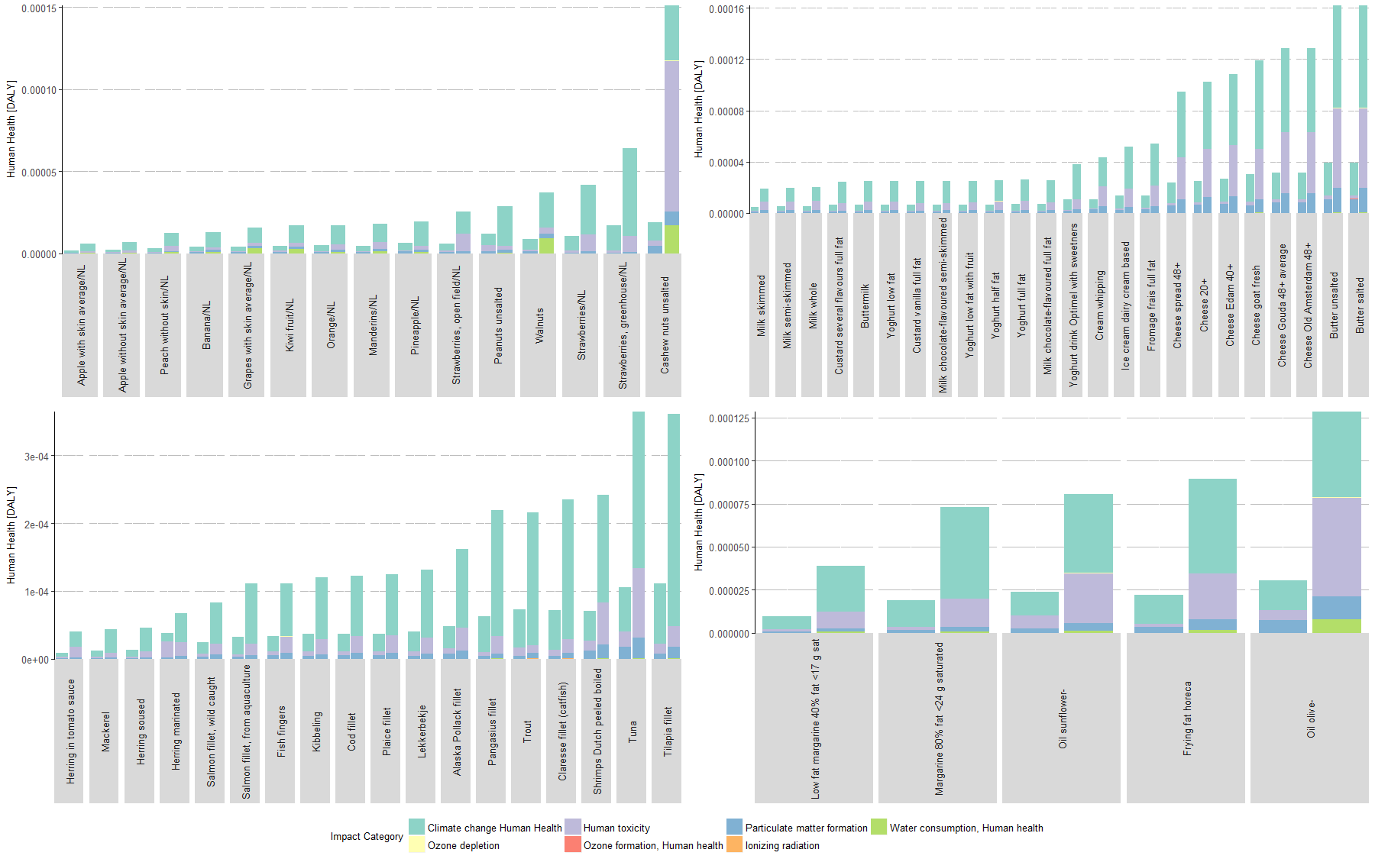
Fig. S8b. The impact of food products on human health from an Egalitarian perspective
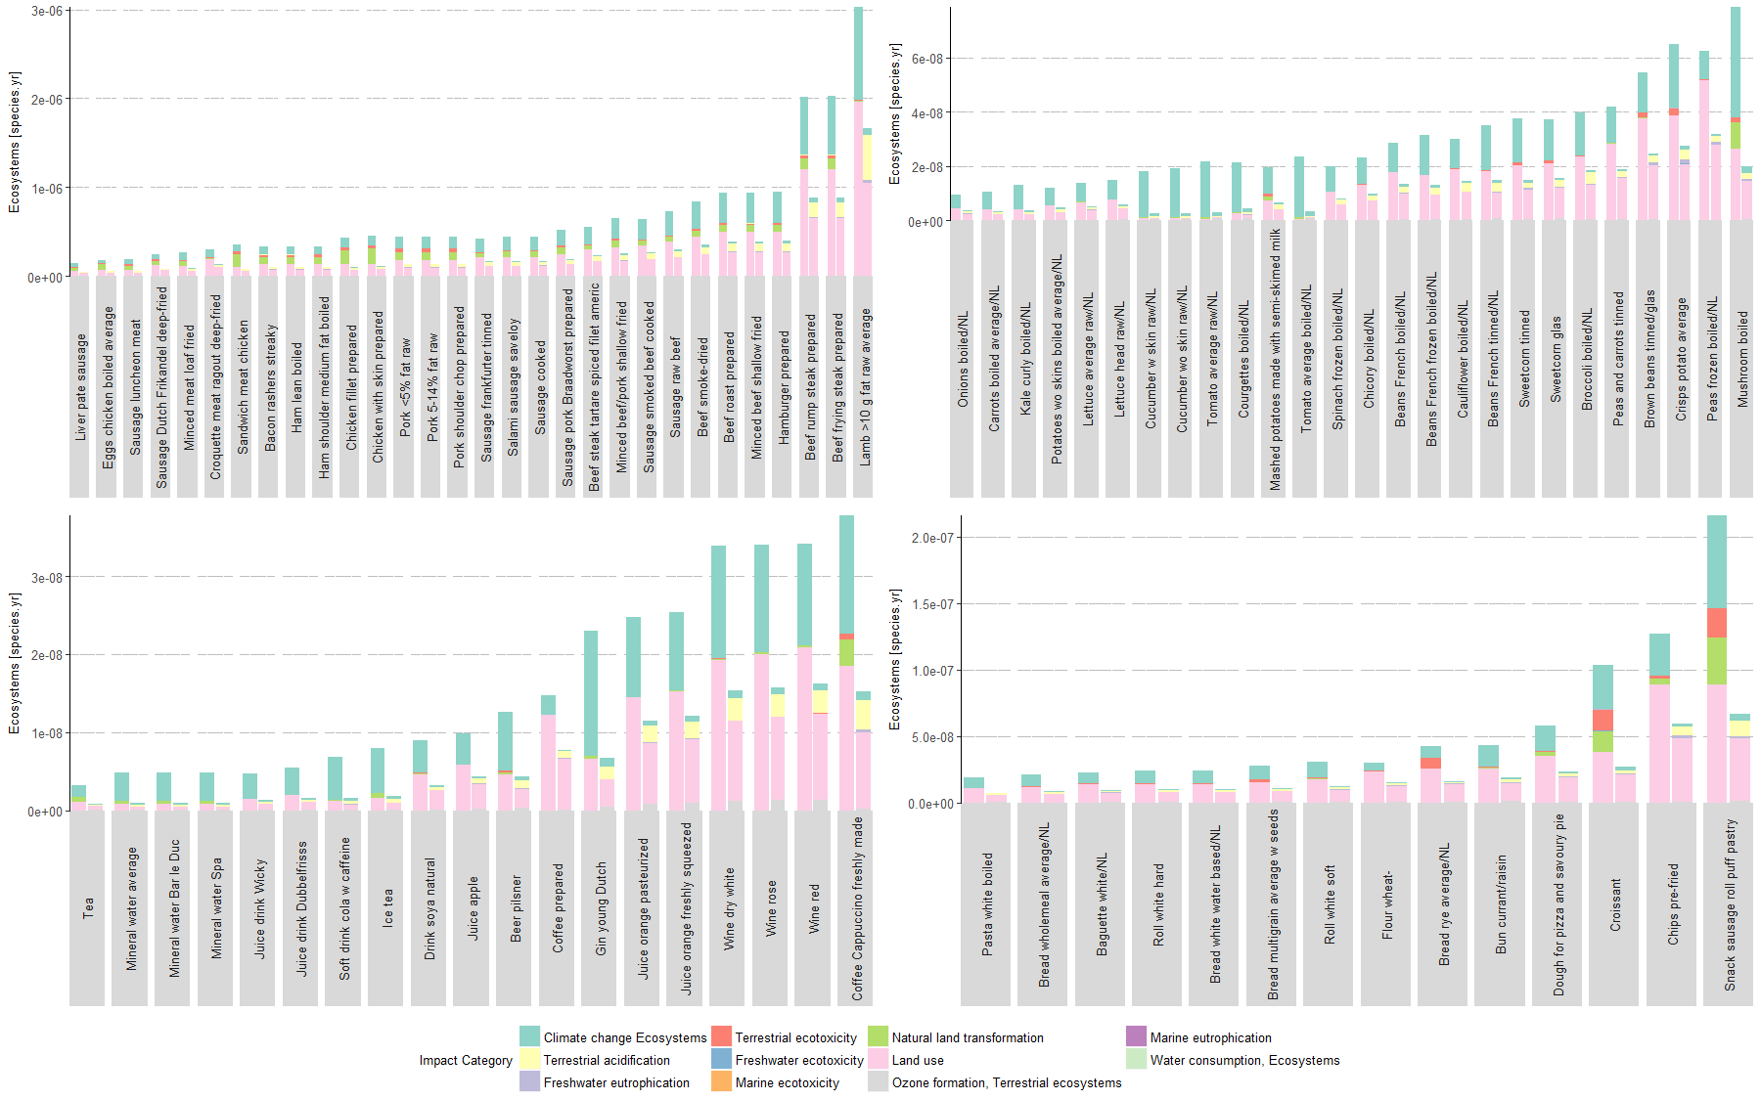
Fig. S9a. The impact of food products on ecosystems from an Individualist perspective
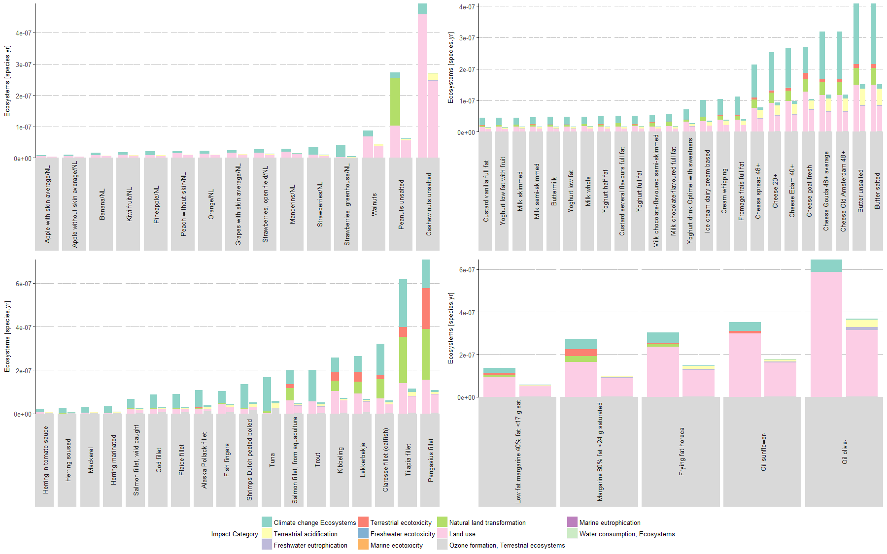
Fig. S9b. The impact of food products on ecosystems from an Individualist perspective
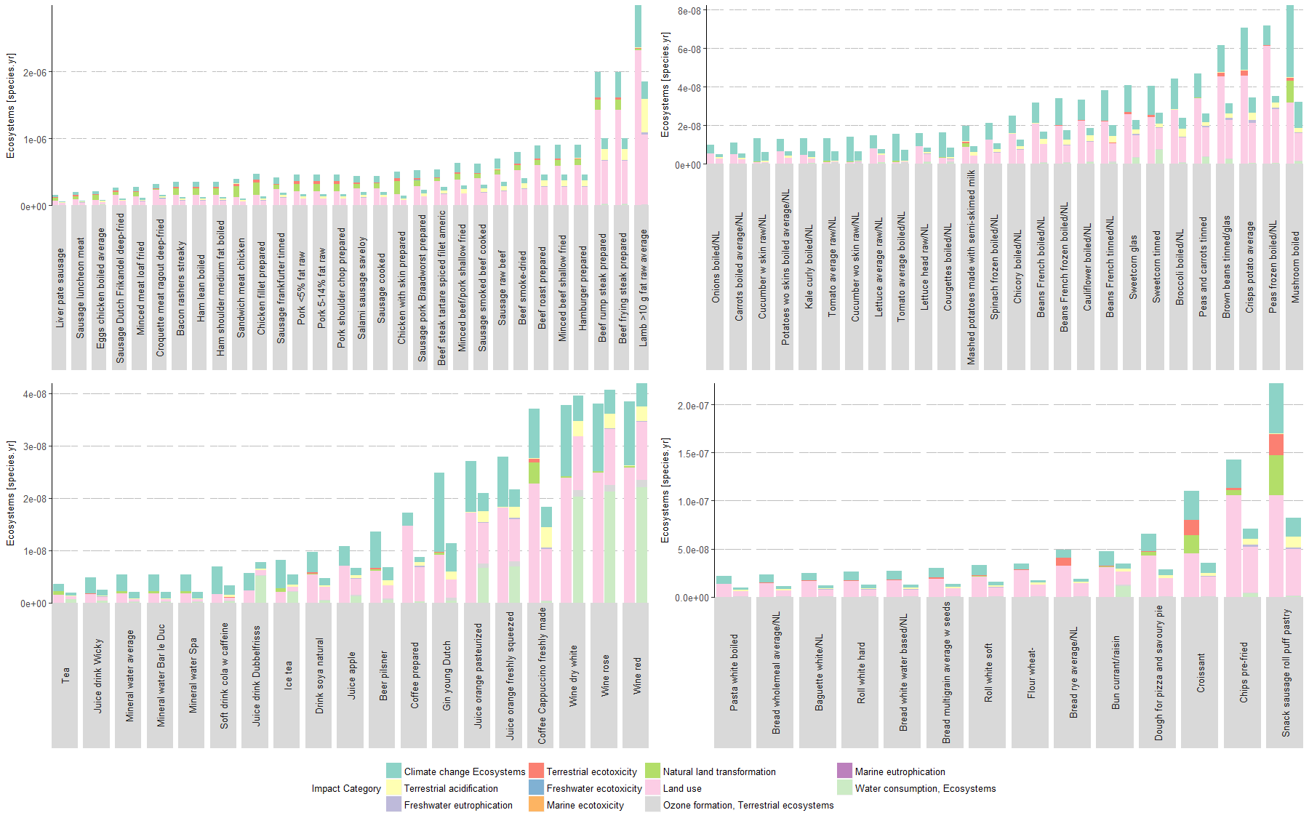
Fig. S10a. The impact of food products on ecosystems from a Hierarchist perspective
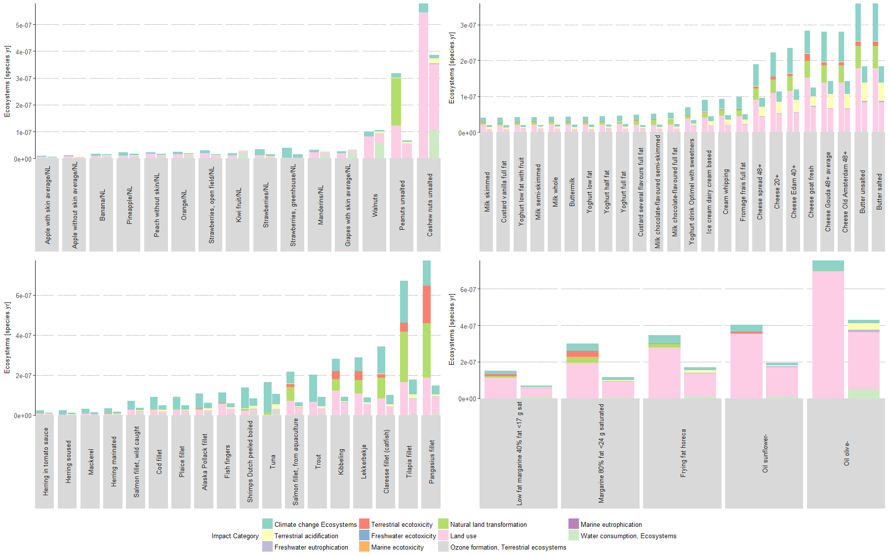
Fig. S10b. The impact of food products on ecosystems from a Hierarchist perspective
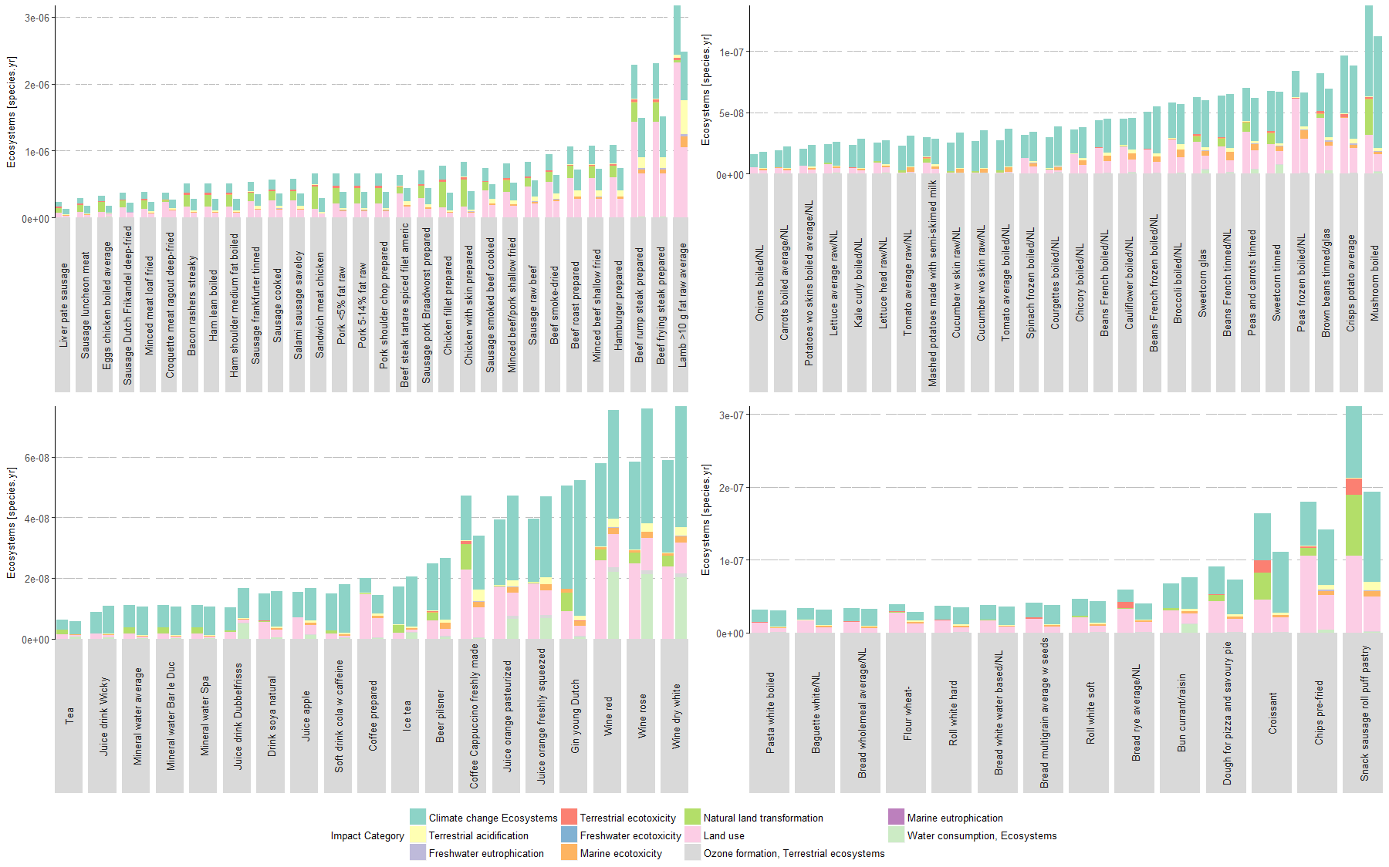
Fig. S11a. The impact of food products on ecosystems from an Egalitarian perspective
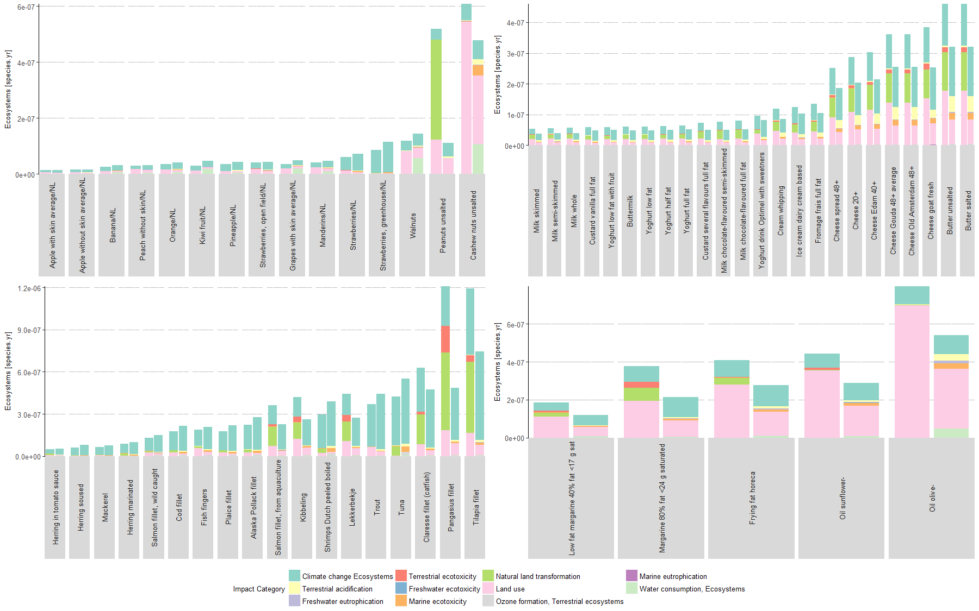
Fig. S11b. The impact of food products on ecosystems from an Egalitarian perspective

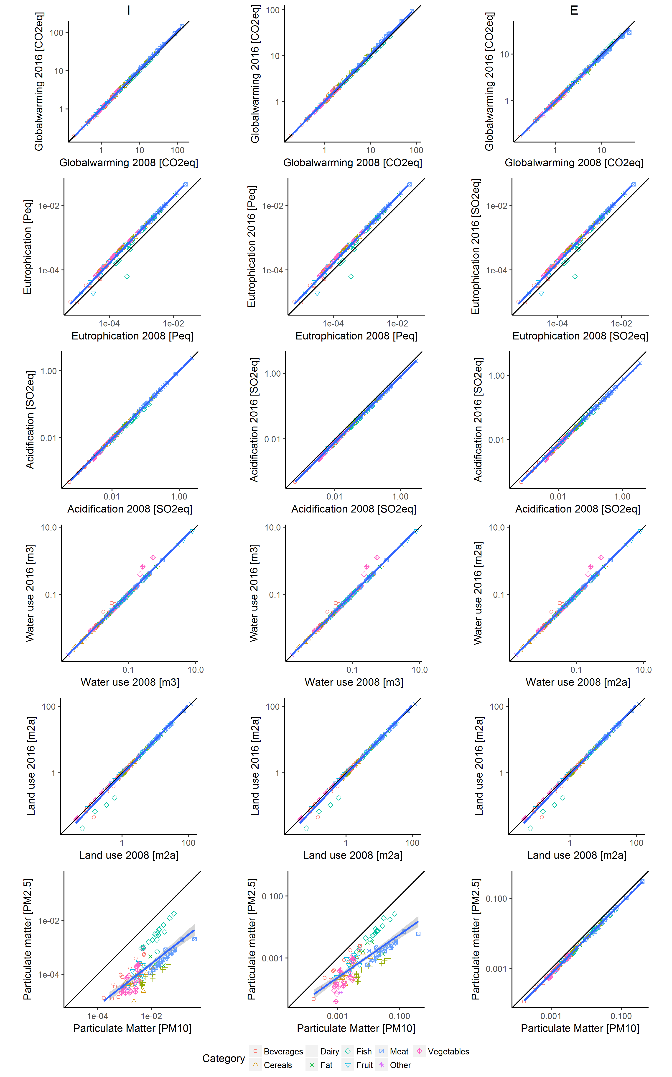
Fig. S12. Impact per kg of 152 food products in ReCiPe 2016 compared with ReCiPe 2008. Impacts for six midpoint categories (Global warming, Freshwater eutrophication, Terrestrial acidification, Water use, Land use and Fine Particulate matter formation) and for three different value choices (Individualist (I), Hierarchist (H) and Egalitarian (E). Line for best fit in blue, black line indicates 1:1 line.
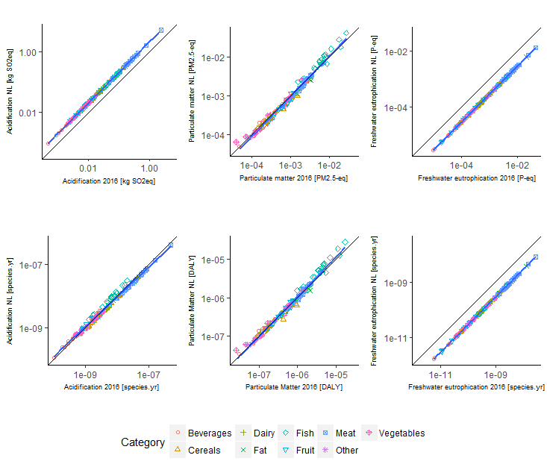
Fig. S13. Impact per kg of 152 food products in ReCiPe 2016, with global-average and Dutch-specific characterisation factors. Impacts for three impact categories on mid and endpoint level, i.e. terrestrial acidification, fine particulate matter formation and freshwater eutrophication. All impacts are from a hierarchist perspective. Line for best fit in blue, black line indicates 1:1 line.

References
Bare J (2011) TRACI 2 . 0 : the tool for the reduction and assessment of chemical and other environmental impacts 2 . 0. Clean Technol Environ Policy 687–696. doi: 10.1007/s10098-010-0338-9
Bulle C, Fantke P, Jolliet O et al (2018) Impact World+. http://www.impactworldplus.org/. Accessed 24 Aug 2018
Goedkoop M, Heijungs R, Huijbregts M et al (2009) ReCiPe 2008. 1–44. doi: 10.029/2003JD004283
Goldstein B, Foss S, Gjerris M, et al (2016) Ethical aspects of life cycle assessments of diets. Food Policy 59:139–151. doi: 10.1016/j.foodpol.2016.01.006
Hauschild MZ, Goedkoop M, Guinée J et al (2013) Identifying best existing practice for characterization modeling in life cycle impact assessment. Int J Life Cycle Assess 683–697. doi: 10.1007/s11367-012-0489-5
Huijbregts MAJ, Steinmann ZJN, Elshout PMF et al (2016) ReCiPe 2016. Bilthoven, the Netherlands
Huijbregts MAJ, Steinmann ZJN, Elshout PMF, Stam G (2017) ReCiPe2016 : a harmonized life cycle impact assessment method at midpoint and endpoint level. Int J Life Cycle Assess 1–16. doi: 10.1007/s11367-016-1246-y
Itsubo N, Inaba A (2003) A new LCIA method: LIME has been completed. Int J Life Cycle Assess 8:305–305. doi: 10.1007/BF02978923
LC-Impact (2018) LC-Impact. http://lc-impact.eu/. Accessed 24 Aug 2018
Manfredi M, Vignali G (2014) Life cycle assessment of a packaged tomato puree: A comparison of environmental impacts produced by different life cycle phases. J Clean Prod 73:275–284. doi: 10.1016/j.jclepro.2013.10.010
Slimani N, Ferrari P, Ocke M et al (2000) Standardization of the 24-hour diet recall calibration method used in the European Prospective Investigation into Cancer and Nutrition (EPIC): general concepts and preliminary results. Eur J Clin Nutr 54:900–917. doi: 10.1038/sj.ejcn.1601107
Smetana S, Mathys A, Knoch A, Heinz V (2015) Meat alternatives : life cycle assessment of most known meat substitutes. Int J Life Cycle Assess 2050:1254–1267. doi: 10.1007/s11367-015-0931-6
Van Rossum CTM, Fransen HP, Verkaik-Kloosterman J, et al (2011) Dutch National Food Consumption Survey 2007-2010

