**ARun-o-Run Tutorial**

**(unity 3D Game)**

**Amanullah f2017065056**

**(GDD)**

**1** make environment.. Using ui 3d cube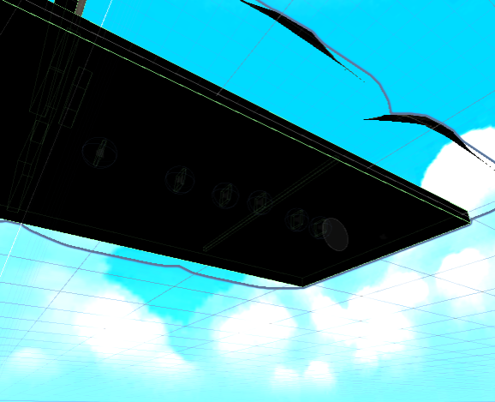

Addded skybox from unity store .and also add environment like forest from unity store pack

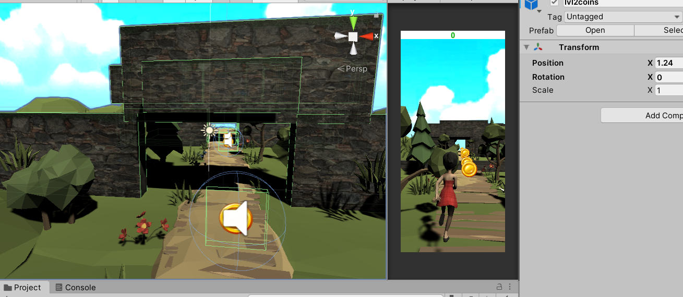

For barrier /obstacle / game over used 2d cube and in src used pic of stone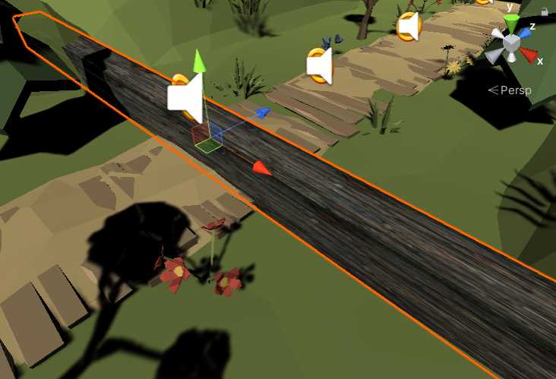



make a player that we used in with the help of mixamo.com

and added to unity in our game using animator.

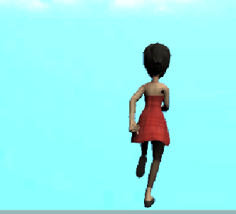

**Added score ui using laibrary unityEninge.ui**

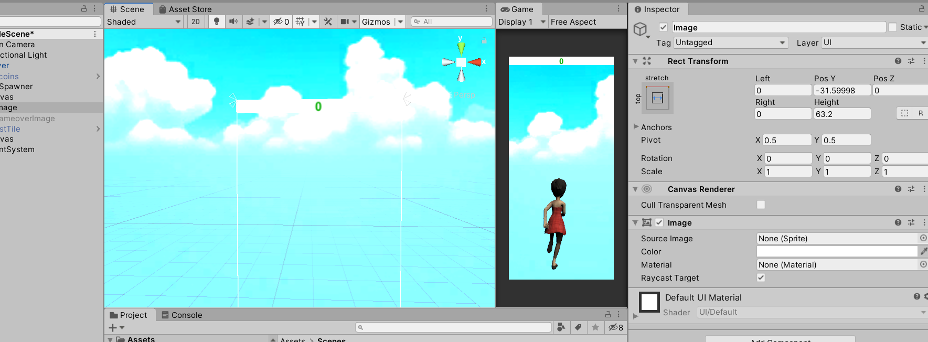

**Added sprites of coins and also add in their sound using sound scource.**

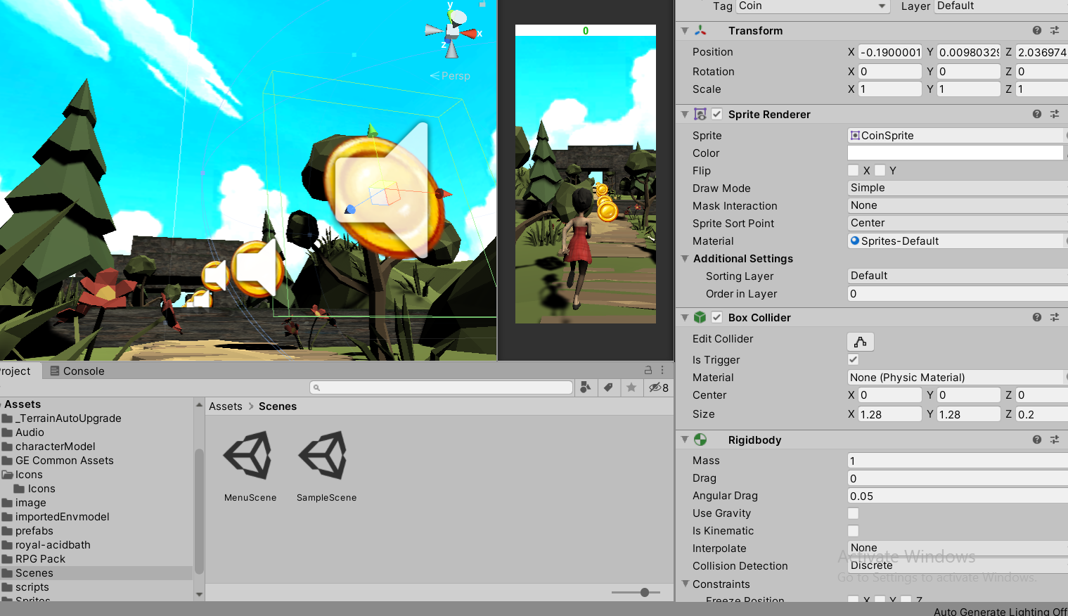

**In this I make a ui added button text which work is play again and main menu button.**

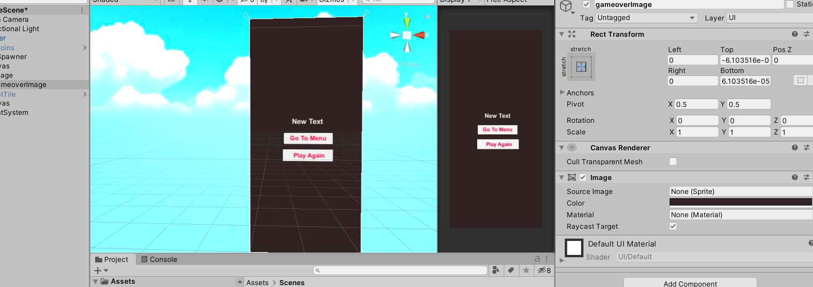

**Added button and text in ui. Which is setting play button and quit button**

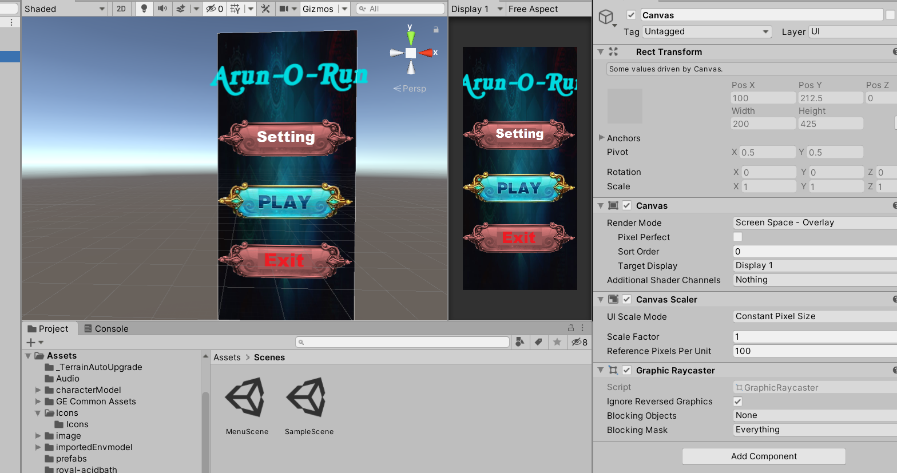

**Make more images ui for main menu and settings menu , sound menu , play button etc.**

**Here is in side tab wo use multiple screen wich we link through an object .**

**Added buttons for back , menu , score ,**

**Thank you .!**

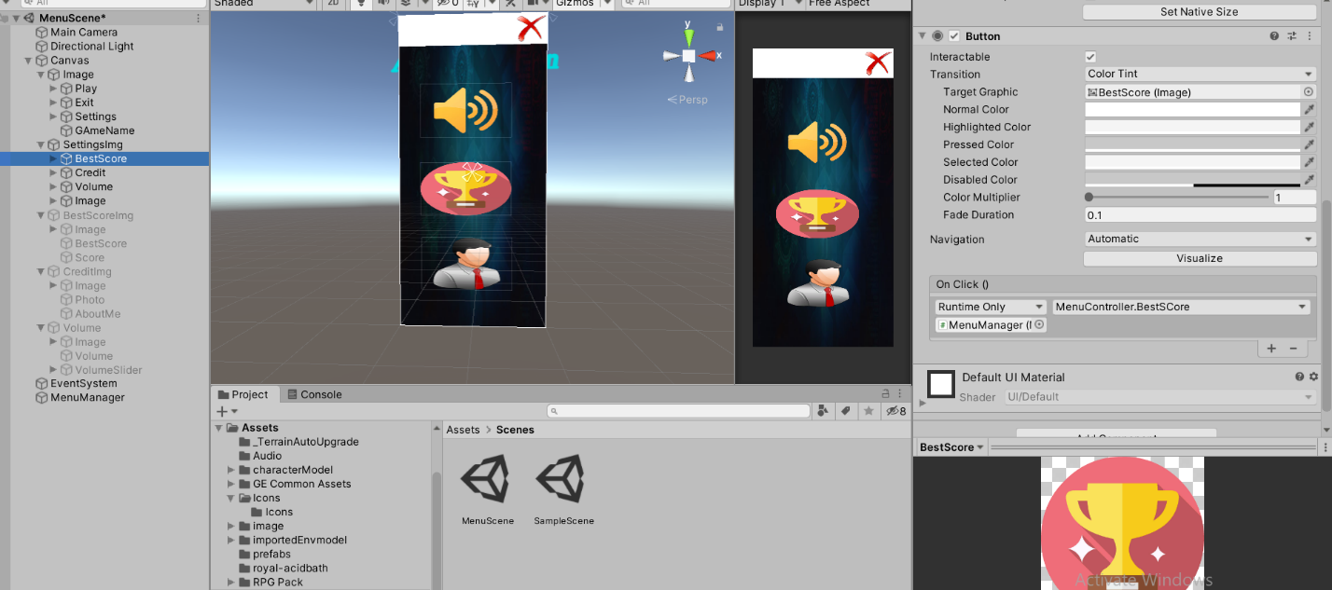

**(run out of time for making documentation that’swhy its short /just a short overview)**