Bhavya Anand
2501730046
Sem- III- E
Batch - 2025-29
Course- B.Tech CSE AIML
Nand To Tetris
Assignment-1

Q1. Implement Xor, Mux(2,4 ways), Dmux

Xor-
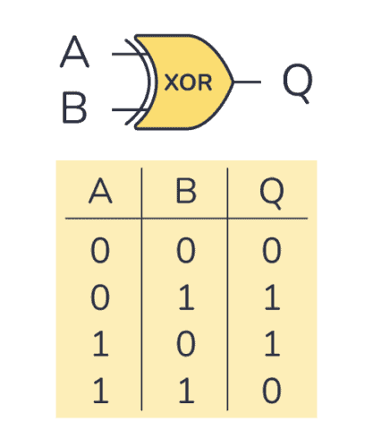

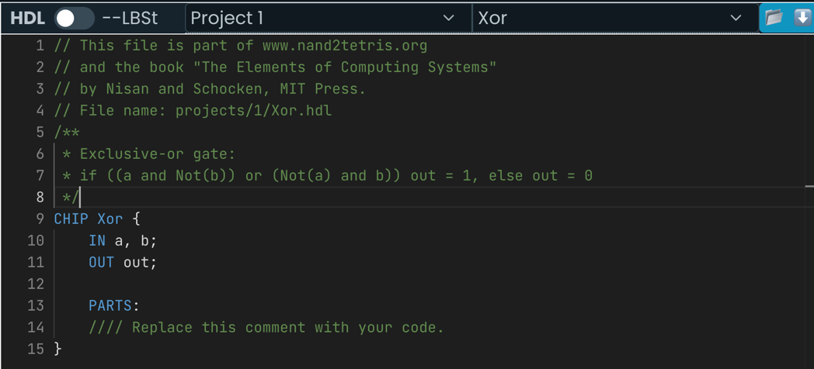
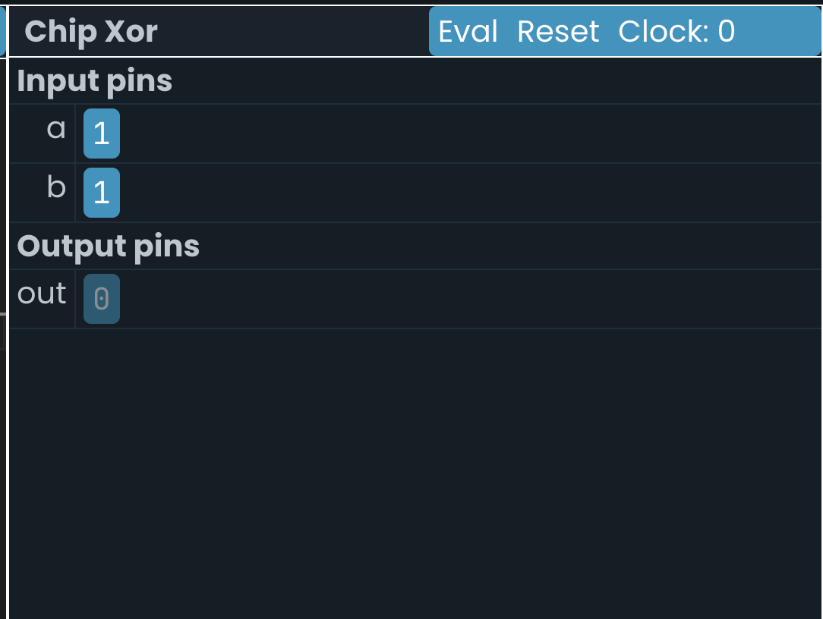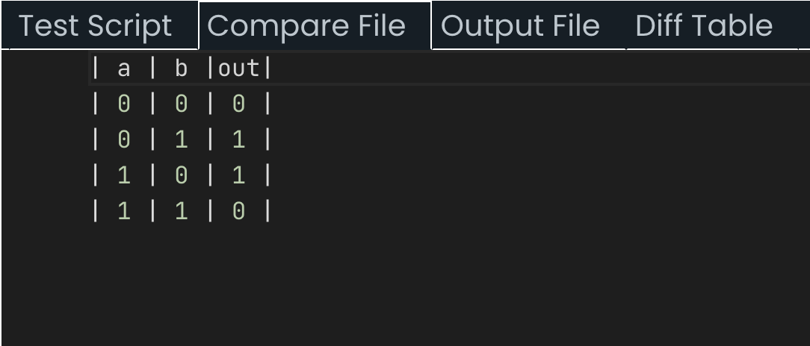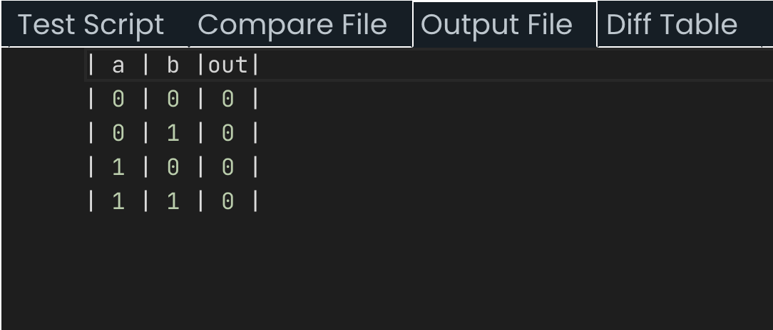
Code-
// This file is part of www.nand2tetris.org
// and the book "The Elements of Computing Systems"
// by Nisan and Schocken, MIT Press.
// File name: projects/1/Xor.tst

load Xor.hdl,
compare-to Xor.cmp,
output-list a b out;

set a 0,
set b 0,
eval,
output;

set a 0,
set b 1,
eval,
output;

set a 1,
set b 0,
eval,
output;

set a 1,
set b 1,
eval,
output;

2. Mux (2ways)-
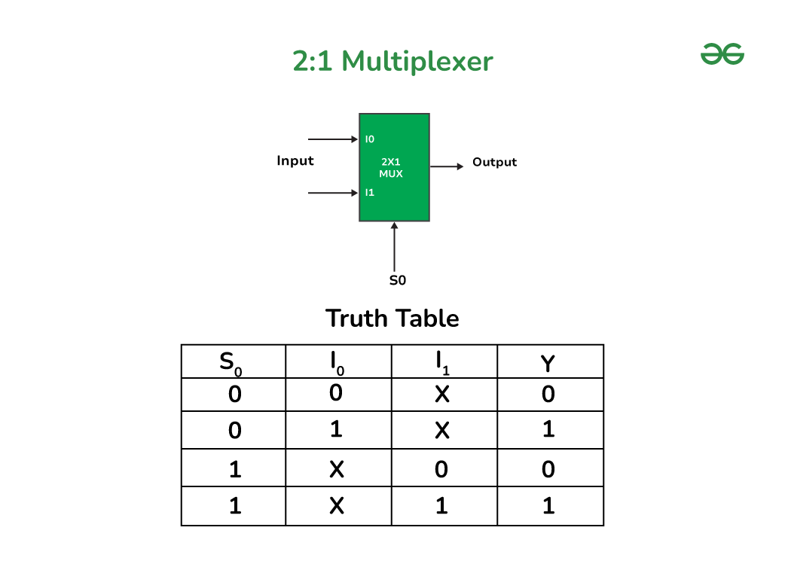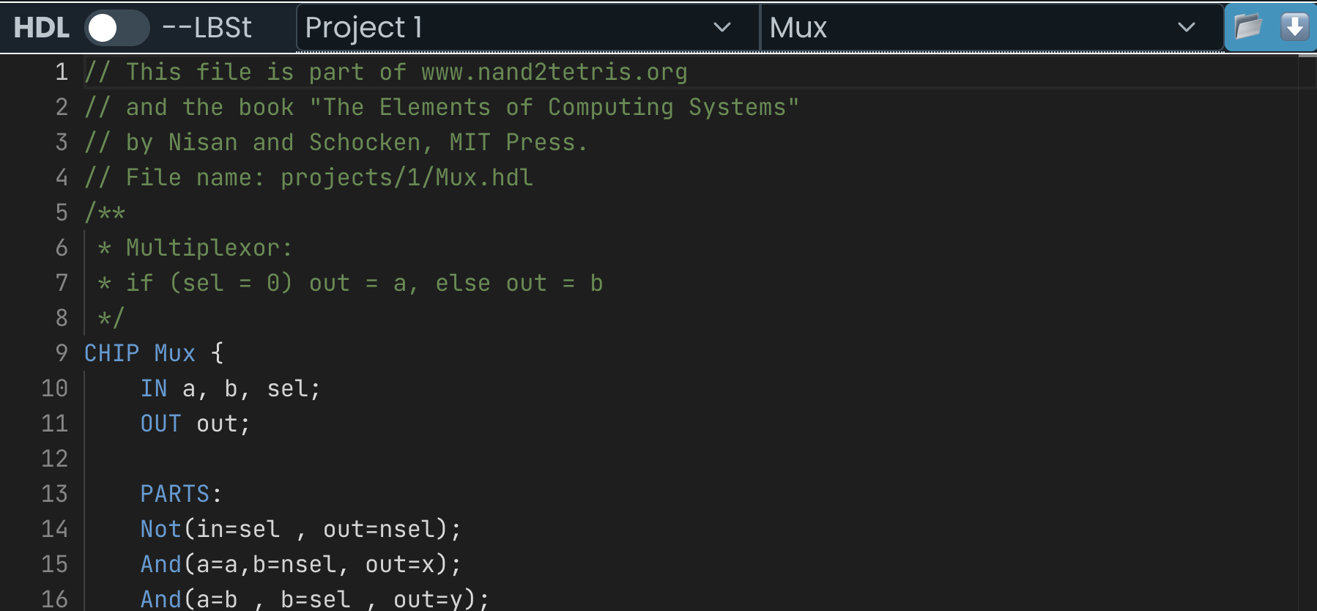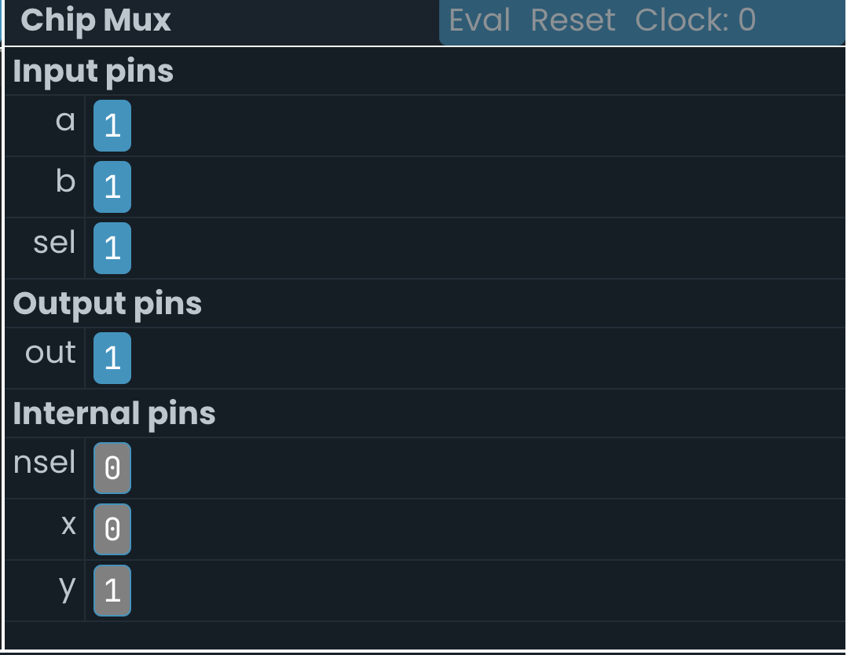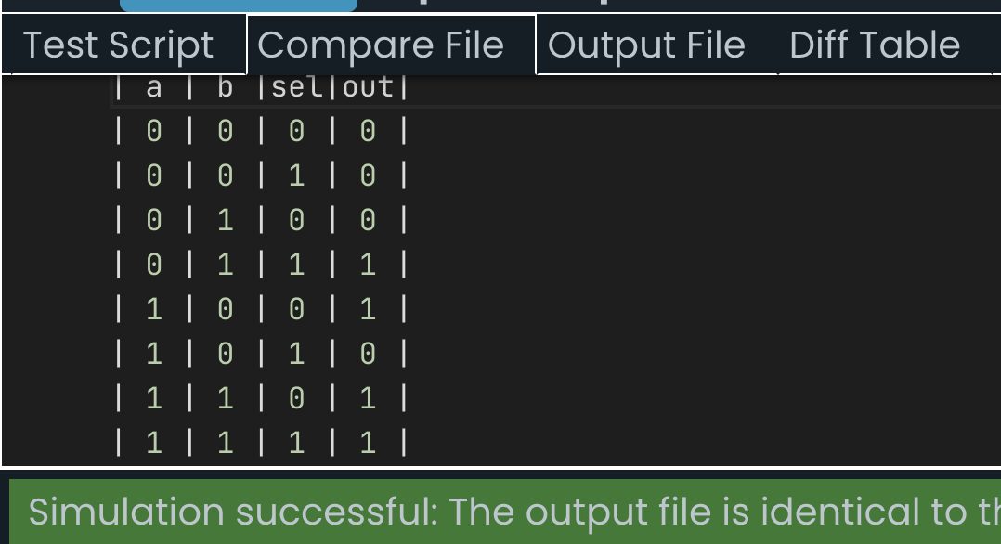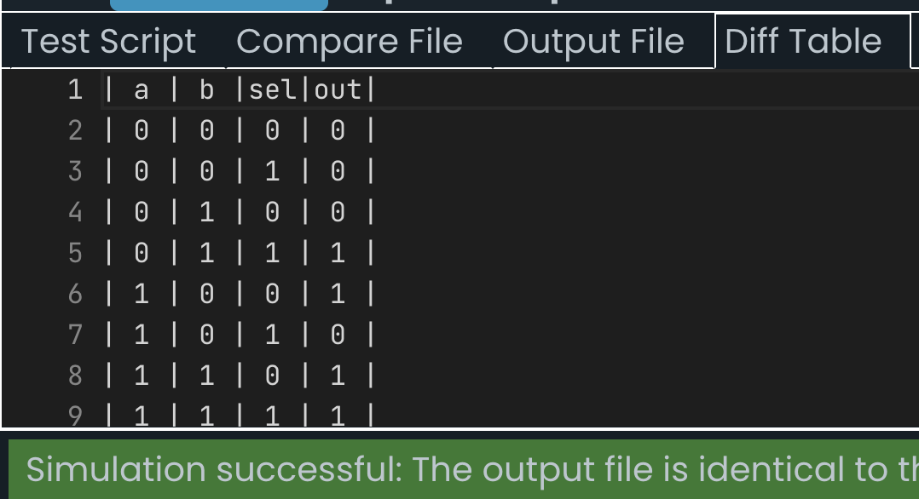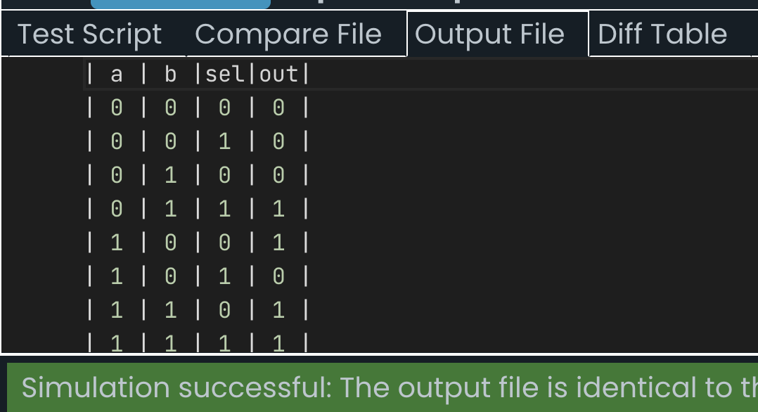
Code-
// This file is part of www.nand2tetris.org
// and the book "The Elements of Computing Systems"
// by Nisan and Schocken, MIT Press.
// File name: projects/1/Mux.tst

load Mux.hdl,
compare-to Mux.cmp,
output-list a b sel out;

set a 0,
set b 0,
set sel 0,
eval,
output;

set sel 1,
eval,
output;

set a 0,
set b 1,
set sel 0,
eval,
output;

set sel 1,
eval,
output;

set a 1,
set b 0,
set sel 0,
eval,
output;

set sel 1,
eval,
output;

set a 1,
set b 1,
set sel 0,
eval,
output;

set sel 1,
eval,
output;

3. Mux(4ways)
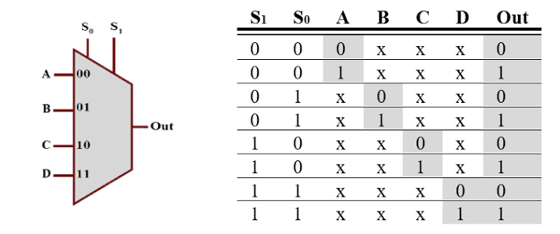
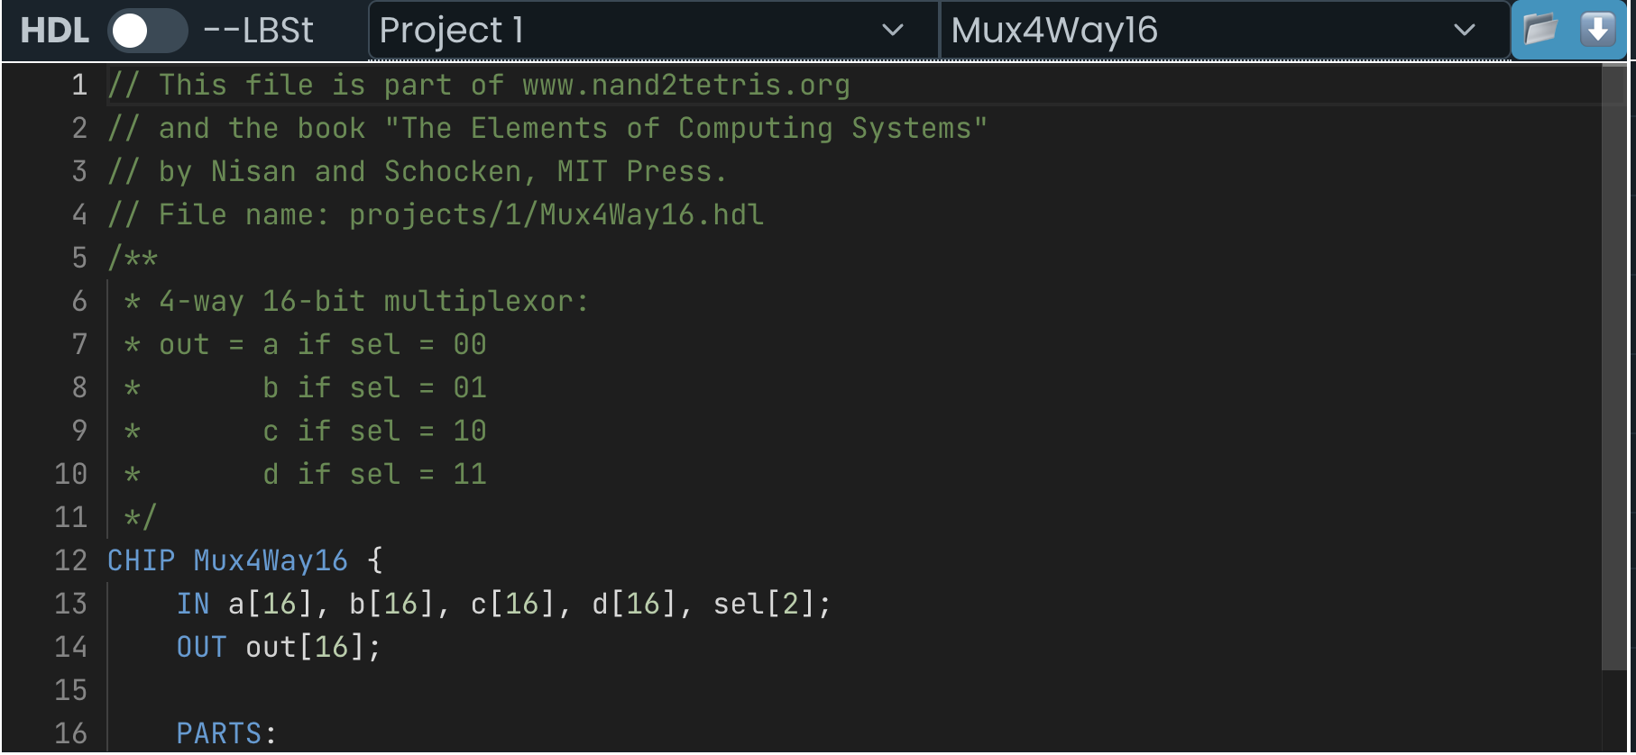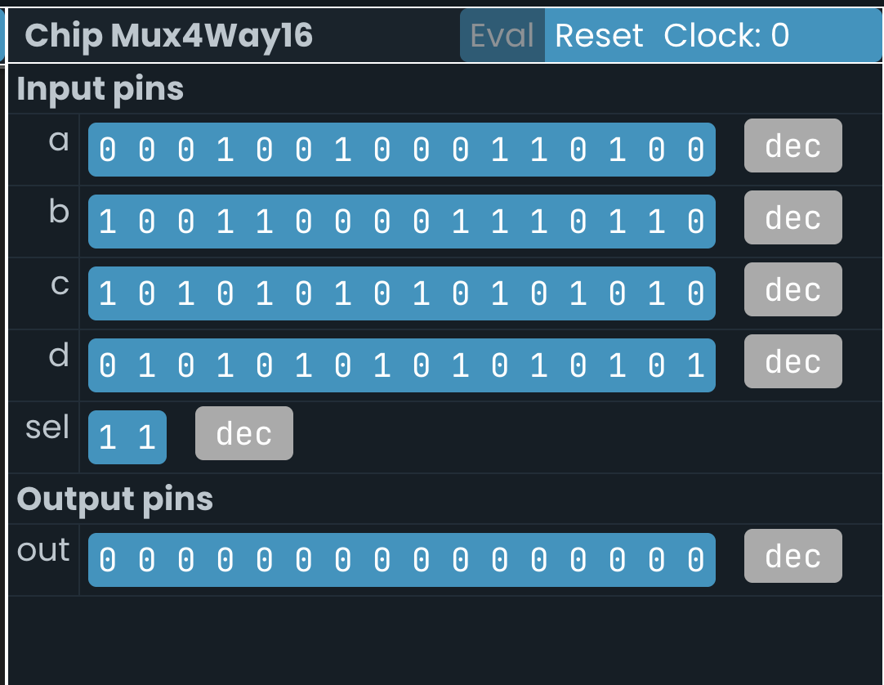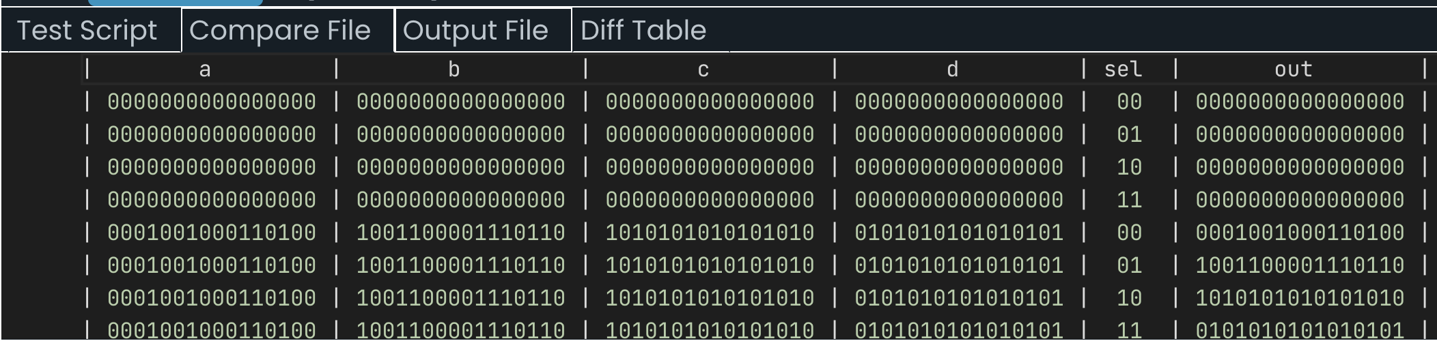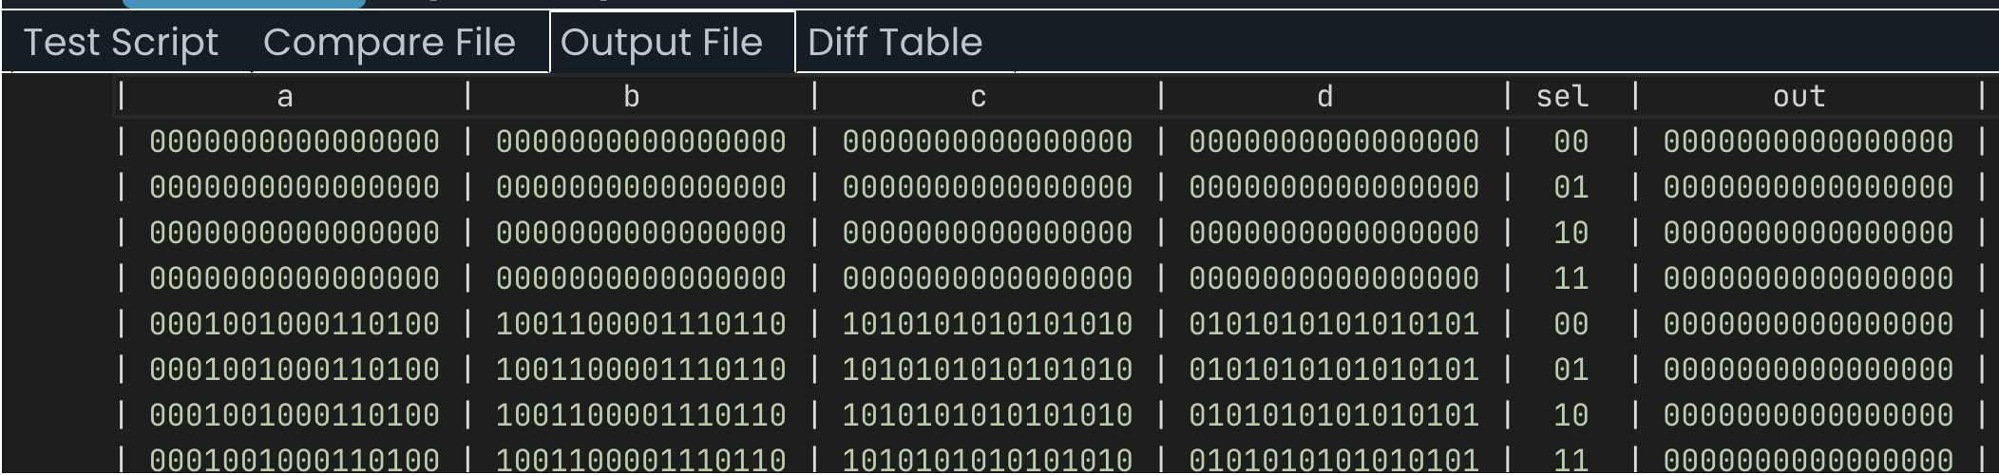
Code-
// This file is part of www.nand2tetris.org
// and the book "The Elements of Computing Systems"
// by Nisan and Schocken, MIT Press.
// File name: projects/1/Mux4Way16.tst

load Mux4Way16.hdl,
compare-to Mux4Way16.cmp,
output-list a%B1.16.1 b%B1.16.1 c%B1.16.1 d%B1.16.1 sel%B2.2.2 out%B1.16.1;

set a 0,
set b 0,
set c 0,
set d 0,
set sel 0,
eval,
output;

set sel 1,
eval,
output;

set sel 2,
eval,
output;

set sel 3,
eval,
output;

set a %B0001001000110100,
set b %B1001100001110110,
set c %B1010101010101010,
set d %B0101010101010101,
set sel 0,
eval,
output;

set sel 1,
eval,
output;

set sel 2,
eval,
output;

set sel 3,
eval,
output;

4. Demux-
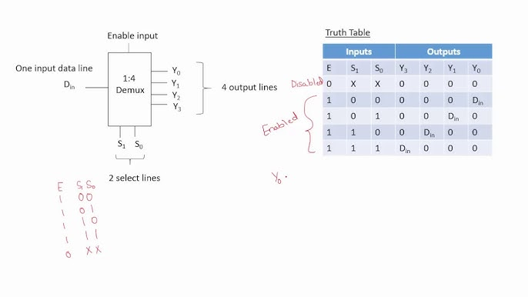
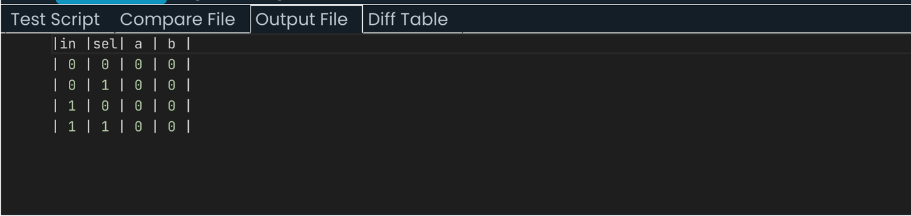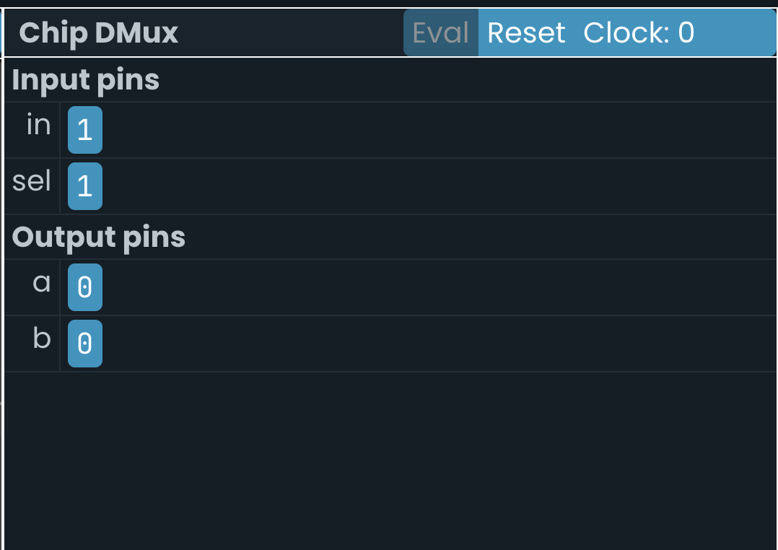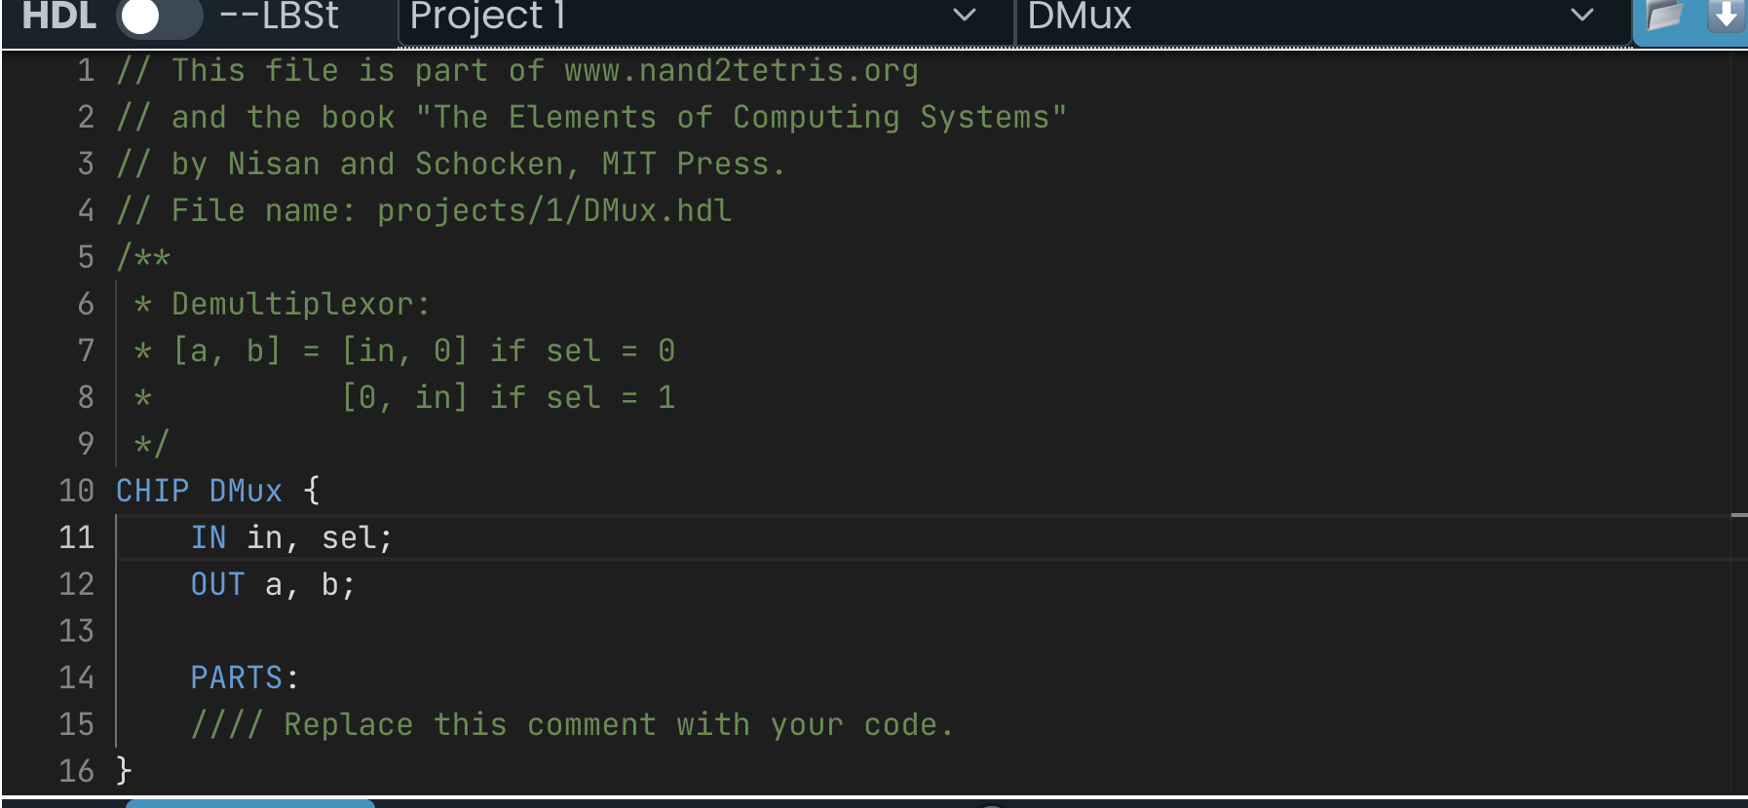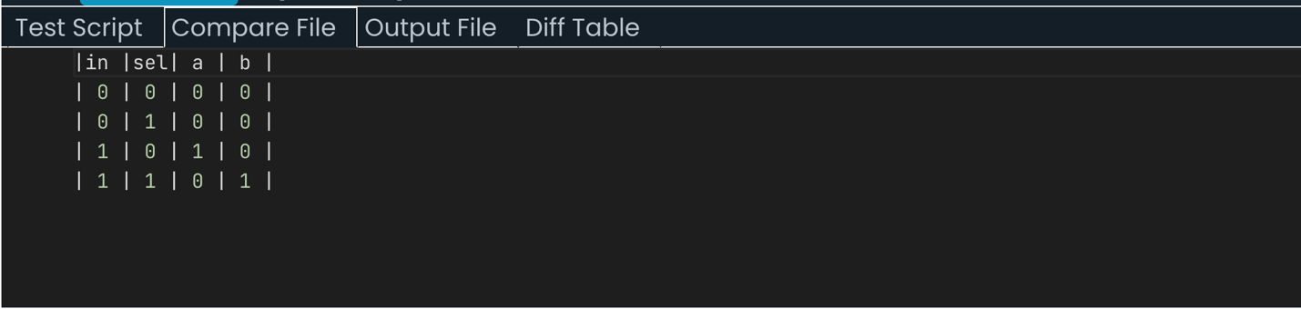
Code-
// This file is part of www.nand2tetris.org
// and the book "The Elements of Computing Systems"
// by Nisan and Schocken, MIT Press.
// File name: projects/1/DMux.tst

load DMux.hdl,
compare-to DMux.cmp,
output-list in sel a b;

set in 0,
set sel 0,
eval,
output;

set sel 1,
eval,
output;

set in 1,
set sel 0,
eval,
output;

set sel 1,
eval,
output;

