Bhavya Anand
2501730046
Sem- III- E
Batch - 2025-29
Course- B.Tech CSE AIML
Nand To Tetris
Assignment-1

Q1. Implement NOT,AND,OR gates using only NAND gate
- And Gate-
Logic diagram and Bollean Exp.

And gate-
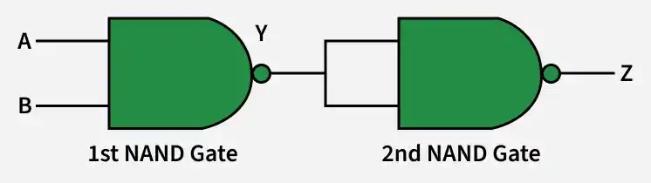
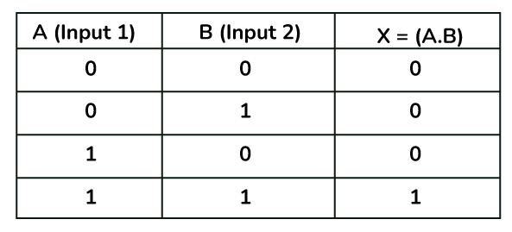
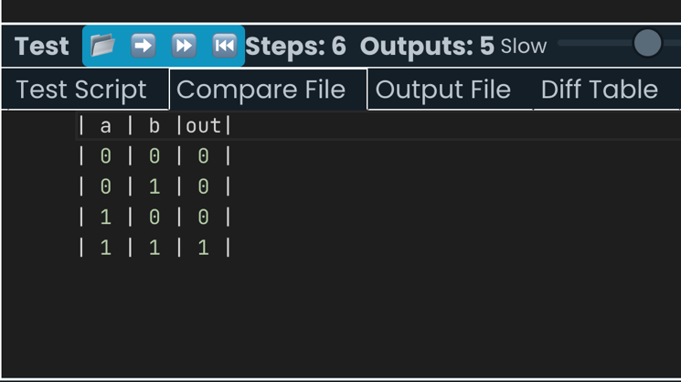
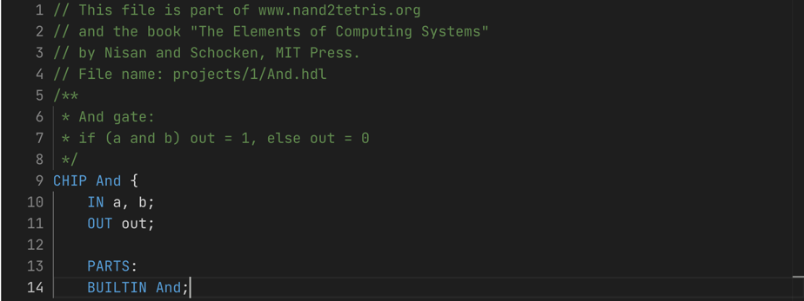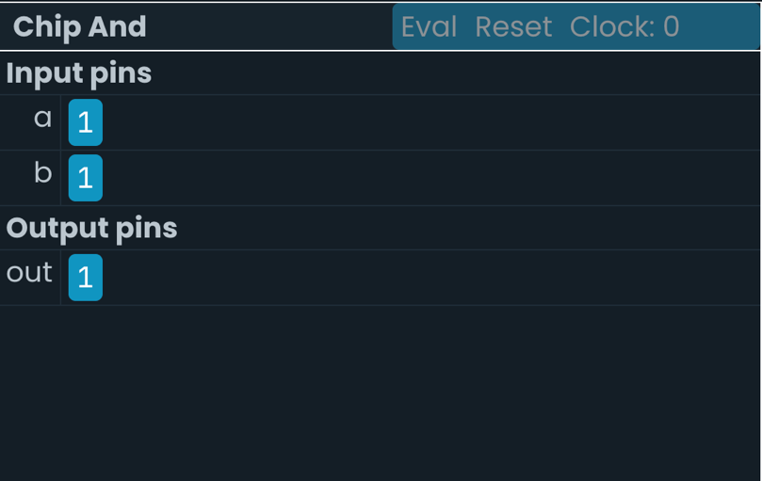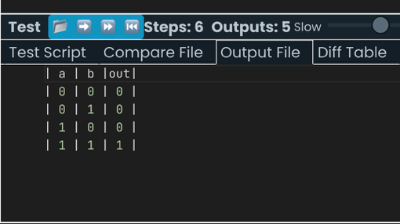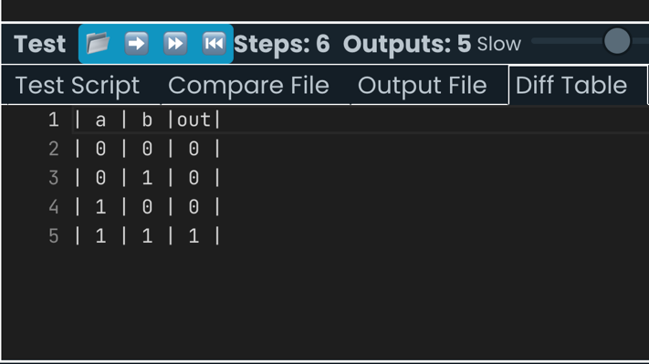

Code-
// This file is part of www.nand2tetris.org
// and the book "The Elements of Computing Systems"
// by Nisan and Schocken, MIT Press.
// File name: projects/1/And.tst

load And.hdl,
compare-to And.cmp,
output-list a b out;

set a 0,
set b 0,
eval,
output;

set a 0,
set b 1,
eval,
output;

set a 1,
set b 0,
eval,
output;

set a 1,
set b 1,
eval,
output;

Not Gate-
// This file is part of www.nand2tetris.org
// and the book "The Elements of Computing Systems"
// by Nisan and Schocken, MIT Press.
// File name: projects/1/Not.tst

load Not.hdl,
compare-to Not.cmp,
output-list in out;

set in 0,
eval,
output;

set in 1,
eval,
output;

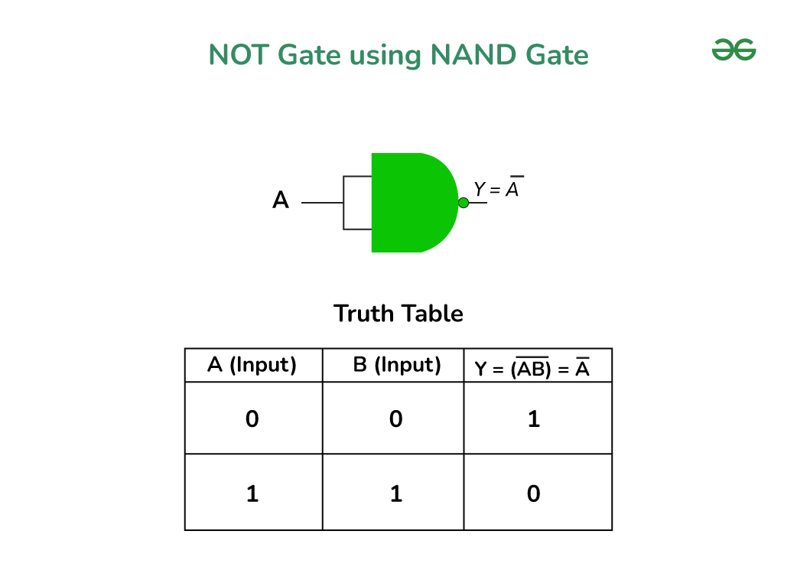

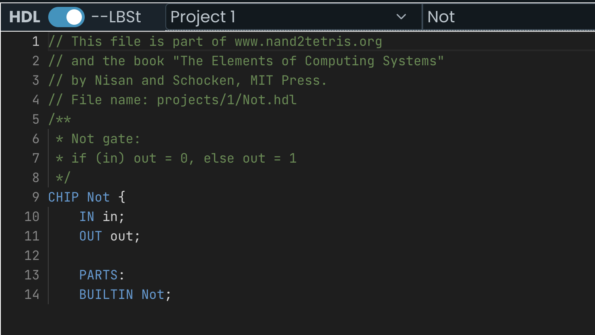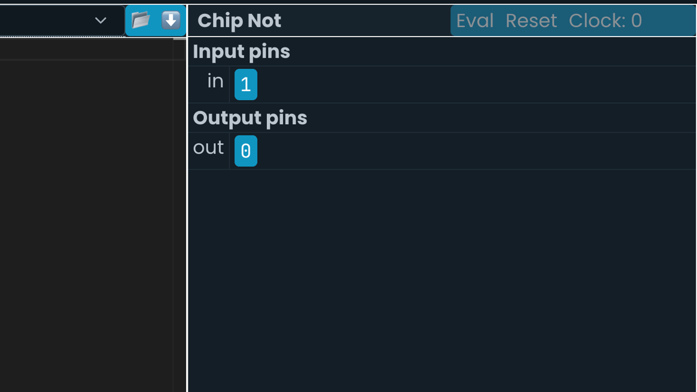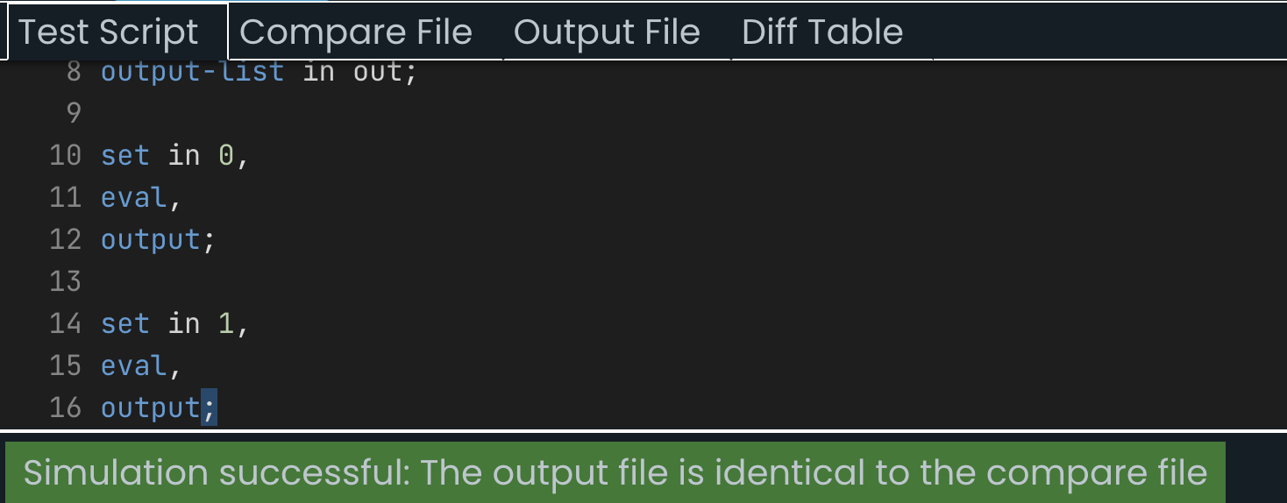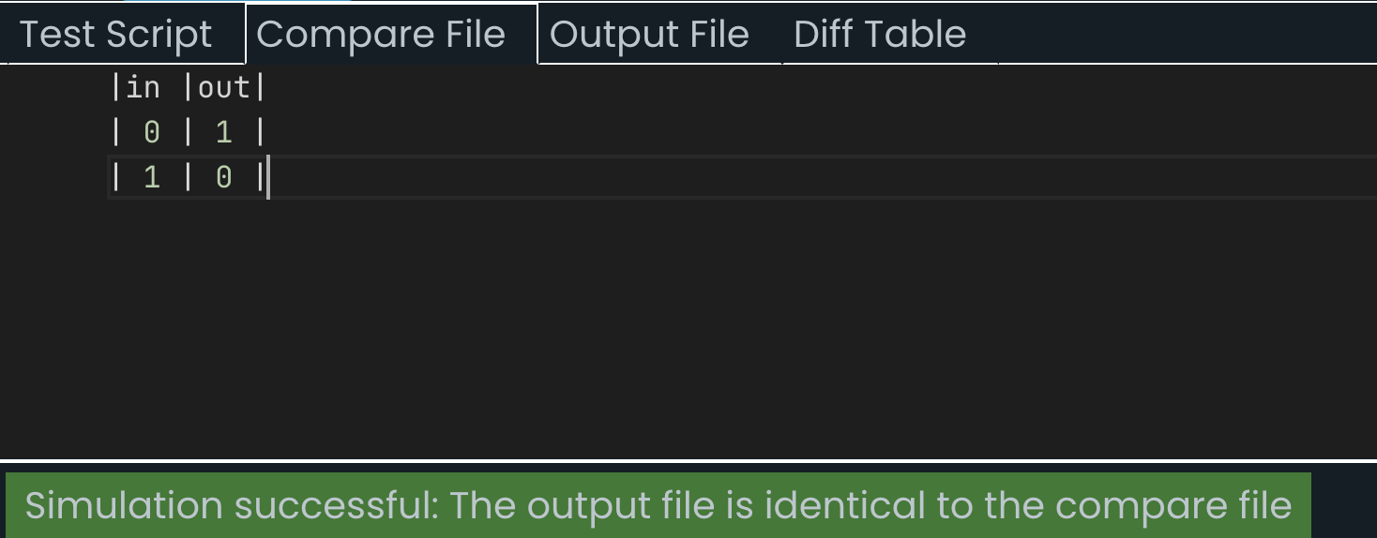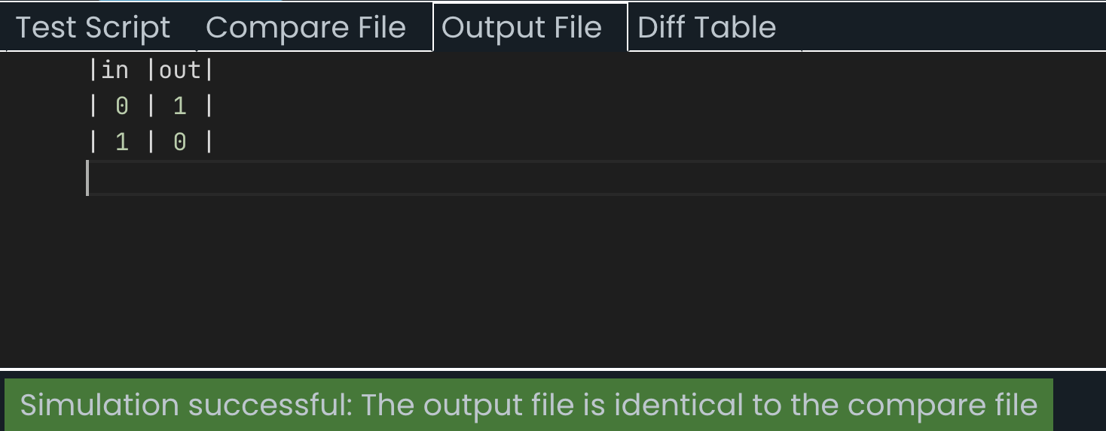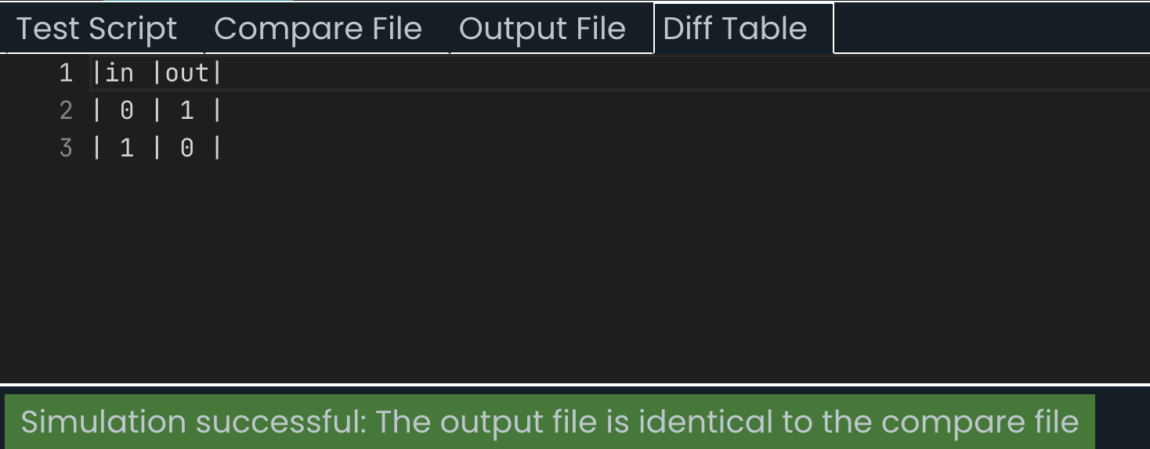

- OR Gate-

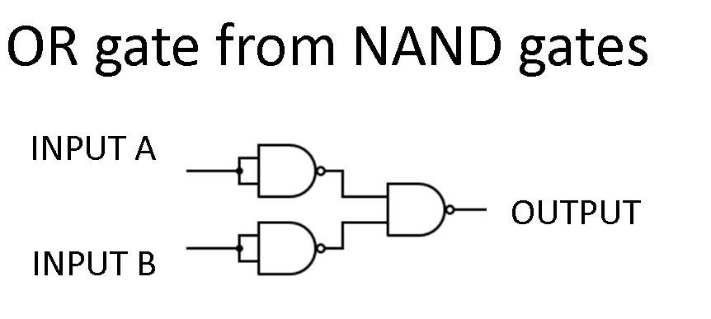
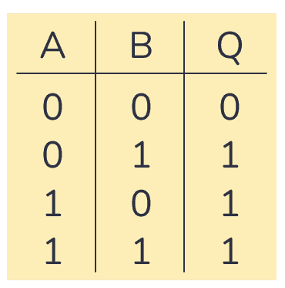

// This file is part of www.nand2tetris.org
// and the book "The Elements of Computing Systems"
// by Nisan and Schocken, MIT Press.
// File name: projects/1/Or.tst

load Or.hdl,
compare-to Or.cmp,
output-list a b out;

set a 0,
set b 0,
eval,
output;

set a 0,
set b 1,
eval,
output;

set a 1,
set b 0,
eval,
output;

set a 1,
set b 1,
eval,
output;

