**Numerical Optimization with Python**

Alon

Ex.1 – programming part – final report

All the files (including plots and console print can be found at the exercise git repo[1]

b)

i.

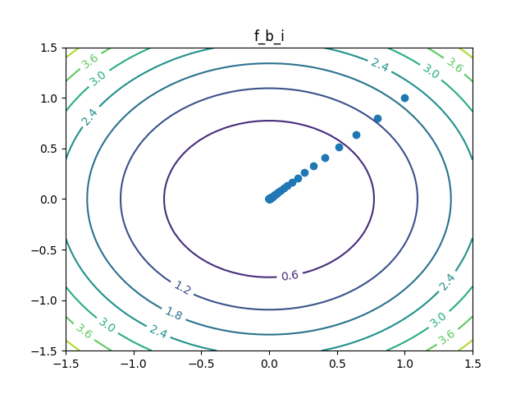

**Last print to console:**

Iteration number: 63 current location: |[7.84637717e-07 7.84637717e-07|] current obj val: 1.2313126936373286e-12 current step length: 2.774113252056106e-07 current change in objective function value: 6.926133901709975e-13

Function f_b_i final success status: Success

ii.

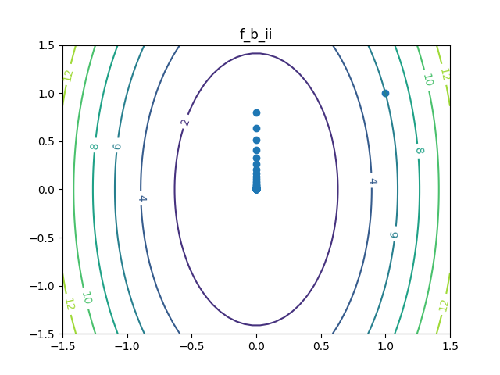

**Last print to console:**

Iteration number: 61 current location: |[0.00000000e+00 1.22599643e-06|] current obj val: 1.503067252975255e-12 current step length: 3.064991081731779e-07 current change in objective function value: 8.454753297985806e-13

Function f_b_ii final success status: Success

iii.

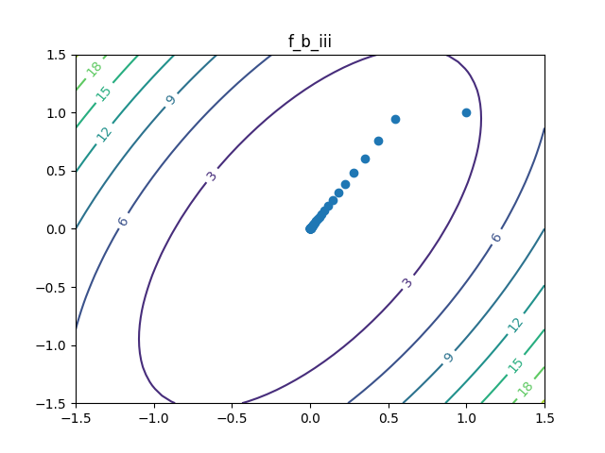

**Last print to console:**

Iteration number: 63 current location: |[5.35917527e-07 9.28236386e-07|] current obj val: 1.148830383164744e-12 current step length: 2.6795876352117417e-07 current change in objective function value: 6.462170905301688e-13

Function f_b_iii final success status: Success

c. Rosenbrock function:

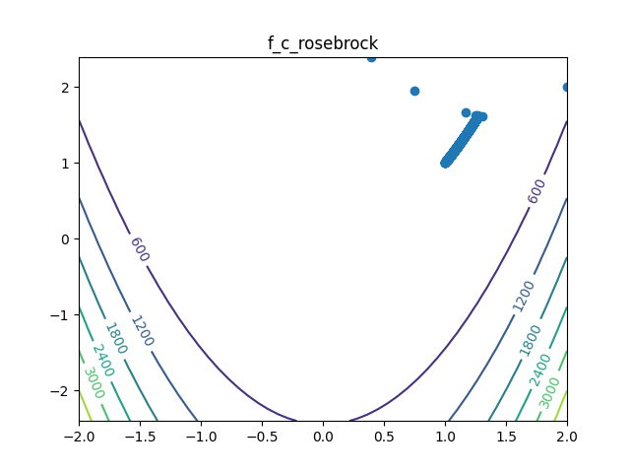

**Last print to console:**

Iteration number: 747 current location: |[0.99926881 1.00253746|] current obj val: 0.001599982740383528 current step length: 0.0008943679278030026 current change in objective function value: 8.677160997410185e-08

Function f_c_rosebrock final success status: Success

d. Linear function (*a* is 2-dimensional constant vector where each entry is equal to 2)

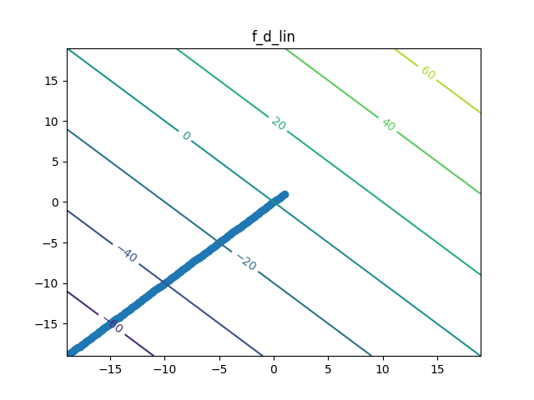

**Last print to console:**

Iteration number: 100 current location: |[-19. -19.|] current obj val: -75.99999999999986 current step length: 0.282842712474618 current change in objective function value: 0.7999999999999972

Function f_d_lin final success status: Fail

1. <https://github.com/Amannor/python_numerical_optimizations>