ASSIGNMENT -3 MONGO DB

Q-1 TOTSAL SALES PER PRODUCT

n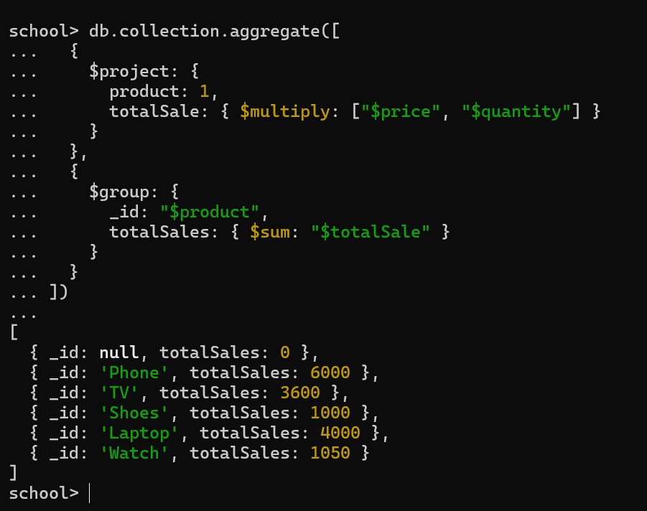

Q-2 TOTAL REVENUE PER PRODUCT

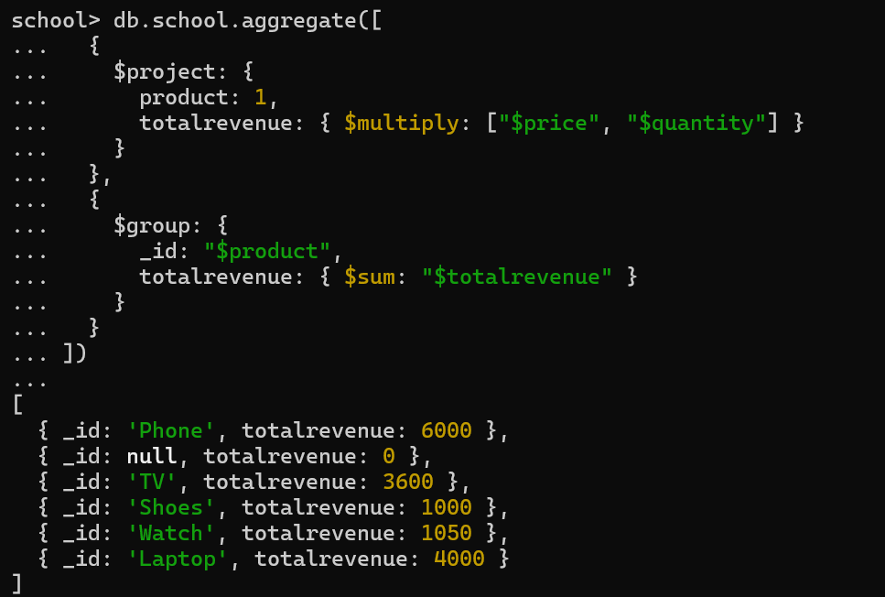

Q3-3. Total revenue per category.

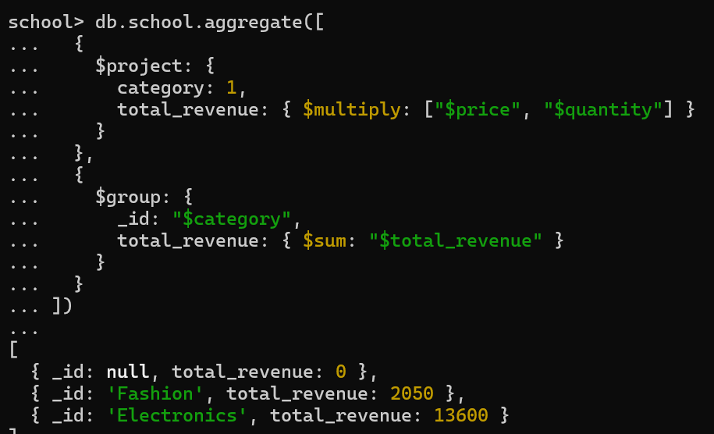

Q-4 COUNTS OF PRODUCT PER CATEGORY

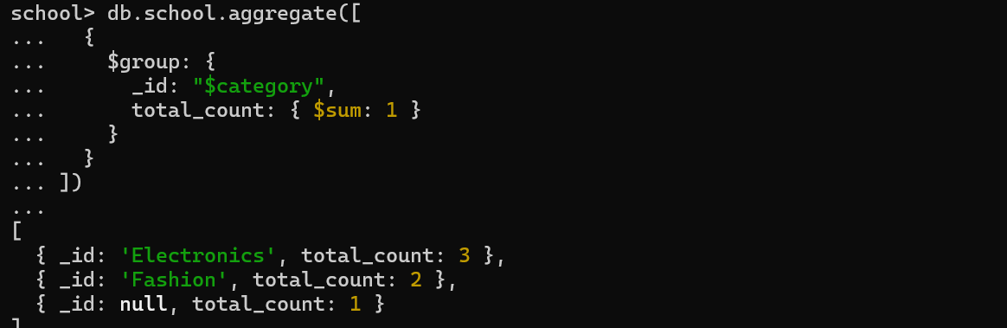

Q-5. Store-wise total sales.

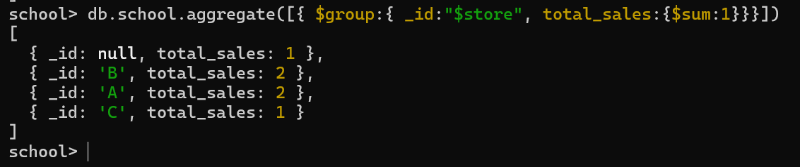

Q6-. Average price of products per category.

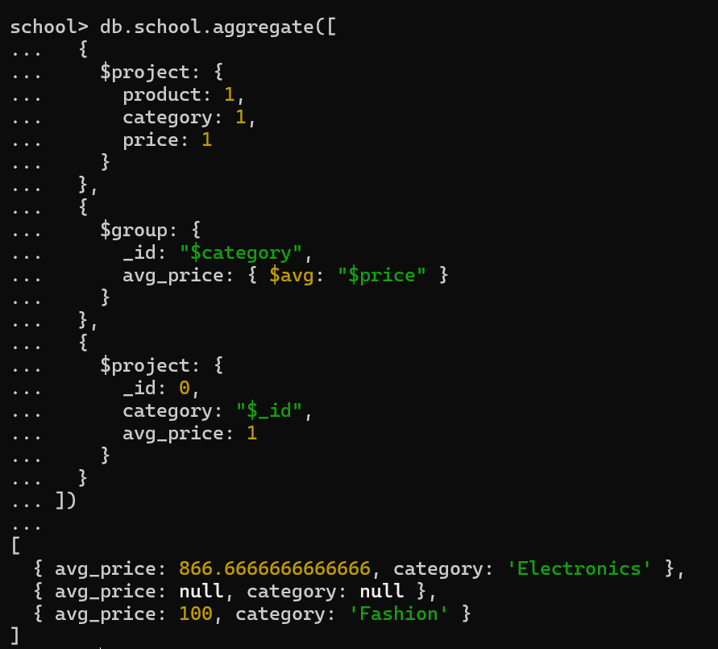

Q7-Top-selling product.

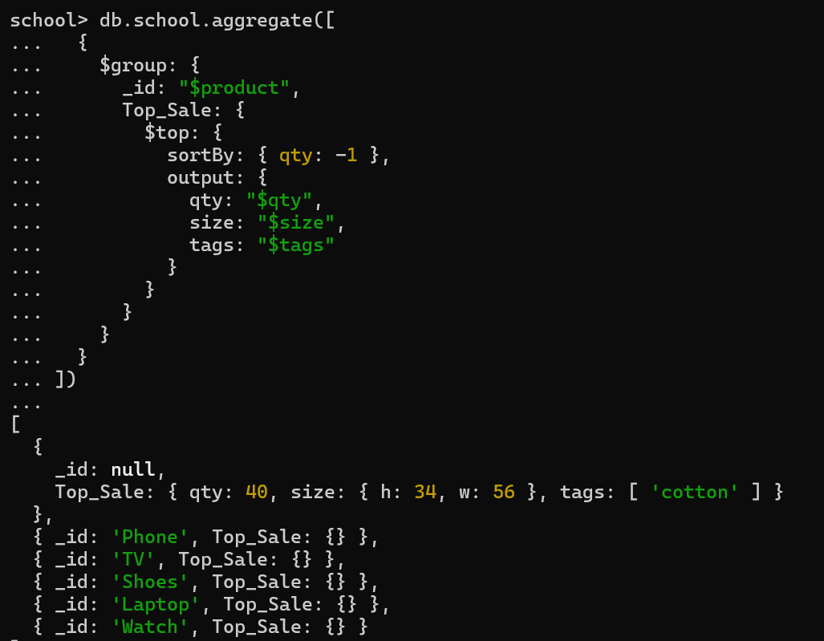

Q8- Total sales for Electronics category.

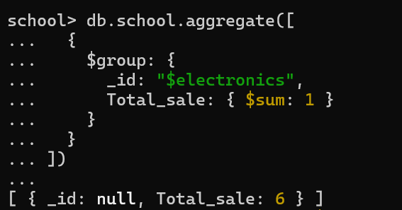

**Q9-**Sales trend over time (day-wise total sales).

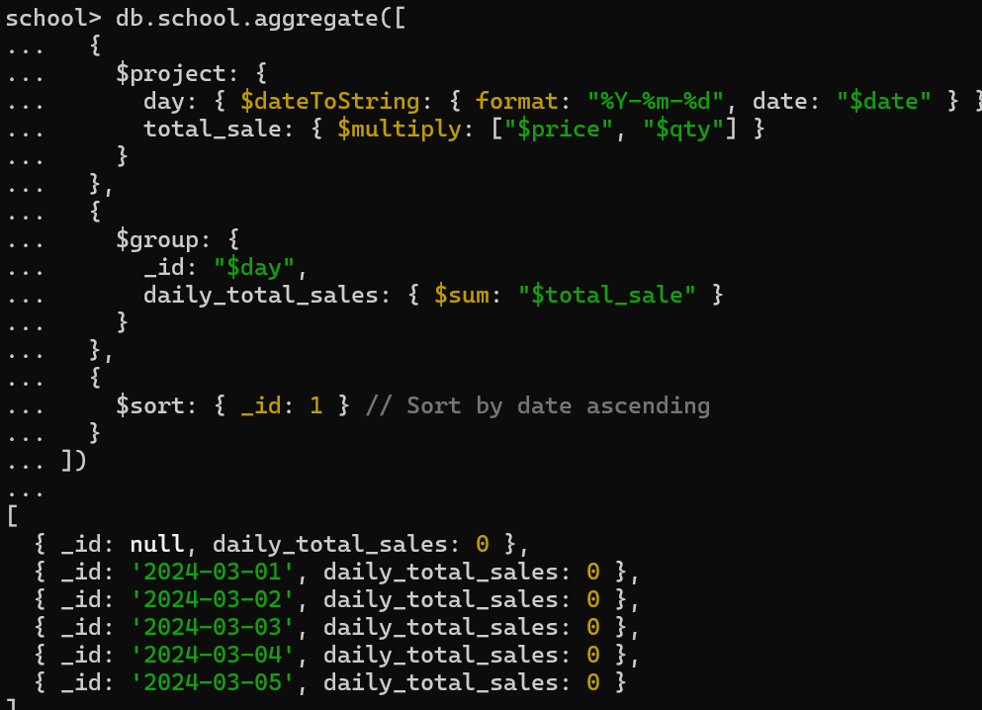

**Q-10** Highest revenue-generating product



**Q-11** Average revenue per sale.

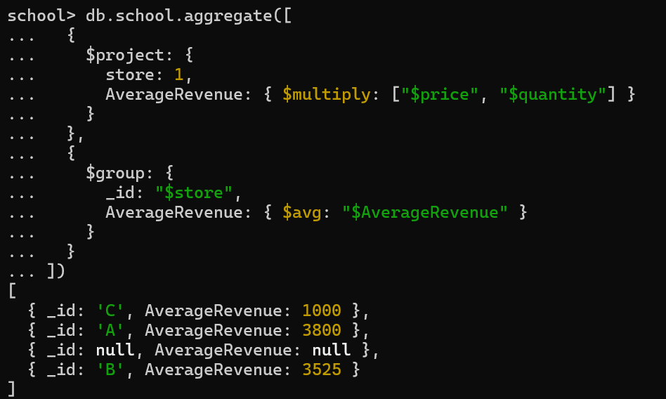

q-12 total sales per store

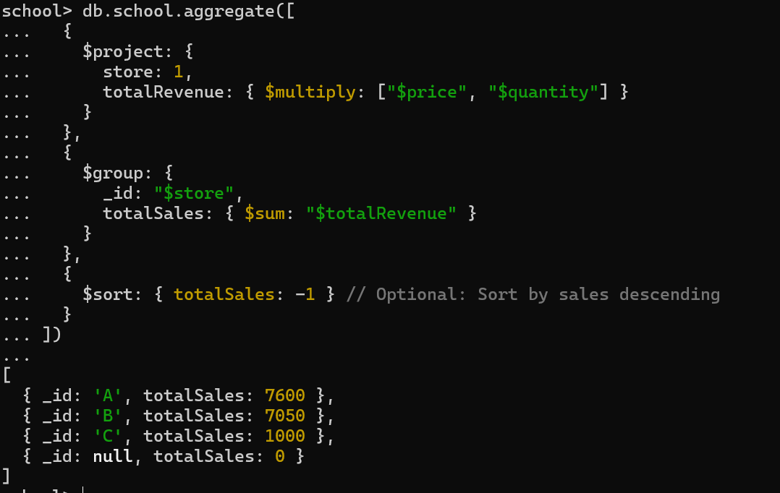

**Q-13 PRODUCT SOLD MORE THAN 5 TIMES**

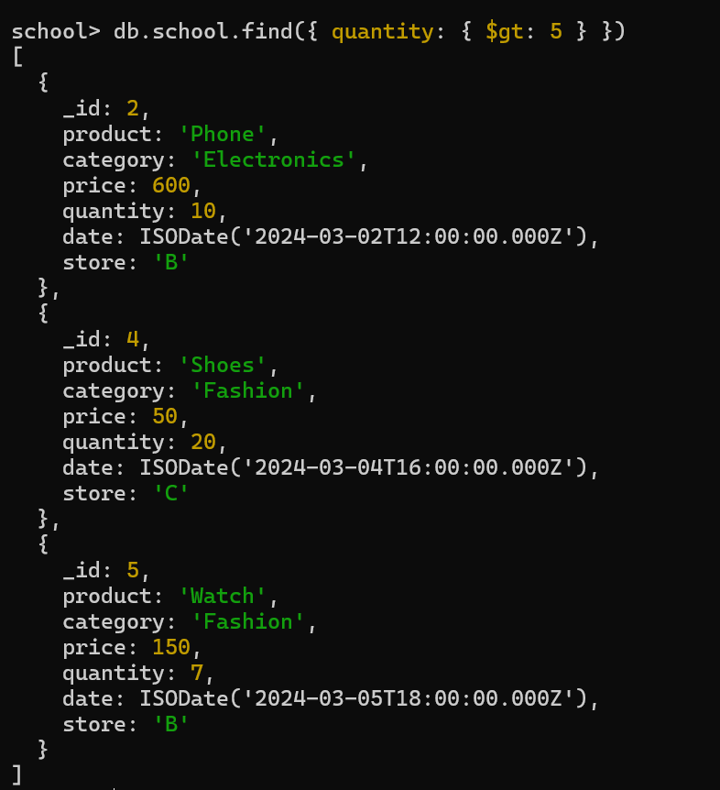

**Q-14** Least sold product. 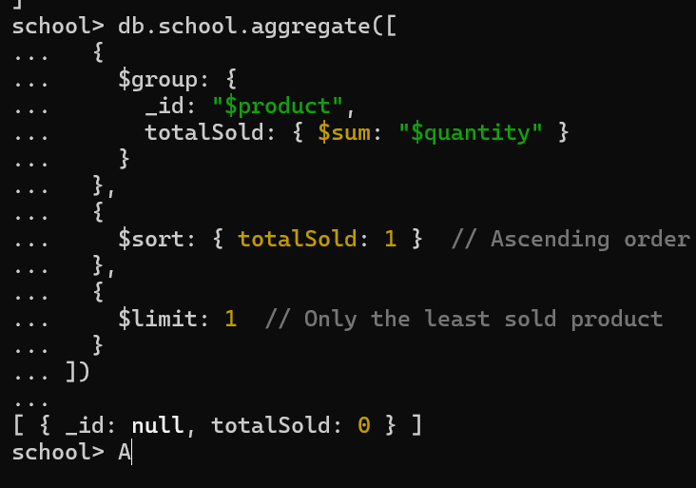

**Q-15**Monthly sales summary.

**Q-16 UNIQUE PRODUCT SOLD**

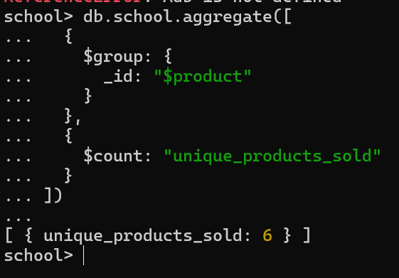

**Q-17 MAX AND MIN PRICE**

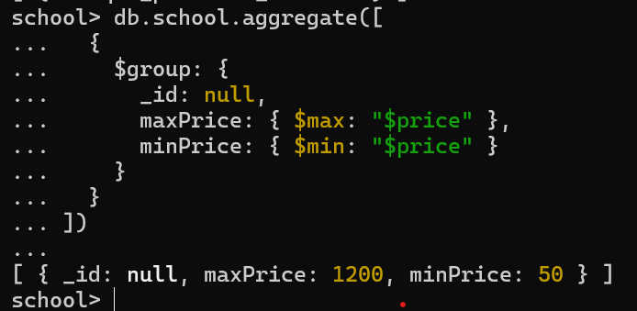

**Q-18**  Total revenue per product in descending order.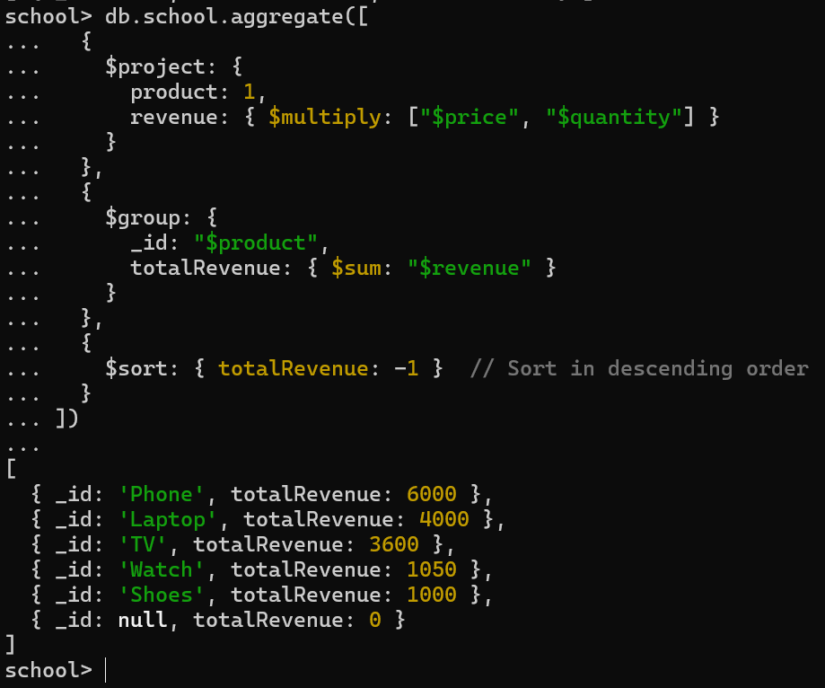

**Q-19** Revenue generated per store per category.

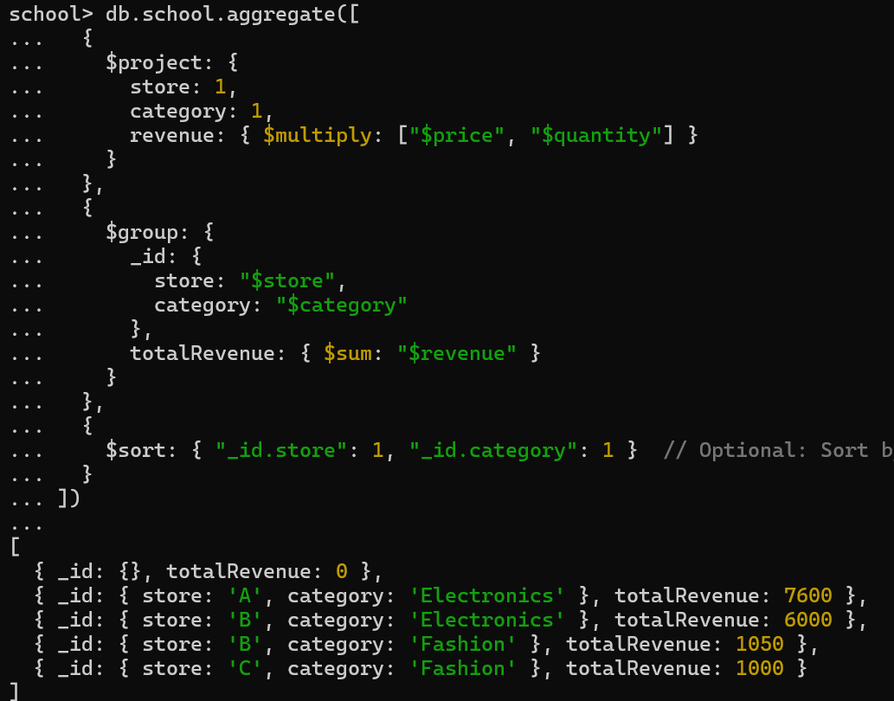

**Q-20**Products contributing more than 50% revenue.

**db.school.aggregate([**

**{**

**$project: {**

**product: 1,**

**revenue: { $multiply: ["$price", "$quantity"] }**

**}**

**},**

**{**

**$group: {**

**_id: "$product",**

**totalRevenue: { $sum: "$revenue" }**

**}**

**},**

**{**

**$group: {**

**_id: null,**

**allProducts: {**

**$push: { product: "$_id", revenue: "$totalRevenue" }**

**},**

**grandTotal: { $sum: "$totalRevenue" }**

**}**

**},**

**{**

**$unwind: "$allProducts"**

**},**

**{**

**$project: {**

**product: "$allProducts.product",**

**revenue: "$allProducts.revenue",**

**grandTotal: 1,**

**percentage: {**

**$multiply: [**

**{ $divide: ["$allProducts.revenue", "$grandTotal"] },**

**100**

**]**

**}**

**}**

**},**

**{**

**$match: {**

**percentage: { $gt: 50 }**

**}**

**}**

**])**