ASSIGNMENT-02

Q1- insert the data

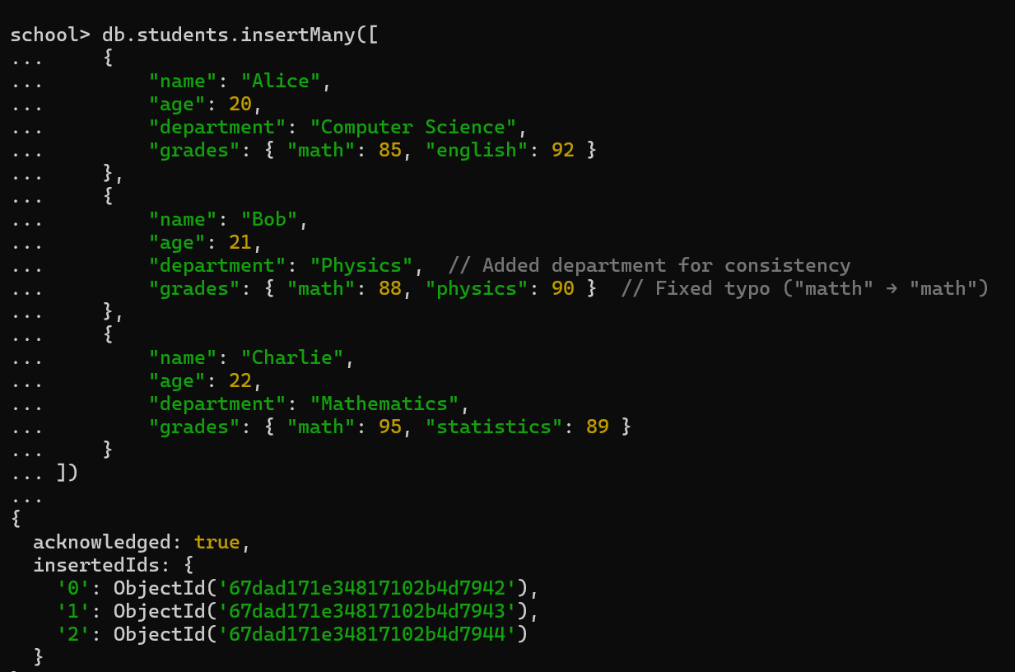

Q2-Write a query to display all students who are in the Computer Science department.

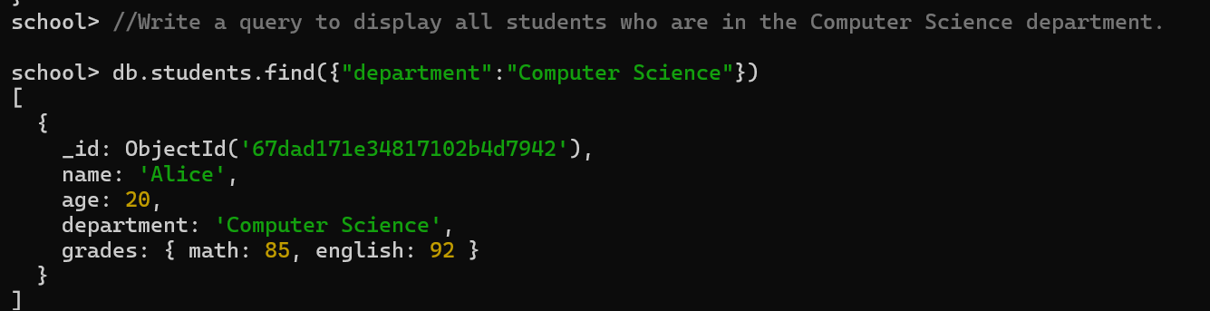

Q3-Write a query to update the grades of a student named Alice by adding a new subject

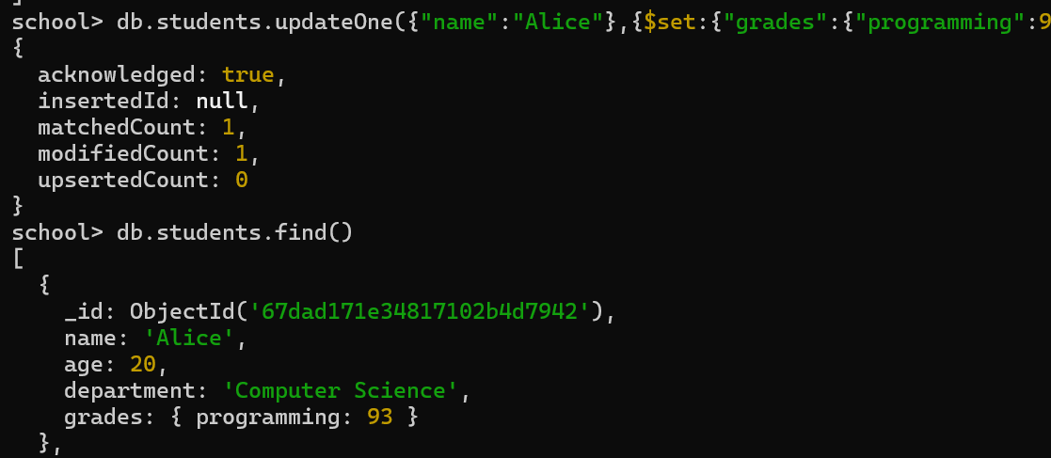

Q4-Write a query to increment the age of all students by 1

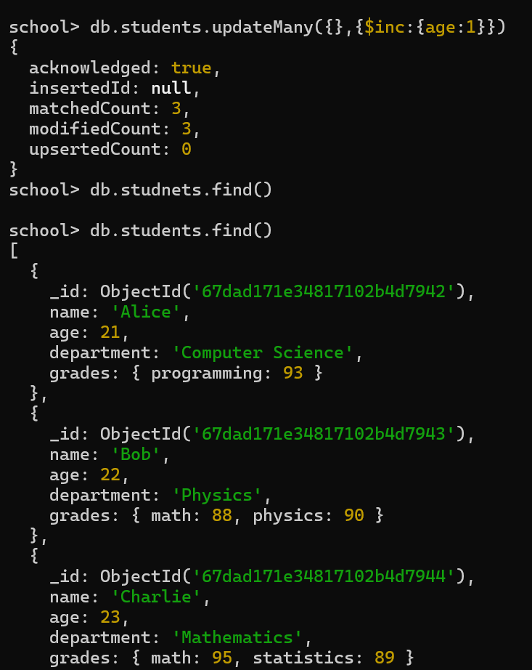

1. Q5-Write a query to delete all students who are 23 years old.

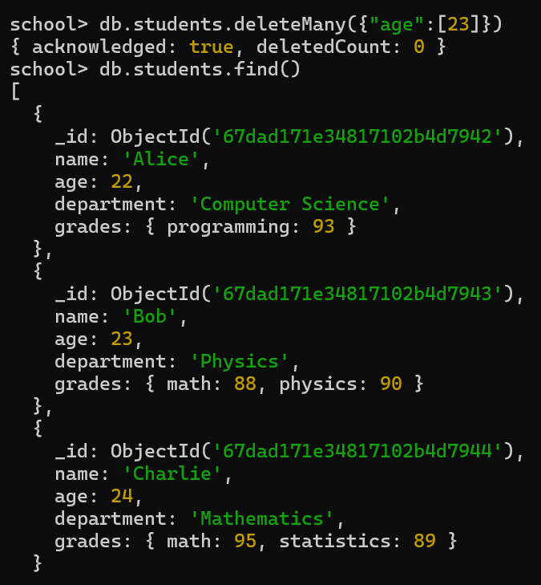

Q6-Write a query to create an index on the name field of the students collection.



Q7-Write an aggregation query to group students by their department and calculate the average age in each department.

