- What % of month-to-month customers churn vs. one-year vs. two-year contracts?
SELECT
Contract AS contract_type,
COUNT(*) AS total_customers,
SUM(CASE WHEN Churn = 'Yes' THEN 1 ELSE 0 END) AS churned_customers,
ROUND(
SUM(CASE WHEN Churn = 'Yes' THEN 1 ELSE 0 END) * 100.0 / COUNT(*),
2
) AS churn_rate_pct
FROM churn_data
GROUP BY Contract
ORDER BY churn_rate_pct DESC;

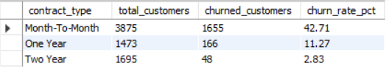

- Does churn rate drop as tenure increases? At what tenure does risk stabilize?
select case
when tenure between 1 and 4 then "1-4"
when tenure between 5 and 9 then "5-9"
when tenure between 10 and 19 then "10-19"
when tenure between 20 and 29 then "20-29"
when tenure between 30 and 39 then "30-39"
when tenure between 40 and 49 then "40-49"
when tenure between 50 and 59 then "50-59"
when tenure between 60 and 69 then "60-69"
else "above 70"
end as tenure_group,
count(*) as total,
SUM(CASE WHEN Churn = 'Yes' THEN 1 ELSE 0 END) AS churned_customers,
ROUND(SUM(CASE WHEN Churn = 'Yes' THEN 1 ELSE 0 END) * 100.0 / COUNT(*),2) AS churn_rate_pct
from churn_data
group by 1
order by churn_rate_pct desc;
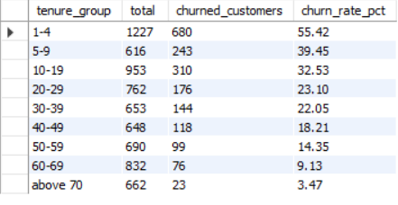

- Do customers with higher MonthlyCharges churn more than lower-paying ones?
select case
when MonthlyCharges between 18 and 29 then "18 and 29"
when MonthlyCharges between 30 and 49 then "30 and 49"
when MonthlyCharges between 50 and 69 then "50 and 69"
when MonthlyCharges between 70 and 89 then "70 and 89"
when MonthlyCharges between 90 and 109 then "90 and 109"
when MonthlyCharges between 110 and 129 then "110 and 129"
else "above 130"
end as charge_range,
count(monthlycharges),
SUM(CASE WHEN Churn = 'Yes' THEN 1 ELSE 0 END) AS churned_customers,
ROUND(SUM(CASE WHEN Churn = 'Yes' THEN 1 ELSE 0 END) * 100.0 / COUNT(*),2) AS churn_rate_pct
from churn_data
group by 1
order by MIN(MonthlyCharges);
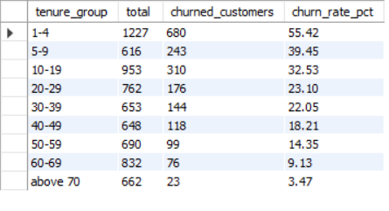

- churn difference by PaymentMethod :
select paymentmethod,
count(*) as total,
SUM(CASE WHEN Churn = 'Yes' THEN 1 ELSE 0 END) AS churned_customers,
ROUND(SUM(CASE WHEN Churn = 'Yes' THEN 1 ELSE 0 END) * 100.0 / COUNT(*),2) AS churn_rate_pct
from churn_data
group by 1;

