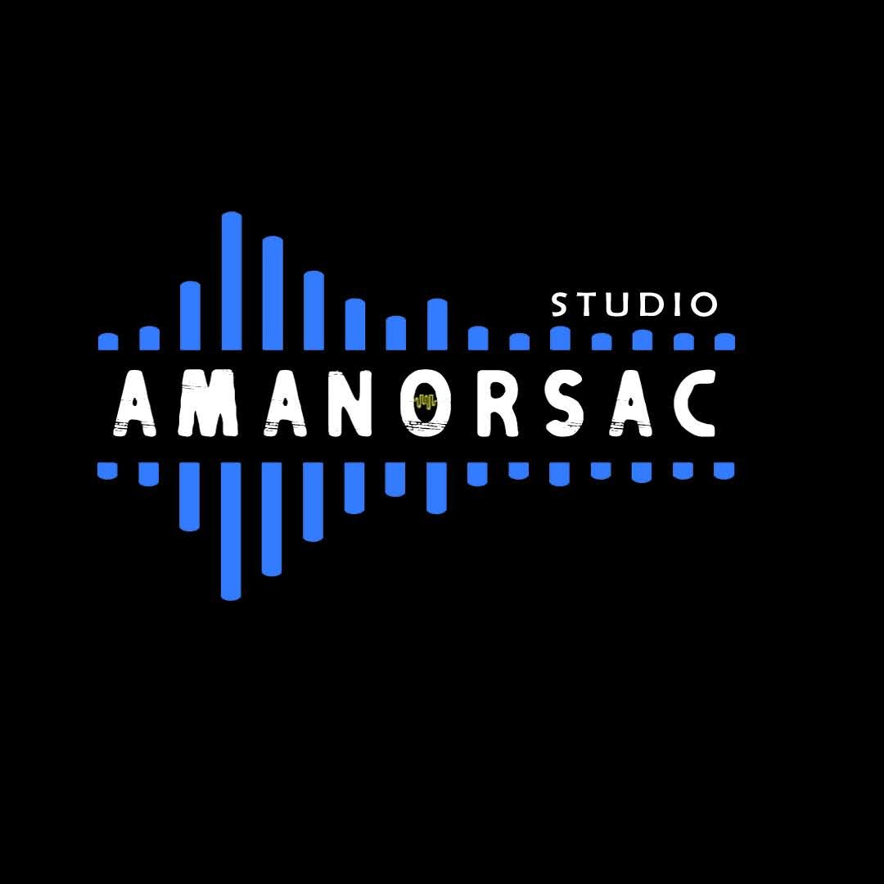
AMANORSAC STUDIO
MIXING SUITE
20 Premium Mixing Plugins + Analog Mix Rack
Complete Design, Engineering & Autonomous Codex Handoff Specification
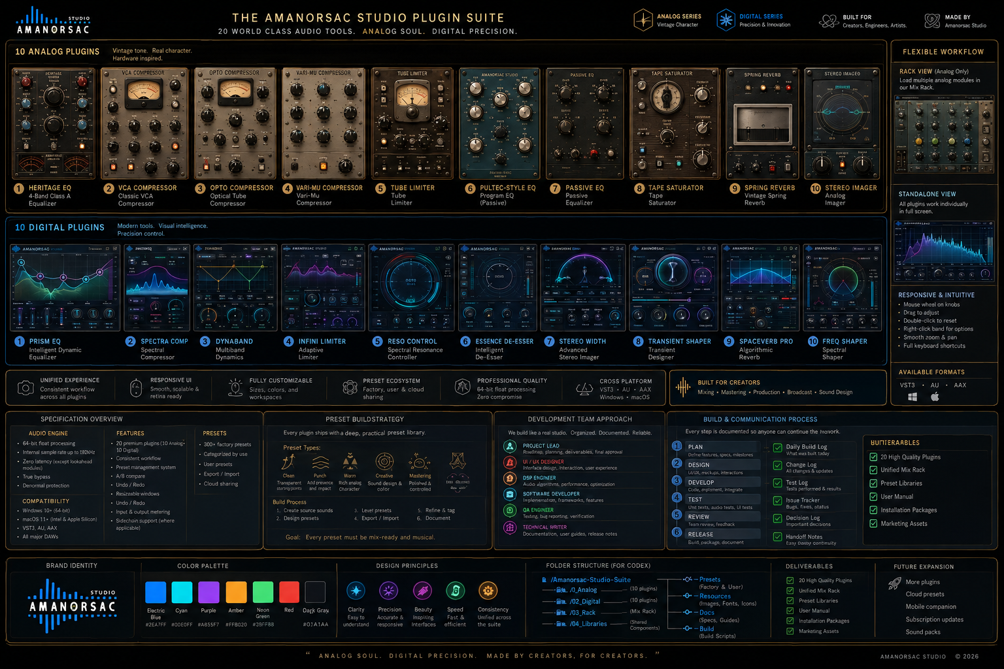
Suite concept board. Individual engineering mockups and machine-readable specifications in this package are authoritative for implementation geometry and interaction.
REVISION 1.0 • DESIGN APPROVED BASELINE • PRESET AUTHORING REQUIRED BEFORE RELEASE

Document Control
Item | Specification
Product owner / brand | Amanorsac Studio
Package status | Design baseline + implementation specification
Authoritative artifact | Amanorsac_Studio_Mixing_Suite_Codex_Build_Specification.docx
Plugin count | 20 individually loadable plugins: 10 analog-series + 10 digital-series
Rack | Separate optional Analog Mix Rack; analog modules only; digital plugins never load in the rack
Preset status | Do not ship with placeholder presets. Final preset authoring and audition occurs after plugin behavior is feature-complete and frozen.
Primary implementation target | JUCE 8, C++20, CMake; VST3 + AU first; AAX adapter when authorized AAX SDK/tooling is available
Platforms | Windows 10/11 x64 and macOS 13+ Intel/Apple Silicon
Source of truth hierarchy | 1) this DOCX; 2) 04_Machine_Spec JSON; 3) engineering PNGs; 4) approved high-fidelity concept renders; 5) dev logs / decisions
No-guessing rule — If a requirement is ambiguous, Codex must not silently invent behavior. It must check the authoritative hierarchy, inspect the machine JSON, and if still unresolved log the ambiguity in docs/dev/DECISIONS.md with the safest reversible interpretation. Do not block unrelated work.

Contents
- 1. Product Definition and Scope
- 2. Approved Visual Direction
- 3. Reference Manuals and IP/Trade-Dress Policy
- 4. Product Architecture
- 5. Brand System
- 6. Digital UI System
- 7. Analog UI System
- 8. Input, Mouse, Keyboard and Context Menus
- 9. Analog Mix Rack
- 10. Runtime / Plugin Architecture
- 11. Preset Ecosystem and Pre-Release Authoring
- 12. Virtual Development Team
- 13. Repository Ownership and Contracts
- 14. Logging, Continuity and Handoff
- 15. Build/Test/CI Requirements
- 16. Release Gates
- 17–36. Individual Plugin Specifications
- Appendix A. Master Codex Prompt
- Appendix B. Required Files
- Appendix C. Reference Manual Learnings

1. Product Definition and Scope
Amanorsac Studio Mixing Suite is a coherent professional mixing ecosystem consisting of ten analog-style processors, ten digital precision processors, and one optional analog-only modular rack. The suite must feel like one brand without forcing all processors into the same interface metaphor. Analog processors prioritize tactile physicality and character. Digital processors prioritize direct manipulation, visualization, speed and precision.

1.1 Non-negotiable product rules
- All 20 processors load individually in the DAW as separate plugins. The rack is an additional option, not the primary loading method.
- Only analog-series processors may load inside the Analog Mix Rack. Digital processors must never appear as rack modules.
- Every plugin supports full host parameter automation, state recall, undo/redo, A/B, preset load/save, bypass, input/output metering where relevant, HiDPI rendering and resizable UI.
- Digital tools must support fast graph-first mouse interaction, including wheel control, fine adjustment modifiers, direct numeric entry and right-click contextual editing.
- Analog tools must preserve tactile layouts and readable parameter values without copying the distinctive faceplate, trade dress, artwork or label layout of existing commercial hardware/plugins.
- Amanorsac Studio branding and supplied logo are mandatory. Do not invent alternate company names or logos.
- Factory presets are a release requirement but are authored only after DSP and automation contracts are frozen.

2. Approved Visual Direction

2.1 Approved high-fidelity visual anchors
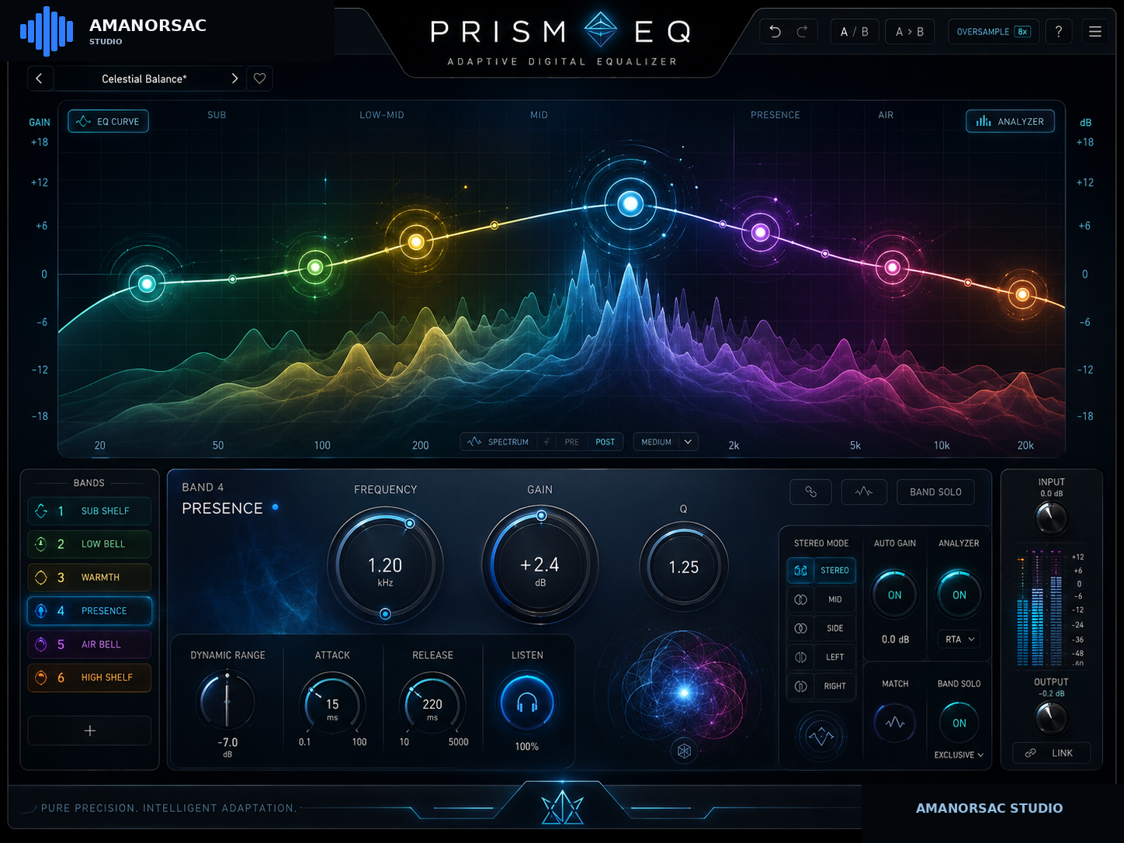
Approved digital-family emotional target: PRISM EQ. Production implementation must retain this premium neon/glass depth while following the engineering geometry and interaction contracts.
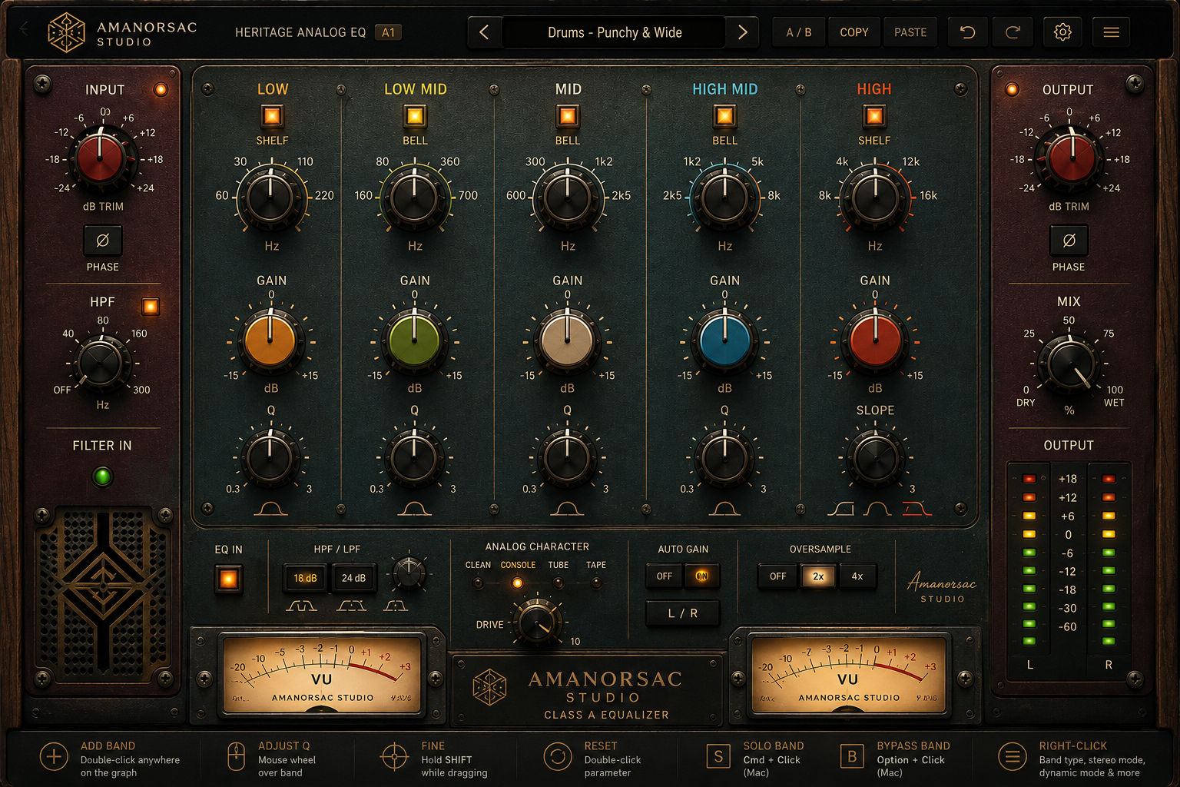
Approved analog-family emotional target: Heritage Analog EQ. Production implementation must retain this tactile material depth, warmth and hardware presence while following the engineering geometry and parameter contracts.

2.2 Engineering design set
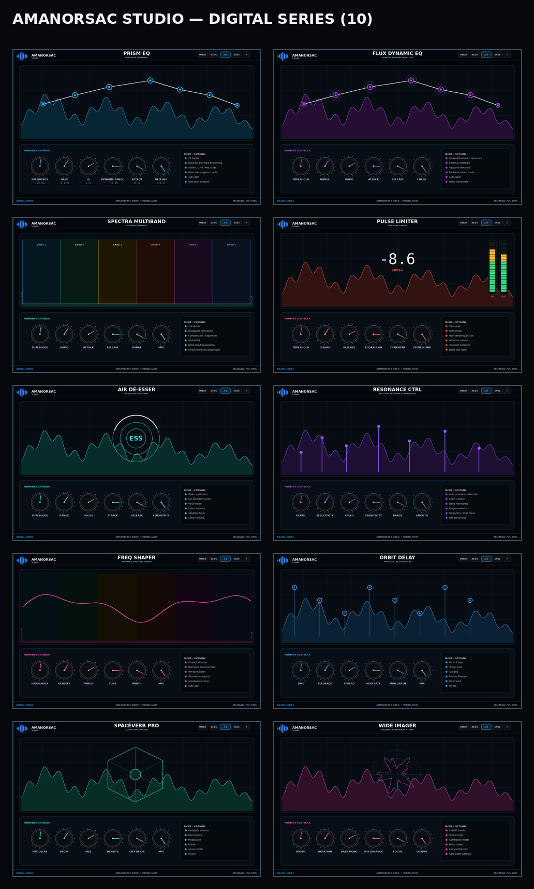
Digital engineering design set: black glass, spectral visualization, electric color accents, graph-first direct manipulation.
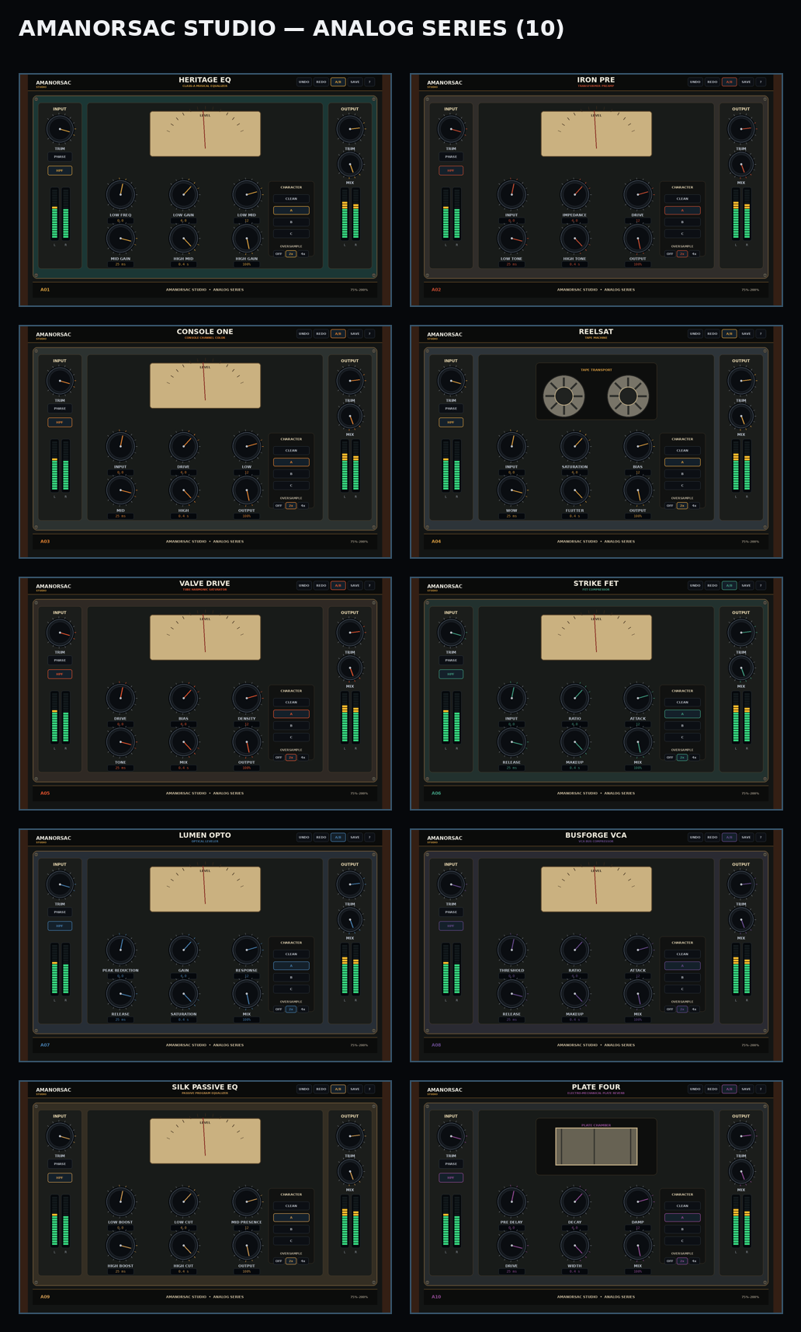
Analog engineering design set: dark metal, warm brass/wood, VU/LED metering, tactile controls and individual faceplate personalities.
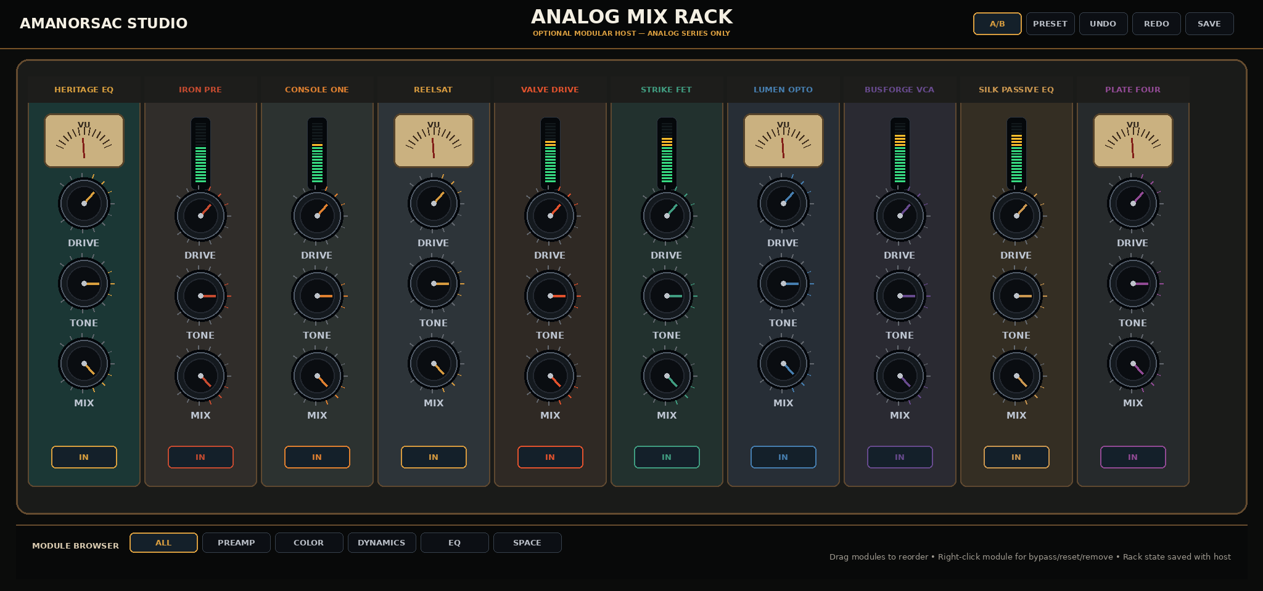
Analog Mix Rack engineering layout. Ten analog families are visible as compact vertical modules. Rack is a separate plugin and analog-only.
Visual hierarchy — The user-approved high-fidelity PRISM EQ and Heritage Analog EQ concepts establish the emotional target. The engineering images in this package establish geometry, grouping and control hierarchy. Codex must reproduce the geometry and states from the engineering spec, while using production-quality gradients, textures, meters, lighting and assets consistent with the approved concepts.

3. Reference Manuals and IP / Trade-Dress Policy
The uploaded manuals are used as workflow and feature references, not visual templates and not sources for branded circuit copies. The suite must stand on original Amanorsac Studio industrial design, terminology and DSP implementation.

3.1 Safe use of references
- Allowed: learn functional expectations such as signal flow, M/S processing, per-band solo/bypass/delta, visual tap grids, modular ordering, gain staging, damping, sidechains, preset workflows and advanced/basic disclosure patterns.
- Not allowed: copy screenshots, panel artwork, logos, fonts, knob caps, proprietary icons, exact faceplate arrangement, model numbers, famous product names, distinctive meter art, or a hardware/plugin trade dress that creates source confusion.
- Do not name Amanorsac products after identifiable third-party hardware. Names such as “Pultec”, “1176”, “LA-2A”, “1073”, “SSL”, “REDD”, “TG” etc. are prohibited in shipping product names and interface labels unless separately licensed.
- Working product names in this spec must undergo trademark/name clearance before public launch. If a name is unavailable, keep IDs A01–A10 / D01–D10 stable and change only display strings.
Legal scope — This specification is a product-design risk-reduction policy, not legal advice. Final commercial release should receive a real trademark/trade-dress review.

4. Product Architecture
Item | Specification
Framework | JUCE 8 application/plugin framework, C++20, CMake presets
Audio precision | 64-bit internal DSP where meaningful; host I/O may be 32/64-bit
Sample rates | 44.1, 48, 88.2, 96, 176.4, 192 kHz
Channel layouts | Mono and stereo for all applicable processors; mono-to-stereo allowed for Plate Four and SpaceVerb where host supports it
Realtime safety | No allocations, locks, file I/O, logging or UI operations in processBlock/audio callback
Parameter state | Central APVTS/value-tree contract with stable string IDs; never rename IDs after preset beta
Latency | Report exact algorithm/oversampling/lookahead latency to host; dynamic latency changes only when host-safe and documented
Bypass | Click-free; state-preserving; latency behavior host-correct
Oversampling | Per-plugin options as defined; anti-aliasing filters initialized off audio thread
Denormals | Flush/guard denormals in DSP
Serialization | Versioned state schema; migrations required for every incompatible state change

4.1 Common signal-chain services
- Input/output gain with smoothing
- Click-free mix/bypass ramps
- Host tempo and transport adapter
- Common meter bus with peak/RMS/true-peak where needed
- Oversampling service
- M/S and L/R matrix service
- Preset/state versioning
- A/B snapshot service
- Undo/redo transaction manager
- Common tooltip/value-entry layer

5. Brand System
Official source logo supplied by product owner.
Item | Specification
Digital base | #03070C near-black; panels #08101A; border #22465F; text #F4F7FA; secondary #A9B3C2; brand electric blue #2E7EFF
Analog base | #0F0D0B; metal #181B19; brass #D89D3F; wood #34201A; cream #F0E5C8
Typography | A clean modern sans-serif; production font must be redistributable. Default engineering reference: Inter-equivalent / system sans. Numeric fields may use a monospaced font.
Logo usage | Digital: original blue/white mark. Analog: full logo on About/splash; monochrome/brass treatment allowed on faceplate without altering geometry.
Color rule | Color is never the only state indicator; selected/bypassed/dynamic states also change outline, icon or text.
Texture rule | Analog may use subtle metal/wood/grille textures. Digital must remain clean, glass-like and visualization-led.
Animation rule | No gratuitous animation. All motion must communicate signal, state or interaction. Meter target 60 fps where host/UI allows; degrade gracefully to 30 fps.

6. Digital UI System
Item | Specification
Reference canvas | 1536 × 960 px at 100% scale
Top bar | x=0 y=0 w=1536 h=74
Primary visualization | x=42 y=102 w=1452 h=464
Control dock | x=42 y=590 w=1452 h=300
Footer/status | x=0 y=916 w=1536 h=44
Minimum hit target | 28 × 28 px; preferred 32 × 32 px
Default scale | 100%; user scale 75, 90, 100, 110, 125, 150, 175, 200%
Resize behavior | Graph area grows first. Control dock maintains minimum control sizes; at narrow widths optional panels collapse behind labeled buttons, never disappear permanently.

6.1 Digital component language
- Graph-first workflow with direct nodes/taps/crossovers.
- Selected objects receive a bright accent outline plus filled core and a dedicated control inspector.
- Hover previews exact value; drag begins only after 2 px pointer travel to prevent accidental moves.
- Numeric fields support drag-scrub, double-click text entry, Up/Down arrows, Enter commit and Escape cancel.
- Analyzer must never steal drag events from active nodes.
- Context menus use native-feeling dark panels, keyboard navigation and checkmarks for current state.

7. Analog UI System
Item | Specification
Reference canvas | 1536 × 960 px at 100%
Top bar | x=38 y=0 w=1460 h=72
Chassis | x=58 y=92 w=1420 h=754
Input strip | x=80 y=122 w=180 h=683
Main processor | x=282 y=122 w=972 h=683
Output strip | x=1276 y=122 w=180 h=683
Bottom identification strip | x=58 y=860 w=1420 h=64
Resize behavior | Uniform physical scaling by default to preserve faceplate relationships; text/hit regions remain crisp via vector drawing/HiDPI assets.

7.1 Analog component language
- Knobs: weighted, low-glare black metal; colored cap/indicator identifies function family, not state alone.
- Meters: responsive, damped VU/GR or LED meters as functionally appropriate.
- Switches: tactile square/rocker controls with explicit text; no decorative switches that do nothing.
- Wear/texture: subtle only; labels must remain legible at 75% UI scale.
- Every analog processor includes numeric tooltip/value entry despite its hardware-inspired surface.

8. Input, Mouse, Keyboard and Context Menus

8.1 Digital graph interaction — mandatory
Item | Specification
Double-click empty graph | Create a new band/object at pointer frequency/time with neutral gain/default mode.
Drag node | Direct manipulation. EQ: horizontal = frequency, vertical = gain.
Mouse wheel over EQ/dynamic node | Adjust Q. This is mandatory and must feel continuous and responsive.
Shift + wheel | Fine Q adjustment.
Shift + drag | Fine adjustment for active dimension.
Double-click a parameter/control | Reset to default.
Right-click band/node | Open contextual menu with Band Type, Processing Mode, Dynamic Mode and Actions.
Cmd/Ctrl + click band | Momentary solo while held; do not write solo to host automation.
Alt/Option + click band | Toggle bypass.
Delete/Backspace | Delete selected band/object after valid selection.
Wheel over knob | Adjust hovered parameter with small increments; Shift = finer.
Double-click numeric readout | Type exact value; accept units when unambiguous.

8.2 PRISM / FLUX right-click band menu
- Band Type: Bell, Low Shelf, High Shelf, Low Cut, High Cut, Notch, Band Pass, Tilt.
- Processing Mode: Stereo, Left, Right, Mid, Side.
- Dynamic Mode: Static, Dynamic Down, Dynamic Up.
- Actions: Solo, Bypass, Delta, Reset, Duplicate, Copy, Paste, Delete.
- Current choice receives checkmark. Disabled operations are visible but disabled, not removed.
- Same functions must also exist in an inspector/menu so right-click is never the only access path.

8.3 Scrolling and precision
- Wheel input must be high-resolution and trackpad-friendly; consume the event only when pointer is over an adjustable target.
- Use acceleration caps so a fast scroll cannot jump through an entire parameter range unexpectedly.
- All continuous controls use parameter-specific skew/log mapping, not linear raw-value mapping for frequency/time ranges.
- Pointer capture releases cleanly when mouse leaves window or host changes focus.

9. Analog Mix Rack
Item | Specification
Product type | Separate plugin: Amanorsac Studio Analog Mix Rack
Allowed processors | A01–A10 only. Digital D01–D10 are not loadable and do not appear in the rack browser.
Slots | 12 total slots; initial view shows up to 10 compact vertical modules at 100% width; horizontal scroll if window is narrower or slot count exceeds visible area
Ordering | Drag module by header to reorder; animated insertion guide; no audio glitches during reorder
Module menu | Right-click header: Bypass, Reset, Copy, Paste, Duplicate, Remove, Open Full View
Full view | Double-click a rack module to open its full processor editor inside rack focus overlay; Escape returns to rack
Global controls | Input trim, output trim, global bypass, A/B, oversampling policy, chain preset browser
Automation | Host-visible parameter IDs include slot index + stable module parameter ID. Reordering changes routing but does not silently remap active host automation; use internal slot UUID mapping.
State | Rack preset stores order, module type, settings, bypass/mix and rack globals
Latency | Sum child latency; report chain total; rebuild safely when module order/quality changes

10. Runtime / Plugin Architecture

10.1 Repository target
AmanorsacStudioMixingSuite/
CMakeLists.txt
cmake/
src/common/{audio,dsp,ui,state,presets,metering}/
src/plugins/digital/D01_PrismEQ ... D10_WideImager/
src/plugins/analog/A01_HeritageEQ ... A10_PlateFour/
src/rack/AnalogMixRack/
assets/{brand,digital,analog,icons}/
tests/{unit,dsp,golden,state,ui_smoke,host}/
presets/{factory,user_schema}/
docs/{spec,dev,release}/
logs/
tools/
build/ (ignored)

10.2 Stable contracts
- Parameter IDs are public contracts once preset beta starts. Display labels may change; IDs do not.
- DSP classes expose prepare/reset/process and parameter setters with smoothing. UI never accesses DSP internals directly; it reads/writes parameter/state contracts.
- All meters use lock-free atomics/ring buffers.
- Preset schema includes plugin ID, schema version, parameter map, optional UI state, tags and author.
- The rack hosts the same analog DSP module classes used by individual plugins; no duplicate DSP implementations.

11. Preset Ecosystem and Pre-Release Authoring
Release order — Do not spend major effort on factory presets while DSP behavior is still changing. Finish processors, freeze parameter contracts, then enter the dedicated preset phase before release.

11.1 Preset targets
Item | Specification
Minimum per plugin | 25 curated factory presets
Target per plugin | 40 curated factory presets after audition
Rack chain presets | Minimum 30 complete analog chains
Total target | ≈800 individual presets + 30 rack chains
User preset location | Platform-standard user application data folder; never write factory bundle location
Preset tags | Source, Intent, Genre, Intensity, Character, Author, Version
Audition rule | Presets should be level-aware. Where the processor changes loudness by design, include loudness-matched comparison guidance or automatic compensation as appropriate.
Preset QA | Open/recall test; parameter bounds; no clipping surprises; musical audition on representative sources; tag/name review

11.2 Required preset categories
- Vocals / BGV
- Kick / Snare / Toms / Drum Bus
- Bass
- Acoustic / Electric Guitar
- Keys / Piano / Synth
- Strings / Brass
- Mix Bus
- Mastering
- Broadcast / Dialog where appropriate
- Creative / Sound Design

12. Virtual Development Team
Codex operates as a coordinated virtual team. It may execute roles sequentially, but it must identify the active role in status/log entries and respect ownership boundaries. No role may silently rewrite another subsystem contract.
Role | Responsibility
Product / Tech Lead | Owns architecture, milestones, scope, source-of-truth and integration approval.
UI/UX Engineer | Implements exact geometry, interaction states, rendering, accessibility and screenshot regression.
Plugin Platform Engineer | JUCE wrappers, formats, parameter/state, host integration, CMake, packaging.
DSP Architecture Lead | Shared DSP primitives, oversampling, metering, smoothing, quality modes.
EQ / Spectral DSP Engineer | D01/D02/D03/D05/D06/D07/D10 plus analog EQ/filter blocks.
Dynamics DSP Engineer | A06/A07/A08 and D04 plus sidechain/detector infrastructure.
Time / Space DSP Engineer | A04/A10 and D08/D09.
Analog Character DSP Engineer | A02/A03/A04/A05/A09 nonlinear color models; originality + stability.
QA / Test Engineer | Unit, numerical, regression, host, automation, stress and visual tests.
Build / Release Engineer | CI, signing/notarization hooks, installers, artifacts, hashes, release manifests.
Preset / Documentation Engineer | Factory presets, browser taxonomy, user manual, release notes and final audition sheets.

13. Repository Ownership and Contracts
- Shared infrastructure changes require an entry in DECISIONS.md before cross-plugin API changes.
- Plugin-specific code must stay inside its plugin folder unless genuinely reusable.
- UI assets are immutable inputs at build time; no code-generated placeholder logos in shipping UI.
- Tests live adjacent in test target folders, not hidden in scratch scripts.
- Generated build outputs never enter source control.

14. Logging, Continuity and Handoff
Mandatory logging — Every build, test run, failure, fix, architecture change, UI change, milestone and release candidate must be written to the project logs. A later agent must be able to continue without reading chat history.
Item | Specification
docs/dev/STATUS.md | Current milestone, active role, last known good build, next 5 actions, blockers.
logs/BUILD_LOG.md | Every configure/build/package command and outcome.
logs/TEST_LOG.md | Every automated/manual test run, environment and result.
docs/dev/CHANGE_LOG.md | Meaningful product/UI/DSP changes; user-visible and technical.
docs/dev/DECISIONS.md | Architecture and behavior decisions with rationale and alternatives.
docs/dev/KNOWN_ISSUES.md | Open defects with severity, reproduction, owner and workaround.
docs/dev/HANDOFF.md | Last completed task, exact files changed, current failures, commands to resume.
docs/dev/MILESTONES.md | Definition and pass/fail status of each milestone.
docs/release/RELEASE_CHECKLIST.md | Format, tests, signing, preset, docs and packaging gates.

14.1 Build log entry format
## YYYY-MM-DD HH:MM — BUILD-####
Role: Build/Release Engineer
Commit/Workspace: <hash or dirty-state summary>
Platform: Windows/macOS + version + architecture
Command: <exact command>
Configuration: Debug/Release; format; sample target
Result: PASS/FAIL
Duration: <time>
Warnings/Errors: <summary>
Artifacts: <paths + hashes>
Tests triggered: <IDs>
Next action: <one concrete action>

14.2 Handoff rule
- Before ending any work session, update STATUS.md and HANDOFF.md even if the build is broken.
- HANDOFF.md must state the last command that succeeded and the first command the next agent should run.
- Never write “works” without a test/build ID. Reference BUILD-#### and TEST-####.
- Every known broken test remains listed until confirmed fixed by a later TEST entry.

15. Build / Test / CI Requirements

15.1 Required build matrix
- Windows 11 x64: VST3 Release + Debug smoke
- macOS current supported: AU + VST3, arm64 and x86_64/universal where practical
- AAX build only when authorized SDK/toolchain exists; absence is an external blocker, not a reason to stop VST3/AU work
- Standalone test harness target may be built for development; shipping it is optional and separate from “individual plugin” requirement

15.2 Audio test matrix
Item | Specification
Sample rates | 44.1 / 48 / 88.2 / 96 / 176.4 / 192 kHz
Buffer sizes | 32 / 64 / 128 / 256 / 512 / 1024 samples
Signals | Silence, impulse, DC, sine, sweep, multitone, pink noise, full-scale transient, denormal-level signal
State tests | Save/load, duplicate instance, DAW reopen, old-schema migration, random parameter fuzz within bounds
Automation | Fast ramps, touch/latch, parameter gesture boundaries, session reload
Bypass | Null/near-null expected where processor neutral; no click; latency consistent
NaN/Inf | No propagation; assert in debug; sanitize in release path
CPU | Profile at 48/96/192 kHz; no allocations in audio thread; bounded worst-case
Visual | Screenshot regression at 100% and 150%; hover/selected/bypass/error states

15.3 Host smoke tests
- Studio One / Fender Studio Pro equivalent workflow
- Ableton Live
- Logic Pro for AU
- Pro Tools for AAX when available
- At least one generic plugin-validation tool per platform

16. Release Gates
☐ All 20 individual plugins scan and instantiate
☐ Analog Mix Rack scans and loads all A01–A10 modules only
☐ No digital plugin appears in rack browser
☐ All parameter/state migrations tested
☐ No P0/P1 bugs; documented P2 accepted explicitly
☐ Preset minimum reached and auditioned
☐ A/B, undo/redo, bypass and automation pass
☐ Resize/HiDPI/accessibility pass
☐ Installer/uninstaller and clean-machine scan pass
☐ Copyright/trade-dress/name review complete
☐ Manual/release notes complete
☐ Release candidate hash logged and reproducible

17. D01 — PRISM EQ
Precision Equalizer
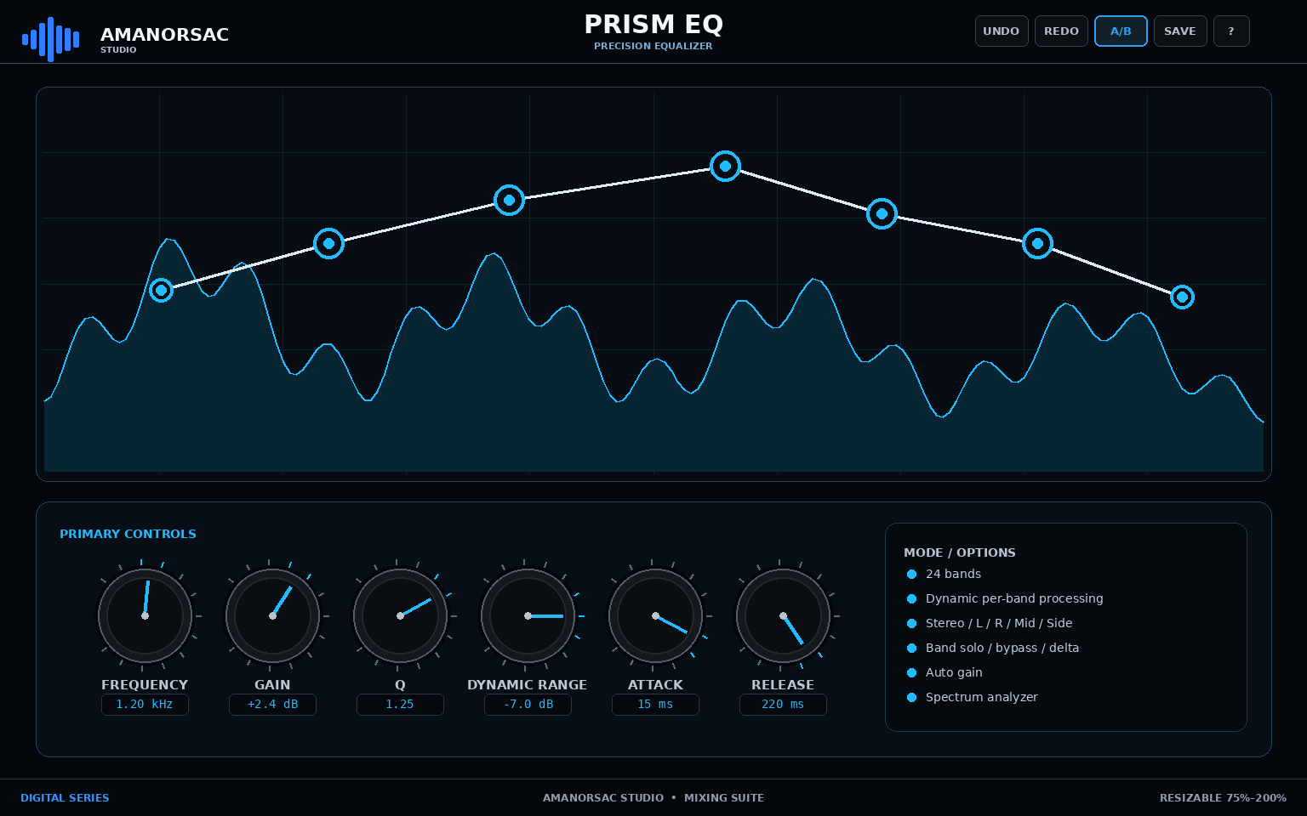
Engineering UI reference — PRISM EQ. Geometry is authoritative; final rendering should reach the approved Amanorsac Studio material/lighting quality.
Item | Specification
Series | Digital
Reference canvas | 1536 × 960
Primary role | Precision Equalizer
Feature set | 24 bands; Dynamic per-band processing; Stereo / L / R / Mid / Side; Band solo / bypass / delta; Auto gain; Spectrum analyzer
Parameter count / schema entries | 24

Signal flow / processing intent
Input → analyzer tap → up to 24 EQ bands (static/dynamic, per-band stereo mode) → optional Color stage → Auto Gain → Output. Analyzer is display-only and never changes sound unless explicitly in adaptive mode.

UI geometry
Item | Specification
topbar | x=0, y=0, x2=1536, y2=74
visualizer | x=42, y=102, x2=1494, y2=566
control_dock | x=42, y=590, x2=1494, y2=890
footer | x=0, y=916, x2=1536, y2=960

Digital interaction requirements
- All graph objects are directly draggable and keyboard focusable.
- Mouse wheel over nodes/knobs adjusts context parameter; PRISM/FLUX wheel-over-band = Q.
- Right-click contextual menu is implemented exactly as Section 8 and duplicated through inspector controls.
- Solo/Delta are monitoring operations and do not write accidental automation.

Parameter contract
ID / Label | Type | Range / Values | Default | Automation
input_gain  Input Gain | float | -24 to 24 dB | 0 dB | Yes
output_gain  Output Gain | float | -24 to 24 dB | 0 dB | Yes
auto_gain  Auto Gain | bool | Off / On | True | Yes
analyzer  Analyzer | bool | Off / On | True | Yes
analyzer_speed  Analyzer Speed | enum | slow / medium / fast | medium | Yes
processing_quality  Quality | enum | eco / normal / high / linear-phase | high | Yes
oversampling  Oversampling | enum | off / 2x / 4x / 8x | 2x | Yes
color_mode  Color | enum | clean / console / tube / tape | clean | Yes
color_drive  Color Drive | float | 0 to 24 dB | 0 dB | Yes
color_amount  Color Amount | float | 0 to 100 % | 0 % | Yes
band.type  Band Type | enum | bell / low_shelf / high_shelf / low_cut / high_cut / notch / band_pass / tilt | bell | Yes
band.frequency  Band Frequency | float | 20 to 40000 Hz | 1000 Hz | Yes
band.gain  Band Gain | float | -30 to 30 dB | 0 dB | Yes
band.q  Band Q | float | 0.05 to 50 | 1.0 | Yes
band.slope  Filter Slope | float | 6 to 96 dB/oct | 24 dB/oct | Yes
band.stereo_mode  Band Stereo Mode | enum | stereo / left / right / mid / side | stereo | Yes
band.dynamic_mode  Dynamic Mode | enum | off / downward / upward | off | Yes
band.dynamic_range  Dynamic Range | float | 0 to 24 dB | 6 dB | Yes
band.threshold  Dynamic Threshold | float | -72 to 0 dB | -24 dB | Yes
band.attack  Dynamic Attack | float | 0.1 to 200 ms | 15 ms | Yes
band.release  Dynamic Release | float | 10 to 3000 ms | 220 ms | Yes
band.enabled  Band Enabled | bool | Off / On | True | Yes
band.solo  Band Solo | bool | Off / On | False | No
band.delta  Band Delta | bool | Off / On | False | No

18. D02 — FLUX DYNAMIC EQ
Adaptive Dynamic Equalizer
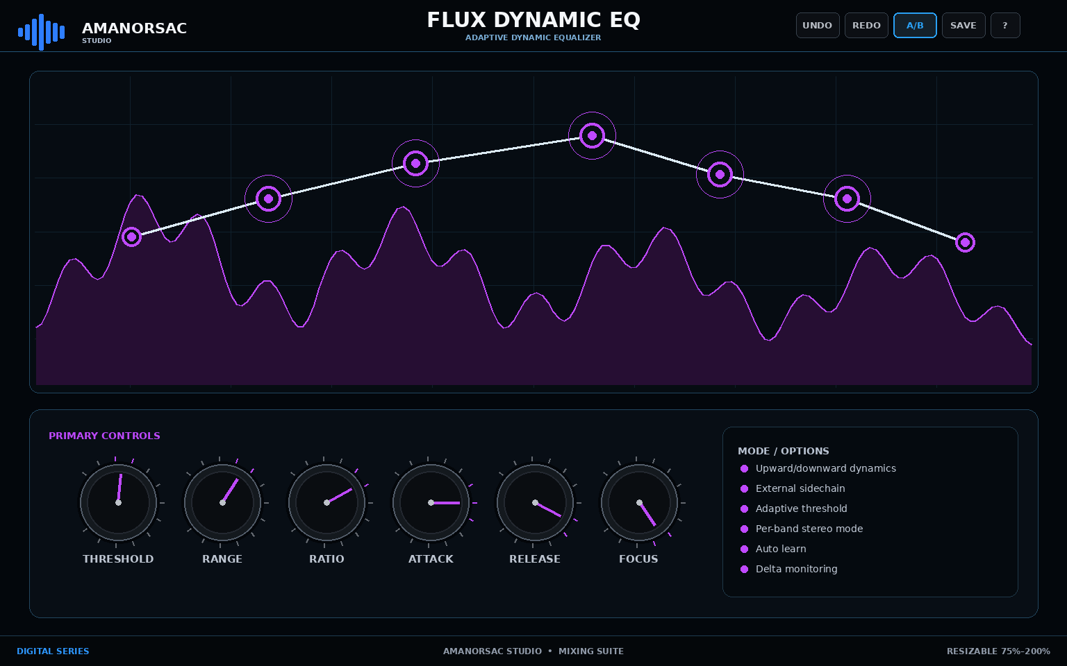
Engineering UI reference — FLUX DYNAMIC EQ. Geometry is authoritative; final rendering should reach the approved Amanorsac Studio material/lighting quality.
Item | Specification
Series | Digital
Reference canvas | 1536 × 960
Primary role | Adaptive Dynamic Equalizer
Feature set | Upward/downward dynamics; External sidechain; Adaptive threshold; Per-band stereo mode; Auto learn; Delta monitoring
Parameter count / schema entries | 17

Signal flow / processing intent
Input → sidechain analysis → adaptive dynamic EQ band bank → band summing → output trim. Per-band upward/downward action is independent; external sidechain substitutes detector input only.

UI geometry
Item | Specification
topbar | x=0, y=0, x2=1536, y2=74
visualizer | x=42, y=102, x2=1494, y2=566
control_dock | x=42, y=590, x2=1494, y2=890
footer | x=0, y=916, x2=1536, y2=960

Digital interaction requirements
- All graph objects are directly draggable and keyboard focusable.
- Mouse wheel over nodes/knobs adjusts context parameter; PRISM/FLUX wheel-over-band = Q.
- Right-click contextual menu is implemented exactly as Section 8 and duplicated through inspector controls.
- Solo/Delta are monitoring operations and do not write accidental automation.

Parameter contract
ID / Label | Type | Range / Values | Default | Automation
input_gain  Input Gain | float | -24 to 24 dB | 0 dB | Yes
output_gain  Output Gain | float | -24 to 24 dB | 0 dB | Yes
band_count  Bands | int | 1 to 12 | 4 | Yes
adaptive  Adaptive Mode | bool | Off / On | True | Yes
external_sc  External Sidechain | bool | Off / On | False | Yes
band.frequency  Frequency | float | 20 to 40000 Hz | 1000 Hz | Yes
band.q  Q | float | 0.1 to 24 | 1.2 | Yes
band.threshold  Threshold | float | -72 to 0 dB | -24 dB | Yes
band.range  Range | float | -24 to 24 dB | -4 dB | Yes
band.ratio  Ratio | float | 0.25 to 20 | 2 | Yes
band.attack  Attack | float | 0.1 to 500 ms | 20 ms | Yes
band.release  Release | float | 5 to 5000 ms | 250 ms | Yes
band.stereo_mode  Stereo Mode | enum | stereo / left / right / mid / side | stereo | Yes
band.direction  Direction | enum | down / up | down | Yes
band.listen  Listen | bool | Off / On | False | No
auto_learn  Auto Learn | bool | Off / On | False | No
delta  Delta | bool | Off / On | False | No

19. D03 — SPECTRA MULTIBAND
Six-Band Dynamics
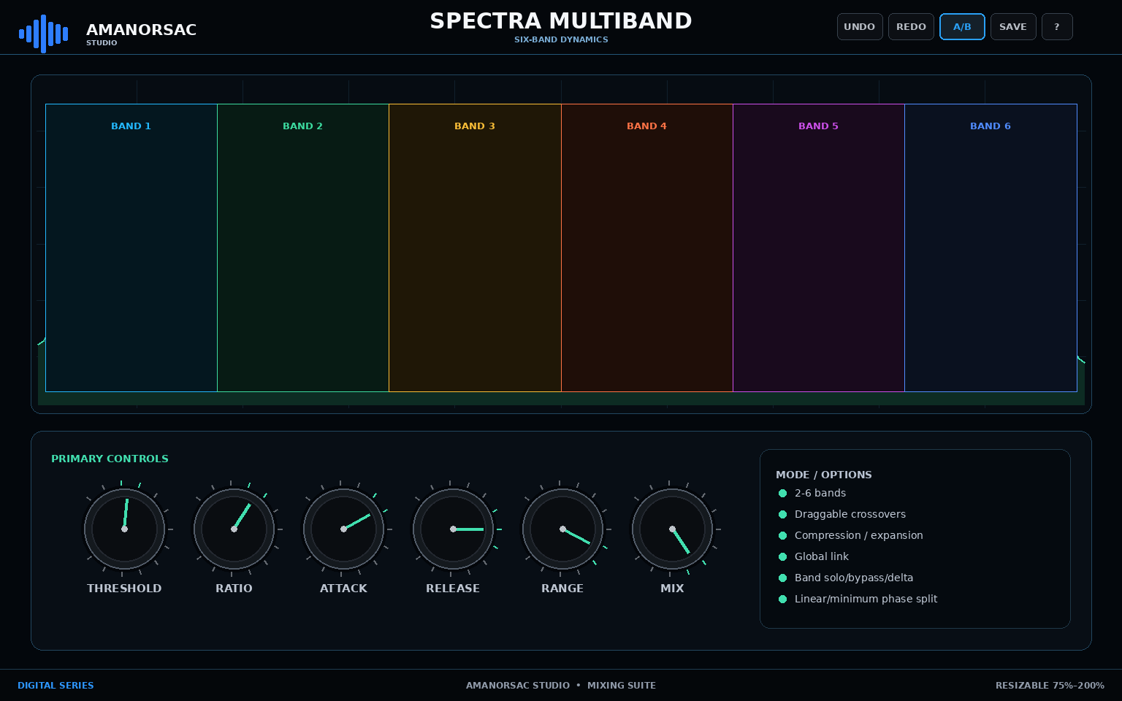
Engineering UI reference — SPECTRA MULTIBAND. Geometry is authoritative; final rendering should reach the approved Amanorsac Studio material/lighting quality.
Item | Specification
Series | Digital
Reference canvas | 1536 × 960
Primary role | Six-Band Dynamics
Feature set | 2-6 bands; Draggable crossovers; Compression / expansion; Global link; Band solo/bypass/delta; Linear/minimum phase split
Parameter count / schema entries | 15

Signal flow / processing intent
Input → crossover bank → 2–6 independent dynamics bands → phase-correct recombination → global mix/output.

UI geometry
Item | Specification
topbar | x=0, y=0, x2=1536, y2=74
visualizer | x=42, y=102, x2=1494, y2=566
control_dock | x=42, y=590, x2=1494, y2=890
footer | x=0, y=916, x2=1536, y2=960

Digital interaction requirements
- All graph objects are directly draggable and keyboard focusable.
- Mouse wheel over nodes/knobs adjusts context parameter; PRISM/FLUX wheel-over-band = Q.
- Right-click contextual menu is implemented exactly as Section 8 and duplicated through inspector controls.
- Solo/Delta are monitoring operations and do not write accidental automation.

Parameter contract
ID / Label | Type | Range / Values | Default | Automation
band_count  Band Count | int | 2 to 6 | 4 | Yes
split_phase  Split Phase | enum | minimum / linear | minimum | Yes
global_mix  Global Mix | float | 0 to 100 % | 100 % | Yes
global_link  Global Link | float | 0 to 100 % | 100 % | Yes
band.threshold  Threshold | float | -72 to 0 dB | -24 dB | Yes
band.ratio  Ratio | float | 0.25 to 20 | 3 | Yes
band.attack  Attack | float | 0.1 to 500 ms | 20 ms | Yes
band.release  Release | float | 5 to 5000 ms | 250 ms | Yes
band.range  Range | float | -30 to 30 dB | -6 dB | Yes
band.makeup  Makeup | float | -18 to 18 dB | 0 dB | Yes
band.mode  Mode | enum | compress / expand_up / expand_down | compress | Yes
band.solo  Solo | bool | Off / On | False | No
band.bypass  Bypass | bool | Off / On | False | Yes
band.delta  Delta | bool | Off / On | False | No
xover.frequency  Crossover | float | 40 to 18000 Hz | 1000 Hz | Yes

20. D04 — PULSE LIMITER
True-Peak Limiter
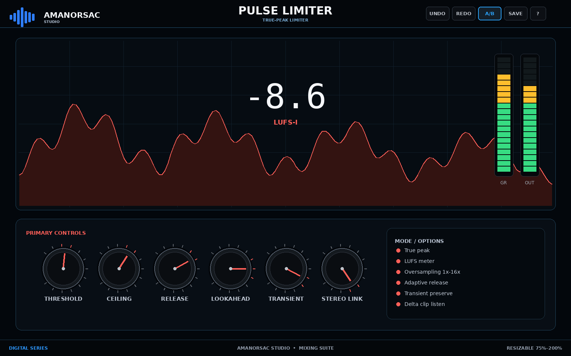
Engineering UI reference — PULSE LIMITER. Geometry is authoritative; final rendering should reach the approved Amanorsac Studio material/lighting quality.
Item | Specification
Series | Digital
Reference canvas | 1536 × 960
Primary role | True-Peak Limiter
Feature set | True peak; LUFS meter; Oversampling 1x-16x; Adaptive release; Transient preserve; Delta clip listen
Parameter count / schema entries | 12

Signal flow / processing intent
Input → optional lookahead → limiting core → true-peak reconstruction/ceiling control → output meter. Report lookahead + oversampling latency.

UI geometry
Item | Specification
topbar | x=0, y=0, x2=1536, y2=74
visualizer | x=42, y=102, x2=1494, y2=566
control_dock | x=42, y=590, x2=1494, y2=890
footer | x=0, y=916, x2=1536, y2=960

Digital interaction requirements
- All graph objects are directly draggable and keyboard focusable.
- Mouse wheel over nodes/knobs adjusts context parameter; PRISM/FLUX wheel-over-band = Q.
- Right-click contextual menu is implemented exactly as Section 8 and duplicated through inspector controls.
- Solo/Delta are monitoring operations and do not write accidental automation.

Parameter contract
ID / Label | Type | Range / Values | Default | Automation
threshold  Threshold | float | -36 to 0 dB | -8 dB | Yes
ceiling  Ceiling | float | -3 to 0 dBTP | -1 dBTP | Yes
lookahead  Lookahead | float | 0 to 20 ms | 1 ms | Yes
release  Release | float | 20 to 2000 ms | 250 ms | Yes
release_mode  Release Mode | enum | adaptive / manual | adaptive | Yes
transient_preserve  Transient Preserve | float | 0 to 100 % | 40 % | Yes
stereo_link  Stereo Link | float | 0 to 100 % | 100 % | Yes
oversampling  Oversampling | enum | 1x / 2x / 4x / 8x / 16x | 8x | Yes
true_peak  True Peak | bool | Off / On | True | Yes
style  Style | enum | transparent / balanced / punch / dense | balanced | Yes
delta  Delta Listen | bool | Off / On | False | No
target_lufs  Target LUFS | float | -24 to -5 LUFS | -9 LUFS | Yes

21. D05 — AIR DE-ESSER
Intelligent De-Essing
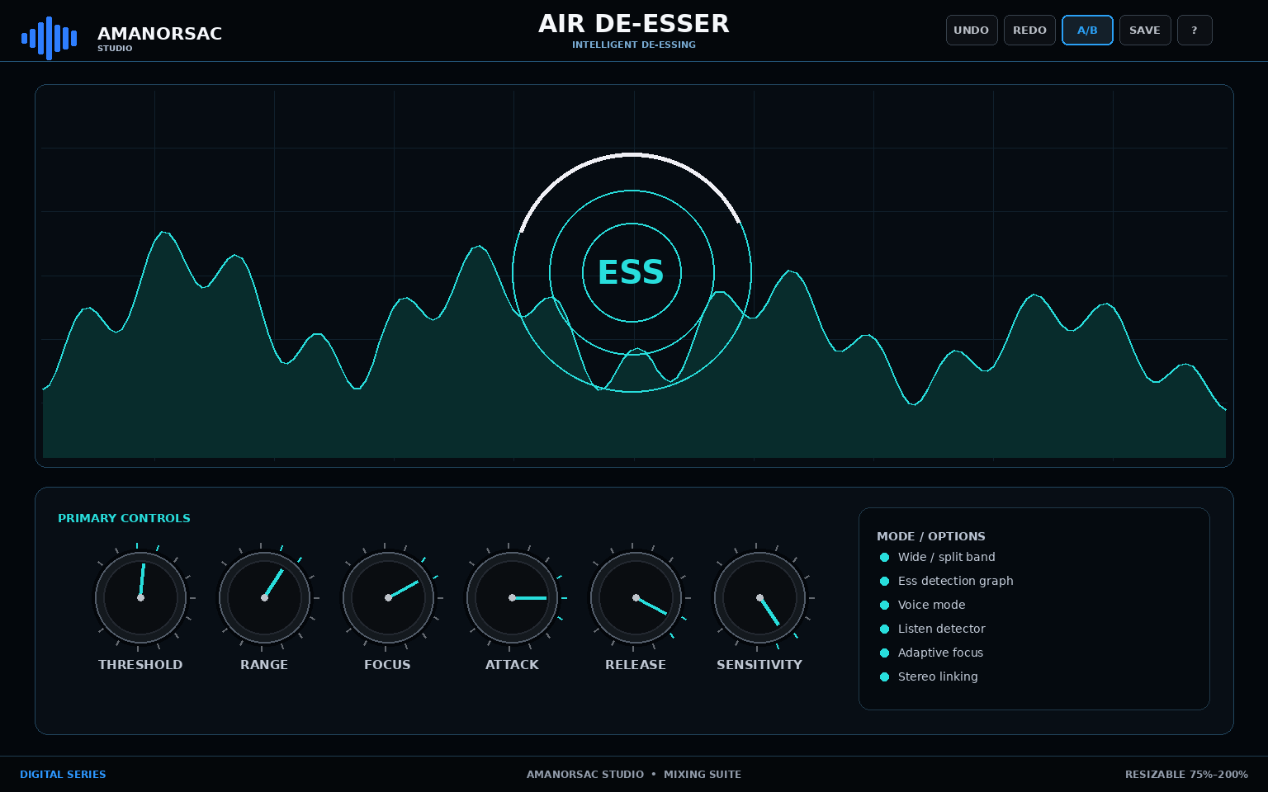
Engineering UI reference — AIR DE-ESSER. Geometry is authoritative; final rendering should reach the approved Amanorsac Studio material/lighting quality.
Item | Specification
Series | Digital
Reference canvas | 1536 × 960
Primary role | Intelligent De-Essing
Feature set | Wide / split band; Ess detection graph; Voice mode; Listen detector; Adaptive focus; Stereo linking
Parameter count / schema entries | 11

Signal flow / processing intent
Input → sibilance detector → wide/split/smart reduction path → stereo link stage → output. Detector listen is monitoring-only.

UI geometry
Item | Specification
topbar | x=0, y=0, x2=1536, y2=74
visualizer | x=42, y=102, x2=1494, y2=566
control_dock | x=42, y=590, x2=1494, y2=890
footer | x=0, y=916, x2=1536, y2=960

Digital interaction requirements
- All graph objects are directly draggable and keyboard focusable.
- Mouse wheel over nodes/knobs adjusts context parameter; PRISM/FLUX wheel-over-band = Q.
- Right-click contextual menu is implemented exactly as Section 8 and duplicated through inspector controls.
- Solo/Delta are monitoring operations and do not write accidental automation.

Parameter contract
ID / Label | Type | Range / Values | Default | Automation
threshold  Threshold | float | -60 to 0 dB | -24 dB | Yes
range  Reduction Range | float | 0 to 24 dB | 8 dB | Yes
focus  Focus Frequency | float | 1500 to 16000 Hz | 6500 Hz | Yes
bandwidth  Bandwidth | float | 0.2 to 4 oct | 1.2 oct | Yes
attack  Attack | float | 0.1 to 50 ms | 2 ms | Yes
release  Release | float | 10 to 1000 ms | 120 ms | Yes
sensitivity  Sensitivity | float | -12 to 12 dB | 0 dB | Yes
mode  Mode | enum | wide / split / smart | split | Yes
voice_profile  Voice Profile | enum | neutral / bright / dark | neutral | Yes
listen  Detector Listen | bool | Off / On | False | No
stereo_link  Stereo Link | float | 0 to 100 % | 100 % | Yes

22. D06 — RESONANCE CTRL
Spectral Resonance Controller
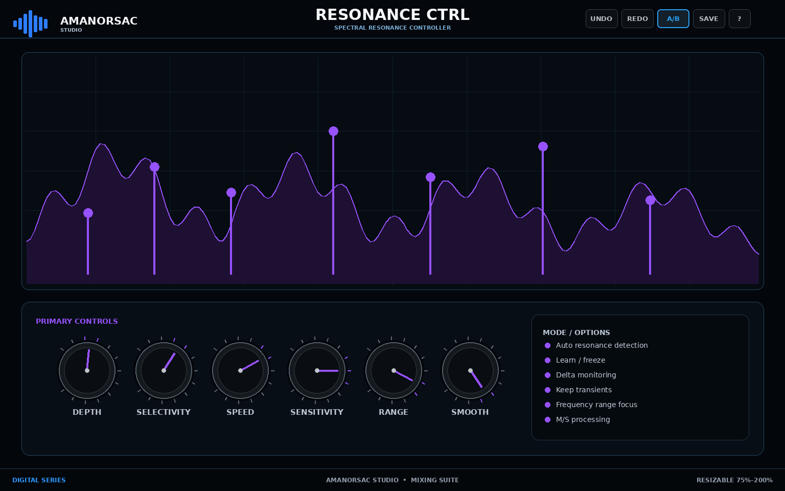
Engineering UI reference — RESONANCE CTRL. Geometry is authoritative; final rendering should reach the approved Amanorsac Studio material/lighting quality.
Item | Specification
Series | Digital
Reference canvas | 1536 × 960
Primary role | Spectral Resonance Controller
Feature set | Auto resonance detection; Learn / freeze; Delta monitoring; Keep transients; Frequency range focus; M/S processing
Parameter count / schema entries | 12

Signal flow / processing intent
Input → spectral analysis → resonance target estimator → dynamic attenuation filters → transient keep → output. Learn/freeze controls target profile only.

UI geometry
Item | Specification
topbar | x=0, y=0, x2=1536, y2=74
visualizer | x=42, y=102, x2=1494, y2=566
control_dock | x=42, y=590, x2=1494, y2=890
footer | x=0, y=916, x2=1536, y2=960

Digital interaction requirements
- All graph objects are directly draggable and keyboard focusable.
- Mouse wheel over nodes/knobs adjusts context parameter; PRISM/FLUX wheel-over-band = Q.
- Right-click contextual menu is implemented exactly as Section 8 and duplicated through inspector controls.
- Solo/Delta are monitoring operations and do not write accidental automation.

Parameter contract
ID / Label | Type | Range / Values | Default | Automation
depth  Depth | float | 0 to 100 % | 35 % | Yes
selectivity  Selectivity | float | 0 to 100 % | 60 % | Yes
speed  Speed | float | 0 to 100 % | 50 % | Yes
sensitivity  Sensitivity | float | 0 to 100 % | 50 % | Yes
smooth  Smooth | float | 0 to 100 % | 35 % | Yes
low_freq  Low Range | float | 20 to 10000 Hz | 80 Hz | Yes
high_freq  High Range | float | 200 to 40000 Hz | 18000 Hz | Yes
learn  Learn | bool | Off / On | False | No
freeze  Freeze Profile | bool | Off / On | False | Yes
delta  Delta | bool | Off / On | False | No
transient_keep  Keep Transients | float | 0 to 100 % | 65 % | Yes
stereo_mode  Stereo Mode | enum | stereo / mid / side / left / right | stereo | Yes

23. D07 — FREQ SHAPER
Harmonic Spectral Shaper
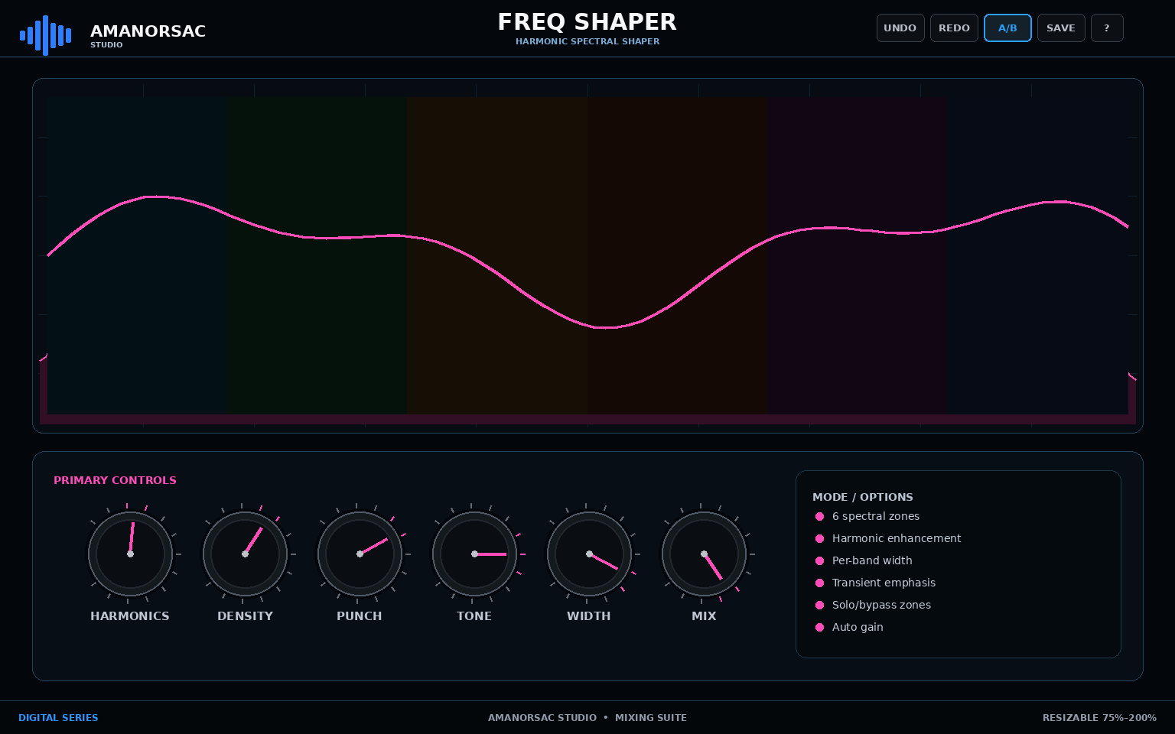
Engineering UI reference — FREQ SHAPER. Geometry is authoritative; final rendering should reach the approved Amanorsac Studio material/lighting quality.
Item | Specification
Series | Digital
Reference canvas | 1536 × 960
Primary role | Harmonic Spectral Shaper
Feature set | 6 spectral zones; Harmonic enhancement; Per-band width; Transient emphasis; Solo/bypass zones; Auto gain
Parameter count / schema entries | 10

Signal flow / processing intent
Input → 6-zone crossover/spectral split → harmonic enhancement + density + transient shaping + width per zone → recombine → direct/wet mix → auto gain.

UI geometry
Item | Specification
topbar | x=0, y=0, x2=1536, y2=74
visualizer | x=42, y=102, x2=1494, y2=566
control_dock | x=42, y=590, x2=1494, y2=890
footer | x=0, y=916, x2=1536, y2=960

Digital interaction requirements
- All graph objects are directly draggable and keyboard focusable.
- Mouse wheel over nodes/knobs adjusts context parameter; PRISM/FLUX wheel-over-band = Q.
- Right-click contextual menu is implemented exactly as Section 8 and duplicated through inspector controls.
- Solo/Delta are monitoring operations and do not write accidental automation.

Parameter contract
ID / Label | Type | Range / Values | Default | Automation
direct  Direct | float | -60 to 0 dB | 0 dB | Yes
global_mix  Mix | float | 0 to 100 % | 50 % | Yes
punch  Punch | float | -100 to 100 % | 0 % | Yes
zone.harmonics  Harmonics | float | 0 to 48 dB | 0 dB | Yes
zone.density  Density | float | 0 to 100 % | 50 % | Yes
zone.width  Width | float | 0 to 200 % | 100 % | Yes
zone.enabled  Enabled | bool | Off / On | True | Yes
zone.solo  Solo | bool | Off / On | False | No
xover.frequency  Crossover | float | 20 to 20000 Hz | 1000 Hz | Yes
auto_gain  Auto Gain | bool | Off / On | True | Yes

24. D08 — ORBIT DELAY
Multi-Tap Creative Delay
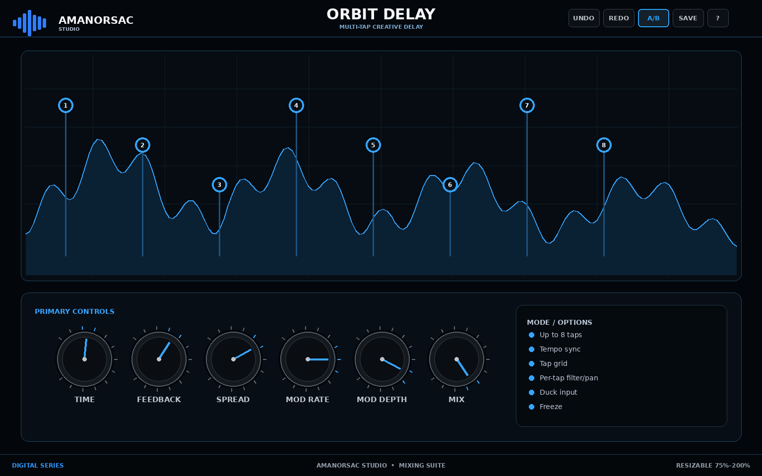
Engineering UI reference — ORBIT DELAY. Geometry is authoritative; final rendering should reach the approved Amanorsac Studio material/lighting quality.
Item | Specification
Series | Digital
Reference canvas | 1536 × 960
Primary role | Multi-Tap Creative Delay
Feature set | Up to 8 taps; Tempo sync; Tap grid; Per-tap filter/pan; Duck input; Freeze
Parameter count / schema entries | 13

Signal flow / processing intent
Input → tap generator (max 8) → per-tap time/level/pan/filter → modulation → feedback loop → ducking/mix → output.

UI geometry
Item | Specification
topbar | x=0, y=0, x2=1536, y2=74
visualizer | x=42, y=102, x2=1494, y2=566
control_dock | x=42, y=590, x2=1494, y2=890
footer | x=0, y=916, x2=1536, y2=960

Digital interaction requirements
- All graph objects are directly draggable and keyboard focusable.
- Mouse wheel over nodes/knobs adjusts context parameter; PRISM/FLUX wheel-over-band = Q.
- Right-click contextual menu is implemented exactly as Section 8 and duplicated through inspector controls.
- Solo/Delta are monitoring operations and do not write accidental automation.

Parameter contract
ID / Label | Type | Range / Values | Default | Automation
tempo_sync  Tempo Sync | bool | Off / On | True | Yes
time  Time | float | 1 to 6000 ms | 375 ms | Yes
feedback  Feedback | float | 0 to 98 % | 35 % | Yes
mix  Mix | float | 0 to 100 % | 25 % | Yes
duck  Ducking | float | 0 to 100 % | 25 % | Yes
mod_rate  Mod Rate | float | 0.01 to 20 Hz | 0.35 Hz | Yes
mod_depth  Mod Depth | float | 0 to 50 ms | 3 ms | Yes
tap.enabled  Tap Enabled | bool | Off / On | True | Yes
tap.time  Tap Time | float | 0 to 6000 ms | 250 ms | Yes
tap.level  Tap Level | float | -60 to 6 dB | -6 dB | Yes
tap.pan  Tap Pan | float | -100 to 100 % | 0 % | Yes
tap.filter  Tap Filter | float | 20 to 20000 Hz | 8000 Hz | Yes
freeze  Freeze | bool | Off / On | False | Yes

25. D09 — SPACEVERB PRO
Algorithmic Reverb
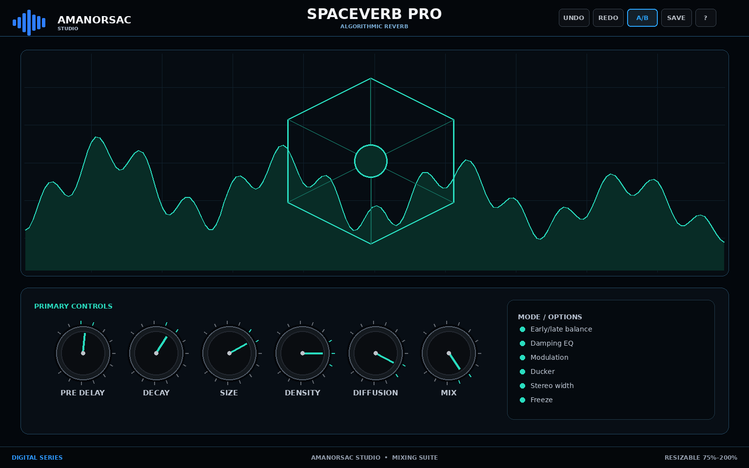
Engineering UI reference — SPACEVERB PRO. Geometry is authoritative; final rendering should reach the approved Amanorsac Studio material/lighting quality.
Item | Specification
Series | Digital
Reference canvas | 1536 × 960
Primary role | Algorithmic Reverb
Feature set | Early/late balance; Damping EQ; Modulation; Ducker; Stereo width; Freeze
Parameter count / schema entries | 14

Signal flow / processing intent
Input → pre-delay → early reflections → late algorithmic network → damping/modulation → ducking → stereo width → mix/output.

UI geometry
Item | Specification
topbar | x=0, y=0, x2=1536, y2=74
visualizer | x=42, y=102, x2=1494, y2=566
control_dock | x=42, y=590, x2=1494, y2=890
footer | x=0, y=916, x2=1536, y2=960

Digital interaction requirements
- All graph objects are directly draggable and keyboard focusable.
- Mouse wheel over nodes/knobs adjusts context parameter; PRISM/FLUX wheel-over-band = Q.
- Right-click contextual menu is implemented exactly as Section 8 and duplicated through inspector controls.
- Solo/Delta are monitoring operations and do not write accidental automation.

Parameter contract
ID / Label | Type | Range / Values | Default | Automation
pre_delay  Pre Delay | float | 0 to 500 ms | 25 ms | Yes
decay  Decay | float | 0.1 to 40 s | 2.4 s | Yes
size  Size | float | 0 to 100 % | 70 % | Yes
density  Density | float | 0 to 100 % | 65 % | Yes
diffusion  Diffusion | float | 0 to 100 % | 60 % | Yes
early_late  Early/Late | float | -100 to 100 % | 0 % | Yes
low_damp  Low Damp | float | 0.1 to 2 | 0.8 | Yes
high_damp  High Damp | float | 0.1 to 2 | 0.6 | Yes
mod_rate  Mod Rate | float | 0.01 to 5 Hz | 0.35 Hz | Yes
mod_depth  Mod Depth | float | 0 to 100 % | 20 % | Yes
duck  Ducker | float | 0 to 100 % | 20 % | Yes
width  Width | float | 0 to 200 % | 120 % | Yes
mix  Mix | float | 0 to 100 % | 25 % | Yes
freeze  Freeze | bool | Off / On | False | Yes

26. D10 — WIDE IMAGER
Frequency-Dependent Stereo
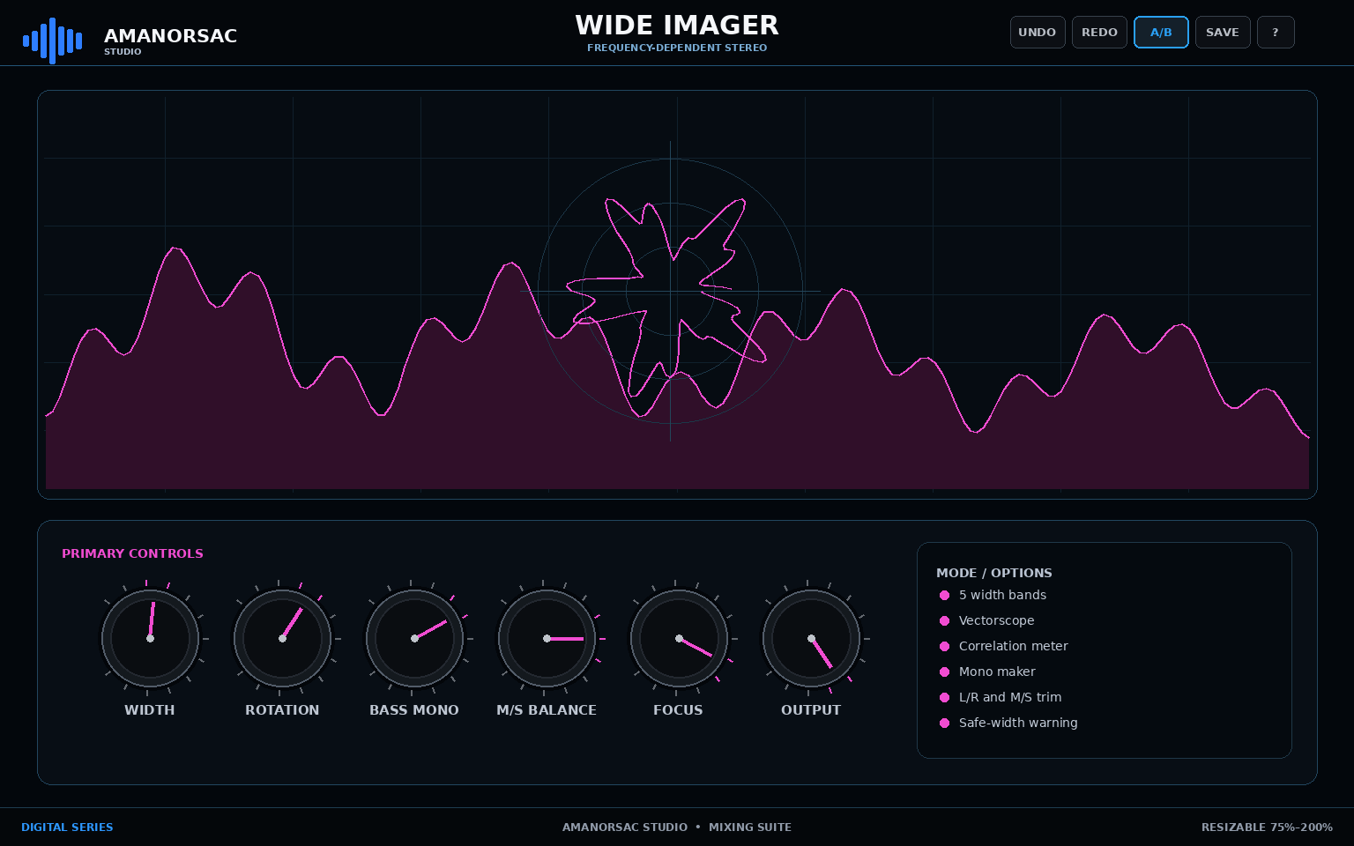
Engineering UI reference — WIDE IMAGER. Geometry is authoritative; final rendering should reach the approved Amanorsac Studio material/lighting quality.
Item | Specification
Series | Digital
Reference canvas | 1536 × 960
Primary role | Frequency-Dependent Stereo
Feature set | 5 width bands; Vectorscope; Correlation meter; Mono maker; L/R and M/S trim; Safe-width warning
Parameter count / schema entries | 11

Signal flow / processing intent
Input → M/S analysis → 5 frequency-dependent width bands → bass mono / rotation / M-S balance → safety correlation logic → output.

UI geometry
Item | Specification
topbar | x=0, y=0, x2=1536, y2=74
visualizer | x=42, y=102, x2=1494, y2=566
control_dock | x=42, y=590, x2=1494, y2=890
footer | x=0, y=916, x2=1536, y2=960

Digital interaction requirements
- All graph objects are directly draggable and keyboard focusable.
- Mouse wheel over nodes/knobs adjusts context parameter; PRISM/FLUX wheel-over-band = Q.
- Right-click contextual menu is implemented exactly as Section 8 and duplicated through inspector controls.
- Solo/Delta are monitoring operations and do not write accidental automation.

Parameter contract
ID / Label | Type | Range / Values | Default | Automation
global_width  Global Width | float | 0 to 250 % | 100 % | Yes
rotation  Rotation | float | -90 to 90 deg | 0 deg | Yes
bass_mono  Bass Mono | float | 20 to 500 Hz | 120 Hz | Yes
ms_balance  M/S Balance | float | -100 to 100 % | 0 % | Yes
focus  Focus | float | 0 to 100 % | 50 % | Yes
output_gain  Output | float | -24 to 24 dB | 0 dB | Yes
band.width  Band Width | float | 0 to 250 % | 100 % | Yes
xover.frequency  Crossover | float | 40 to 18000 Hz | 1000 Hz | Yes
safe_width  Safe Width | bool | Off / On | True | Yes
correlation_alarm  Correlation Alarm | float | -1 to 1 | 0 | Yes
mono_check  Mono Check | bool | Off / On | False | No

27. A01 — HERITAGE EQ
Class-A Musical Equalizer
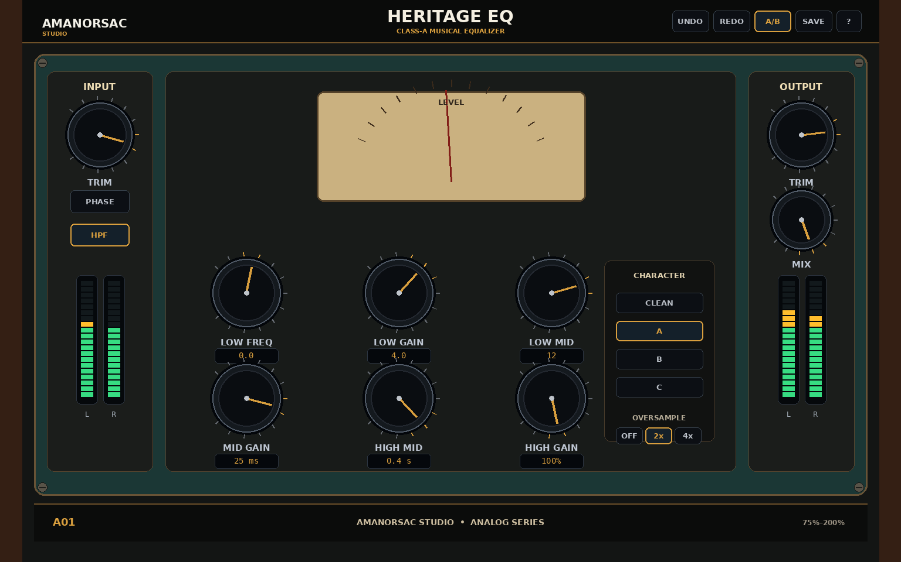
Engineering UI reference — HERITAGE EQ. Geometry is authoritative; final rendering should reach the approved Amanorsac Studio material/lighting quality.
Item | Specification
Series | Analog
Reference canvas | 1536 × 960
Primary role | Class-A Musical Equalizer
Feature set | 5 musical bands; HPF/LPF; Clean/Console/Tube/Tape color; Auto gain; L/R or M/S; 2x/4x oversampling
Parameter count / schema entries | 20

Signal flow / processing intent
Input trim → HPF/LPF → five musical EQ bands → selected Analog Character stage → Auto Gain → mix → output trim.

UI geometry
Item | Specification
topbar | x=38, y=0, x2=1498, y2=72
chassis | x=58, y=92, x2=1478, y2=846
input | x=80, y=122, x2=260, y2=805
main | x=282, y=122, x2=1254, y2=805
output | x=1276, y=122, x2=1456, y2=805
footer | x=58, y=860, x2=1478, y2=924

Analog interaction requirements
- Vertical knob drag by default; mouse wheel works when hovered.
- Shift = fine; double-click = reset; right-click = exact value/reset/copy/paste.
- Physical-looking controls must always expose exact values via tooltip/entry.
- No decorative control may be non-functional unless explicitly marked as visual-only in machine JSON.

Parameter contract
ID / Label | Type | Range / Values | Default | Automation
input_trim  Input Trim | float | -24 to 24 dB | 0 dB | Yes
hpf  HPF | float | 20 to 300 Hz | 20 Hz | Yes
lpf  LPF | float | 2000 to 40000 Hz | 40000 Hz | Yes
band.low.freq  Low Frequency | float | 30 to 220 Hz | 60 Hz | Yes
band.low.gain  Low Gain | float | -15 to 15 dB | 0 dB | Yes
band.low.q  Low Q | float | 0.3 to 3 | 0.7 | Yes
band.lowmid.freq  Low Mid Frequency | float | 80 to 700 Hz | 250 Hz | Yes
band.lowmid.gain  Low Mid Gain | float | -15 to 15 dB | 0 dB | Yes
band.mid.freq  Mid Frequency | float | 300 to 2500 Hz | 1000 Hz | Yes
band.mid.gain  Mid Gain | float | -15 to 15 dB | 0 dB | Yes
band.highmid.freq  High Mid Frequency | float | 1200 to 8000 Hz | 3500 Hz | Yes
band.highmid.gain  High Mid Gain | float | -15 to 15 dB | 0 dB | Yes
band.high.freq  High Frequency | float | 4000 to 16000 Hz | 12000 Hz | Yes
band.high.gain  High Gain | float | -15 to 15 dB | 0 dB | Yes
character  Analog Character | enum | clean / console / tube / tape | clean | Yes
drive  Drive | float | 0 to 10 | 0 | Yes
auto_gain  Auto Gain | bool | Off / On | True | Yes
stereo_mode  Stereo Mode | enum | lr / ms | lr | Yes
mix  Mix | float | 0 to 100 % | 100 % | Yes
output_trim  Output Trim | float | -24 to 24 dB | 0 dB | Yes

28. A02 — IRON PRE
Transformer Preamp
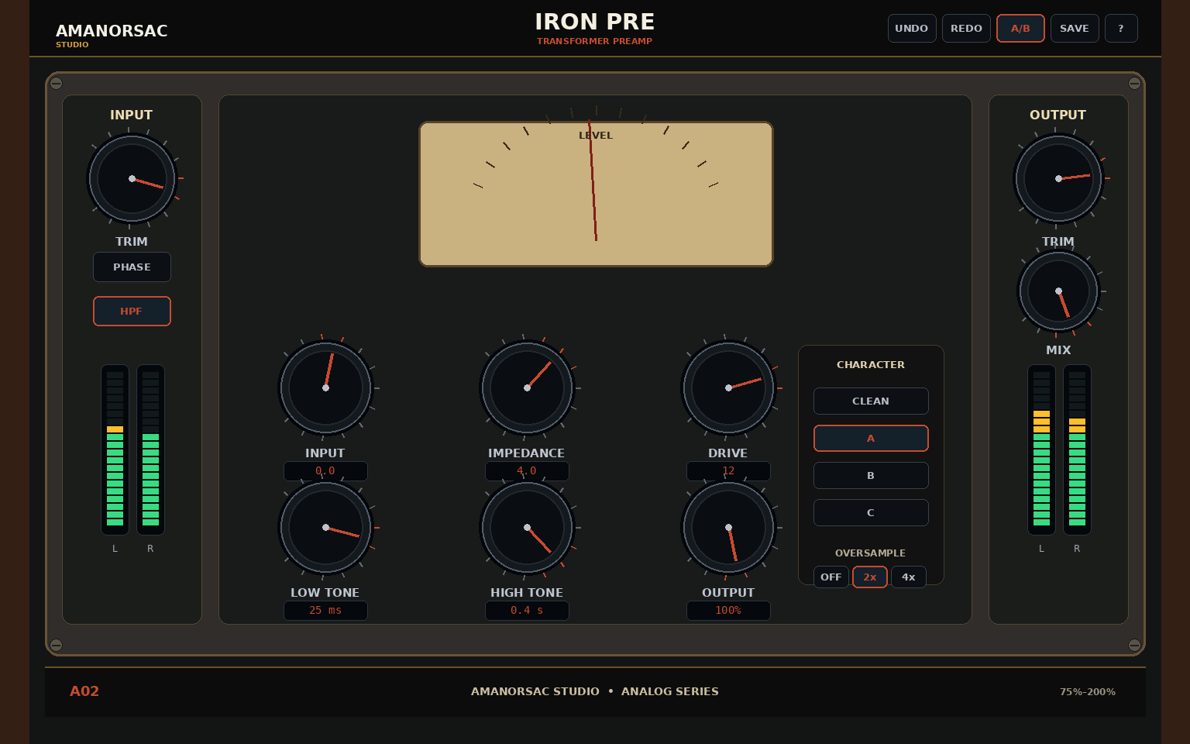
Engineering UI reference — IRON PRE. Geometry is authoritative; final rendering should reach the approved Amanorsac Studio material/lighting quality.
Item | Specification
Series | Analog
Reference canvas | 1536 × 960
Primary role | Transformer Preamp
Feature set | 3 transformer characters; Pad / phase; HPF; Saturation trim; Auto gain; Stereo link
Parameter count / schema entries | 11

Signal flow / processing intent
Input/pad/phase → impedance profile → transformer/nonlinear preamp → HPF → low/high tone → saturation → output.

UI geometry
Item | Specification
topbar | x=38, y=0, x2=1498, y2=72
chassis | x=58, y=92, x2=1478, y2=846
input | x=80, y=122, x2=260, y2=805
main | x=282, y=122, x2=1254, y2=805
output | x=1276, y=122, x2=1456, y2=805
footer | x=58, y=860, x2=1478, y2=924

Analog interaction requirements
- Vertical knob drag by default; mouse wheel works when hovered.
- Shift = fine; double-click = reset; right-click = exact value/reset/copy/paste.
- Physical-looking controls must always expose exact values via tooltip/entry.
- No decorative control may be non-functional unless explicitly marked as visual-only in machine JSON.

Parameter contract
ID / Label | Type | Range / Values | Default | Automation
input  Input | float | -24 to 24 dB | 0 dB | Yes
impedance  Impedance | enum | low / medium / high | medium | Yes
drive  Drive | float | 0 to 100 % | 25 % | Yes
transformer  Transformer | enum | iron_a / iron_b / iron_c | iron_a | Yes
pad  Pad | bool | Off / On | False | Yes
phase  Phase | bool | Off / On | False | Yes
hpf  HPF | float | 20 to 320 Hz | 50 Hz | Yes
low_tone  Low Tone | float | -6 to 6 dB | 0 dB | Yes
high_tone  High Tone | float | -6 to 6 dB | 0 dB | Yes
saturation  Saturation | float | 0 to 100 % | 20 % | Yes
output  Output | float | -24 to 24 dB | 0 dB | Yes

29. A03 — CONSOLE ONE
Console Channel Color
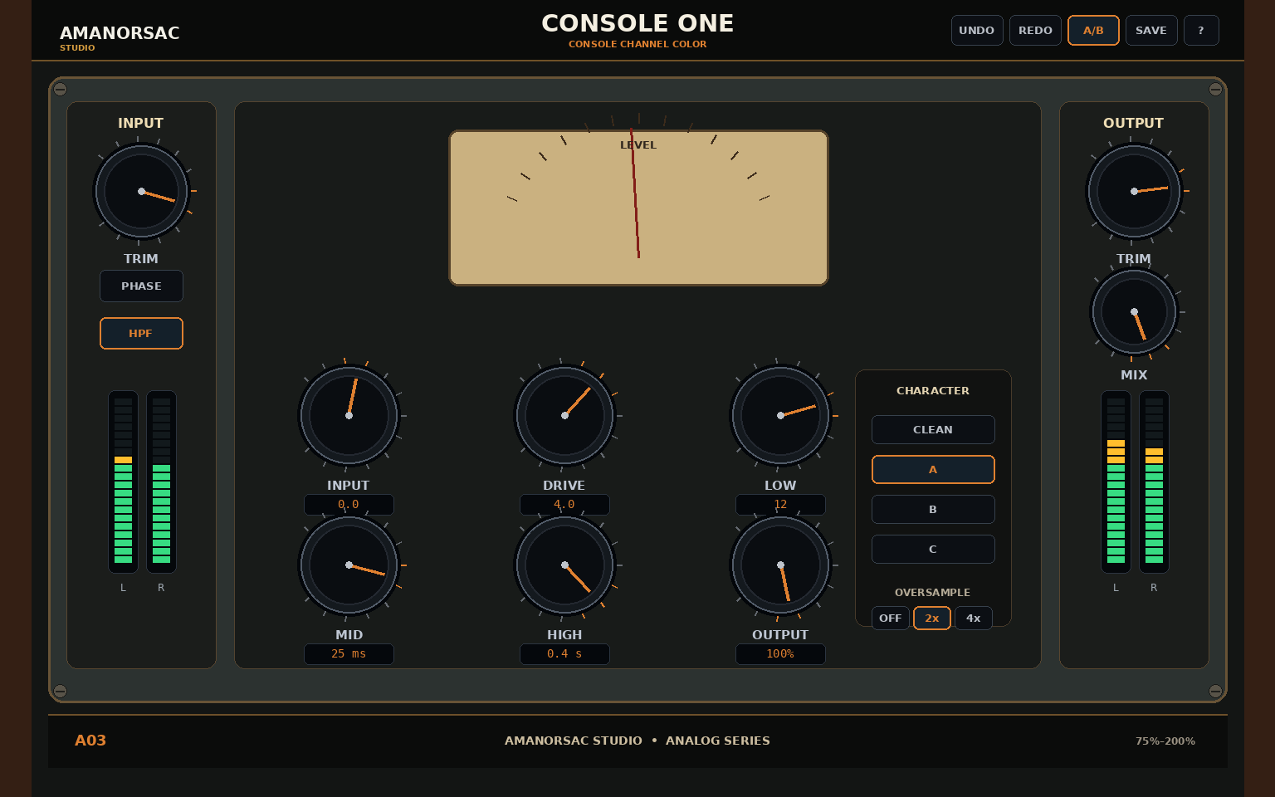
Engineering UI reference — CONSOLE ONE. Geometry is authoritative; final rendering should reach the approved Amanorsac Studio material/lighting quality.
Item | Specification
Series | Analog
Reference canvas | 1536 × 960
Primary role | Console Channel Color
Feature set | Preamp + 3-band EQ; HPF; Console bus color; Noise optional; Stereo/dual/MS; Mix control
Parameter count / schema entries | 12

Signal flow / processing intent
Input → preamp drive → HPF → 3-band channel EQ → console bus color → optional noise → mix/output.

UI geometry
Item | Specification
topbar | x=38, y=0, x2=1498, y2=72
chassis | x=58, y=92, x2=1478, y2=846
input | x=80, y=122, x2=260, y2=805
main | x=282, y=122, x2=1254, y2=805
output | x=1276, y=122, x2=1456, y2=805
footer | x=58, y=860, x2=1478, y2=924

Analog interaction requirements
- Vertical knob drag by default; mouse wheel works when hovered.
- Shift = fine; double-click = reset; right-click = exact value/reset/copy/paste.
- Physical-looking controls must always expose exact values via tooltip/entry.
- No decorative control may be non-functional unless explicitly marked as visual-only in machine JSON.

Parameter contract
ID / Label | Type | Range / Values | Default | Automation
input  Input | float | -24 to 24 dB | 0 dB | Yes
drive  Drive | float | 0 to 100 % | 20 % | Yes
hpf  HPF | float | 20 to 300 Hz | 40 Hz | Yes
low  Low | float | -12 to 12 dB | 0 dB | Yes
mid_freq  Mid Frequency | float | 100 to 8000 Hz | 1200 Hz | Yes
mid  Mid | float | -12 to 12 dB | 0 dB | Yes
high  High | float | -12 to 12 dB | 0 dB | Yes
bus_color  Bus Color | float | 0 to 100 % | 20 % | Yes
noise  Noise | bool | Off / On | False | Yes
stereo_mode  Stereo Mode | enum | stereo / dual / ms | stereo | Yes
mix  Mix | float | 0 to 100 % | 100 % | Yes
output  Output | float | -24 to 24 dB | 0 dB | Yes

30. A04 — REELSAT
Tape Machine
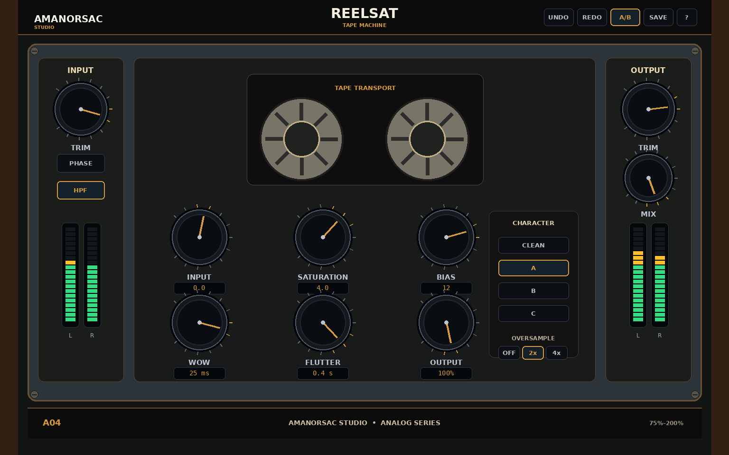
Engineering UI reference — REELSAT. Geometry is authoritative; final rendering should reach the approved Amanorsac Studio material/lighting quality.
Item | Specification
Series | Analog
Reference canvas | 1536 × 960
Primary role | Tape Machine
Feature set | 3 tape formulas; 7.5/15/30 ips; Head bump; HF rolloff; Hiss optional; Linked I/O
Parameter count / schema entries | 12

Signal flow / processing intent
Input → tape formula/speed/bias core → saturation/head bump/HF rolloff → wow/flutter → optional hiss → mix/output.

UI geometry
Item | Specification
topbar | x=38, y=0, x2=1498, y2=72
chassis | x=58, y=92, x2=1478, y2=846
input | x=80, y=122, x2=260, y2=805
main | x=282, y=122, x2=1254, y2=805
output | x=1276, y=122, x2=1456, y2=805
footer | x=58, y=860, x2=1478, y2=924

Analog interaction requirements
- Vertical knob drag by default; mouse wheel works when hovered.
- Shift = fine; double-click = reset; right-click = exact value/reset/copy/paste.
- Physical-looking controls must always expose exact values via tooltip/entry.
- No decorative control may be non-functional unless explicitly marked as visual-only in machine JSON.

Parameter contract
ID / Label | Type | Range / Values | Default | Automation
input  Input | float | -18 to 18 dB | 0 dB | Yes
formula  Formula | enum | vintage / classic / modern | modern | Yes
speed  Speed | enum | 7.5 / 15 / 30 | 15 | Yes
bias  Bias | float | -3 to 6 dB | 0 dB | Yes
saturation  Saturation | float | 0 to 100 % | 30 % | Yes
wow  Wow | float | 0 to 100 % | 5 % | Yes
flutter  Flutter | float | 0 to 100 % | 4 % | Yes
head_bump  Head Bump | float | 0 to 100 % | 25 % | Yes
hf_rolloff  HF Rolloff | float | 0 to 100 % | 15 % | Yes
hiss  Hiss | float | 0 to 100 % | 0 % | Yes
mix  Mix | float | 0 to 100 % | 100 % | Yes
output  Output | float | -18 to 18 dB | 0 dB | Yes

31. A05 — VALVE DRIVE
Tube Harmonic Saturator
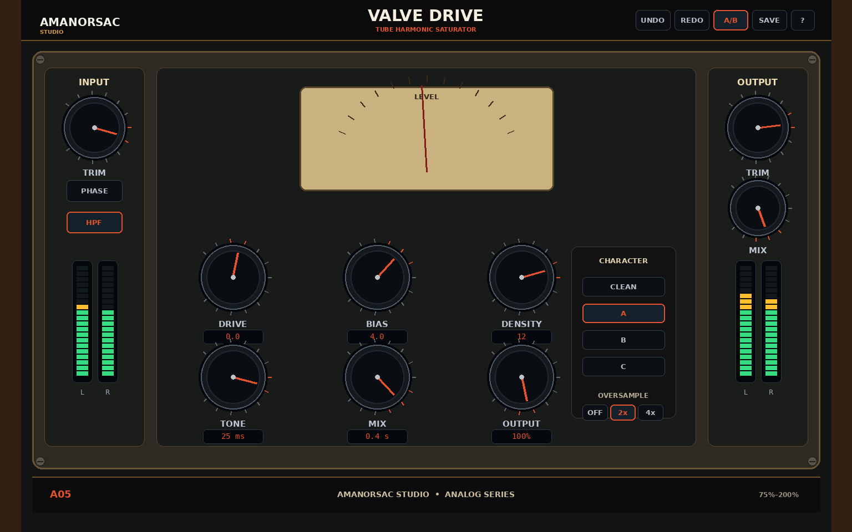
Engineering UI reference — VALVE DRIVE. Geometry is authoritative; final rendering should reach the approved Amanorsac Studio material/lighting quality.
Item | Specification
Series | Analog
Reference canvas | 1536 × 960
Primary role | Tube Harmonic Saturator
Feature set | 3 valve topologies; Even/odd balance; Pre/post tone; Auto gain; Soft clip; Stereo/MS
Parameter count / schema entries | 11

Signal flow / processing intent
Input → selected valve topology → bias/harmonic balance/density → tone/emphasis → soft clip → mix/output.

UI geometry
Item | Specification
topbar | x=38, y=0, x2=1498, y2=72
chassis | x=58, y=92, x2=1478, y2=846
input | x=80, y=122, x2=260, y2=805
main | x=282, y=122, x2=1254, y2=805
output | x=1276, y=122, x2=1456, y2=805
footer | x=58, y=860, x2=1478, y2=924

Analog interaction requirements
- Vertical knob drag by default; mouse wheel works when hovered.
- Shift = fine; double-click = reset; right-click = exact value/reset/copy/paste.
- Physical-looking controls must always expose exact values via tooltip/entry.
- No decorative control may be non-functional unless explicitly marked as visual-only in machine JSON.

Parameter contract
ID / Label | Type | Range / Values | Default | Automation
drive  Drive | float | 0 to 36 dB | 6 dB | Yes
topology  Topology | enum | triode / pentode / cascade | triode | Yes
bias  Bias | float | -100 to 100 % | 0 % | Yes
density  Density | float | 0 to 100 % | 50 % | Yes
harmonic_balance  Harmonic Balance | float | -100 to 100 % | 25 % | Yes
tone  Tone | float | -100 to 100 % | 0 % | Yes
pre_emphasis  Pre Emphasis | float | 0 to 100 % | 0 % | Yes
post_emphasis  Post Emphasis | float | 0 to 100 % | 0 % | Yes
soft_clip  Soft Clip | bool | Off / On | True | Yes
mix  Mix | float | 0 to 100 % | 100 % | Yes
output  Output | float | -24 to 24 dB | 0 dB | Yes

32. A06 — STRIKE FET
FET Compressor
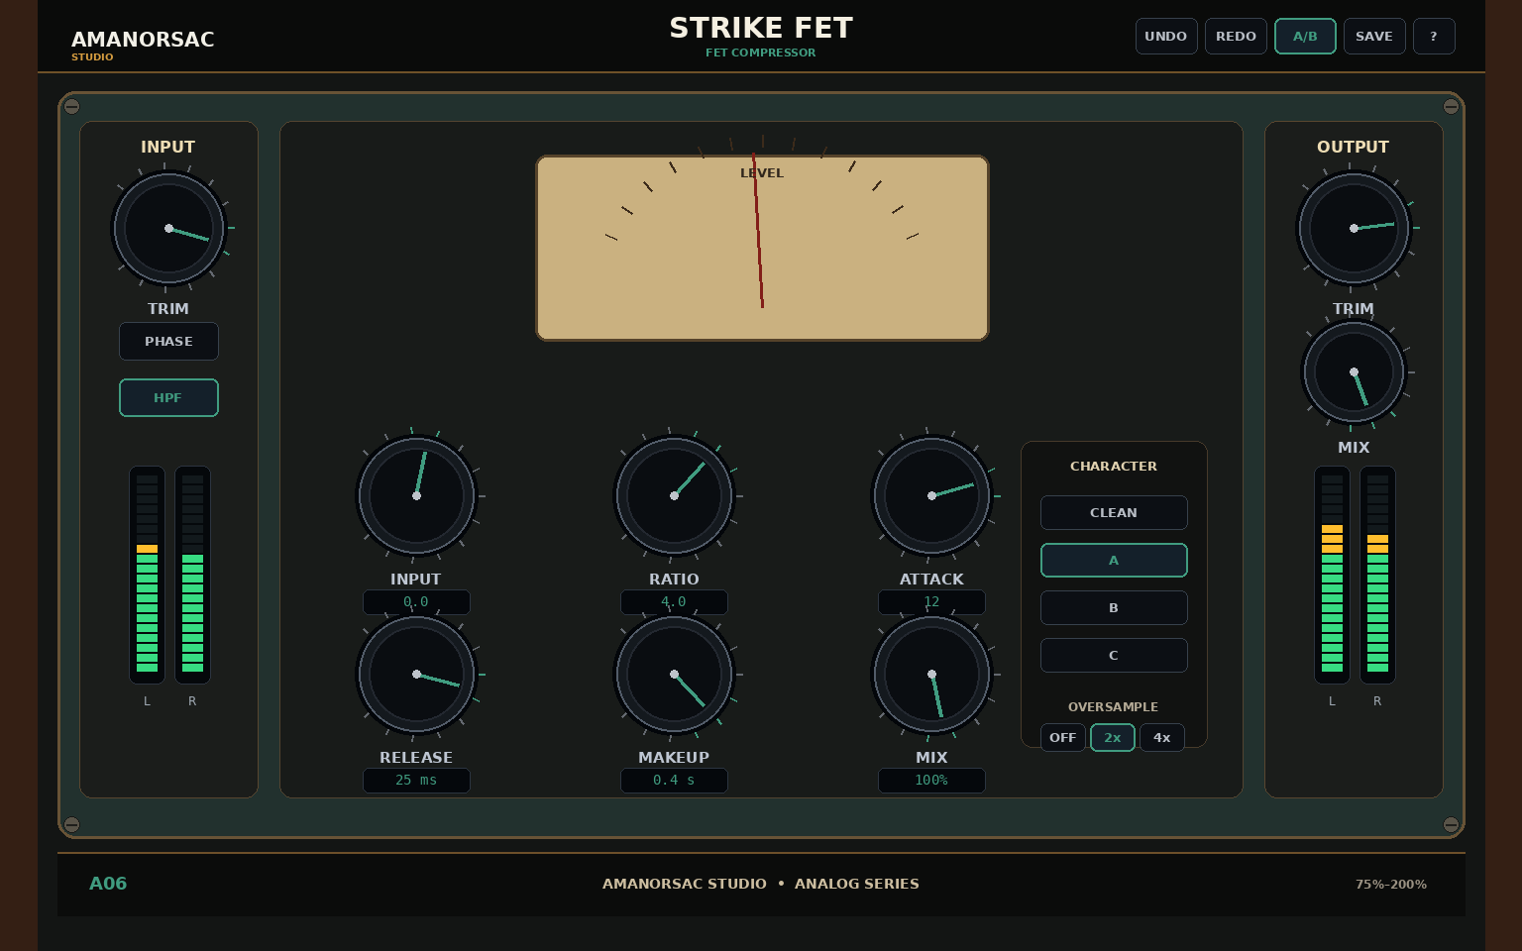
Engineering UI reference — STRIKE FET. Geometry is authoritative; final rendering should reach the approved Amanorsac Studio material/lighting quality.
Item | Specification
Series | Analog
Reference canvas | 1536 × 960
Primary role | FET Compressor
Feature set | Fast FET behavior; All-buttons creative mode; SC HPF; External sidechain; Saturation; GR VU
Parameter count / schema entries | 10

Signal flow / processing intent
Input → FET detector/compressor → makeup + saturation → parallel mix → output. Sidechain HPF/external SC affects detector only.

UI geometry
Item | Specification
topbar | x=38, y=0, x2=1498, y2=72
chassis | x=58, y=92, x2=1478, y2=846
input | x=80, y=122, x2=260, y2=805
main | x=282, y=122, x2=1254, y2=805
output | x=1276, y=122, x2=1456, y2=805
footer | x=58, y=860, x2=1478, y2=924

Analog interaction requirements
- Vertical knob drag by default; mouse wheel works when hovered.
- Shift = fine; double-click = reset; right-click = exact value/reset/copy/paste.
- Physical-looking controls must always expose exact values via tooltip/entry.
- No decorative control may be non-functional unless explicitly marked as visual-only in machine JSON.

Parameter contract
ID / Label | Type | Range / Values | Default | Automation
input  Input | float | -24 to 24 dB | 0 dB | Yes
ratio  Ratio | enum | 2:1 / 4:1 / 8:1 / 12:1 / 20:1 / all | 4:1 | Yes
attack  Attack | float | 0.02 to 20 ms | 1 ms | Yes
release  Release | float | 20 to 1500 ms | 200 ms | Yes
makeup  Makeup | float | -12 to 24 dB | 0 dB | Yes
sc_hpf  SC HPF | float | 20 to 500 Hz | 80 Hz | Yes
external_sc  External SC | bool | Off / On | False | Yes
saturation  Saturation | float | 0 to 100 % | 15 % | Yes
mix  Mix | float | 0 to 100 % | 100 % | Yes
output  Output | float | -24 to 24 dB | 0 dB | Yes

33. A07 — LUMEN OPTO
Optical Leveler
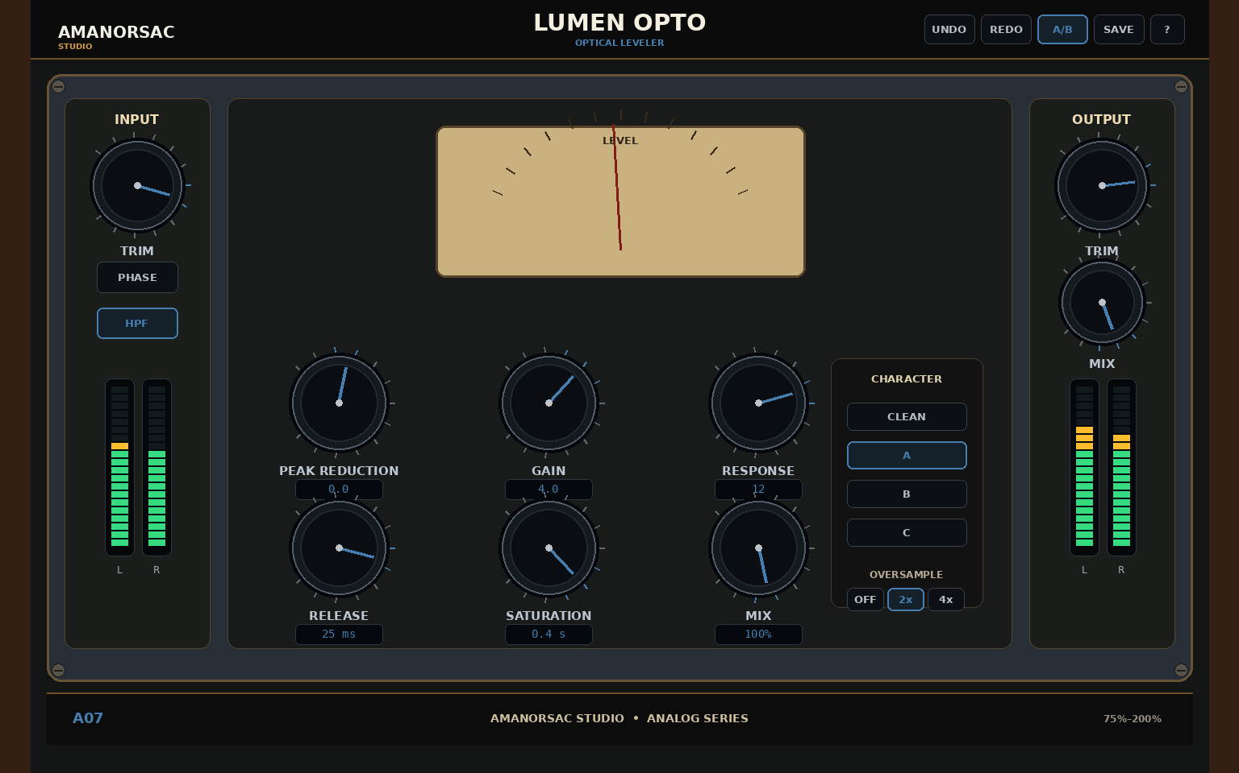
Engineering UI reference — LUMEN OPTO. Geometry is authoritative; final rendering should reach the approved Amanorsac Studio material/lighting quality.
Item | Specification
Series | Analog
Reference canvas | 1536 × 960
Primary role | Optical Leveler
Feature set | Smooth optical detector; Fast/slow response; SC HPF; Stereo link; Tube output color; GR VU
Parameter count / schema entries | 9

Signal flow / processing intent
Input → optical detector/leveling cell → recovery behavior → tube output color → parallel mix → output.

UI geometry
Item | Specification
topbar | x=38, y=0, x2=1498, y2=72
chassis | x=58, y=92, x2=1478, y2=846
input | x=80, y=122, x2=260, y2=805
main | x=282, y=122, x2=1254, y2=805
output | x=1276, y=122, x2=1456, y2=805
footer | x=58, y=860, x2=1478, y2=924

Analog interaction requirements
- Vertical knob drag by default; mouse wheel works when hovered.
- Shift = fine; double-click = reset; right-click = exact value/reset/copy/paste.
- Physical-looking controls must always expose exact values via tooltip/entry.
- No decorative control may be non-functional unless explicitly marked as visual-only in machine JSON.

Parameter contract
ID / Label | Type | Range / Values | Default | Automation
peak_reduction  Peak Reduction | float | 0 to 100 % | 35 % | Yes
gain  Gain | float | -12 to 24 dB | 0 dB | Yes
response  Response | enum | fast / slow | slow | Yes
release  Release | float | 0.05 to 5 s | 0.6 s | Yes
sc_hpf  SC HPF | float | 20 to 500 Hz | 80 Hz | Yes
saturation  Tube Color | float | 0 to 100 % | 15 % | Yes
stereo_link  Stereo Link | float | 0 to 100 % | 100 % | Yes
mix  Mix | float | 0 to 100 % | 100 % | Yes
output  Output | float | -24 to 24 dB | 0 dB | Yes

34. A08 — BUSFORGE VCA
VCA Bus Compressor
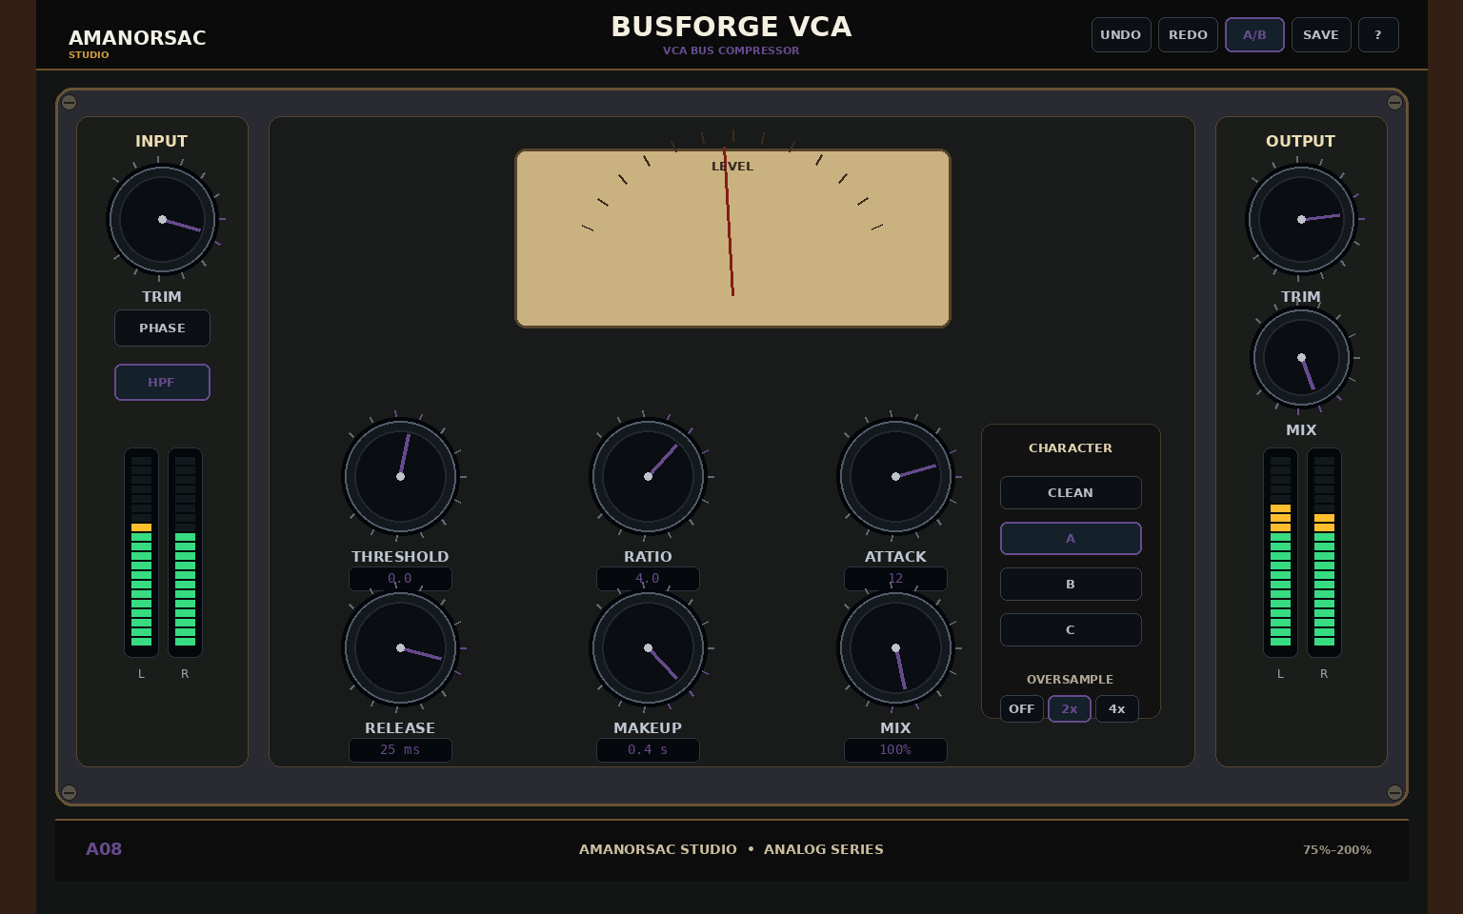
Engineering UI reference — BUSFORGE VCA. Geometry is authoritative; final rendering should reach the approved Amanorsac Studio material/lighting quality.
Item | Specification
Series | Analog
Reference canvas | 1536 × 960
Primary role | VCA Bus Compressor
Feature set | Bus glue behavior; Auto release; SC HPF; Stereo link; Soft/hard knee; GR meter
Parameter count / schema entries | 10

Signal flow / processing intent
Input → VCA detector/compressor → makeup → parallel mix. Auto release and SC HPF are detector behaviors.

UI geometry
Item | Specification
topbar | x=38, y=0, x2=1498, y2=72
chassis | x=58, y=92, x2=1478, y2=846
input | x=80, y=122, x2=260, y2=805
main | x=282, y=122, x2=1254, y2=805
output | x=1276, y=122, x2=1456, y2=805
footer | x=58, y=860, x2=1478, y2=924

Analog interaction requirements
- Vertical knob drag by default; mouse wheel works when hovered.
- Shift = fine; double-click = reset; right-click = exact value/reset/copy/paste.
- Physical-looking controls must always expose exact values via tooltip/entry.
- No decorative control may be non-functional unless explicitly marked as visual-only in machine JSON.

Parameter contract
ID / Label | Type | Range / Values | Default | Automation
threshold  Threshold | float | -60 to 0 dB | -18 dB | Yes
ratio  Ratio | enum | 1.5:1 / 2:1 / 4:1 / 10:1 | 4:1 | Yes
attack  Attack | float | 0.1 to 30 ms | 10 ms | Yes
release  Release | float | 0.05 to 1.2 s | 0.3 s | Yes
auto_release  Auto Release | bool | Off / On | False | Yes
makeup  Makeup | float | -12 to 24 dB | 0 dB | Yes
sc_hpf  SC HPF | float | 20 to 500 Hz | 90 Hz | Yes
knee  Knee | enum | hard / soft | soft | Yes
stereo_link  Stereo Link | float | 0 to 100 % | 100 % | Yes
mix  Mix | float | 0 to 100 % | 100 % | Yes

35. A09 — SILK PASSIVE EQ
Passive Program Equalizer
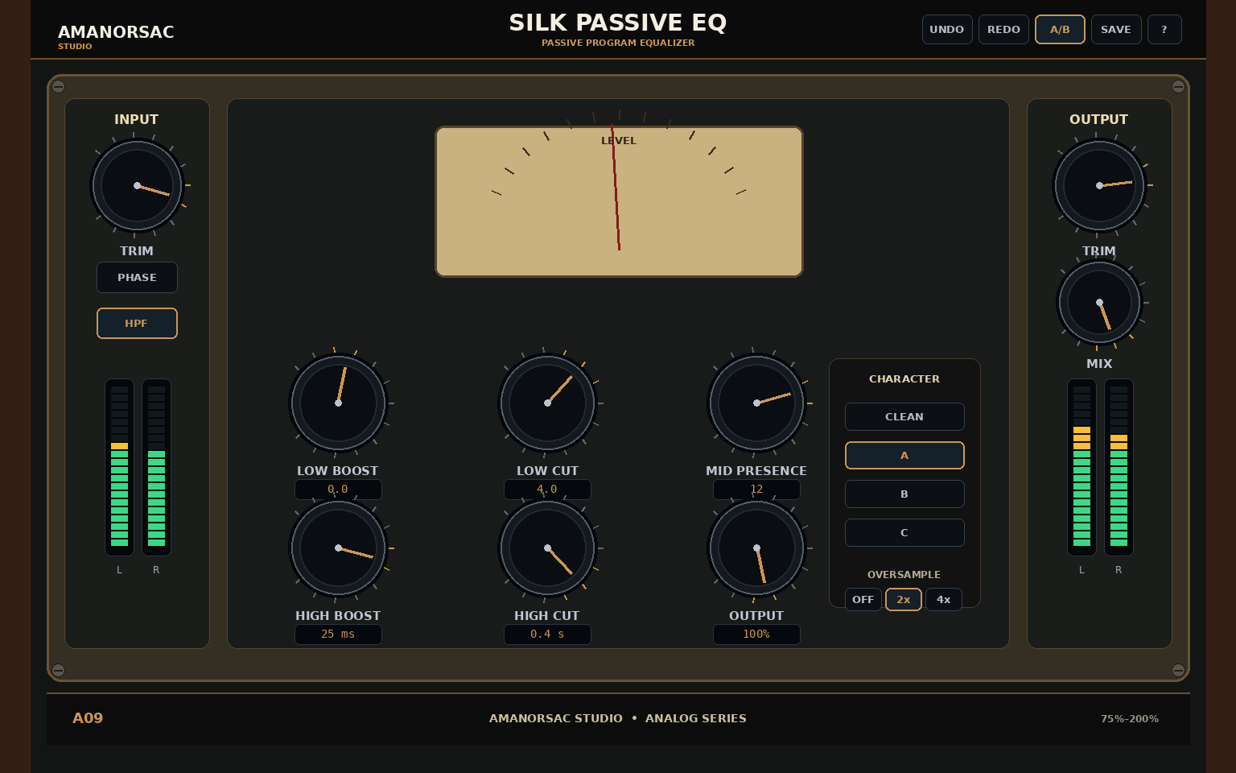
Engineering UI reference — SILK PASSIVE EQ. Geometry is authoritative; final rendering should reach the approved Amanorsac Studio material/lighting quality.
Item | Specification
Series | Analog
Reference canvas | 1536 × 960
Primary role | Passive Program Equalizer
Feature set | Broad passive curves; Selectable frequencies; Tube/solid output; Input drive; Stereo/MS; Auto gain
Parameter count / schema entries | 11

Signal flow / processing intent
Input drive → broad passive low/mid/high network → selected output stage → output trim.

UI geometry
Item | Specification
topbar | x=38, y=0, x2=1498, y2=72
chassis | x=58, y=92, x2=1478, y2=846
input | x=80, y=122, x2=260, y2=805
main | x=282, y=122, x2=1254, y2=805
output | x=1276, y=122, x2=1456, y2=805
footer | x=58, y=860, x2=1478, y2=924

Analog interaction requirements
- Vertical knob drag by default; mouse wheel works when hovered.
- Shift = fine; double-click = reset; right-click = exact value/reset/copy/paste.
- Physical-looking controls must always expose exact values via tooltip/entry.
- No decorative control may be non-functional unless explicitly marked as visual-only in machine JSON.

Parameter contract
ID / Label | Type | Range / Values | Default | Automation
low_freq  Low Frequency | float | 20 to 160 Hz | 60 Hz | Yes
low_boost  Low Boost | float | 0 to 12 dB | 0 dB | Yes
low_cut  Low Cut | float | 0 to 12 dB | 0 dB | Yes
mid_freq  Mid Presence Frequency | float | 200 to 5000 Hz | 1200 Hz | Yes
mid_gain  Mid Presence | float | -10 to 10 dB | 0 dB | Yes
high_freq  High Frequency | float | 3000 to 20000 Hz | 10000 Hz | Yes
high_boost  High Boost | float | 0 to 12 dB | 0 dB | Yes
high_cut  High Cut | float | 0 to 12 dB | 0 dB | Yes
output_stage  Output Stage | enum | tube / solid | tube | Yes
drive  Drive | float | 0 to 100 % | 10 % | Yes
output  Output | float | -18 to 18 dB | 0 dB | Yes

36. A10 — PLATE FOUR
Electro-Mechanical Plate Reverb
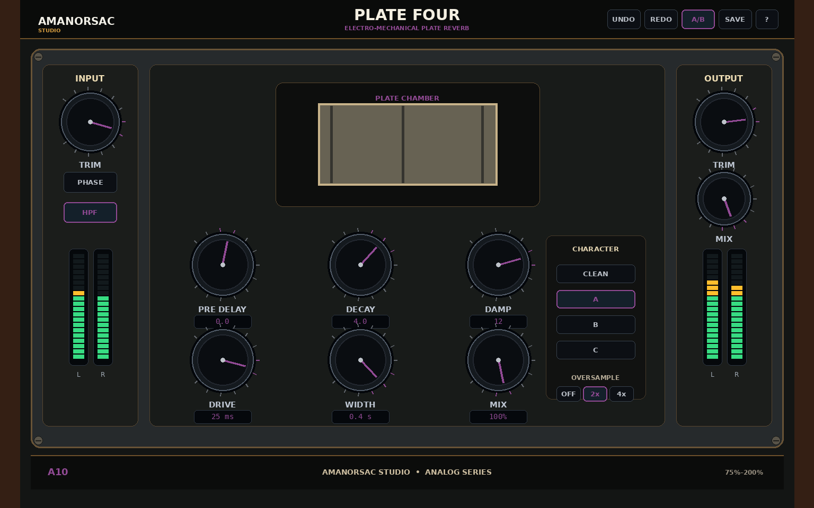
Engineering UI reference — PLATE FOUR. Geometry is authoritative; final rendering should reach the approved Amanorsac Studio material/lighting quality.
Item | Specification
Series | Analog
Reference canvas | 1536 × 960
Primary role | Electro-Mechanical Plate Reverb
Feature set | 4 original plate characters; Bass cut; Treble shelf; Crosstalk; Analog noise optional; Stereo/mono-stereo
Parameter count / schema entries | 12

Signal flow / processing intent
Input → pre-delay → selected plate model → damping/bass cut/treble/drive/crosstalk → width → wet/dry → output.

UI geometry
Item | Specification
topbar | x=38, y=0, x2=1498, y2=72
chassis | x=58, y=92, x2=1478, y2=846
input | x=80, y=122, x2=260, y2=805
main | x=282, y=122, x2=1254, y2=805
output | x=1276, y=122, x2=1456, y2=805
footer | x=58, y=860, x2=1478, y2=924

Analog interaction requirements
- Vertical knob drag by default; mouse wheel works when hovered.
- Shift = fine; double-click = reset; right-click = exact value/reset/copy/paste.
- Physical-looking controls must always expose exact values via tooltip/entry.
- No decorative control may be non-functional unless explicitly marked as visual-only in machine JSON.

Parameter contract
ID / Label | Type | Range / Values | Default | Automation
plate  Plate | enum | A / B / C / D | A | Yes
pre_delay  Pre Delay | float | 0 to 500 ms | 25 ms | Yes
decay  Decay | float | 0.4 to 8 s | 2.5 s | Yes
damp  Damp | float | 0 to 100 % | 45 % | Yes
bass_cut  Bass Cut | float | 20 to 500 Hz | 80 Hz | Yes
treble  Treble | float | -12 to 12 dB | 0 dB | Yes
drive  Drive | float | 0 to 100 % | 10 % | Yes
crosstalk  Crosstalk | float | 0 to 100 % | 25 % | Yes
noise  Analog Noise | float | 0 to 100 % | 0 % | Yes
width  Width | float | 0 to 200 % | 110 % | Yes
mix  Mix | float | 0 to 100 % | 100 % | Yes
output  Output | float | -24 to 24 dB | 0 dB | Yes

Appendix A — Master Codex Execution Prompt
You are the autonomous implementation team for Amanorsac Studio Mixing Suite. Treat the attached DOCX and 04_Machine_Spec JSON files as authoritative. Build all 20 individually loadable plugins and the separate analog-only Mix Rack. Do not substitute your own UI composition, branding, product names, parameter ranges or interaction behavior. If there is conflict, use the source-of-truth hierarchy in Document Control.
Operate as the virtual roles defined in Section 12. Keep the repository buildable. Implement shared platform/state/UI infrastructure first, then one representative digital plugin (D01 PRISM EQ) and one representative analog plugin (A01 Heritage EQ), validate them, then parallelize the remaining processors by subsystem. The rack must reuse analog DSP modules, not duplicate them.
At the start of every work session: read docs/dev/STATUS.md, docs/dev/HANDOFF.md, docs/dev/KNOWN_ISSUES.md, and the latest BUILD_LOG/TEST_LOG entries. At the end of every work session update STATUS and HANDOFF. Log every build, test, failure, fix, architecture change, UI change, milestone and release candidate. Never claim something passes without BUILD/TEST IDs.
Do not stop after planning or scaffolding. Continue through implementation, testing, integration, host validation, packaging, documentation and the preset-authoring phase. If an external blocker exists (AAX SDK, signing credentials, unavailable commercial test host), record it and continue all work that does not depend on it.
Preset authoring begins only after DSP/parameter contracts are frozen. Do not ship until the preset minimums and release gates are complete.

Appendix B — Required Package Files
- 00_README.md
- 01_Documentation/Amanorsac_Studio_Mixing_Suite_Codex_Build_Specification.pdf
- 01_Documentation/COPYRIGHT_AND_REFERENCE_POLICY.md
- 01_Documentation/MASTER_CODEX_PROMPT.md
- 01_Documentation/PRESET_AUTHORING_PLAN.md
- 02_Designs/00_Approved_Visual_Anchors/A01_Heritage_EQ_Approved_Visual.png
- 02_Designs/00_Approved_Visual_Anchors/D01_PRISM_EQ_Approved_Visual_Branded.png
- 02_Designs/00_Suite_Overview_Concept.png
- 02_Designs/01_Digital/D01_PRISM_EQ.png
- 02_Designs/01_Digital/D02_FLUX_DYNAMIC_EQ.png
- 02_Designs/01_Digital/D03_SPECTRA_MULTIBAND.png
- 02_Designs/01_Digital/D04_PULSE_LIMITER.png
- 02_Designs/01_Digital/D05_AIR_DE-ESSER.png
- 02_Designs/01_Digital/D06_RESONANCE_CTRL.png
- 02_Designs/01_Digital/D07_FREQ_SHAPER.png
- 02_Designs/01_Digital/D08_ORBIT_DELAY.png
- 02_Designs/01_Digital/D09_SPACEVERB_PRO.png
- 02_Designs/01_Digital/D10_WIDE_IMAGER.png
- 02_Designs/02_Analog/A01_HERITAGE_EQ.png
- 02_Designs/02_Analog/A02_IRON_PRE.png
- 02_Designs/02_Analog/A03_CONSOLE_ONE.png
- 02_Designs/02_Analog/A04_REELSAT.png
- 02_Designs/02_Analog/A05_VALVE_DRIVE.png
- 02_Designs/02_Analog/A06_STRIKE_FET.png
- 02_Designs/02_Analog/A07_LUMEN_OPTO.png
- 02_Designs/02_Analog/A08_BUSFORGE_VCA.png
- 02_Designs/02_Analog/A09_SILK_PASSIVE_EQ.png
- 02_Designs/02_Analog/A10_PLATE_FOUR.png
- 02_Designs/03_Rack/R01_Analog_Mix_Rack.png
- 02_Designs/Analog_Contact_Sheet.png
- 02_Designs/Digital_Contact_Sheet.png
- 03_Brand/Amanorsac_Studio_Logo_Source.JPG
- 03_Brand/Amanorsac_Studio_Logo_Transparent.png
- 04_Machine_Spec/interaction_profiles.json
- 04_Machine_Spec/plugins/A01.json
- 04_Machine_Spec/plugins/A02.json
- 04_Machine_Spec/plugins/A03.json
- 04_Machine_Spec/plugins/A04.json
- 04_Machine_Spec/plugins/A05.json
- 04_Machine_Spec/plugins/A06.json
- 04_Machine_Spec/plugins/A07.json
- 04_Machine_Spec/plugins/A08.json
- 04_Machine_Spec/plugins/A09.json
- 04_Machine_Spec/plugins/A10.json
- 04_Machine_Spec/plugins/D01.json
- 04_Machine_Spec/plugins/D02.json
- 04_Machine_Spec/plugins/D03.json
- 04_Machine_Spec/plugins/D04.json
- 04_Machine_Spec/plugins/D05.json
- 04_Machine_Spec/plugins/D06.json
- 04_Machine_Spec/plugins/D07.json
- 04_Machine_Spec/plugins/D08.json
- 04_Machine_Spec/plugins/D09.json
- 04_Machine_Spec/plugins/D10.json
- 04_Machine_Spec/suite_manifest.json
- 05_Dev_Templates/AGENTS.md
- 05_Dev_Templates/BUILD_LOG.md
- 05_Dev_Templates/CHANGE_LOG.md
- 05_Dev_Templates/DECISIONS.md
- 05_Dev_Templates/HANDOFF.md
- 05_Dev_Templates/KNOWN_ISSUES.md
- 05_Dev_Templates/MILESTONES.md
- 05_Dev_Templates/RELEASE_CHECKLIST.md
- 05_Dev_Templates/STATUS.md
- 05_Dev_Templates/TEST_LOG.md
- 06_Tools/augment_specs.py
- 06_Tools/create_docs.py
- 06_Tools/generate_assets.py
- 07_Presets/README.md

Appendix C — Reference Manual Learnings
Reference | Workflow / concept learned
abbey-road-saturator.pdf | Useful reference for explicit signal-flow thinking, pre/post tone shaping, M/S-specific processing and multiple saturation behaviors.
magma-tube-channel-strip.pdf | Useful reference for simple channel-strip hierarchy, input headroom/drive relationship, EQ + expander/gate + compressor grouping and readable VU metering.
loair.pdf | Useful reference for generated low-frequency content, source-feed routing and time alignment concepts.
vitamin.pdf | Useful reference for multiband harmonic enhancement, crossover editing, per-band solo/bypass and frequency-dependent stereo width.
vocal-rider.pdf | Useful reference for detector-vs-program separation, target/range concepts, sidechain-relative automatic gain and automation writing.
supertap-1.pdf | Useful reference for graphical multi-tap editing, tap placement, per-tap pan/filter and modulation/feedback workflow.
clarity-vx-pro-v16-update.pdf | Useful reference for basic vs advanced disclosure, per-band process amounts, crossovers, solo/bypass/delta and precision shortcuts.
cla-mixhub-v3.pdf | Useful reference for modular/channel context, reorderable processing and multi-processor workflow; Amanorsac rack remains original and analog-only.
ir-convolution-reverb.pdf | Useful reference for convolution/IR library architecture and controllable acoustic-space concepts.
atlas-reverb.pdf | Useful reference for program-first algorithmic reverb, persistent main controls, damp/space/ducker/EQ subpages.
abbey-road-vinyl.pdf | Useful reference for modeling an interacting analog system rather than a single generic “warmth” control.
abbey-road-tg-mastering-chain.pdf | Useful reference for reorderable modules, per-module stereo/MS modes and collapsed/expanded concepts.
abbey-road-reverb-plates.pdf | Useful reference for plate characters, damping, pre-delay, drive/noise options and mono-to-stereo considerations.
j37-tape.pdf | Useful reference for tape speed/formula/bias/wow/flutter as separate dimensions of tape character.
abbey-road-chambers.pdf | Useful reference for hybrid delay/feedback/reverb routing and user-visible signal-flow documentation.

