**AppName**: ticketsvalidationsde

This is app is background app used to apply the user validation messages on the tickets details page

**Description:**

Following validation are covered by this app.

1) User clicks on the sendReply Button, user will get confirmation message to check if they want to proceed with sending email to the customer, if yes email is sent else, you will get the error message that email is not sent.

2) User change the status of the ticket from resolved to closed user get the confirmation message if they have added added notes or informed customer, if yes then status remain closed user can update the ticket else status is reverted back to resolved.

**Screenshots**

1. User changes the status from Resolved to Closed. Confirmation box ask to Save or Cancel

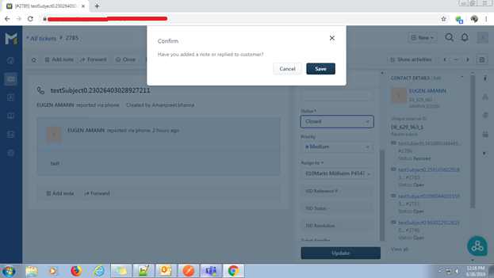

1. Incase Use choose cancel status is reverted back to Resolved

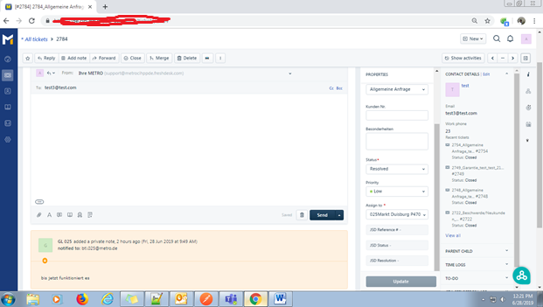

1. User Click on Reply button to send email to customer and Clicks on Send, Confirm dialog box comes up to Save or Cancel, Once user Cancels Email is not sent also error notification also appears on screen as shown in next screen shot.

